NAME: ………………………………………………………CLASS:……………………………

INDEX NO: ……………………….....................

312/1
GEOGRAPHY
PAPER 1
TIME: 2 ¾ HOURS

FORM 4
Kenya Certificate of Secondary Education (K.C.S.E)

INSTRUCTIONS:

- The paper comprises of 2 sections A and B.
- Attempt all question in section A.
- In section B, answer question 6 and choose any other two questions.
- Use separate answer sheets for section A and each question in section B.

This paper consists of 6 printed pages. Candidates should check the question paper to ensure that all pages are printed as indicated and no questions are missing.
SECTION A
Answer all questions in this section
1. (a) What is the relationship between Geography and Physics. (2 marks)
(b) Name the three main layers of the atmosphere from the earth’s surface upwards. (3 marks)
2. (a) Name two layers of discontinuity that are part of the interior structure of the earth. (2 marks)
(b) State three characteristics of the outer core in the interior structure of the earth. (3 marks)
3. (a) Distinguish between orogeny and orogenesis. (2 marks)
(b) Name the countries where the following fold mountains are found. (3 marks)
i) A kwapim hills
ii) Deccan Plateau
iii) Cape ranges
4. a) State three ideal conditions for the formation of an artesian well (3 marks)
b) Give two ways in which underground water may reach the earth surface. (2 marks)
5. (a) Define a lake. (2 marks)
(b) State three effects of a lake on the climate of the surrounding areas. (3 marks)

SECTION B (75marks)
Answer question 6 and any other two questions from this section
6. Study the map of Karatina (1:50000) sheet 121/3 provided and answer the following questions.
(a) (i) Convert the RF of the map into a statement scale. (1 mark)
(ii) Calculate the bearing of the church at Hiriga grid square 8457 from the cattle dip at Kaburuini
grid square 8756. (2 marks)
(iii) Calculate the area of Karatina town. Give your answer in square kilometres. (2 marks)
(iv) Name the two districts covered by the map. (2 marks)
(b) The rectangle below represent an area on the map extract bounded by easting 85 and 92and northing 45 and 51.
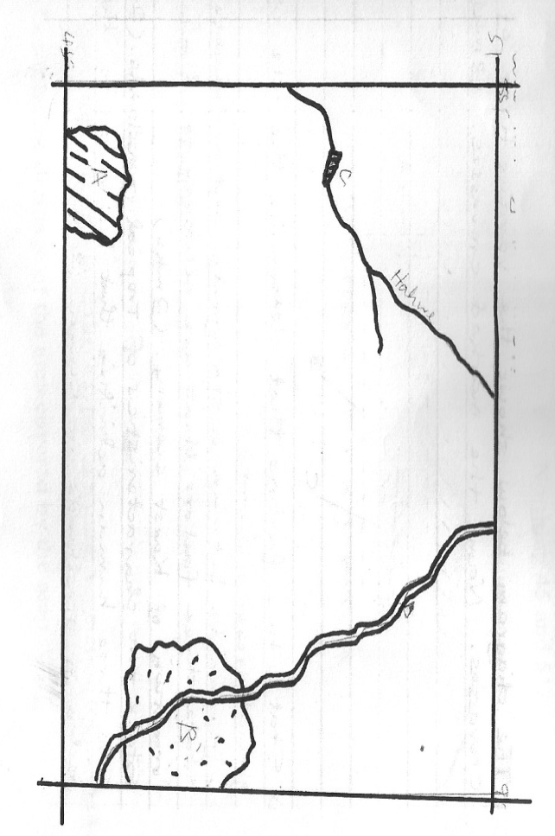

Identify the features marked A, B, C and D. (4 marks)
(c) Citing evidence from the map, give three economic activities carried out in the area covered by the
map. (6 marks)
(d) Apart from forests, name three types of natural vegetation found to the East of Easting 94. (3marks)
(e) Describe the drainage of the area covered by the map. (5 marks)

7. a) i) Name three features that form as a result of river erosion. (3 marks)
ii) Describe the following processes of river transportation.
Suspension (2 marks)
Traction (2 marks)
(b) i) Using a well labeled diagram describe how a natural levee forms. (5 marks)
ii) Outline two factors that may lead to the flooding of a river with natural levees. (2 marks)
iii) Give two ways in which rivers can improve food security in a region. (2 marks)
(c) Your class is planning to carry out a field study of a river in its youthful stage.
(i) Formulate threehypotheses for your study. (3 marks)
(ii) Give three reasons why it would be necessary to write a work schedule for the study. \ (3marks)
(iii) In what ways would you record the data collected from the study. (3 marks)
8. (a) Name four types of faults. (4 marks)
(b) State three causes of faulting. (3 marks)
(c) Using well labelled diagrams, describe the formation of Rift valley by compressional forces. (6 marks)
(d) Apart from Rift valley, name three features formed through faulting. (3 marks)
(e) You intend to carry out a field study on faulting at the Rift valley.
(i) Identify three sources of data you would use to prepare for the study. (3 marks)
(ii) State three positive effects of faulting to human economic activities you are likely to identify. (3 marks)
(iii) Outline any three problems you are likely to encounter during the field study. (3 marks)
9. The diagram below shows some surface features in a karst region. Use it to answer question (a)
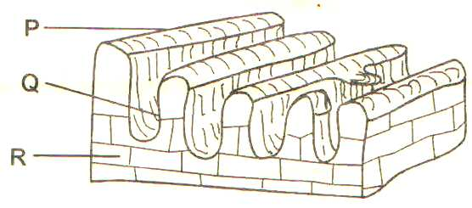

a) Name the features marked P, Q and R. (3 marks)
b) Outline three factors that influence the development of karst scenery. (3 marks)
c) Using suitable diagrams, describe how the following features which are found in limestone areas are
formed.
i) A swallow hole (5 marks)
ii) A doline (3 marks)
d) Explain three ways in which limestone landscapes influence human activities. (6 marks)
e) Form four students of your school undertook field work on a karst landscape.
i) State two objectives of their study. (2 marks)
ii) Give one reason why they need to pre-visit the area. (1 mark)
10. (a) List
i) Four characteristics of desert soil. (4 marks)
ii) Two factors that contribute to soil leaching. (2 marks)
b) Explain how each of the following factors influence the formation of soil.
i) Parent rock (2 marks)
ii) Living organisms (2 marks)
iii) Topography (2 marks)
c) Draw a well labelled diagram of a soil profile of a mature soil. (5 marks)
d) Explain four ways in which human activities contribute to soil erosion. (8 marks)

