NAME: ………………………………………………………CLASS:……………………………

INDEX NO: ……………………………….
312/2
GEOGRAPHY
PAPER 2
TIME: 2 ¾ HOURS

FORM 4
Kenya certificate of secondary education (K.C.S.E)

Instructions to Candidates
a) This paper has two Sections: A and B.
b) Answer all the questions in Section A.
c) Answer Questions 6 and any other two questions from section B.
d) All answers must be written in the answer booklet provided.
e) This paper consists of 4 printed pages.
f) Candidates should check the question paper to ascertain that all the pages are printed as indicated and that no questions are missing.
g) Candidates should answer the questions in English.

This paper consists of 4 printed pages. Candidates should check the question paper to ensure that all pages are printed as indicated and no questions are missing.
SECTION A
Answer all questions in this section
1. a) State two ways in which minerals occur. (2 marks)
b) Describe panning as a method of mining. (3 marks)
2. (a) Name two indigenous softwood tree species found in Kenya. (2 marks)
(b) State three factors that favour the development of softwood forests in Canada. (3 marks)
3. a) Define international trade. (2 marks)
b) Name three major imports from Europe to Kenya. (3 marks)
4. a) Define eco-tourism. (2marks)
b) State three factors which have made Switzerland a major tourist destination. (3marks)
5. State five factors which influence nucleated settlement pattern. (5 marks)
SECTION B
Answer question 6 and any other two questions from this section
6. Study the photograph below and use it to answer question (a)
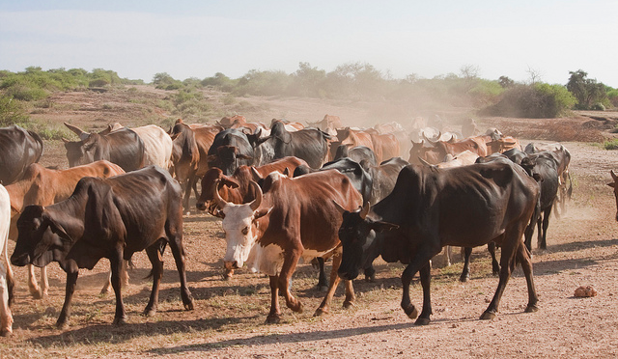

a) (i) Name the type of photograph shown above (1 mark)
(ii) What time of the day was the photograph taken if the camera was held facing south? (1 mark)
iii) Draw a rectangle measuring 16cm by 9cm to represent the area of the photograph. On it
sketch and label the main features shown on the photograph. (5 marks)
iv) Describe the landscape of the area represented by the photograph. (3 marks)
(b) (i) Identify two counties in the Rift Valley where ranching is practiced. (2 marks)
(ii) Name one exotic breed of beef cattle reared in Kenya (1 mark)
c) State four physical factors which favour beef farming in Argentina. (4 marks)
d) Explain four benefits of beef farming to the economy of Argentina (8 marks)
7. (a) State two advantages of written communication. (2 marks)
(b) Use the outline map of East Africa provided to answer questions (i) and (ii).
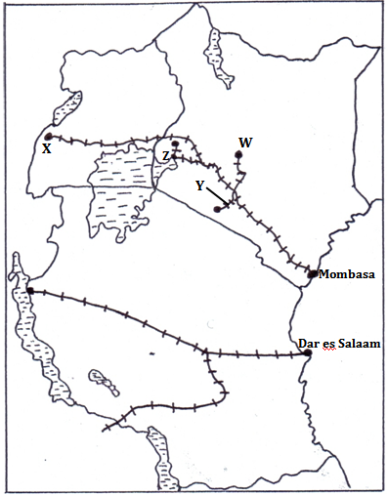

(i) Name the towns marked W and X. (2 marks)
(ii) Name the railway lines marked Y and Z. (2 marks)
(c)(i) State two ways in which Kenya would benefit from the construction of the Standard gauge
railway. (2 marks)
(ii) Explainthree factors that hinder development of River transport in Africa. (6 marks)
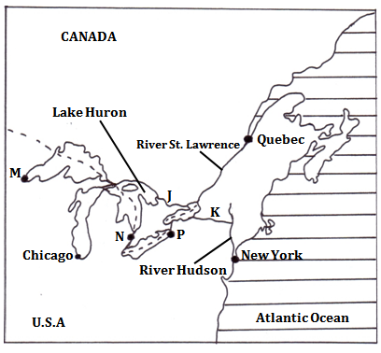
(d) The map below shows the Great Lakes and St. Lawrence Seaway. Use it to answer question (i) and (ii).

(i) Name the canals marked J and K. (2 marks)
(ii) Name the towns marked M, N and P. (3 marks)
(e) Explain three measures that were taken to solve the challenges that faced navigation along the Great Lakes and St. Lawrence Seaway. (6 marks)
8. a )i) Name two countries found in the North West pacific fishing ground. (2marks)
ii) Explain four physical factors that favour fishing in the above fishing ground. (8marks)
b) Describe the following methods of fishing:
i) drifting (4marks)
ii) purse seine (4marks)
c) Compare fishing in Kenya and Japan under the following sub-headings:
i) fishing ground (2marks)
ii) climate (2marks)
d) State three significance of fishing to the economy of Kenya. (3marks)

9. a) State three physical conditions that favour large scale farming in Kenya. (3marks)
b) Describe the cultivation of sugarcane in the lake region of Kenya from preparation of land to the harvesting stage. (5marks)
c) i) Give five problems facing sugarcane farming in Kenya. (5marks)
ii) Explain three reasons why Kenya import sugar yet she is a producer of the same commodity. (6marks)
d) Your class visited a sugar factory for a field study on sugar processing.
i) Outline four stages of sugar processing that the class have observed. (4marks)
ii) Name two by- products of sugar that the class may have identified during the study. (2marks)
10. a) i) Apart from water and air pollution, name two other types of pollution. (2 marks)
ii) Give three ways through which water is polluted. (3 marks)
iii) Explain three effects of air pollution on the environment. (6 marks)
b) i) Explain three factors that lead to frequent flooding in the lake region of Kenya. (6 marks)
ii) State three ways through which floods are controlled in the lake region of Kenya.(3 marks)
c) You are planning to carry out a field study on effects of wind on the environment.
i) State two methods of data collection you are likely to use. (2 marks)
ii) Give three ways in which your findings will benefit the local people. (3 marks)

