FORM 4

312/1
GEOGRAPHY
PAPER 1
TIME: 2¾ HOURS

NAME: ________________________________________________________

ADM NO: _______________________________ CLASS: __________

Kenya Certificate of Secondary Education
Geography
Paper 1
2 ¾ Hours

INSTRUCTIONS TO CANDIDATES
- This paper has two sections: A and B
- Answer ALL questions in section A.
- In section B answer question 6 (six) and any other two questions.
- All answers MUST be written in the Foolscap papers provided.

This paper consists of 7 printed pages.
Candidates should check the question paper to ensure that all the pages are printed as indicated and no questions are missing.

Turn Over

SECTION A
Answer all questions
- (a) Name two types of tectonic plate boundaries (2mks)
- Give three proofs supporting the theory of continental drift. (3mks)
- The diagram below represents zones of natural vegetation on a mountain within the tropical region. Use it to answer question (a)
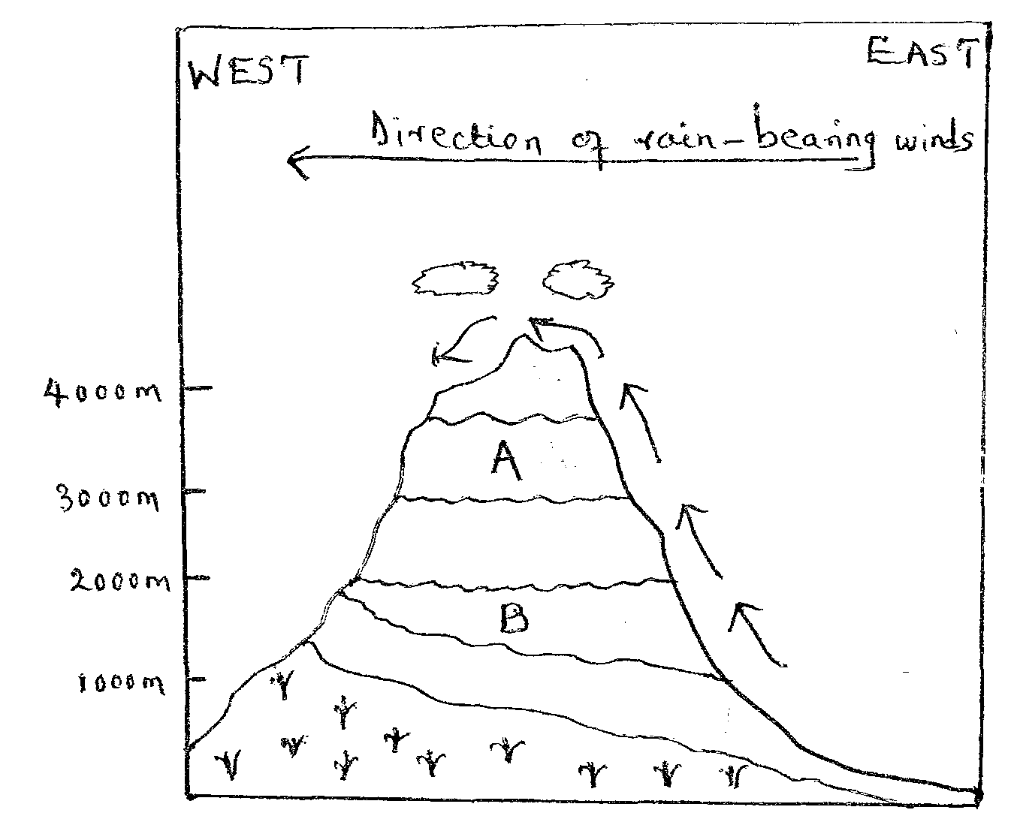
- (i) Identify vegetation zones A and B (2mks)
(ii) Give three reasons why the mountain top has no vegetation
(3mks)
3. (a) Describe three factors that influence wind transportation of materials in a desert. (3mks)
(b) Draw a well-labelled diagram of a barchans dune. (3mks)
4. (a) Name a lake in East Africa that was formed through the following processes.
(i) Crustal warping (1mk)
(ii) River deposition (1mk)
(iii) Glacial erosion (1mk)
- Give two effects of human-made lakes to the physical environment.
(2mks)
5. (a) Differentiate between elluviation and illuviation soil forming processes.
(2mks)
(b) Identify two causes of chemical degeneration of soil (3mks)

SECTION B
Answer question 6 and any other two questions from this section
6. Study the map of Kitale 1:50,000 (sheet 75/3) provided and answer the following questions
- (i) Identify the types of scales used in the area covered by
the map. (2mks)
(ii) Name two physical features found in grid square 2816.
(2mks)
(iii) Give two methods of showing relief found in the area
covered by the map. (2mks)
(iv) Calculate the area of the area covered by the papyrus swamp near Keelah Farm, give your answer in square kilometers. (2mks)
- On the square draw a square measuring 10cm by 10cm to
represent the area enclosed by Easting 25 and 30 and Northings 15 and 20. On the square mark and draw name the following. (5mks)
- All weather road loose surface
- River Koitobos
- Forested area
- Describe the drainage of the area covered by the map (6mks)
- Citing evidence from the map, explain three factors favouring the growth of the forest in the area covered by the map. (6mks)

7. (a) (i) What is a mineral? (2mks)
(ii) Describe the following characteristics of minerals (2mks)
- Cleavage (2mks)
- Luster (2mks)
- Tenacity (2mks)
(b) (i) Differentiate between the processes of the formation of plutonic
rocks and volcanic rocks.
(ii) Name two examples of extrusive igneous rocks (2mks)
(c) State three characteristics of sedimentary rocks (3mks)
(d) Explain the significance of rocks to the economy of Kenya under the following
- Energy (2mks)
- Water (2mks)
- Suppose form IV students undertook a field study of rocks within the
local environment.
- Why would they need the following equipments for their study
- Geological hammer (1mk)
- Polythene bags (1mk)
- State two hypothesis for their study (2mks)
- Outline two follow-up activities they may have undertaken for their study. (2mks)
8. (a) (i) Define faulting (2mks)
(ii) Study the diagram below and use to answer the questions that
follow.

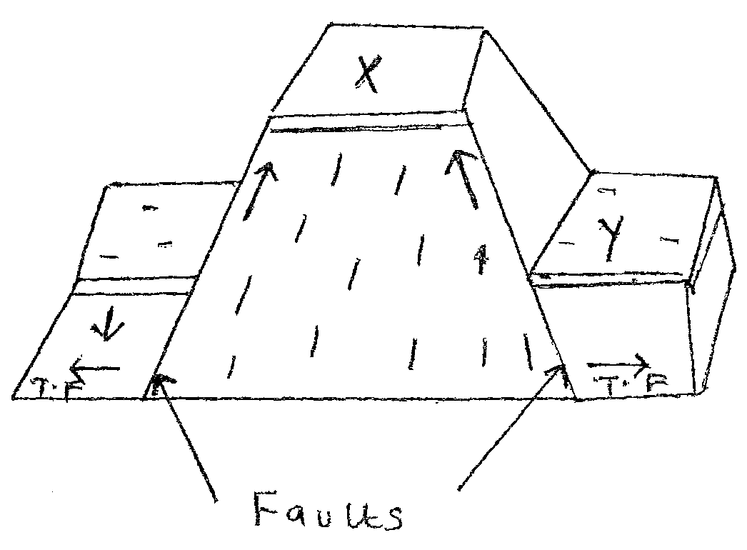
Identify the parts labeled X and Y (2mks)
(b) (i) Using well-labelled diagrams describe how a rift valley may be formed by tensional forces (7mks)
(ii) Explain the effects of faulting on the human environment (6mks)
- (i) Differentiate between vulcanicity and volcanicity (2mks)
(ii) State three characteristics of a composite volcanic (3mks)
(iii) Describe the influence of mount Kenya on drainage. (2mks)

9. (a) (i) Differentiate between mass wasting and mass movement (2mks)
(ii) Give two agents of weathering (2mks)
(iii) State three factors influencing the rate of weathering (3mks)
- Give two processes of weathering as a result of temperature
change (2mks)
(b) Explain three significances of weathering to the physical and human environment (6mks)
(c) (i) State two physical conditions that may influence landslides
(2mks)
(ii) The diagram below shows a type of landslide
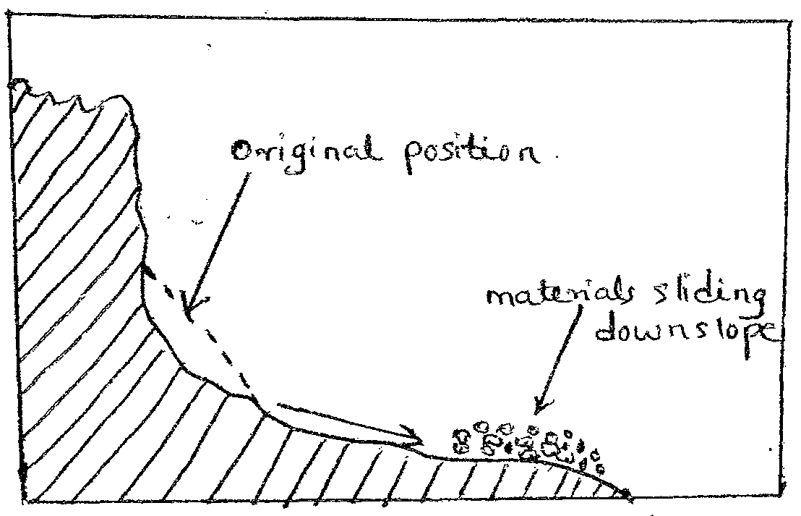
Identify the resultant feature above and describe how it occurs (4mks)
- Explain the effects of mass wasting on the following
- Creation of lakes (2mks)
- Formation of new landforms (2mks)

10. (a) (i) Define the hydrological cycle (2mks)
(ii) State three factors that determine the amount of surface run-off
(3mks)
(b) (i) Outline three characteristics of a river in its old stage. (3mks)
(ii) Explain three causes of river rejuvenation (6mks)
- Using well labeled diagram, describe the formation of antecedent drainage system.
- Your class is planning to carry out a filed study of a waterfall
- Give three reasons why it is important to study the work of
rivers through field work.
- State three problems you are likely to encounter during the field study.

