441/ 2
HOME SCIENCE
PAPER 2
CLOTHING AND TEXTILES
(PRACTICAL)
TIME: 2 ½ HOURS

FORM 3

Kenya Certificate of Secondary Education (K.C.S.E)

441/ 2
HOME SCIENCE
PAPER 2
CLOTHING AND TEXTILES
(PRACTICAL)
TIME: 2 ½ HOURS

This paper consists of 3 printed pages. Candidates should check to ensure that all pages are printed as indicated and no questions are missing

A pattern of a child’s skirt is provided. You are advised to study the sketches, the questions and the layout before you begin the test.

MATERIALS PROVIDED
- A – FRONT YOKE
B – SKIRT FRONT
C – SKIRT BACK
D – POCKET
E – WAIST BAND
- Plain light weight cotton fabric 50cm long by 91cm wide
- Serving thread to match the fabric
THE TEST
Using the materials provided, cut out and make the right half of the skirt to show the following
- Working of the dart at the back skirt
- Preparation and attachment of the patch pocket
- Joining the front yoke with the skirt front using an overlaid seam (do not neaten)
- Joining the side seam using a neatened open seam
- Preparation of the waist band
- Attaching the waist band
- Neatening the hem by edge stitching

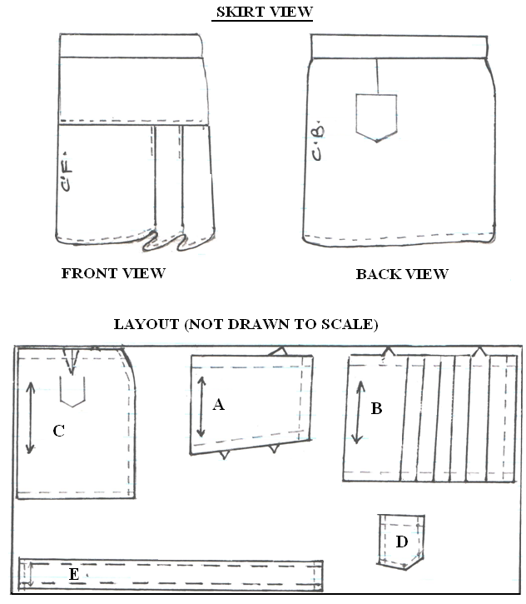
NB: At the end of the examination, firmly sew to your work, on a single fabric a label bearing your name
Remove unwanted threads and pins on your work
Any pattern piece that has not been stitched should be attached to your work before handling it for marking

