441/2
HOMESCIENCE
(CLOTHING CONSTRUCTION)
(PRACTICAL)
PAPER 2
2 ½ HOURS

FORM THREE
HOMESCIENCE (CLOTHING CONSTRUCTION)
PAPER 2
(PRACTICAL)
2 ½ HOURS

This paper consists of 3 printed pages. Candidates should check the question paper to ensure that all pages are printed as indicated and no questions are missing.

- A pattern of a child’s dress bodice is provided. You are advised to study the sketches, the question paper and the layout before you begin the test.
Materials provided
  - Front Bodice
  - Back Bodice
  - Sleeve
  - Front Neck Facing
  - Back Neck Facing
  - Sleeve Opening Facing
  - Sleeve Binding
- Light weight plain cotton fabric 65cm long by 90cm wide
- Sewing thread
The test
Using the materials provided, cut out and make the light half of a child’s dress bodice as shown in the sketch below to show the following.
- Making of a shoulder dart on front bodice.
- The working of a neatened open seam at the shoulder
- The neatening of the back facing.
- The attaching of the neckline facing sandwiching its centre back between the garment and the facing.
- The making of French seam at the side
- The preparation of the faced sleeve opening.
- The making of an unneatened open sea at the underarm.
- The binding of the lower edge of the sleeve.
- The attachment of the sleeve to the bodice and the neatening of half of ht armhole seam using loop witches.
- Sewing on of a button with a shank on front bodice.
At the end of the examination firmly sew onto your work, on a single fabric, a label bearing your name and index number. Remove the needle and pins from your work. Then fold your work carefully and place it in the envelope provided.
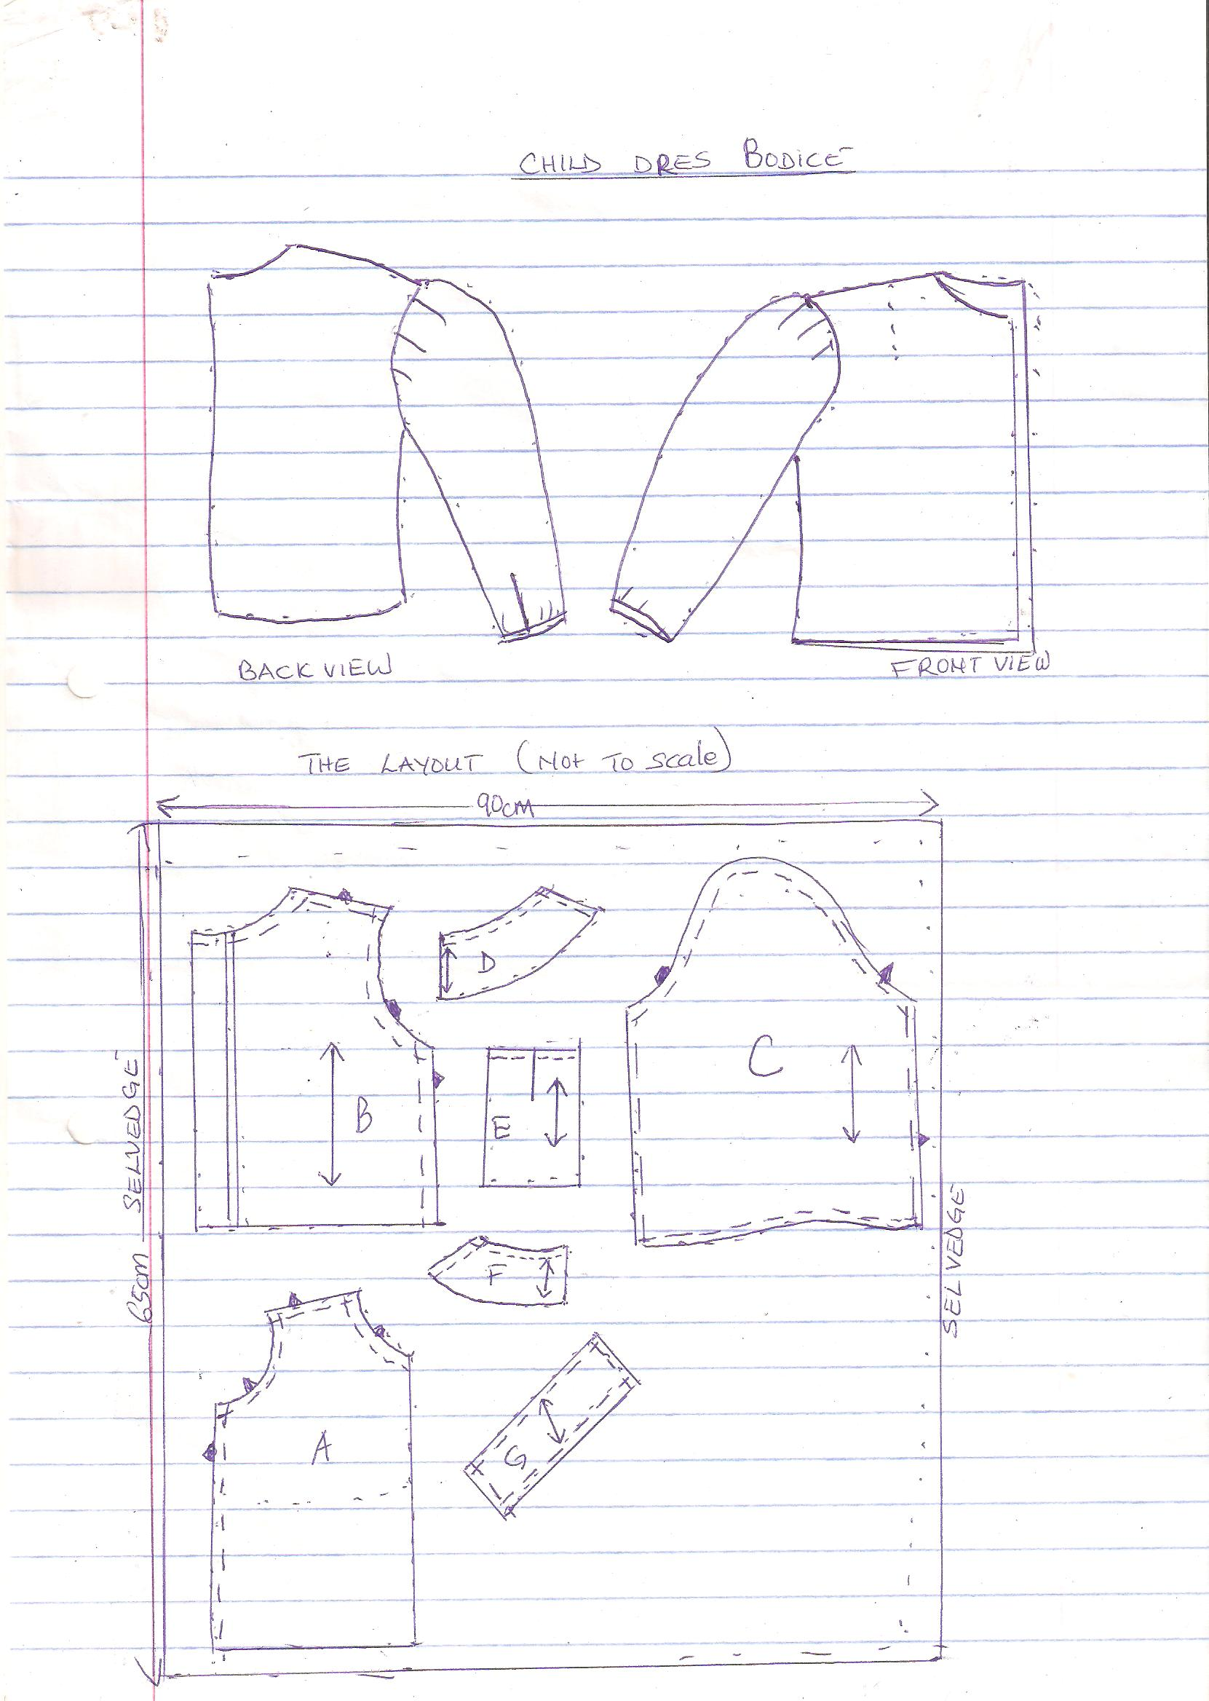

441/3
HOMESCIENCE
PAPER 3
FOODS AND NUTRITION.
PRACTICAL.
1 ¾ HOURS.
SET 5
FORM THREE

Instructions to candidates
PLANNING SESSION: 30 Minutes
PRACTICAL TEST SESSION: 1 ¼ HOURS
Read the test carefully.
- Write your name and index number on every sheet of paper used.
- Textbooks and recipes may be used during the planning session as reference materials.
- You will be expected to keep to your order of work during the practical session.
- You are only allowed to take away your reference materials at the end of planning session.
- You are not allowed to bring additional notes to the practical session.

This paper consists of 2 printed pages. Candidates should check the question paper to ensure that all the pages are printed as indicated and no questions are missing

THE TEST
You plan to make breakfast for your baby brother ad yourself. Using all the ingredients listed below, prepare, cook and serve two courses breakfast. Include a beverage.
Ingredients
- millet / sorghum flour
- sugar
- fat / oil
- eggs / sausages
- milk
- tea leaves
- wheat flour
Planning session – 30 minutes
For each task listed below – use separate sheets of paper and make duplicate copies using carbon paper. Then proceed as follows.
- Identify the dishes and writ
- Write down your order of work.
- Make a list of the food stuff and equipments you will require.

