Name: …………………….……………………... Index No: ….………………………/.….…
121/2 Candidates Signature ……………………
MATHEMATICS ALT A Date: ……………………………....……….
PAPER 2
Time: 2 ½ Hours

Kenya Certificate of Secondary Education (K.C.S.E)

Instructions to Candidates
- Write your name, Index number, Admission Number, Sign and write the date of examination in the spaces provided above.
- The paper consists of two sections: Section A and Section B.
- Answer ALL the questions in Section A and only any FIVE questions in Section B.
- Show all the STEPS in your working, giving your answer at each stage in the spaces below each question.
- Marks may be given for correct working even if the answer is wrong
- Non-programmable silent electronic calculators and KNEC Mathematical tables may be used, except stated otherwise.
- This paper consists of 14 printed pages.
- Candidates should check the question paper to ensure that all pages are printed as indicated and no questions are missing.
For Examiners Use Only
Section A
1 | 2 | 3 | 4 | 5 | 6 | 7 | 8 | 9 | 10 | 11 | 12 | 13 | 14 | 15 | 16 | Total

Section B
Grand Total

17 | 18 | 19 | 20 | 21 | 22 | 23 | 24 | Total

This paper consists of 15 printed pages. Candidates should check carefully
to ascertain that all the pages are printed as indicated and no questions are missing.

SECTION A (50 Marks)
Answer all the questions from this section in the spaces provided
- Make t the subject of the formula (3marks)
$s=\frac{wd}{t}\left(t-d/2\right)$

- a) Show that the circle with equation $(x – 3)$² + $(y – 4)$²$= 25$ passes through the origin. (1mark)

b) Find the coordinates of another point (not the origin) where the circle cuts the $x$-axis. (3marks)

- A survey carried out in a rural town on the number of young people who went for HIV test was shown in the table below
Percentage infected | $$36-39$$ | $$40-43$$ | $$44-47$$ | $$48-51$$ | $$52-55$$ | $$56-59$$
No of people | 6 | 5 | 3 | 3 | 2 | 1
Calculate the quartile deviation of the data. (4marks)

- A shear parallel to the x-axis (the invariant line) maps (1,2) onto point (5,2)
a) Determine the shear factor. (2marks)

b) Hence state the shear matrix. (1mark)

- A colony of bees was found to have 250 bees at the beginning. Thereafter the number of bees doubled every two days. Find how many bees there were after 16 days (3marks)

- Solve $2 sin^{2}x – 3sin x + 1=0$for $0^{0}≤ x ≤ 360^{0}$ (3marks)

- The circumference of the circle of latitude x⁰ south is 3751nm. Find x to the nearest whole number. (3marks)

- a) Determine the turning point of the curve y=x³ – 3x² + 3x – 6 (2marks)

b) State the nature of the point identified in a above, (1mark)

- Nine men working 8 hours a day can weed a field in 15 days. How many hours a day must 27 men work in order to weed the same field in 5 days? (2marks)

- Solve the equation below using the completing square method
3x² – 7x + 2= 0 (3marks)

- Given that $tan = x$ show that (3marks)
$$\frac{Cos sin^{2} + cos^{2}}{Sin } = 1/x$$

- (a) Expand and simplify the binomial expression $(2-x)$⁶ (1 mark)

(b) Use the expansion up to the term in x³ to estimate to 3 decimal places. (2marks)

- Without using calculators or mathematical tables simplify (3marks)
$\frac{\sqrt{63} + \sqrt{72}}{\sqrt{32} + \sqrt{28}}$

- A line L₁ has the equation x+2y = 4. The line L₂ is perpendicular to L₁ and passes through the origin
(a) Determine the equation of L₂. (1mark)

(b) Find using matrix method the co-ordinates of the intersection point of the two lines. (2marks)

- By correcting each number to one significant figure, approximate the value of $788 × 0.006.$ Hence calculate the percentage error arising from this approximation. (3marks)

- The diagram below represents a garden ABC.

- Draw the locus of points equidistant from sides AB and AC.
- Draw the locus of points equidistant from points A and C
- A bead is lost within a region which is nearer to point A than to point C and closer to side AC than to side AB. Show by shading the region where the bead can be located. (3marks)

SECTION II (50 MARKS)
Attempt any five questions in this section
- A bag contains 3 black balls and 6 white balls. If two balls are drawn from the bag one a time, find the:-
- Probability of drawing two white balls
- with replacement (2marks)

- without replacement (2marks)

- Probability of drawing a black ball and white ball.
- with replacement (3marks)

- without replacement (3marks)

- In the figure below, O is the centre of the circle AB and AC are tangents. Angle ABD = 40⁰ and ACD = 30⁰. find:
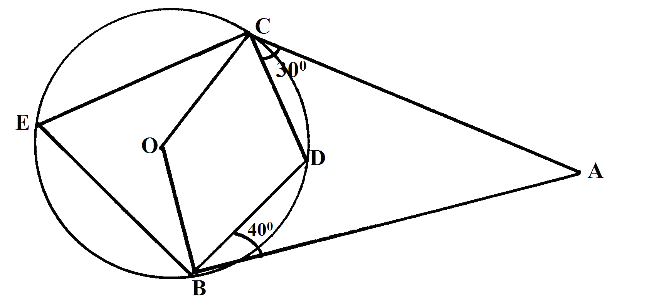

- Angle CEB (6marks)

- Angle OCB (2marks)

- Angle CAB (2marks)

- Income rates for income earned were charged as follows.
Income in sh. per month Rate in Ksh. per sh.20
1 – 8, 400 2
8401 – 18, 000 3
18001 – 30, 000 4
30, 001 – 36, 000 5
36, 001 – 48, 000 6
48, 001 and above 7
A civil servant earns a monthly salary of ksh.19, 200. His house allowance is ksh.12, 000 per month. Other allowances per month are transport ksh.13, 000 and medical allowance ksh.2, 300. He is entitled to a personal relief of ksh.1, 240 per month. Determine
- (i) His taxable income per month (2 marks)

(ii) Net tax (5 marks)

- In addition, the following deductions were made.
NHIF sh.230
Service charge ksh.100
Loan repayment ksh.4, 000
Cooperative shares of ksh.1, 200
Calculate his net salary per month (3marks)

- The figure below represents a model of a tower VPQR. The horizontal base PQR is an equilateral triangle of sides 9cm. The length of the edges are VP = VQ = VR = 20.5cm. Point M is the mid-point of PQ and VM = 20cm. Point N is on the base and vertically below V
P
M
Q
R
V
N
20 cm
9cm
20.5 cm

Calculate
- The length RM (2marks)

- The length of the model. (4marks)

- The angle between
- Plane VPR and the base (2marks)

- Line VR and the base (2marks)

- In ΔAOB, OA = 6aOB = 9b. M is the midpoint of OA and P lies on MB such that MB = 5MP
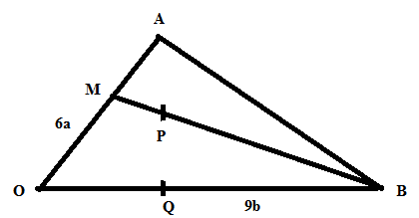

- Express in terms of $a$ and $b$ the following vectors; giving your answer in its simplest form.
(i) MB

(ii) AB

(iii) AB

(iv) AP (6 marks)

- Given that Q lies on OB such that OQ = 3b express AQ in terms of a and b (1 mark)

- Hence show that A, P and Q are collinear. (3 marks)

- A tailor makes two types of garments A and B. Garment A requires 3m of material while B requires 2 ½ m of material. The tailor uses not more than 600m of material daily in making both garments. The tailor must make not more than 100 garments of type A and not less than 80 of type B each day.
- Write down four inequalities from this information. (4 marks)

- Draw a graph for the inequalities shading the unwanted regions. (4 marks)

- If the tailor makes a profit of sh.80 on garment A and a profit of sh. 60 on garment B, how many garments must she make in order to maximize her total profit if all the garments are sold at once. (2 marks)

- (a) Using the trapezium rule, estimate the area enclosed by the curve$y=x^{2}$, the x-axis and the line $x=5$ and $x=2$ taking 7 ordinates. (3 marks)

(b) Find the exact area. (3 marks)

(c) Find the % error in using trapezium rule. (2 marks)

(d) Estimate the area using mid-ordinate rule. (2 marks)

- A publisher employs two agents John and James. John is paid at a rate of sh.240 per week. James is paid at the rate ofsh. 185 per week. John earns no commission on the first 1800 books sold and a commission at a rate of 5% on each extra book sold. James earns a commission of 2.5% on each book sold.In a certain year, each sold a total of 15000 books at the rate of sh. 83.50.
- Find who earned more money and by how much. (assume 1 year has 52 weeks)
(7 marks)

b) In another year James earned a total of sh. 51370. Calculate the number of books he sold that year. (3marks)

