Name: …………………………………………………………… Index no ……..…...................................

School: ……………………………………………………....…. Candidate’s sign ……………………....

Date: ……………………………………………………………

121/1
MATHEMATICS
PAPER 1
TIME: 2 ½ HOURS.

Kenya Certificate of Secondary Education (K.C.S.E.)

INSTRUCTIONS TO CANDIDATES:
- Write your name, Index number, date and signature in the space provided at the top of the page.
- The paper consists of two sections; Section 1 and Section II.
- Answer all the questions in section I and any other five from Section II.
- Answer and workings must be done on the questions paper in the spaces below each question.
- Show all the steps in your calculations giving your answers at each stage in the spaces below each question.
- Marks may be awarded for correct working even if the answer is wrong.
- Non – programmable silent electronic calculators and KNEC tables may be used.

For Examiner’s Use Only:

SECTION 1
Question | 1 | 2 | 3 | 4 | 5 | 6 | 7 | 8 | 9 | 10 | 11 | 12 | 13 | 14 | 15 | 16 | TOTAL
Marks

SECTION II
Grand Total
Question | 17 | 18 | 19 | 20 | 21 | 22 | 23 | 24 | TOTAL
Marks

This paper consists of 12 printed pages. Candidates should check to ascertain that all papers are printed as indicated and that no questions are missing

SECTION 1 (50 MARKS)
Attempt all the questions
1. The number line below shows an integer operation whose result is 7.

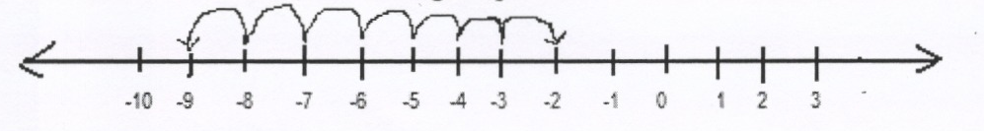

Write down the actual operation. (l mk)

2. Work out 18.5 x 7.698 leaving your answer in expanded form. (2mks)

3. What is the total value of digit six in the solution to 1725 -125 + 6591 ÷ 39 x 5 of 90? (3mks)

4. All composite numbers divisible by 3 between 10 and 30 are arranged in descending order to
form a single natural number. Write down the number formed in words. (3mks)

5 If x + 3 is the reciprocal of x- 4 , find the value of x. (3mks)
x- 9 x+1

6. Complete the shape below using the dotted centre to show a rotational symmetry of order 5. (2mks)

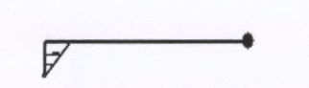

7. The lines 4ax = 3y + 12 and 7bx —2 = 3y are parallel. Find the ratio a:b (3mks)

8. Simplify (12-x-6x²)(9x²+16) completely (4mks)
81x⁴ -256

9. Solve for x in 3^{-2x+1} -10(3^{-x}) + 3 = 0, without using tables. (3mks)

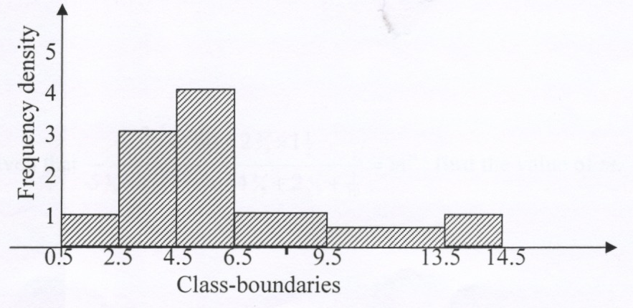
10.

Using the histogram shown above, complete the frequency table below. (3mks)
Class boundary | Frequency
0.5-2.5 | 2
2.5 – 4.5 | 6
4.5 - 6.5
6.5 - 9.5
9.5 – 13.5
13.5 – 14.5

11. Use the actual mean for the data below to calculate the standard deviation for the following scores.
Score | 1 | 2 | 3 | 4 | 5 | 6
f | 1 | 2 | 2 | 2 | 5 | 2
(4mks)

12. A wire 180cm long was used to make a model of a triangular-based prism. The cross-section has sides
of length 10cm each. Calculate the volume of the resulting shape. (4mks)

13. Given that ³/ ₅ of 60 -2 ²/₃ x 1½ = m^{m}, find the value of m. (3mks)
5⁵/₈ x 1⁷/₉ – ⁵/₄of 4 ⁴/₅ + 2⁴/₅ ÷ ⁷/₁₀

14. Solve the following inequalities and show on a number line the region satisfying the values of
x -1 < x and 3 + x ≥ x
2 5 8 3 4
x for

(4mks)

15. For a given right-angled triangle ABC, Sin B =0.8. Use the single triangle to find Tan² (90-B) (4mks)

16. Use mathematical tables to evaluate. (4mks)
√
3
3.576 1
3.18² + √0.257

SECTION 11(50 MARKS)
Attempt all the questions
17. In the figure below, QOT is a diameter, angle QTP = 47°, angle TQR = 73° and angle SRT = 38°.
Calculate giving reasons in each case:
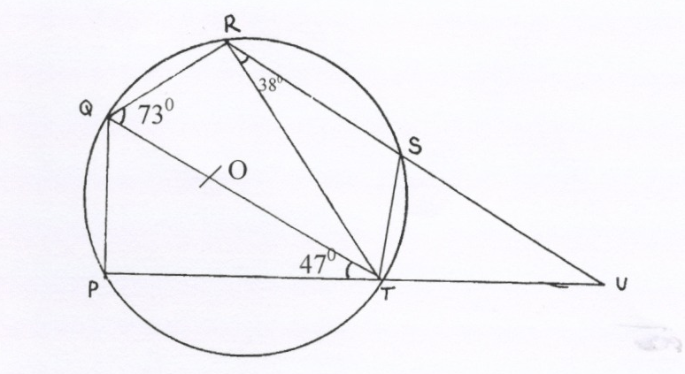
R
Q
38º
S
73º

P
T
U
47º

a) angle RST. (l mk)

b) angle SUT (3mks)

c) Obtuse angle ROT. (2mks)

d) angle PST (2mks)

e) Reflex angle SOP (2mks)

18. (a) Use graphical method to solve the equations x + 2y = 5 and 3x -2y= 7 (7mks)

(b) Verify your solutions by using matrix method. (3mks)

19. In the figure, PQRS is a rectangle with point P(4, 2) and Q (2, 8). Given that the equation of the
line PR is 2y = 2x + 4, find;
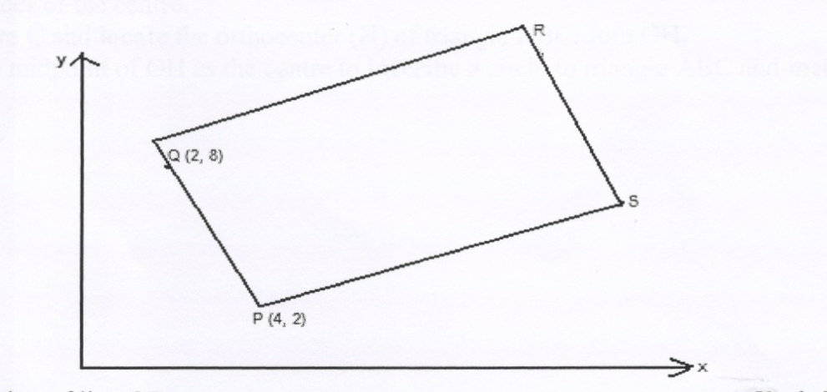
Y
R

Q(2,8)
S

P(4,2)
X

a) the equation of line QP (2mks)

b) the equation of line QR (2mks)

c) the co-ordinates of R (3mks)

d) the co-ordinates of S (3mks)

20. Draw a circle centre 0 and radius 4 cm. (l mk)
(a) From any point A on the circumference, draw two chords AB = 7cm and AC = 7.5cm on the
opposite sides of the centre. (2mks)
(b) Join B to C and locate the orthocenter (H) of triangle ABC. Join OH. (4mks)
(c) Use the midpoint of OH as the centre to inscribe a circle to triangle ABC and measure its
radius. (3mks)

21. In the figure below, the top cone was formed from a sector of area 132 cm² (using π = 22 )
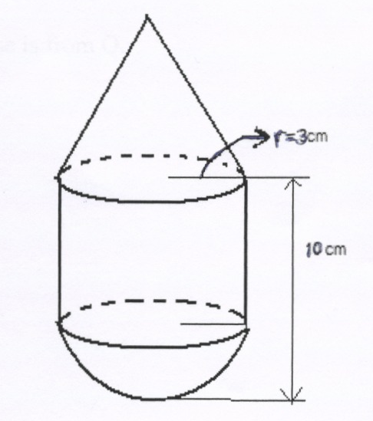
7

r = 3cm

10cm

Calculate:
(a) The total surface area of the shape. (6mks)

(b) The volume of the shape. (4mks)

22. At 2.00 pm, a ship is at a position P from where a light house L is 12km away on a bearing of
320º. At 4.00pm, the ship is at a position Q from where the lighthouse is now on a bearing of
035°. Given that the ship is traveling due West, find by calculation;
a) How far the lighthouse is from Q. (3mks)

b) The speed of the ship. (2mks)

c) The closest distance of the ship from the light house. (2mks)

d) The lighthouse, point Q and point P were noted to be along the circumference of a circular
field. Find the distance of P from the centre of the field. (3mks)

23. Calculate the shaded area in the figure below given that the circles of centres A and B have radius of
7cm and 10.5cm respectively intersecting at points P and Q with PQ = 6cm. (l0mks)
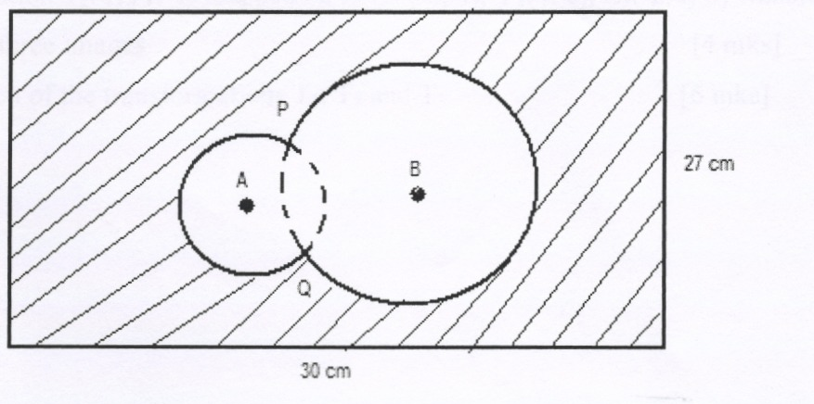

24. Triangle XYZ whose vertices are (3, -2), (-2,-3) and (1, -3) respectively is mapped on X₁ (5, -1),
Y₁ (0, -2) Z₁ (3, -2) by transformation T₁. XYZ is mapped on to X₂ (-3,2),Y₂( 2,3), Z₂( -1,3) by
transformation T₂. XYZ is mapped on to X₃ (-6, 4), Y₃(4, 6), Z₃(-2,6) by transformation T3.
a) Plot XYZ and its three images (4mks)
b) Describe fully each of the transformations T₁, T₂ and T₃. (6 mks)
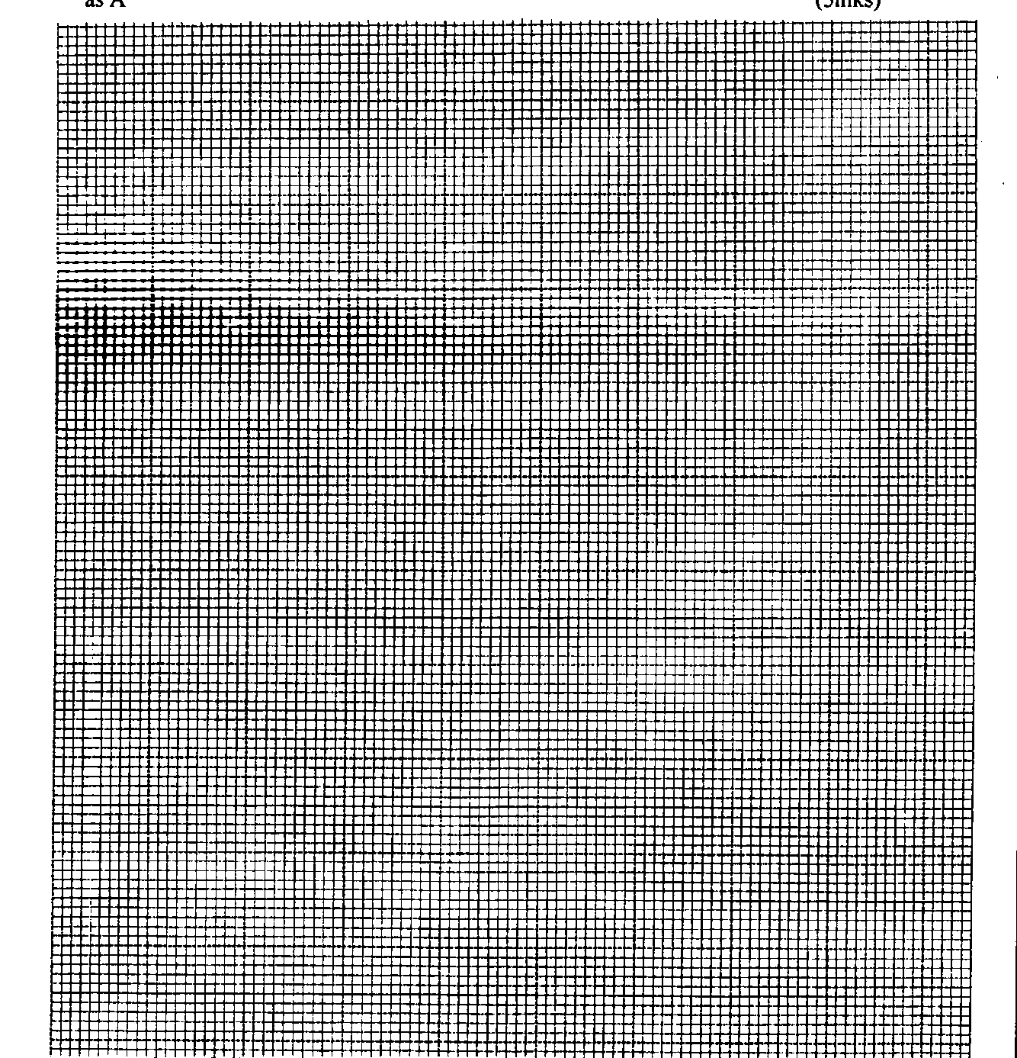
age graph

