Name……………………………………………………………….. Class ….…………………

Index Number ……………………..……… Class Number………………………

MATHEMATICS
PAPER 1
TIME: 2 ½ HOURS

Instructions to candidates

- Write your name, index and class number in the spaces provided above.
- The paper consists of two sections: section I and section II.
- Answer all the questions in section I and any five in section II
- Section I has sixteen questions and section two has eight questions
- All answers and working must be written on the question paper in the spaces provided below each question.
- Show all the steps in your calculations, giving your answers at each stage in
the spaces below each question
- KNEC Mathematical table and silent non-programmable calculators
may be used.

For examiner’s use only

Section I
1 | 2 | 3 | 4 | 5 | 6 | 7 | 8 | 9 | 10 | 11 | 12 | 13 | 14 | 15 | 16 | Total

Section II
17 | 18 | 19 | 20 | 21 | 22 | 23 | 24 | total
Grand
Total
- Evaluate the following:
73 x $\left(\frac{4 \left(-9-2\right)x -4 – 15 + -3}{-3 x-3+ -8 (-6+ -2)}\right)$ (3 mks)

- The marked price of an article is Ksh 1020. A shopkeeper sold the article to his customer after allowing him a 10% discount on the marked price. If the shopkeeper still made a profit of 20%. Determine how much he had paid for it? (3 mks)

- Solve the following inequality and state the integral values showing your answer on a number line. (3 mks)

2x – 1 < 7 + x < 3x + 1

- Solve the equation; (3 mks)

4^{-2y} + 1 – 3 x 4^{-y} = 11

- The normal to the curve y = 3x² + ax -7 at x = -2 is given by the equation 8y = x – 22, find the value of a. (3 mks)

- A metallic sphere is immersed in water in a cylindric container of radius 7cm causing a rise of 7.5 cm in the water level. Find the radius of the sphere correct to two significance figures. (4 mks)
- Use reciprocal tables to evaluate f if; (3 mks)

$$\frac{1}{52.3}- \frac{1}{44.81}= \frac{1}{f}$$

- Without using mathematical tables, find the values of x if; (3 mks)

log₁₆ (7x – 14) – log₁₆ (6 – 3x) = $\frac{3}{2}$

- Simplify completely; (4 mks)

$\frac{{2x}^{2}- 98}{{3x}^{2}- 16x-35} ÷ \frac{x+7}{3x+4}$

- A Kenyan businessman bought a car from Japan worth 2,950,000 Japanese yen. On arrival in Kenya custom duty of 30% was charged on the value of the goods.
If the exchange rates were as follows:
1 US dollar = 124 Japanese Yen
1 US dollar = 87 Kenya shillings
Calculate the duty paid in Kenya shillings. (3 mks)

- From a window 25m above a street, the angle of elevation of the top of a wall on the opposite side is 15⁰. If the angle of depression of the base of the wall from the window is 35⁰. Find;
- The width of the street. (1 mk)

- The height of the wall on the opposite side. (2 mks)

- Find the a cute angle between the line 3y = 10x + 11 and the line y = 3. (2 mks)

- The ratio of the radii of two similar cylindrical tanks is 3 : 5. If the volume of the larger tank is 9000 L, find the volume of the small tank. (3 mks)

- Pipe x can fill an empty tank in 3 hours, while pipe y can fill the same tank in 6 hours. When the tank if full, it can be emptied by pipe z in 8 hours. Pipe x and y are opened at the same time, when the tank is empty, one hour later pipe z is also opened. Find the total time taken to fill the tank. (4 mks)

- The size of each interior angle of a polygon is x⁰ and each exterior angle is x - 108 ⁰ calculating the number of sides of the polygon. (3 mks) 3

- In the figure below the circles centre O and C touch internally at N and <POQ = 80⁰. If the radius of the large circle is 20cm, calculate the radius of the smaller circle. (3 mks)

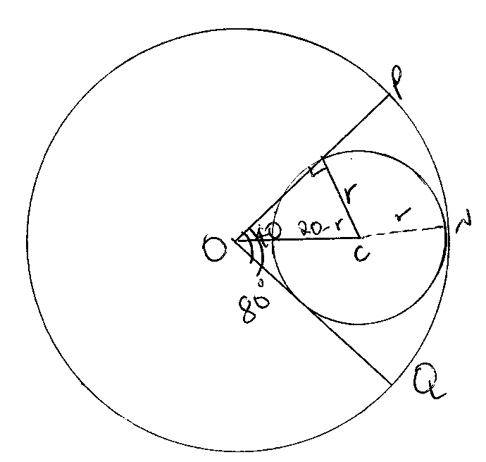

SECTION II

- In ΔAOB, O is the origin and OA and a and OB = b. X is the midpoint of OA and Y is a on AB such that 5AY = 3AB. Z is a point on OB produced such that BZ = ZOB..

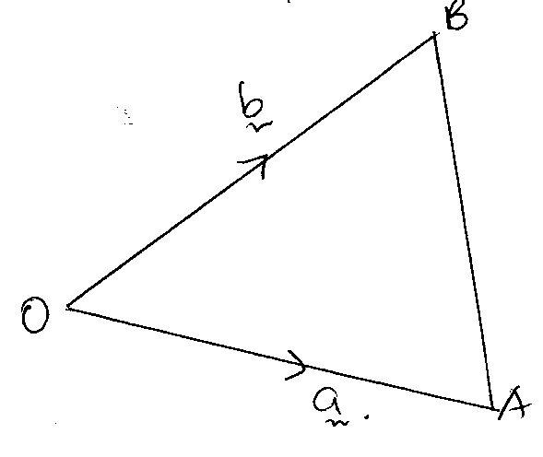
- Express:

- OX

- OZ

- OY

- XZ in terms of a and b. (4 mks)

- Show that X, Y and Z are collinear. (4 mks)

- Hence find the ratio XZ : XY. (2 mks)

- The marks obtained by 100 candidates in an examination were recorded in table below.

Marks | 0 – 9 | 10 – 19 | 20 – 29 | 30 – 39 | 40 – 49 | 50 – 59 | 60 – 69
No of candidates | 12 | 16 | 24 | 18 | 14 | 10 | 6

Draw a cumulative frequency curve and use it to estimate;
- (i) Mean

(ii) Quartile deviation

- The percentage of candidates failing if the pass mark is 25 marks.

- Range of marks scored by the middle 50% of the candidates. (10 mks)

- The relationship between the variables p and v is known to be of the form V = aP^{n} where a and n are constants. For some fixed values of P, values of V are obtained through an experiment. The following table shows the corresponding values of logP and logV.

logP | 0.301 | 0.699 | 1.00 | 1.300
logV | 1.398 | 0.602 | 0.00 | $$\overline{1}.452$$

- Draw the graph of logV against logP. (6 mks)

- Deduce from your graph the values of a and n. (4 mks)

- A lorry travels from Nairobi to Lodwar and back. From Nariobi to Lodwar, the average speed of the lorry is 70 km/h and from Lodwar to Nairobi, the lorry averages 20 km/h slower and takes 4 hours longer than on the journey from Nairobi to Lowdar.

- Find the distance between Nairobi and Lodwar. (4 mks)

- Diesel consumption is 0.32 litres per kilometer on the journey from Nairobi to Lodwar. This rate of fuel consumption increases by 25% on the return journey. Calculate the amount of diesel the lorry consumes for the trip. (3 mks)

- The lorry makes 2 rand trips per week. If diesel costs sh 65 per litre, determine the total cost of diesel required to run the lorry for 3 months. (3 mks)

- Find the area of the shaded region if O₁ and O₂ are the centres of the sector with radius 8cm and 6 cm respectively, and AB = 8 cm. (10 mks)

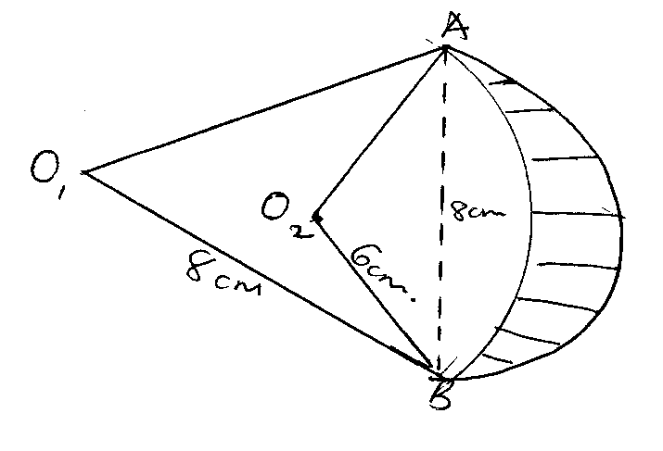

- A triangle M whose vertices are A (2,3), B (B,3) and C (4,1) is mapped onto triangle M¹ whose vertices are;
A¹(-4,3), B¹ (-1,3) and C¹ (x,y) by a transformation N = 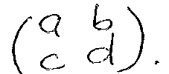

- Find:
- Matrix N of the transformation. (3 mks)

- Coordinates of C₁ hence plot the two triangles on the grid provided.

- Triangle M² is the image of triangle M¹ under a reflection in the line y = x. Find a single matrix that map M and M₂. (4 mks)

- Three secondary schools, St Georges, Kenya High and Moi Girls are such that St. Georges is directly to the south of Kenya high and are 400m apart. Moi Girls is situated at N 70⁰E of St Georges and are 7000m apart.

- Calculate the distance between Moi Girls and Kenya High. (5 mks)

- A cyclist from Kenya high cycling at 5 km/h started his journey at 9.00 am towards Moi girls to deliver a message, meanwhile a messenger was sent from Moi Girls and started her journey at 9.15 am towards St. Georges walking at 3 km/h meeting on the way. Calculate the distance from St. Georges to the meeting point. (5 mks)

- Three taps P, Q and R fill a tank in 50 min, X min and y min respectively. The 3 taps are turned on and after 5 min tap R is closed. After another 3 min tap Q is closed and tap P took 12 min to fill the tank. If the three taps fill the tank in 9 ¹/₁₁. Find x and y. (10 mks)

