NAME: ________________________________________________________

ADM NO: _______________________________ CLASS: __________

121/1
MATHEMATICS
PAPER 1
TIME: 2½ HOURS

Kenya Certificate of Secondary Education
.

INSTRUCTIONS TO CANDIDATES
- This paper contains two sections: section I and section II
- Show all the steps in your calculations, giving your answers at each stage in the spaces below each question.
- Marks may be given for correct working even if the answer is wrong.
- Non programmable silent electronic calculators and KNEC mathematical tables may be used, except where stated otherwise.

For Examiner’s Use only
Section I
1 | 2 | 3 | 4 | 5 | 6 | 7 | 8 | 9 | 10 | 11 | 12 | 13 | 14 | 15 | 16 | Total
Section II
17 | 18 | 19 | 20 | 21 | 22 | 23 | 24 | Total
Grand Total

This paper consists of 16 printed pages. Candidates should check the question paper to ensure that all the pages are printed as indicated and no questions are missing.

Turn Over

SECTION I (50 MARKS)

- Using the logarithm tables solve the following, give your answer to 4 significant figures
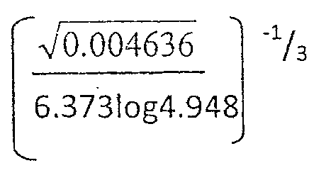
(3 mks)

- Kamau toured Switzerland Germany. In Switzerland he bought his wife a present worth 72 Deutsche marks. Find the value of the present in:
- Swiss Francs

- Kenya shillings correct to the nearest sh, if
1 Swiss Franc = 1.25 Deutsche marks
1 Swiss Franc = 48.2 Kenya shillings (3 mks)

- Without using tables or a calculator simplify (3 mks)
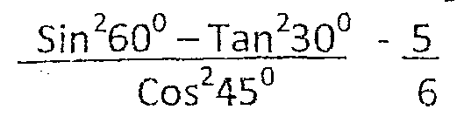

- Use tables of cubes, square roots and reciprocals to evaluate (3 mks)
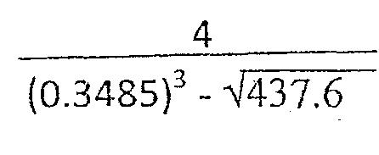

- Find the value of ª/_{b} given the following simultaneous equations
(4 mks)
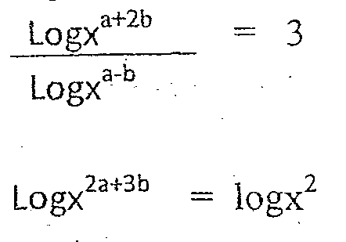

- The mean of 5 numbers is 12. The numbers are in the ratio 1:2:3:4:5. Find the smallest and the largest numbers (3 mks)

- Find the inequalities that are satisfied by the region R below (3 mks)
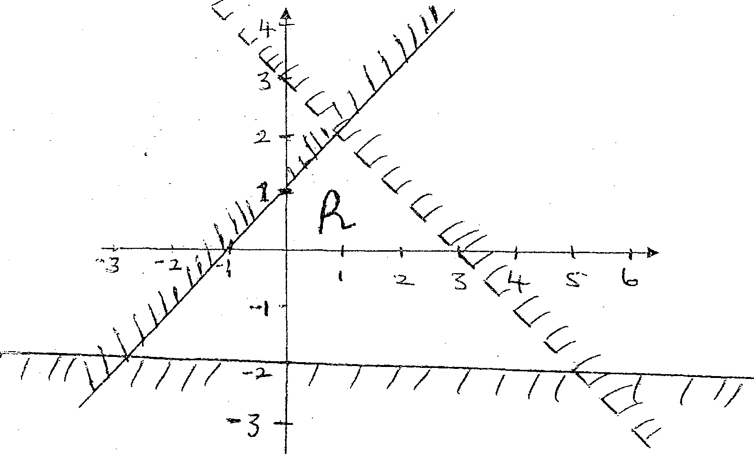

- Point PQRS are vertices of base of a right pyramid whose a small Top pyramid VTUZW has been removed to form a frustum. The frustum stands on a rectangular base measuring 32cm by 24cm and a rectangular top measuring 8cm by 6cm the top is parallel to the base and ¾ up the vertical height of the original pyramid. Each slant edge of the original pyramid is 45cm long. Calculate to the nearest whole number the volume of the frustum (4 mks)

- A matatu travelling at 99km/hr passes a checkpoint at 9.00am. A police patrol car traveling at 132km/hr in the same direction passes through the police check point at 9.15am. If the matatu and the police patrol car continue at their uniform speeds, calculate at what time the police car will overtake the matatu (3 mks)

- Find a if the vectors (a + 1) i + 4 j and -2i +6j are parallel . (3 mks)

- From the roof of a house the angle of elevation of the top of a tree is
40⁰ and the angle of depression of the bottom of the tree from the top of the house is 25⁰. If the house is 12m tall, calculate the highest of the tree (3 mks)

- Given that the ratio x: y = 2 : 3, find the ratio (5x- 2y) : (x + y) (3 mks)

- Me. Lee walks 5km on a bearing of 315⁰ from Thika town and then
walks due south to Juja Mall which is 8km from Thika town. Calculate the bearing of Juja Mall from Thika town (3 mks)

- Two similar containers weigh 40kg and 625kg respectively. If the
surface area of the smaller one is 112cm², find the surface area of the bigger one in m² (3 mks)

- Find the exact value of (3 mks)
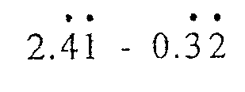

- The figure below is a section of a school logo. The logo has a rotational
symmetry of order 3 about 0. Complete the figure to show the logo (3 mks)

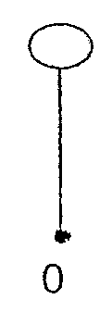

SECTION II (50 MARKS)
Answer only five questions in this section in the spaces provided

- The diagram below is a sketch showing a figure PQRS in which PS is
parallel to QR. PS and RS are perpendicular at S. The co-ordinates of P, Q and R are (0, 2), (3, 13) and (12, 16) respectively

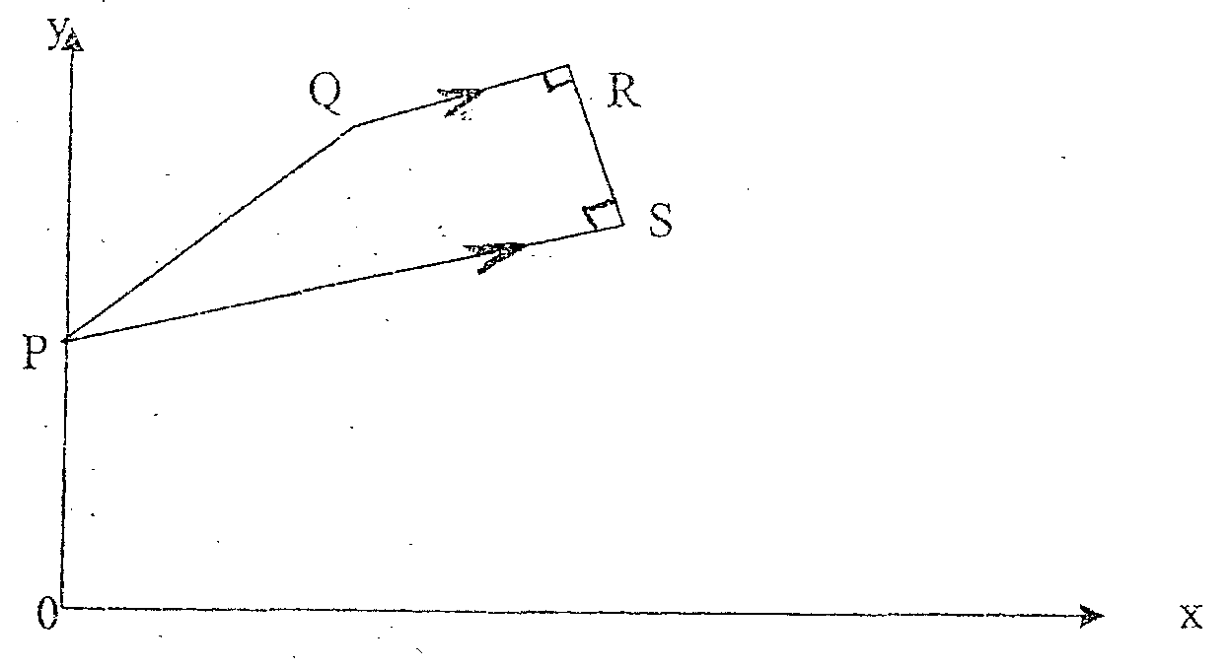
Find the
  - Equation of PS and RS (2 mks)

  - Co-ordinates of S (2 mks)

The line PQ produced meets the line SR produced at T. Find the;
  - Co-ordinates of T (2 mks)

  - Ratio of the area of triangle PTR to the area of trapezium PQRS (4 mks)

- In the figure below PQR is a tangent to the circle at Q. TS is a
diameter and TSR and QUV are straight lines. QS is parallel to TV.
Angles SQR = 40⁰ and TQV = 55⁰

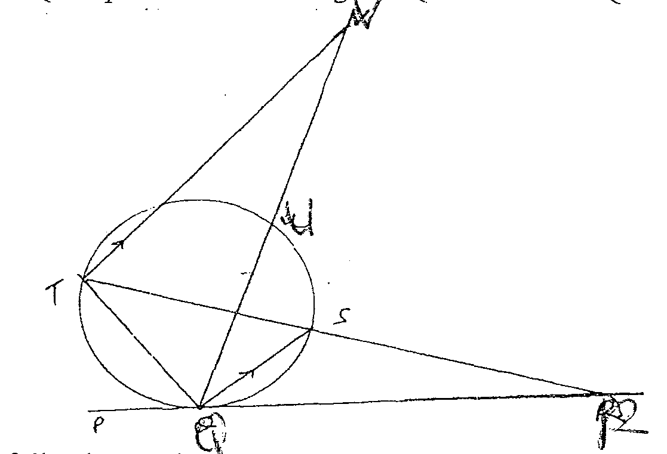

  - Find the following angles giving reasons each case
- <QTS (2 mks)

- <QRS (2 mks)

- <QVT (2 mks)

- <QUT (2 mks)

  - Given that QR = 8cm, and SR = 4cm. Find the radius of the circle (2 mks)

19. a) Construct triangle ABC in which the base BC = 5cm, AC = 4cm, and
angle ABC = 30⁰. Measure AB (3 mks)

    - Find the difference in area of the two possible triangles. (give the answer to one sf) (3 mks)

    - Construct triangle ACD equal in area to the bigger triangle ABC such that D is on BC produced. Measure AD, (3 mks)

    - Mark the Orthocentre of triangle ACD (1 mk)

- a) Draw the graph of the equation y = 2x³ + 3x² – 12x + 3 within -4
≤ x ≤ 2 (5 mks)

    - Use the graph to estimate the
- Roots of the equation 2x³ + 3x² – 12x + 3 = 0 (1 mk)

- Average gradient between x = 0 and x = 2 (2 mks)

- The gradient at the point where x = -1 (2 mks)

- A police post P is 1820m from a school S on a bearing of 192⁰. Village
Y is 1650 from the police post on a bearing of 162⁰. Village Z is 1300m from the police post on a bearing of 286⁰. Using a scale of 1cm to represent 200m,

  - Make a scale drawing to show the positions of P,S,Y and Z
(6 mks)

  - Find the distance and the bearing of Y from Z (2 mks)

  - Find the distance and the bearing of village S from Z (2 mks)

- Muindi bought 6 cows and 15goats at an auction and spent a total of
shs. 97500. His friend Mueni bought on1 cow less and five goats more than Muindi and spent shs. 5000 less.

  - If both bought each animal at the same price, determine the
price of each animal at the auction (4 mks)

  - Muindi sold all his animals at a profit of 40% per cow and 50%
per goat while Mueni sold all his animals at a profit of 50% per cow and 40% per goat. Determine who made more profit and by how much (4 mks)

  - The cost of a goat was decreased in the ratio 2: 3. Find the loss
made by Mueni in buying and selling goats only (2 mks)

- A right circular cylinder of height 12cm and radius 4cm is filled with
water. A heavy circular cone of height 9cm and base radius 6cm is lowered, with vertex downwards and axis vertical into the cylinder until the cone rests on the rim of cylinder as shown below
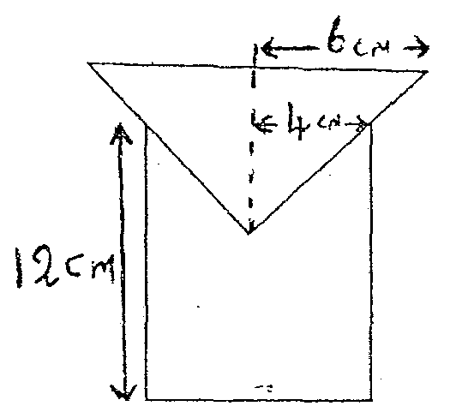

Find
  - The volume of water which spills over from the cylinder (6 mks)

  - The height of water in the cylinder after the spillage (4 mks)

- The triangle A(-5, 0), B (0, -3), C( 0, 3) is reflected on line x = 0
  - i) Plot triangle ABC and its image on the grid provided
(2 mks

- What is the name of the plane figure formed in (i) above? (1 mk)

  - The figure in (ii) above is translated through (3). Draw the solid
Formed (4)

- Calculate the surface area of the solid formed (4 mks)

- Calculate the volume of the solid (3 mks)

