Name: …………………….……………………... Index No: ….………………………/.….…
121/1 Candidates Signature ……………………
MATHEMATICS ALT A Date: ……………………………....……….
PAPER 1
Time: 2 ½ Hours

Kenya Certificate of Secondary Education (K.C.S.E)

Instructions to Candidates
- Write your name, Index number, Admission Number, Sign and write the date of examination in the spaces provided above.
- The paper consists of two sections: Section A and Section B.
- Answer ALL the questions in Section A and only any FIVE questions in Section B.
- Show all the STEPS in your working, giving your answer at each stage in the spaces below each question.
- Marks may be given for correct working even if the answer is wrong
- Non-programmable silent electronic calculators and KNEC Mathematical tables may be used, except stated otherwise.
- This paper consists of 14 printed pages.
- Candidates should check the question paper to ensure that all pages are printed as indicated and no questions are missing.

For Examiners Use Only
Section A
1 | 2 | 3 | 4 | 5 | 6 | 7 | 8 | 9 | 10 | 11 | 12 | 13 | 14 | 15 | 16 | Total

Section B
Grand Total

17 | 18 | 19 | 20 | 21 | 22 | 23 | 24 | Total

This paper consists of 16 printed pages. Candidates should check carefully
to ascertain that all the pages are printed as indicated and no questions are missing.

SECTION A (50 Marks)
Answer all the questions from this section in the spaces provided
- Use logarithm tables to evaluate (4 marks)
5

- Solve for x and y (3 marks)
3^{2x – y}= 27
4^{x} ÷ 16^{y} = 1

- Evaluate without using mathematical tables or calculator (3 marks)
¾ + ²/₅ ÷ ³/₅ of1²/₃
(1 ¾ - ⁵/₈) ×²/₉

- A line $y=mx +8$ makes an angle of 75.97⁰with the x-axis, find the co-ordinates of the point where the line cuts the x-axis. (3 marks)

- Find the integral values of x which satisfy the inequalities. (3 marks) $3x – 2 < 10 + x < 2 + 5x$

- A camera which is marked at Ksh 2400 is sold to a consumer after allowing him a 10% discount. By so doing the trader still makes a profit of 20% on the cost of the camera. Determine the cost price of the camera. (3 marks)

- Solve for θ given that θ is acute and$sin$ (3θ - 50⁰) – $cos$ (2θ + 10⁰) = 0. (2 marks)

- The cost of the car outside Kenya is US $ 4,800. You intend to buy one such car through an agent who deals in Japanese yen. The agent will charge 15% commission on the price of the car and further 72,220 Japanese yens for shipment of the car. How many Kenya shillings will you need to send to the agent to obtain the car, given that;
- US $ = 117.20 Japanese yen
1 US $ = Ksh. 72.34 (3 marks)

- A container of height 90cm has a capacity of 4.5litres. What is the height of a similar container of volume 9m³? (3 marks)

- Junior paid shs.320 for a video tape after getting a discount of 13.5%. How much should a shopkeeper have sold the tape to enable him make a profit of 5%. (3 marks)

- Three towns J, K and L are such that K is 40km on a bearing 290⁰ from J. Town L is directly to the south of J. The distance between K and L is 60km. By scale drawing, find the distance of L from J. Using scale of 1:1000 000. (4 marks)

- Express 0.7$\dot{3}$ as fraction. (3 marks)
.

- The figure below shows a hemispherical bowl of thickness 1.5cm. Given that the external surface area is 509cm². Find the volume of the bowl. (Take π= 3.142) (3 marks)

- In the figure below ∠ MNO = 54⁰, and ∠PLM = 50⁰, PN = NM and PO is parallel to LM. Find the value of ∠LPM. (3 marks)
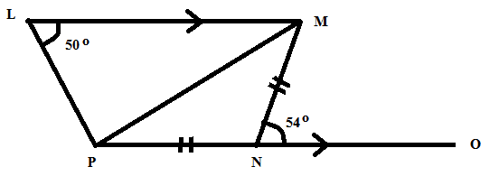

- In the figure below, AB is a diameter of the circle and AB = 8cm, BC=$xcm$ and AC= $2x$cm. Calculate the length of AC to 2 significant figures. (3 marks)
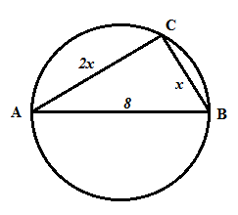

- The angle of elevation of the top of a storey building from point P is 23.61⁰. From another point Q, six metres nearer to the base of the building, the angle of depression from the top of the building is 35⁰. Calculate to 1 decimal place the height of the building. (4 marks)

SECTION I1 (50 MARKS)
Answer ONLY FIVE questions in this section
- The table below shows the number of letters collected from the post office by a school messenger during a school year.
Letters per day | 6 – 10 | 11 – 15 | 16 – 20 | 21 – 25 | 26 – 30 | 31 – 35 | 36 – 40 | 41 – 45 | 46 – 50 | 51 – 55
Frequency | 5 | 19 | 21 | 23 | 25 | 27 | 20 | 25 | 13 | 12
- State the modal class (1 mark)
- Estimate the median of this data. (4 marks)
- Estimate the mean of this data. (3 marks)
- On the grid provided, draw a histogram to represent this data. (2 marks)

- The diagram shows two intersecting circles of radii 20 cm and 15 cm such that their centres A and B are 30 cm apart.
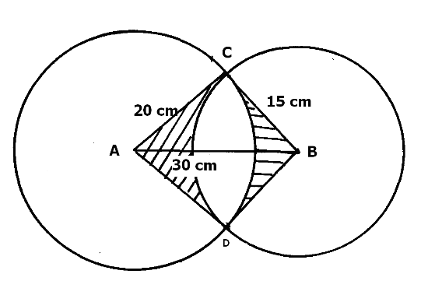

Calculate to 2 decimal places.
a) The area of sector ACD (3marks)

b) The area of sector BCD (3marks)

c) The length of the common CD. (2marks)

d) The area of quadrilateral ACBD (1mark)

e) The shaded area. (1mark)

- A certain number of people agreed to contribute equally to buy books worth sh.12000 for a school library. Five people pulled out so that others agreed to contribute an extra sh. 100 each. Their contribution enabled them to buy books worth sh 2000 more than they originally expected.
a) If the original number of people was x, write down.
- An expression of how much each was originally to contribute. (1mark)

- Two distinct expressions of how much each contributed after the five pulled out. (2 marks)

b) Calculate the value of$x$. (3 marks)

c) Calculate how much each person was expected to contribute originally. (2marks)

- Calculate
i) The number of people who actually made the contribution and how much per person. (2marks)

ii) The ratio of the supposed original contribution to new contribution. (1mark)

- A bus left Nairobi at 7.00am and travelled towards Eldoret at an average speed of 80km/hr. At 7.45am a car left Eldoret towards Nairobi at an average speed of 120km/hr. The distance between Nairobi and Eldoret is 300km
Calculate
a) the time the bus arrived at Eldoret (2 marks)

b) the time of the day the two met. (4 marks)

c) the distance from Nairobi where the two met. (2 marks)

d) the distance of the bus from Eldoret when the car arrived at Nairobi. (2 marks)

- The displacement h metres of a particle moving along a straight line after t seconds is given by h=-2t³+t²+3t
- Find its initial acceleration if it accelerates uniformly. (3 marks)

- Calculate:
- The time when the particle was momentarily at rest (3 marks)

- It’s displacement by the time it comes to rest momentarily (2 marks)

- Calculate the maximum speed attained (2 marks)

- In an n-sided polygon two angles are right angles and each of the remaining angles is 150⁰
- Find the value of n hence the sum of interior angles of this polygon. (4 marks)

- Name the polygon (1 mark)

- Find the areas of a regular octagon of sides 4 cm o 5sf. (5 marks)

- The cost C, of producing n items varies directly as n and partly as the inverse of n. to produce two items it costs Ksh. 135 and to produce three items it costs Ksh. 140
- The constant of proportionality and hence write the equation connecting C and n (5 marks)

- The cost of producing 10 items; (2 marks)

- The number of items of produced at a cost of Ksh. 756. (3 marks)

- (a) On the grid provided draw triangle ABC such that A(6, -2), B(8, -2) and C(6, -1) (2 marks)

(b) Triangle A¹B¹C¹ is the image of triangle ABC under enlargement of scale factor 2 with the centre at (3, 0). Construct and label triangle A¹B¹C¹. State the coordinates of the triangle A¹B¹C¹. (3 marks)
(c) A¹¹B¹¹C¹¹ is the image of A¹B¹C¹ under a certain rotation. If A¹¹ (-2, -1), B¹¹(-2, -5) and C¹¹(0, -1), by construction, find the coordinates of the centre of rotation. (3 marks)
(d) Triangle A¹¹B¹¹C¹¹, is reflected on the line$y=-3$. Draw the triangle A¹¹¹B¹¹¹C¹¹¹ the image of triangle A¹¹B¹¹C¹¹ under reflection in the line.$QUOTE y=-3$ (2 marks)

