Name:….….……………………………………………... Index No: …………………………………….

School:…….……………………………………………. Candidate’s Sign:……………………..….……

Date: ……………………………………………………...

121/1
PAPER 1
MATHEMATICS
TIME: 2 ½ HOURS

Kenya Certificate of Secondary Education (K.C.S.E)

INSTRUCTIONS TO THE CANDIDATES:-
- Write your name and index number in the spaces provided above.
- Sign and write the date in the space provided above.
- This paper consists two sections: Section I and Section II.
- Answer all the questions in Section 1 and any five questions from Section II.
- All working and answers must be written on the question paper in the spaces provided below each question.
- Show all the steps in your calculations, giving your answers at each stage in the spaces provided below each question.
- Non-programmable silent electronic calculators and KNEC mathematical tables may be used, except where stated otherwise.
- Marks may be given for correct working even if the answer is wrong.
- Candidates should check the question paper for error and omissions.

For Examiners’ Use Only.
Section I
Questions | 1 | 2 | 3 | 4 | 5 | 6 | 7 | 8 | 9 | 10 | 11 | 12 | 13 | 14 | 15 | 16 | Total
Marks

Section II
GRAND TOTAL

Questions | 17 | 18 | 19 | 20 | 21 | 22 | 23 | 24 | Total
Marks

This paper consists of 16 printed pages. Candidates should check to ascertain that all pages are printed as indicated and that no questions are missing.
SECTION A (50 MARKS)
Answer all questions in this section
1. Simplify (3mks)

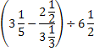

2. Factorise completely (3mks)

3. Use logarithms to evaluate the following 3 0.07893____ (4mks)
37.8 x 43.81

4. Awinja is 100m from the foot of a tower and the angle of elevation of the tower from her position is 49º. Find the height of the tower (2mks)

5. In the figure below, ∠ACD= ∠ABE = 90º. Find the area of the triangle ABE (3mks)
A
B
C
7.5cm
D
E
3cm

6. A square ABCD is such that A(-3,4) C(2,3). Equation of line AB is 3y-2x=18 and equation of line CD is 3y-2x=5. Determine
(a) Equation of line BC in the form y=mx+c (2mks)
(b) Equation of line AD in the form y=mx+c (2mks)

7. Make v the subject of the formula (3mks)

8. A squared brass plate is 2mm thick and has a mass of 1.05kg. The density of brass is 8.4g/cm³. Calculate the length of the plate in centimeters. (3mks)

9. Solve the inequality and write down the integral values satisfying
the inequality (3mks)

10. An arc subtends an angle of 0.9 radians at the centre of a circle whose radius is 13cm. Find the length of the arc (2mks)

11. Simplify 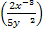 (4mks)

12. At 8.50am, a matatu is traveling at 80km/h and it is 40km behind a lorry travelling at 60km/hr
(a) After how long will the matatu overtake the lorry? (2mks)
(b) At what time will the matatu overtake the lorry? (2mks)

13. John who runs a clothing shop bought a shirt at Ksh. 500 and marked it at Ksh. 600. A customer bought it at Ksh. 550 after engaging John in a lengthy negations process. What was the customer’s percentage discount. (3mks)

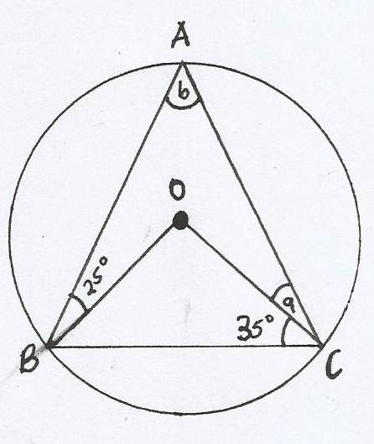
14. In the following figure, O is the centre. Find a and b (2mks)
a_________________
b__________________

15. Using a pair of compasses and a ruler only construct triangle ABC with ABC = 120º and measure BC (3mks)

16. A stool is made by shaping a tree stump into a conical frustrum of vertical height 60cm. If the top radius is 12cm and the bottom is 24cm. calculate the surface area of the stool.π=3.142 (4mks)

SECTION II (50 MARKS)
Answer any five questions in this section in the spaces provided
17. The table below shows marks obtained by 100 candidates at Mwihila Secondary in a mathematics examination.
Marks | 15-24 | 25-34 | 35-44 | 45-54 | 55-64 | 65-74 | 75-84
Frequency | 6 | 14 | 24 | 14 | x | 10 | 10
(i) Determine the value of x (2mks)

(ii) State the modal class (1mk)

(iii) Calculate the mean (3mks)

(iv) Determine the median mark. (4mks)

18. (a) In a stadium, the cost per seat during a match is Ksh. 200. The stadium is built in a such a way that the first row has five seats more than the previous one and there are thirty one rows. If during the match between AFC Leopards and Gor Mahia the stadium is 75% full, how much money is collected if every fan pays. (4mks)

(b) The 3rd term of a geometric sequence is 20 and 6th term is -160.
Calculate:
(i) The common ratio (2mks)

(ii) The first term (2mks)

(iii) The 8th term (2mks)

19. The table below shows measurements of a farm in a fields book. XY=2000m
Y
1800 G 100
F 200 1600
1200 E 300
900 D 100
C 150 600
300 B 200
A 200 100
X
(a) Using a scale 1cm rep 100m. Sketch the map of the farm (2mks)

(b) Calculate the area of the farm in hectares (8mks)

20. Four towns R,T,K and G are such that T is 84km directly to the north of R and K is on bearing of 295º from R at a distance of 60km. G is on a bearing of 340º from K and at a distance of 30km.
(a) Using the scale of 1cm to represent 10km make an accurate scale drawing to show the relative positions of the towns. (3mks)

(b)Find:-
(i) The distance and the bearing of T from K (3mks)

(ii) The distance and the bearing of G from T. (3mks)

(iii) The bearing of R from G (1mk)

21. In the figure below (not drawn to scale) AB=8cm, AC=6cm, AD=7cm, CD=2.82cm and angle CAB=50º
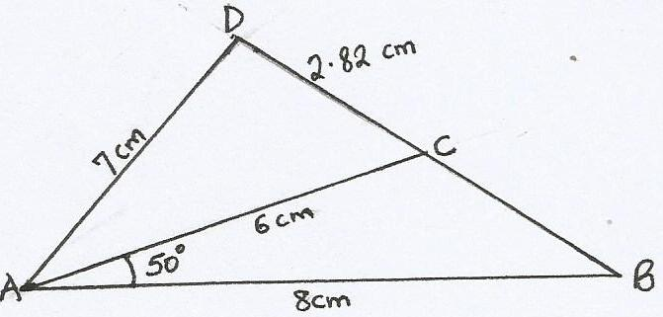

Calculate (to two decimal places )
(a) The length BC (2mks)

(b) The size of angle ABC (3mks)

(c) The size of the angle CAD (3mks)

(d) The area of triangle ACD (2mks)

22. In the figure below, PQ=a and PR=r. QM:MR=1:2. The point S is the mid point of PQ. X is the intersection of PM and SR. SX=hSR, PX = kPM where h and k are constants.
Q
R
P
S
r
q
X

Find:
(a) QR in terms of q and r (1mk)

(b) PM in terms of q and r (2mks)

(c) SR in terms of q and r (2mks)

(d)Express vector SX in two way: in terms of h,r and q and in terms of k,r and q. Hence determine the ratio in which x divides SR.

23. A particle moves a long a straight line so that after t seconds its distance from O, a fixed point on the line is S metres where
S= t³-3t²+2t
(a) When is the particle at O? (4mks)

(b) What is its velocity at these times? (6mks)

24. The points A(2,6) B(1,1) C(3,4) and D (5,3) are the vertices of a quadrilateral ABCD.
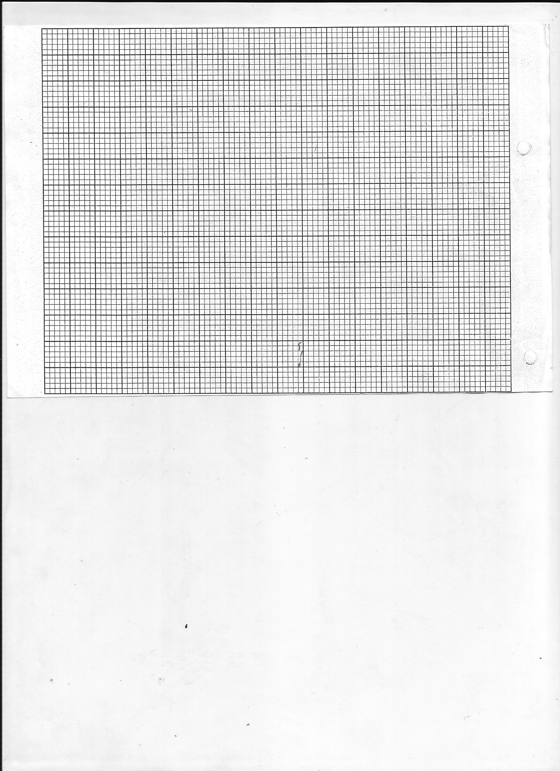
(a) Plot points A,B,C and D on the graph provided and join them to form quadrilateral ABCD (2mks)

(b) Locate and write down the coordinates of A', B', C' and D' and to the image of ABCD under a rotation of positive 90º centre (0,0) on the same grid (3mks)
(c) Reflect A'B'C'D' on the x-axis and draw the image of quadrilateral A'' B'' C'' D'' (3mks)

(d) Draw the mirror line MM for the reflection of ABCD whose image is A'' B'' C'' D'' (2mks)

