Name: …………………………………………………………… Index no ……..…...................................

School: ……………………………………………………....…. Candidate’s sign ……………………....

Date: ……………………………………………………………

121/2
MATHEMATICS
PAPER 2
TIME: 2 ½ HOURS.

Kenya Certificate of Secondary Education (K.C.S.E.)

INSTRUCTIONS TO CANDIDATES:
- Write your name, Index number, date and signature in the space provided at the top of the page.
- The paper consists of two sections; Section 1 and Section II.
- Answer all the questions in section I and any other five from Section II.
- All working must be clearly shown.
- Marks may be awarded for correct working even if the answer is wrong.
- Non – programmable silent electronic calculators and KNEC tables may be used.

For Examiner’s Use Only:

SECTION 1
Question | 1 | 2 | 3 | 4 | 5 | 6 | 7 | 8 | 9 | 10 | 11 | 12 | 13 | 14 | 15 | 16 | TOTAL
Marks

SECTION II
Grand Total
Question | 17 | 18 | 19 | 20 | 21 | 22 | 23 | 24 | TOTAL
Marks

This paper consists of 14 printed pages. Candidates should check to ascertain that all papers are printed as indicated and that no questions are missing

1. A man deposits his money in a savings bank on a monthly basis. Each deposits exceeds the previous one
by Shs 500. If he started by depositing Shs 1500, how’ much will he have deposited in 12 months?
(3mks)

√
2. Make x the subject in the formula: M = x-p (3mks)
p(1+ px)

3. Calculate the shortest distance in nautical miles between M(45°N, 38°E) and
N(45°N, I 42°W) (3mks)

4. Two circles of radii 3cm and 8cm have their centres 13cm apart. Calculate the length of
the direct common tangent. (2mks)

5 (a) Expand ( 1- ½ x)⁶ (2mks)

(b) Hence use the above expansion to the fourth term to find the value of (0.98)⁶ (2mks)

6. The points P, Q and R lie on a straight line. The position vectors of P and Rare
2i + 3j + 13k and 5i — 3j + 4k respectively. Q divides FR internally in the ratio 2:1. Find:
˜
˜
˜
˜
˜
(a) the position vector of Q in terms of i,j, and k. (2mks)
˜
˜
˜

(b) the distance of Q from the origin. (l mk)

3
2
7. Solve for x: (log₃ x)² - ½ 1og₃ x = (4mks)

8. Find the longest side of the right-angled triangle whose other sides are; ( √2 + l)cm and
(√2 - l)cm long, leaving your answer in surd form. (3mks)

9. A circle whose centre is C(2, 3) passes through a point P(a,b). A point M(-2, -⁵/₂) is the mid-point of
the line segment CP.
(a) Calculate the co-ordinates of P (l mk)

(b) Determine the equation of the circle in the form ax² + by² + cx + dy + e = 0 where a, b, c,
d and e are integers. (3mks)

10. In the figure below, PS = PQ, PQ = 10cm, / PSQ=5O°, QR = 12cm and / SQR = 62°. (3mks)
S
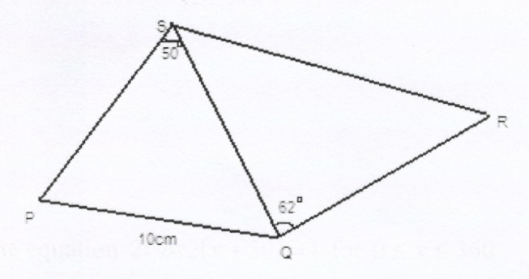
50º

R

p
62º
Q

Find SR (3mks)

11. A quantity y varies partly as the square of x, and partly as x. When y = 20, x = 2 and when y =36, x = 3.
Find the equation showing the relationship between x and y. (3mks)

12. The graph below is part of a straight line obtained from the initial equation y = ax^{n}.
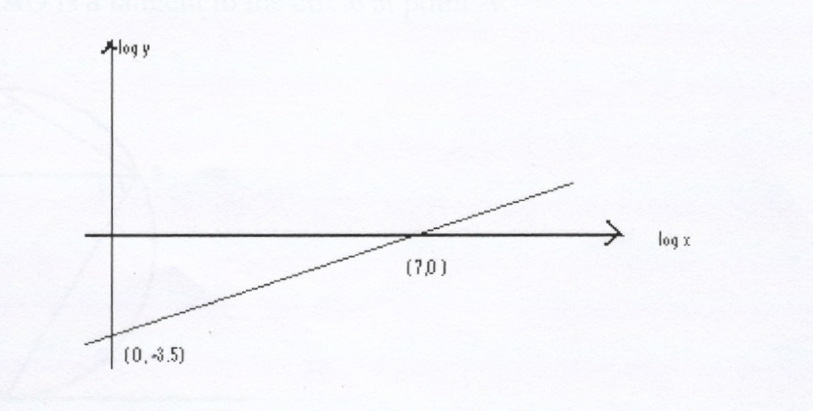
log y

log x

(7,0)

( 0,3.5)

Use the graph to calculate the values of a and n (3mks)

13. The price of a new car is Shs. 800,000. If it depreciates at a constant rate to Shs 550,000
within 4 years, find the annual rate of depreciation. (3mks)

14. Solve the equation 2Cos 2 (x + 30) = 1 for 0 ≤ x ≤ 360. (3mks)

15. A mixture of sand, cement and ballast is in the ratio 5:1:3. If the cost of 7 tonnes of sand is Sh 3000,
5 tonnes of cement sh 50,000 and 8 tonnes of ballast Sh 4000, find the cost of 7tonnes of the mixture.
(3mks)

16. In the figure below, PAQ is a tangent to the circle at point A. (3mks)
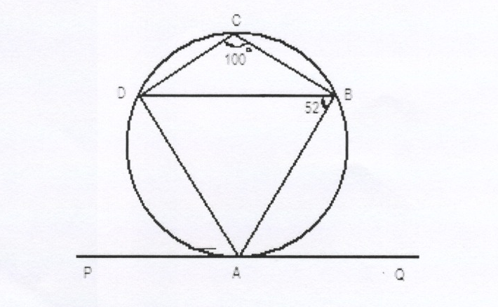
P
A
Q
B
D
C
100º
52º

Find angle DAB and angle BAQ. giving reasons for your answer.

SECTION II (50 MARKS)
Answer any five questions from this section.
17. The table below shows the income tax rates for the year 2006.
Taxable Income per Tax rates KSh per K | Annum in K
1-5808  5809-11280  11281-16752  16753-22224  22225 and above 6 | 2  3  4  5
In the year 2006, Ali’s monthly earnings were as follows:
Basic Salary KShs 22,600;House Allowance Kshs 12,000;
Medical Allowance Kshs 2,880;Transport Allowance KShs 340
Ali was entitled to a monthly personal relief of Sh 1162 and an insurance relief of Sh 450.
Every month the following deductions were made:
NHIF KShs 320; Insurance Premium Shs 3000;Sacco Loan repayment Shs 6000
Sacco Share contribution Shs 1500; Workers Union dues Shs 200
Calculate:
a) Ali’s taxable income in K£ p.a. (l mk)

b) Ali’s monthly tax paid in Kshs (4mks)

c) Ali’s monthly net income from his employment in KShs (2mks)

d) If Ali received a 10% increase in his basic salary, calculate the corresponding percentage
increase on the income tax. (3mks)

18. A man goes to work either by a matatu or by bus from Monday to Thursday. If he goes by matatu the
probability that he will be late is ¹/₅ while if he goes by bus, the probability that he will be late is ¹/₈.
- Suppose he tosses a coin to decide whether to go by a matatu or by bus. what is the
probability that he will be late? (4mks)

b) If he travels by matatu, what is the probability that he will be late
(i) every day (2mks)

(ii) On any three days (4mks)

19. The figure below is a cuboid ABCDFFGH such that AB 8cm, BC = 6cm and CF 4cm.

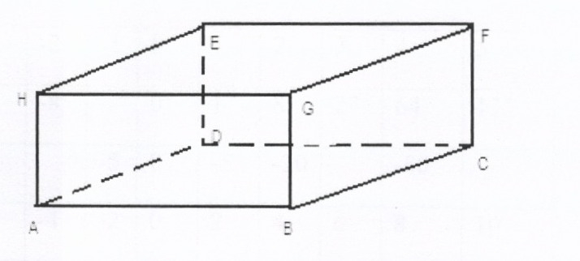
F
E
H
G
C
D

A
B

Determine:
a) the length
(i) AC (2mks)

(ii) AF (2mks)

b) The angle AF makes with plane ABCD. (2mks)

c) The angle plane AEFB makes with the plane ABCD (2mks)

d) Find the angle between line EG and line DC (2mks)

20 (a) Complete the table below for the equation y = x³- 5x² + 2x + 9 (2mks)
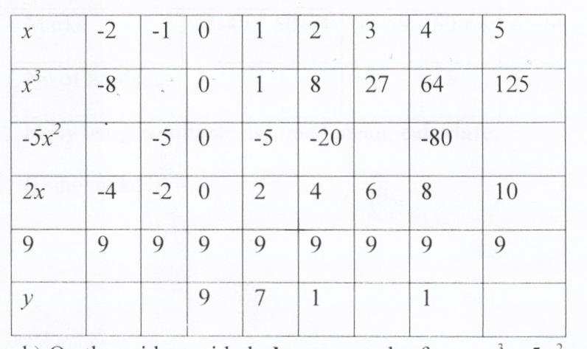

(b) On the grid provided, draw a graph of y = x³5x² + 2x + 9 for -2 ≤ x ≤ 5 (3mks)


c) Use your graph to estimate the roots of the equation x³ -5x² + 2x + 9 = 0 between x = 1
and x 4. (2mks)
d) By drawing a suitable line on the same axis, estimate the roots of the equation
x³ -5x² + x + 5 = 0 (3mks)

21. The following table shows the distribution of marks obtained by 50 students.

Marks | 45-49 | 50-54 | 55-59 | 60-64 | 65-69 | 70-74 | 75-79
No of Students | 3 | 9 | 13 | 15 | 5 | 4 | 1
a) By using a suitable assumed mean, calculate:
(i) the mean (5mks)

b) the variance (3mks)

c) the standard deviation (2mks)

22. (a) Without using a protractor or a set square, construct a parallelogram PQRS such that
PQ = 7.5cm, PS = 5cm and ∠QPS = 67½ °. (4mks)
On the same diagram locate:
(b) A point X such that it is equidistant from P and Q. (l mk)
(c) A point M such that ∠QMS 90°. M is on the same side of QS as R. [2mks]
(d) A region inside the parallelogram in which a variable Y lies such that PY RY and
∠QYS ≥90°. Shade the region represented by Y. (3mks)

23 (a) Calculate the turning point of the function y = x³ -3x and state their nature.
Hence sketch the curve. (5mks)

- Find the area of each of the two segments of the curve y = x³ -3x cut off by the x-axis. (5mks)

24. Rectangle ABCD in which A(1,3), B(8,3), C(8,5) and D(1,5) undergoes a shear with x = 4
as the invariant line.
a) Plot the rectangle ABCD (l mk)
b) If the point C is mapped on the point C¹(8,9) under this transformation, determine the co
ordinates of A^{l}, B^{l} and D^{l}. (3mks)
c) Plot the figure A^{l},B^{l},C^{l},D^{l} (l mk)
d) Find the matrix representing this transformation. (3mks)
e) Using the determinant of the matrix in (d) above, find the area of the figure A^{l}, B^{l}, C^{l}, D^{l} (2mks)

