Name: …………………………………………………………… Index no ……..…...................................

School: ……………………………………………………....…. Candidate’s sign ……………………....

Date: ……………………………………………………………

121/2
MATHEMATICS
PAPER 2
TIME: 2 ½ HOURS

Kenya Certificate of Secondary Education (K.C.S.E.)

INSTRUCTIONS TO CANDIDATES:
- Write your name ,index number , Signature and write date of examination in the spaces provided
- The paper contains two sections. Section I and Section II.
- Answer all the questions in section I and any five questions in section II.
- Answers and working must be written on the question paper in the spaces provided below each question.
- Show all the steps in your calculations giving your answers at each stage in the spaces below each question.
- Marks may be given for correct working even if the answer is wrong.
- Non programmable silent electronic calculators and KNEC mathematical table may be used, except where stated otherwise.
FOR EXAMINERS USE ONLY

SECTION 1
Question | 1 | 2 | 3 | 4 | 5 | 6 | 7 | 8 | 9 | 10 | 11 | 12 | 13 | 14 | 15 | 16 | TOTAL
Marks

SECTION II
Question | 17 | 18 | 19 | 20 | 21 | 22 | 23 | 24 | TOTAL
Marks

TOTAL MARKS

This paper consists of 15 printed pages. Candidates should check to ascertain that all papers are printed as indicated and that no questions are missing

SECTION I ( 50 MARKS)
Answer all questions in this section spaces provided.

1. Using logarithms, evaluate correct to 4d.p.
0.8
25.48 X 0.0212 (4mks)
6.159

2. Solve the equation below.
7^{2x} – 8 X 7^{x} + 7 = 0 (3mks)

3. The expression 1 + x/2 is taken as an approximation for √1 + x. Find the percentage error in doing so if x = 0.44. (3mks)

4. The initial salary of Mr. Lutta is sh. 42, 000 per annum. His salary increases by 13% each year. Determine his total earnings after 15 years. Give your answer to the nearest thousands. (3mks)

5. Mrs. Musundi bought a television set on hire purchase by paying a down payment of Kshs. 5,000 and monthly installments of Kshs. 1, 250 for 2 years. If the interest rate charged was 12% p.a, what is the carrying charge to the nearest hundreds? (3mks)

6. A ball is dropped from the top of a building and its height h, metres above the ground at any time t, seconds is given by h = 350 + 65t – t².
(i) Find the velocity of the ball when t= 2seconds. (2mks)

(ii) State the time when the ball hits the ground. (2mks)

7. Atieno is now four times as old as her daughter and six times as old as her son. Twelve years from now, the sum of the ages of her daughter and son will differ from her age by 9 years. What is Atieno’s present age? (3mks)

8. Solve for θ in the equation sin (3 θ + 120) º = √3 for 0º ≤ θº ≤180º. (3mks)
2

9. T is a transformation represented by the matrix 5x 2 . Under T, a square of area 10cm³ is
-3 x

mapped onto a square of area 110cm² find the value of x. (3mks)

10. Make x the subject of the formula:
h= ∛c-x² (3mks)
b

11. The following distribution shows the masses to the nearest kilogram of 50 pupils in standard 8.

Mass (Kg) | 26-30 | 31-35 | 36-40 | 41-45 | 46-50 | 51-55
frequency | 4 | 12 | 18 | 11 | 4 | 1

Calculate the standard deviation. (3mks)

12. The diagram below shows a circle ABCDE. The line FEG is a tangent to the circle at point E. Line DE is parallel to CG, ∠DEC = 28º and ∠AEG = 32 º.
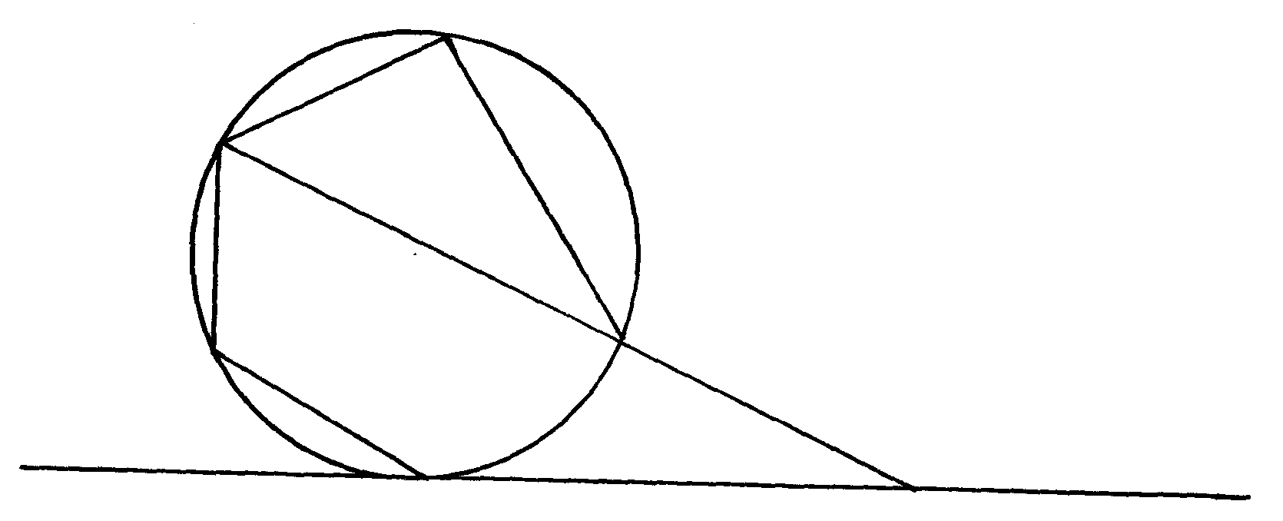
B

C
O

D
A

E
G

Calculate:
(a) ∠AEG (1mk)

(b) ∠ABC (1mk)

13. A two digit number is such that the square of the unit digit is equal to one less than the tens digit and that the unit digit raised to power four and add three times the tens digit is equal to seven. Find the number. (3mks)

14. (i) Expand 5 + x ⁶ up to the term in x³. (2mks)
2

(ii) Use your expansion to estimate the value of 11 ⁶. Correct to one decimal place. (2mks)
2

15. A line segment joining two points P (0, 7) and S (2, 3.8) is divided externally by point Q in the ratio 7:3. Find the co-ordinates of point Q. (3mks)

16. A dam containing 4158m³ of water is to be drained. A pump is connected to a pipe of radius 3.5cm and the machine operates for 8 hours per day. Water flows through the pipe at the rate of 1.5m per second. Find the number of days it takes to drain the dam. (3mks)

SECTION II (50 MARKS)

Answer only five questions from this section.

17. (a) (i) Taking the radius of the earth, R= 6370km and π = ²²/₇, calculate the shortest distance between
the two cities P(60ºN, 29ºW) and Q(60ºN, 31ºE) along the parallel of latitude. (3mks)

(ii) If it is 1200hrs at P, what is the local time at Q. (3mks)

- An aeroplane flew due south from a point A (60ºN, 45ºE) to a point B. the distance covered by
the aeroplane was 800km. determine the position of B. (4mks)

18. (a) Complete the table for y = Sin x + 2cos x. (2mks)
x | 0 | 30 | 60 | 90 | 120 | 150 | 180 | 210 | 240 | 270 | 300
Sin x | 0 |  |  | 1.0 |  | 0.5 |  | -0.5 |  |  | -0.87
2cos x | 2 |  |  | 0 |  | -1.73 |  | -1.73 |  |  | 1.0
y | 2 |  |  | 1.0 |  | -1.23 |  | -2.23 |  |  | 0.13

(b) Draw the graph of y= sin x + 2 Cos x using a scale of 1cm to represent 30º on x-axis and 2cm
to represent 1 unit on y-axis. (3mks)

(c) Solve sin x + 2 cos x = 0 using the graph. (2mks)

(d) Find the range of valves of x for which y≤-0.5. (3mks)

19. (a) Using a ruler and pair of compasses only, construct triangle ABC in which AB=9cm, BC=8.5cm and ∠BAC=60º. (3mks)

(b) On the same side of AB as C:
(i) Determine the locus of a point P such that ∠APB = 60º. (3mks)

(ii) Construct the locus of R such that AR>4cm. (2mks)

(iii) Determine the region T such that ∠ACT ≥∠BCT. (2mks)

20. (a) A figure whose co-ordinates are A(-2, -2), B(-4, -1), C(-4, -3) and D(-2, -3) undergoes successive transformation ERS; where E, R and S are transformations represented by the matrices,
E= -2 0 , S = 0 -1 and R= 0 1
0 -2 -1 0 -1 0
On the grid provided, show the figure ABCD and its image under the successive transformations ERS. (6mks)

(b) Find the matrix representing the single transformation mapping the image found in (a) above
back to the object figure ABCD. (2mks)

- Triangle PQR has vertices at P (2, 2), Q (4, 1) and R (6, 4).On the same grid, show the image
of triangle PQR under a shear with line y = 2 invariant and point R (6,4) is mapped onto R^{l} (2,4).
(2mks)

21. Rates of tax in operation in 2010 are given in the table below:-
K₤ p.a Rate of tax %
1-5208 10
5209-9744 25
9745-14292 20
14293-18840 15
Over 18840 30
- Mr. Lukandu pays sh. 5,400 as P.A.Y.E monthly. He was entitled to house allowances of
Ksh. 9,000p.m and getting a monthly tax relief of sh. 1093. Calculate his monthly basic salary.
(7mks)

(b) Mr. Lukandu other deductions per month were;
Co-operative society contribution sh. 2,000
Loan payment sh. 2,500
Calculate his net salary per month. (3mks)

22. The table below shows marks scored by 100 form four students in a mathematics examination.
Marks | 1-10 | 11-20 | 21-30 | 31-40 | 41-50 | 51-60 | 61-70 | 71-80 | 81-90 | 91-100
No. of students | 2 | 10 | 13 | 17 | 18 | 14 | 10 | 6 | 6 | 4

(

a) Draw an ogive to represent the above information. (5mks)

(b) Using your graph, estimate:
(i) the median (1mk)

(ii) the quartile deviation (3mks)

(c) If the pass mark is 45%, how many students passed? (1mk)

23. The velocity V metres per second of a particle at time, t seconds is given by the equation below:
V = 2t²- 4t + 15.
t | 0 | 1 | 2 | 3 | 4 | 5 | 6 | 7 | 8
V | 15 |  |  |  |  |  |  |  | 111

(a) Complete the table below for values of V and t. (2mks)
(b) On the grid below, draw the graph of V against t. (3mks)
(c) (i) Using the mid-ordinate rule with seven ordinates, estimate the distance covered by the particle between t=1sec and t=8secs. (2mks)

(ii) Determine the exact distance covered by the particle between t=1 sec and t=8sec. (2mks)

(iii) Find the percentage error in the distance covered by the particle when the mid-ordinate rule is used. (1mk)

24. A manager wishes to hire two types of machine. He considers the following facts:
Machine A Machine B
Floor space 2m³ 3 m³
No. of men required to operate 4 3

He has a maximum of 24m² of floor space and a maximum of 36 men available. In addition he is not allowed to hire more machines of type B than of type A.

- If he hires x machines of type A and y machines of type B, write down all the inequalities
that satisfy the above conditions. (3mks)

(b) Represent the inequalities on the grid and shade the unwanted region. (3mks)

(c) If the profit from machine A is sh. 4 per hour and that from using B is shs.8 per hour. What
number of machine of each type should the manager choose to give the maximum profit? (4mks)

