Name................................................................................... Index No.................................
SIGN…………………………………. Date…………………………………….
121/2
MATHEMATICS
Paper Two
Time: 2 ½ hrs

Kenya Certificate of Secondary Education (K.C.S.E)
Instructions to candidates.
- Write your name, index number and your school in the spaces provided at the top of this page.
- the paper contains two sections: section i and section ii
- answer all the questions in section i and any five questions from section ii.
- All answers and workings must be written in the question paper in the spaces provided below each question.
- Marks may be given for correct working even if the answer is wrong.
- un programmed scientific electronic calculators may be used.

Examiner’s use only.
Section I
questions | 1 | 2 | 3 | 4 | 5 | 6 | 7 | 8 | 9 | 10 | 11 | 12 | 13 | 14 | 15 | 16 | Total
marks

section II
question | 17 | 18 | 19 | 20 | 21 | 22 | 23 | 24 | TOTAL
marks

GRAND TOTAL

SECTION I (50 MARKS)
1.Use logarithms to evaluate 0.03629 × 73.395 ^{-⅓}
Log 6 (4marks)

2. Each child in a family of x children gives the others a birthday present. If in one year 12 presents are given, form an equation in x , hence find the number of children in the family. ( 3 marks )

3. Make x the subject of the formula;
H = t + kx
t – kx (3marks)

4. Obtain the first four terms of the expansion of ( 1 + ^{x}/₁₂)⁶ (1mark)

Use your expansion to evaluate ( ⁴/₅ )⁶ (3marks)

5. The coordinates of the points A and B are (2, -3) and (-10, 8) respectively. A point T divides AB in the ratio 5:-2. Find the coordinates of T. (3marks)

6. Given that 8 = a + b√3 and that a and b are rational numbers , find the value of a and b. (3marks)
4 - 2√3

7. In the figure below, QT is a tangent to the circle at Q. AT is a straight line and QD is a chord. Given that AX = 8cm, PT = 12cm, QX = 6.8cm and XD = 7cm.
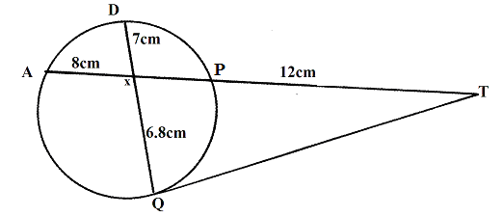
Find the length of;
(a) XP (2marks)

(b) QT (2marks)

8. A trader mixes millet costing sh. 40 per kg with wheat flour costing sh. 60 per kg. Find the ratio in which the two should be mixed so that by selling the mixture at sh. 55, a profit of 10% is realized. ( 3 marks )

9. The probability of winning a game is 0.6. The probability of winning a second game is 0.8 if the first is won. Otherwise if the first game is lost, the probability of winning the second game is 0.5.
Find the probability of winning at least one game out of three. (3marks)

10. Find all integral values that satisfy the inequality 2x + 3 ≥ 5x – 3 > -8. (3marks)

11. A wire model of the earth has a radius of 7m, find the shortest distance between points A$\left({\text{22}}^{0}N,{\text{111}}^{0}E\right)$ and point B $\left({\text{48}}^{0}N,{\text{69}}^{0}W\right)$ on the model. Give your answer to 3 decimal places. (3marks)

12. Given that O is the origin, OA 3i +2j -4k and OB = 6i + 11j + 2k. If X divides AB in the ratio1:2,

find the modulus of OX to 2d.p (3marks)

13. Solve for α in the equation 3cos (2α -10⁰ ) -5sin (2α -10⁰) = 0 , for 0⁰ ≤ α ≥ 180⁰ (3marks)

14.The figure below shows a circle centre O with a quadrilateral ABCD drawn in it, AC is the diameter. 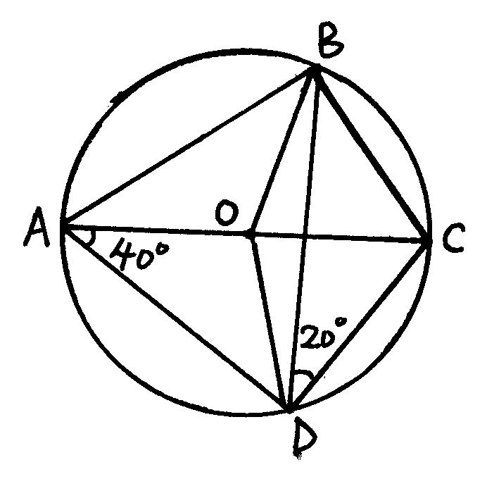
Determine the size of (3marks)
a) ∠BOC

b) ∠BCO

c) ∠BCD

15. Find the centre and radius of a circle whose equation is x² + y² - 4y =21 (3marks)

16. The dimensions of a rectangle are 10cm and 20 cm. If there is an error of 5% in each of the measurements, find the percentage error in the area of the rectangle. (4marks)

SECTION II(50marks)
Answer only five question in this section.
17. The cost of a minibus was Sh. 950,000. It depreciated in value by 5 % per year for the first two years and by 15 % per year for the subsequent years
a) Calculate the value of the minibus after 5 years. (4marks)

b) After 5 years the minibus was sold through a dealer at 25% more than its value to Mr. X
i)Calcute Mr X ‘s buying price. (2marks)

ii) . If the dealer’s sale price was to be taken as its value after depreciation, calculate the average monthly rate of depreciation for the 5 years. (4marks)

18. (a) Draw triangle PQR where P(1,1), Q(-3,2) and R(0,3) on the grid provided. (1mark)

b) Find and draw the image of triangle PQR under transformation whose matrix is $\begin{aligned}(3 \\ (1\end{aligned}($ $\begin{aligned}0 \\ )1 \\ \end{aligned})$. Label the image P¹Q¹R^{1.} (3marks)

c) Triangle P¹Q¹R¹ is transformed onto triangle P¹¹Q¹¹R¹¹ by the transformation matrix -1 0
1 -3
Find the co-ordinates of P¹¹Q¹¹R¹¹and draw it. (2marks)

d) Describe the single transformations which maps triangle PQR onto P¹¹Q¹¹R¹¹. (2marks
e) Find the matrix of transformation in (d) above. (2marks)

19. The second, third and fourteenth terms of an Arithmetic progression are the three consecutive terms of a geometric progression. The 10th term of the arithmetic progression is 18. Find;
a) The first term and the common difference of the progression. (4marks)

b) The sum of the first 10 terms of the progression. (3marks)

c) The sixth term of the AP. (3msrks)

20..Three quantities P ,Q and R are such that P varies directly as the square of Q and inversely as the square root of R.
- Given that P=20 when Q=5 and R=9, find P when Q=7 and R=25. (4 marks)

- If Q increased by 20% and R decreases by 36%,
i) Write an expression for the new value of P. (2marks)

ii) find the percentage change in P. (4 marks)

21. The figure below shows a right pyramid with a rectangular base ABCD. O is the centre of the base. VA =VB=VC=VD=14cm. AB= 12cm and BC=9cm

D
O
A
B
9cm
C
12cmM
14cm

Calculate:
(a) The angle between the line VA and the plane ABCD (3marks)

(b) The angle between the planes VAD and VBC (4marks)

(c) The surface area of the pyramid (3marks)

22. In an experiment the values of two quantities r and s were observed and the results recorded in the table below;
r | 0 | 2 | 4 | 6 | 8 | 10
s | 0.49 | 0.30 | 0.24 | 0.20 | 0.16 | 0.13

s is related to r by an equation of the form s = c where c and d are constants.
d + r
a) State a linear equation connecting r and s (2marks)

b) By drawing a suitable linear graph estimate the values of c and d. (7marks)

c) Hence find the relationship between s and r. (1mark)

23. The table below shows the distribution of marks scored by students in a Maths test at County girls;

Marks | 11 – 20 | 21 – 30 | 31 – 40 | 41 – 50 | 51 – 60 | 61 – 70 | 71 – 80 | 81 – 90
Frequency | 2 | 5 | 6 | 10 | 14 | 11 | 9 | 3

a) State the modal frequency (1 mark)

b) Using an Assumed mean 45.5, calculate the mean score. (3 marks)

c) Calculate the median mark. (3 marks)

d) Calculate the standard deviation. (3 marks)

24. Kakamega bus park allows 10m² of parking space for each matatu and 30m² for each bus. The total space
available is 3000m². the maximum number of vehicles at any time must not exceed 20. There must be

at least as many matatus as buses. If the number of matatus is x and buses is y.
a) Write down three inequalities which must be satisfied. (3marks)

b) On the grid provided, draw a graph to represent the in equalities in (a) above (3marks)

- If the parking charge for a matatu is sh. 50 and for a bus is sh. 250, find how many vehicles of
each kind that should be admitted to maximize income. (3marks)

d) Calculate the income in (c) above. (1mark)

