NAME: …………………………………………. INDEX NO: ..…...……………………….
SCHOOL: ……………………………………… Candidate’s signature: ………………..
Date: ……………………………………
FORM 4
232/1
PHYSICS
PAPER 1
TIME: 2 HRS

INSTRUCTIONS
- Write your name and your index number in the spaces provided.
- This paper consists of two sections, Section A and B. Answer ALL the questions in both section in the spaces provided in this paper.
- ALL working must be clearly shown.
- Mathematical tables and electronic calculators may be used.

FOR EXAMINER’S USE:
SECTION | question | maximum score | Candidate’s score
A | 1-12 | 25
B | 13 | 11
 | 14 | 12
 | 15 | 11
 | 16 | 8
 | 17 | 13
 | Total | 80

SECTION A (25 MARKS)
Answer all the questions in this section in the spaces provided.
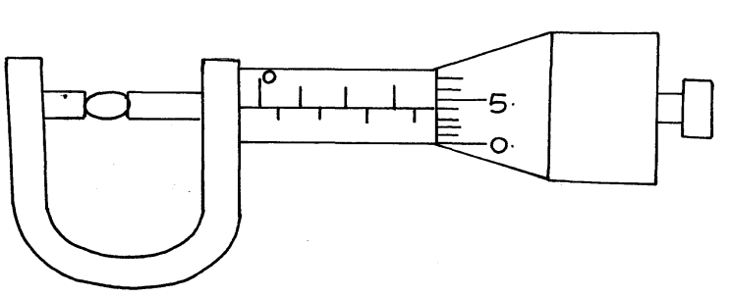
1. Figure 1. shows a micrometer screw gauge being used to measure the diameter of a ball bearing.

If the instrument has a negative zero error of 0.01mm, record the actual diameter of the ball bearing. (1mk)
………………………………………………………………………………………………………
………………………………………………………………………………………………………
2. Figure 2. shows drops of mercury and water on a glass surface,
Mercury drop
Water drop
Glass
Explain the difference in the shapes of the drops. (2mks)
........................................................................................................................................................
……………………………………………………………………………………………………………………………………………………………………………………………………………………

3. Explain why fish can survive under water when the surface is already frozen. (1 mk)
………………………………………………………………………………………………………………………………………………………………………………………………………………………………………………………………………………………………………………………………

4. Figure 3 shows three identical springs each of spring constant 4.5N/m and negligible weight are used to support a load as shown. Determine the total extension of the system. (2mks)
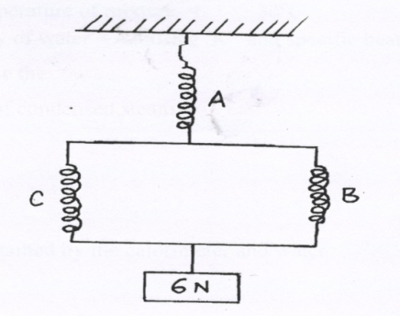

………………………………………………………………………………………………………………………………………………………………………………………………………………
……………………………………………………………………………………………………………………………………………………………………………………………………………..
5. Figure 4 shows a uniform rod AB of negligible weight pivoted at A.

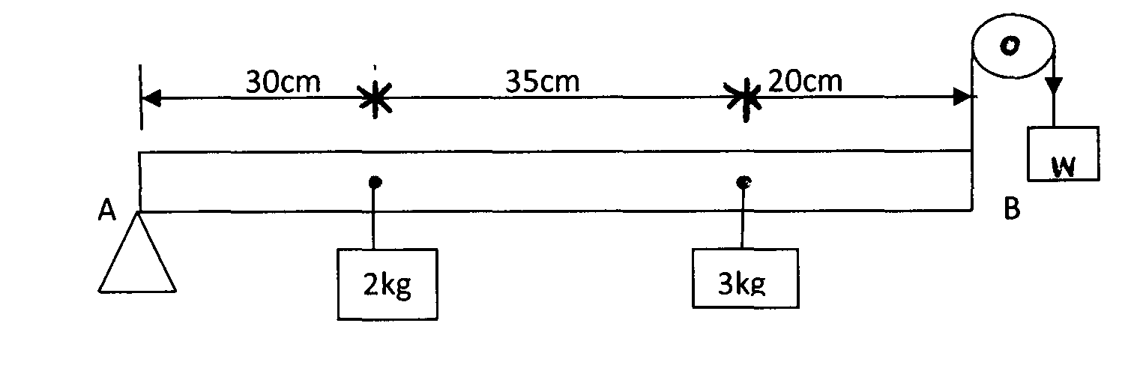

If the system is in equilibrium, determine the weight W shown in the diagram. (3mks)

6. A ball is thrown from the top of a cliff 20m high with a horizontal velocity of 10ms⁻¹. Calculate the distance from the foot of the cliff to where the ball strikes the ground. (3 marks)
………………………………………………………………………………………………………………………………………………………………………………………………………………………………………………………………………………………………………………………………………………………………………………………………………………………………………………………………………………………………………………………………………………………………………………………………………………………………………………
7.The height of mercury column in a barometer density 13600kg/ m⁻³, at a place is 64cm. What would be the height of a column of paraffin in barometer at the same place. (Density of paraffin = 8.0 x 10² kg /m³). (3mks)
………………………………………………………………………………………………………………………………………………………………………………………………………………
………………………………………………………………………………………………………………………………………………………………………………………………………………
………………………………………………………………………………………………………………………………………………………………………………………………………………
………………………………………………………………………………………………………………………………………………………………………………………………………………

8. Explain one advantage of mercury over alcohol as a thermometric liquid. (1mk)
………………………………………………………………………………………………………………………………………………………………………………………………………………………………………………………………………………………………………………………
9.A body of mass M is allowed to slide down an inclined plane. State two factors that affect its final velocity at the bottom of the inclined plane. (2mks)
………………………………………………………………………………………………………………………………………………………………………………………………………………………………………………………………………………………………………………………………

10. A car of mass 1 tone moving at a velocity of 108km/hr is brought to rest in 5 seconds. Calculate the retarding force.(2mks)
……………………………………………………………………………………………………………………………………………………………………………………………………………………………………………………………………………………………………………………………………………………………………………………………………………………………………………………………………………………………………………………………………………………………………………………
11. Explain why a gas cylinder in a house containing cooking fire explodes.(2mks)
………………………………………………………………………………………………………………………………………………………………………………………………………………………………………………………………………………………………………………………………………………………………………………………………………………………………………………………………………………………………………………………………………………………………………………………………………
12.Oil is leaking from a car as it travels along a straight road. One drop falls on the ground every fifty seconds. Figure 5 below shows the pattern of the drop on the ground.

1 2 3 4

•
•
•
•

(i) Describe the motion of the car. (1mk)
…………………………………………………………………………………………………..……………………………………………………………………………………………………………..……………………………………………………………………………………………………....…………………………………………………………………………………………………………
(ii) Determine the acceleration of the car if the distance between drop 1 & 2 is 20 meters and the distance between drop 3 & 4 is 40 meters (2mks)
…………………………………………………………………………………………………..………………………………………………………………………………………………………………………………………………………………………………………………………………………….………………………………………………………………………………………………....…………………………………………………………………………………………………………....

SECTION B - 55 MARKS
Answer all questions in this section in the spaces provided.
13. a) State Pressure Law . (2mk)
……………………………………………………………………………………………………… …………………………………………………………………………………………………………………………………………………………………………………………………………….
b) Figure 6 shows a set up that may be used to verify Pressure law.
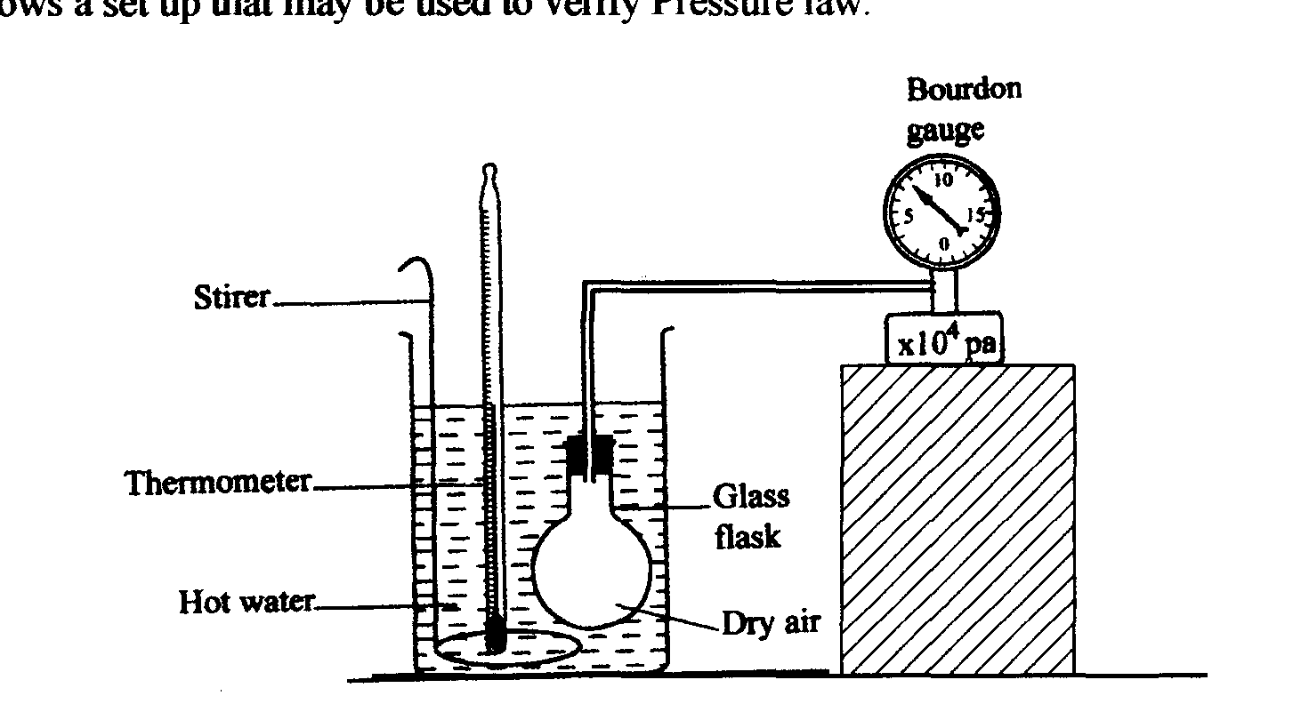

i) State the measurements that may be taken in the experiment. (2mks)
………………………………………………………………………………………………………. …………………………………………………………………………………………………………………………………………………………………………………………………………………… ………………………………………………………………………………………………………..
ii) Explain how the measurement in (i) above may be used to verify Pressure law . (4mks)
…………………………………………………………………………………………………………………………………………………………………………………………………………………… ………………………………………………………………………………………………………… ………………………………………………………………………………………………………………………………………..…………………………………………………………………………………………………………………………………………………………………………………………………………………………………………………………………………………………………………………………………………………………………………………………………………
iii) A car tyre is at an air pressure of 4.0 x 10⁵ Pa at a temperature of 27 °C. While it is running the temperature rises to 75 °C. What is the new pressure in the tyre?(Assume the tyre does not expand) (3mks)
……………………………………………………………………………………………………………………………………………………………………………………………………………………………………………………………………………………………………………………………………………………………………………………………………………………………………………………………………………………………………………………………………………………
14. (a) Define specific latent heat of fusion of a substance. (1mk)
………………………………………………………………………………………………………………………………………………………………………………………………………………………………………………………………………………………………………………………………
(b) Figure 7 below shows a block of ice with two heavy weights hanging such that the copper wire connecting them passes over the block.
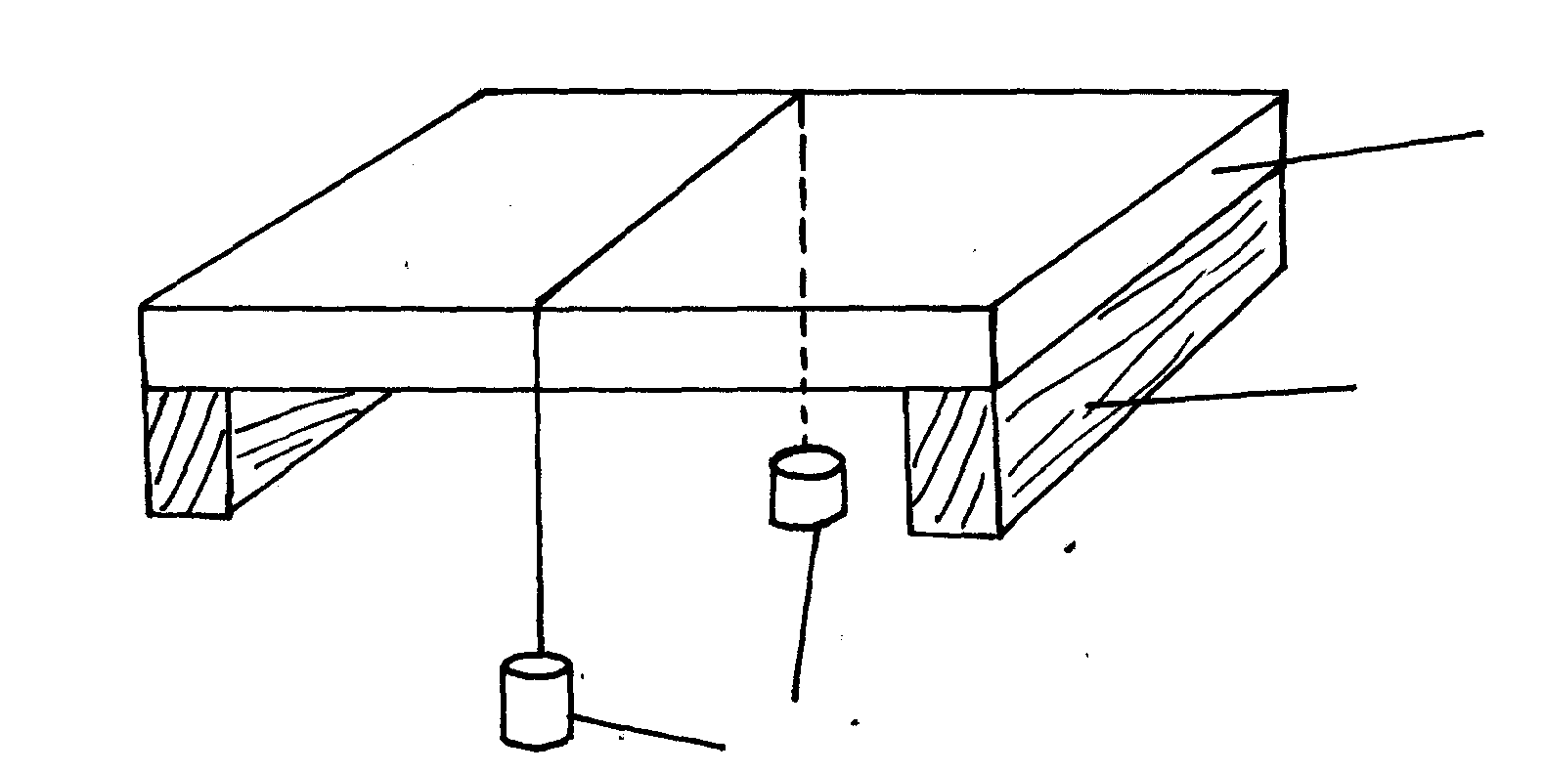

Ice block

Wooden support

weights

(i) It is observed that the wire gradually cuts through the ice block, but leaves it as one piece. Explain (3mks)
………………………………………………………………………………………………………………………………………………..…………………………………………………………………………………………………………………………………………………………………………………………………………………………………………………………………………………
(ii) What change would be observed if the copper wire used in the experiment was placed by a cotton thread. (1mk)
……………………………………………………………………………………………………………………………………………………………………………………………………
(c) A block of ice of mass 40g at 0ºC is placed in a calorimeter containing 400g of water at 20ºC. The heat absorbed by the calorimeter is negligible. The final temperature of the mixture after all the ice has melted is T. (specific latent heat of fusion of ice=340,000 J/kg, specific heat capacity of water=4200JKg⁻¹k⁻¹)
(i) Derive an expression for the heat gained by the ice as it melts to water at temperature T. (2mks)
…………………………………………………………………………………………………. ………………………………………………………………………………………………………………….................……………………………………………………………………………………………………………………………………………………………………………………………………………………………………………………………………………………………………
(ii) Derive an expression for the heat lost by the water. (1mk)
…………………………………………………………………………………………………… ………………………………………………………………………………………………………………………………………………………………………………………………………………………………………………………………………………………………………………………..
(iii) Determine the value of T. (2mks)
…………………………………………………………………………………………………………………………………………………………………………………………………………………………………………………………………………………………………………………………………………………………………………………………………………………………………………………………………………………………………………………………………………………………………………………………………………………………………………………………… (d) State two differences between boiling and evaporation. (2mks)
……………………………………………………………………………………………………………………………………………………………………………………………………………………………………………………………………………………………………………………………………………………………………………………………………………………………………….
15.(a) State the law of floatation. (1mk)
……………………………………………………………………………………………………………………………………………..………………………………………………………………………………………………………………………………………………………………………………

(b) Figure 8 shows a piece of cork held with a light thread attached to the bottom of a beaker. The beaker if filled with water.
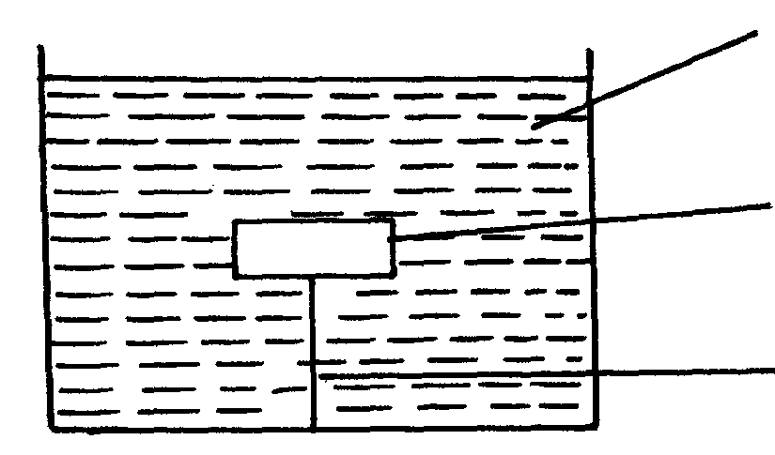
Water

Cork

(i) Indicate and label on the diagram the forces acting on the cork. (3mks)
(ii) Write an expression showing the relationship between the forces. (1mk)
……………………………………………………………………………………………………………………………… …………………………………………………………………………………..
(c) A solid displaces 8.5cm³ of liquid when floating on a certain liquid and 11.5 cm³ when fully submerged in the liquid. The density of the solid if 0.8g/cm3. determine: (i) Up thrust on the solid when floating. (3mks)

(ii) Density of the liquid. (3mks)

16. (a) Name a device that is used to convert sound energy to electrical energy. (1mk)
…………………………………………………………………………………………………………

(b) Define the term efficiency of a machine. (1mk)
………………………………………………………………………………………………………………………………………………………………………………………………………………………………………………………………………………………………………………………………
(c) A pulley system having a velocity ratio of 4 is used to raise a load of 100N through a height of 0.6m at a constant speed using an effort of 60N in a time of 15 seconds.
(i) Calculate the efficiency of the system. (2mks)

(ii) How far does the effort end move in order to raise the load by 0.6m. (2mks)

(iii) Determine the power developed by the effort. (2 mks)

17. (a) Define the following terms: (i) Instantaneous velocity.(1mk)
………………………………………………………………………………………………………………………………………………………………………………………………………………………………………………………………………………………………………………………………
(ii) Uniform acceleration (1mk)
……………………………………………………………………………………………………………………………………………………………………………………………………………………
(b) A car moves with a constant velocity of 15m/s for 300s and is then accelerated uniformly to a velocity of 25m/s in the next 20s. this velocity is maintained for the next 300s. the car is then brought to rest in 30s with uniform deceleration.
(i) Sketch a velocity-time graph for this journey.(2mks)

.From the graph determine;
(ii) The acceleration while the velocity is changing from 15m/s to 25m/s.(2mks)
…………………………………………………………………………………………………………………………………………………………………………………………………………………………………………………………………………………………………………………………………………………………………………………………………………………………………………
(iii) The total distance traveled from the time the car reached maximum velocity of the car during this period.(2mks)
……………………………………………………………………………………………………………………………………………………………………………………………………………………………………………………………………………………………………………………………………………………………………………………………………………………………………………………………………………………………………………………………………………………(c) A ball is thrown horizontally at V=8m/s from a tower. It reaches the ground after 4s. Find:
(i) The horizontal distance d it travels before hitting the ground.(1mk)
…………………………………………………………………………………………………………………………………………………………………………………………………………………………………………………………………………………………………………………………………………………………………………………………………………………………………………
(ii) The height of the tower (2mks)
………………………………………………………………………………………………………………………………………………………………………………………………………………………………………………………………………………………………………………………………………………………………………………………………………………………………………..
(iii) The velocity on impact with the ground.(2mks)
…………………………………………………………………………………………………………………………………………………………………………………………………………………

