NAME: …………………………….………… INDEX NO. ……………………
SCHOOL: ……………………………….…… DATE …………………………..
CANDIDATE’S SIGN. ……………………………………….................

PHYSICS / 232/2
PAPER 1 (THEORY)
TIME: 2 HOURS

FORM 4

INSTRUCTIONS TO CANDIDATES:
- Write your name, school and index number in the spaces provided above
- This paper consists of two sections, A and B.
- Answer all questions in section A and B in the spaces provided.
- All working must be clearly shown in the spaces provided.
- Scientific calculators and KNEC Mathematical tables may be used.
For Examiners’ Use Only
SECTION | QUESTION | MAXIMUM SCORE | CANDIDATE’S SCORE
A | 1-11 | 25
B | 12 | 14
 | 13 | 12
 | 14 | 15
 | 15 | 14
 | TOTAL | 80

SECTION A (25MKS)
- A student placed some olive oil in a burette to a level of 28cm³. She then released 100 drops each of volume 0.056cm³. Find the final reading of the burette. (2mks)

- Distinguish between least count and pitch of a micrometer screw gauge as used in measurement. (2mks)

- Allan stretched a rubber band by a force of 400N to an extension of 8mm. Find the work done by this boy. (3mks)

- State two factors that determine the pressure in a liquid. (1mks)

- The figure 1 shows a mass m suspended using a string. When the mass is suddenly pulled in the direction shown, the string cut.

M

Explain why. (1mk)

- A piece of paper is held in front of the mouth and air blown horizontally over the paper, it is observed that the paper get lifted up. Give reasons. (2mks)

- A tennis ball hits a vertical wall at a velocity of 20m/s and bounces off at the same velocity. Determine the change in velocity. (3mks)

- A hammer is dropped from a tall building 180m high and hit the water in a swimming pool. Calculate:
- The time it takes to hit the water. (2mks)

- The velocity with which it hits the water. (3mks)

- Distinguish between elastic and inelastic collision. (2mks)

- Define the term melting point of a liquid. (1mk)

- An electric pump raises 50 litres of water from a well 15m deep in 30seconds. If the pump is 80% efficient, determine the power rating of the pump. (3mks)

SECTION B (55MKS)

- a) Define the term work as used in Physics and state its SI units. (2mks)

b) The diagram below shows a set of pulleys used to lift a load of 500N
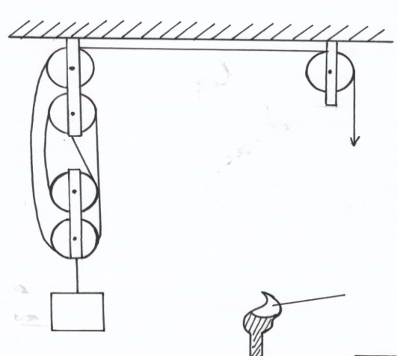

Effort

L = 500N

i) What is the velocity ratio of the pulley system? (1mk)

ii) Calculate the work done on the load if the effort moves down by 0.8m. (3mks)

iii) If the efficiency of the machine is 80%, find the effort required to just lift the
Load. (3mks)

iv) Why is the efficiency of the pulley system not 100%? (2mks)

- A person of mass 75kg runs up a flight of stairs and develops a power of 300W. Calculate the velocity of the man. (3mks)

- Differentiate between angular velocity andangular acceleration, (1mk)

b) A body of mass 200g is tied to a string and whirled in a vertical circle of radius 1m with a speed of 4m/s. calculate:
i) The angular velocity. (2mks)

ii) The tension in the string at the lowest position of the body. (3mks)

c) A block of wood of mass 4kg is suspended from a tree by along light string. A bullet of mass 100g is fired with a velocity of 100ms⁻¹ and embeds itself in the target.
i) At what velocity does the target begin to move after the impact? (2mks)

ii) How high does the target move? (2mks)

iii) State the energy changes on impact up to the highest point. (2mks)

- a) Distinguish between heat capacity and specific heat capacity. (2mks)

b) The figure 2 shows a refrigerator used in domestic. Use it to answer the following questions:
S
Q
P
R

- Name the parts labeled P, Q R and S. (4mks)

- P
- Q
- R
- S

- Explain the function of part labeled S. (2mks)

c) It is noted that steam above boiling water is more dangerous than boilingwater at the same temperature 100⁰C. Explain this observation. (2mks)

- Alula heated 1kg of ice at ⁻10⁰C with an electric heater for 20mintes, and form steam at 100⁰C. Given that C_{i} =2100J/kg ⁰C, L_{f}=3.4 x 10⁵J/kg, C_{w} =4200J/kg ⁰C, and Lv =2.26 x 10⁶ J/kg, find:
i) The total heat supplied. (3mks)

Ii) The power rating of the heater. (2mks)

- a)State the law of flotation (2mk)

b) Define relative density of a substance. (2mks)

c) A hydrometer is floating in a liquid at temperature of 18⁰C. If the temperature of the liquid is raised to 50⁰C state the observation made. (1mk)

d) A cylindrical glass beaker has a uniform cross- sectional area of 50cm² and height 12cm. It floats in water with one third of its volume immersed. A liquid L is poured into the glass until the glass is completely immersed. If the density of water is1.0g/cm³ and density of liquid L is 1.25g/cm³
Determine
- Weight of beaker (3mks)

- Up thrust of water before the beaker is completely immersed. (2mks)

- The volume of liquid Q used (2mks)

- State two uses of a hydrometer. (2mks)

