NAME ____________________________________ INDEX NO. _______________
SCHOOL ____________________________________ SIGNATURE _______________ DATE _______________

232/1
PHYSICS
PAPER 1
TIME: 2 HOURS

FORM 4

INSTRUCTIONS TO CANDIDATES
- Write your name, school and index number in the spaces provided above.
- Write the date of examination and sign in the spaces provided above.
- This paper consists of two sections, Section A and B.
- Answer ALL the questions in section A and B in the spaces provided.
- ALL answers and working MUST be clearly shown.
- Mathematical tables and electronic calculators may be used.
- Take acceleration due to gravity, g = 10m/s²

FOR EXAMINER’S USE ONLY:
Section | Question | Maximum score | Candidate’s score
A | 1−12 | 25
B | 13 | 12
 | 14 | 11
 | 15 | 10
 | 16 | 12
 | 17 | 10
 | Total | 80

This paper consists of 10 printed pages
Candidates should check to ensure that all pages are printed as indicated and no questions are missing

- Figure 1 below shows a micrometer screw gauge being used to measure the diameter of a metal rod. The thimble scale has 50 divisions.
Metal rod
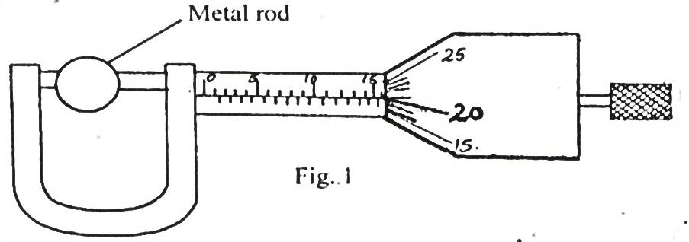
Fig. 1
Find the diameter of the metal rod. (1 mark)

- A man of mass 72kg jumps from a small boat on to the lake shore with a forward velocity of 9.0ms⁻¹.
If the mass of the boat is 216kg, calculate the initial backward velocity of the boat. (3 marks)

- Explain briefly how the temperature in a green house is kept higher than outside. (2 marks)
_________________________________________________________________________________________________________________________________________________________________________________________________________________________________________________________
The diagram shown in figure 2 below is an arrangement of three pulley wheels used to help in lifting loads. Use it to answer questions 4 and 5.
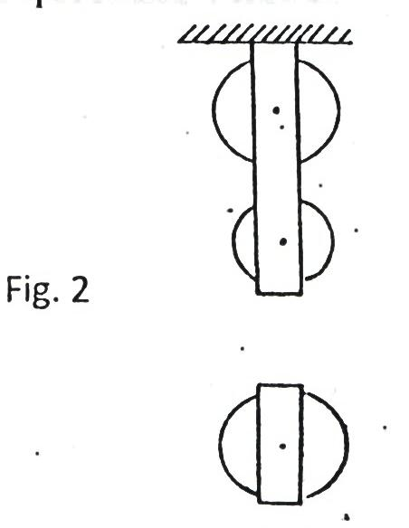 Fig. 2
- Complete the diagram to show how the rope goes round the wheels, position of the load and the effort. (2 marks)

- Write down the velocity ratio (VR) of the system. (1 mark)
___________________________________________________________________________________
- State how temperature affects the speed of sound in air. (1 mark)
______________________________________________________________________________________________________________________________________________________________________
- State two facts which show that heat from the sun does not reach the earth surface by convection. (2 marks)
_________________________________________________________________________________________________________________________________________________________________________________________________________________________________________________________
- The diagram in figure 3 below shows water with negligible viscosity flowing steadily in a tube of different cross-section area. If at a point A, the cross section area is 120cm² and the velocity of water is 0.40ms⁻¹, calculate the velocity at B where cross section area is 4.0cm²? (3 marks)
B
A
Fig. 3

- A motor uses an electrical energy at a rate of 200W and raises a mass of 25kg through a vertical distance of 20m in 0.5 minutes. Determine the efficiency of the motor. (3 marks)

- How long will it take 240V, 3000W electric immersion heater to raise the temperature of 150 litres of water in a well-lagged calorimeter made of copper of mass 20kg from 15⁰ to 70⁰C? (3 marks)

- The diagram shown in the Figure 4 below shows a system in equilibrium with the rule horizontal.
AB is a uniform rule of length 1.0m and weight 1.8N. Calculate the weight of the block X. (3 marks)

40cm

30cm

Fig. 4
180 g
X
Q
B
A

- State the reason why a trailer carrying heavy loads has many wheels. (1 mark)
______________________________________________________________________________________________________________________________________________________________________

SECTION B (55 MARKS)
Answer ALL the questions
- A student in Lugulu Girls set up an experiment to study the acceleration of a trolley using ticker tape timer. The timer made 50 dots per second on the tape. Dots A to E measured 2.5cm apart and dots E
to I measured 4.5cm apart.
- Using a scale drawing show the dots A, B C, D, E, F, G and I as they appeared on the tape. (3 marks)

- Determine the velocity of the trolley from:
- A to E. (2 marks)

- E to I. (2 marks)

- Calculate the acceleration of the trolley. (2 marks)

- What end of the tape was fixed onto the trolley? (1 mark)
___________________________________________________________________________________
- State two precautions that the student should take before she takes her final samples of the dots.
(2 marks)
_________________________________________________________________________________________________________________________________________________________________________________________________________________________________________________________

- a) i) What is Brownian motion? (1 mark)
______________________________________________________________________________________________________________________________________________________________________
ii) Describe with the aid of a diagram, the apparatus you could set up in order to demonstrate Brownian motion of smoke particles suspended in air. (5 marks)
___________________________________________________________________________________________________________________________________________________________________________________________________________________________________________________________________________________________________________________________________________________________________________________________________________________________________________________________________________________________________________________________________________________________________________________________________________________________________________________________________________________________________________________________________________________________________________
b) An oil drop has a volume of 0.01mm³ when it is placed on the surface of some water, it spreads out to form a circular patch of area 500cm²
i) Calculate the thickness of the oil film. (3 marks)

ii) What two assumptions have you made in the answer b(i) above. (2 marks)
_________________________________________________________________________________________________________________________________________________________________________________________________________________________________________________________
- a) i) Distinguish between inelastic and elastic collisions. (2 marks)
____________________________________________________________________________________________________________________________________________________________________________________________________________________________________________________________________________________________________________________________________________

ii) A particle A of mass M moving with an initial velocity, u, makes a head-on collision with another particle B of mass 2M, B being initially at rest. In terms of u, calculate the final velocity of A if the collision is perfectly inelastic. (3 marks)

b) The diagram in Figure 5 below shows a sphere moving in a viscous liquid in a tall measuring cylinder.
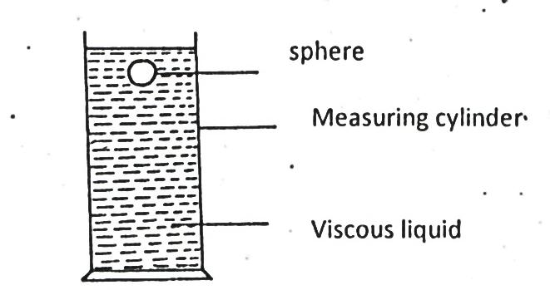
Measuring cylinder
Viscous liquid
Sphere
i) Show on the diagram the forces acting on the sphere. (3 marks)
ii) Sketch a graph showing the variation of velocity with time in figure 6 below. Show on the graph the terminal velocity, V_{T}. (2 marks)

- A mass of 1kg is attached to a cord of length 50cm. It is whirled in a circle in a vertical plane at 10 revolutions per second as shown in the figure below.
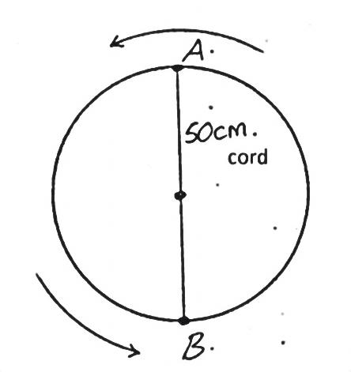
B

A

50cm
cord
- Find the tensions in the cord when the mass is at:
- Highest point of the circle A. (2 marks)

- Lowest point of the circle B. (2 marks)

- i) Describe an experiment to determine specific heat capacity of aluminium block with two holes drilled in it to accommodate a thermometer and an electric heater. (5 marks)
__________________________________________________________________________________________________________________________________________________________________________________________________________________________________________________________________________________________________________________________________________________________________________________________________________________________________________________________________________________________________________________

ii) An immersion heater rated 90W is placed in a liquid of mass 2kg. When the heater is switched on for 15minutes, the temperature of the liquid rises from 20⁰C to 30⁰C. Determine the specific heat capacity of the liquid. (3 marks)

- a) The figure below shows a block of mass 25g and density 200kg/m³ submerged in a certain liquid and suspended from a homogenous horizontal beam by means of a thread. A mass of 2kg is suspended from the beam as shown in the figure below.
30 cm
40 cm
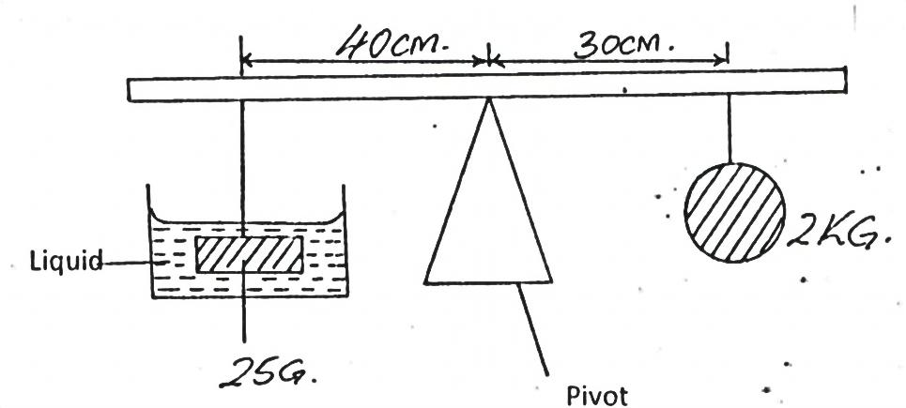
Liquid
25 g
2 kg
Pivot
- Determine the upthrust force acting on the block. (3 marks)

- Calculate the density of the liquid. (3 marks)

b) i) State the law of floatation. (1 mark)
______________________________________________________________________________________________________________________________________________________________________________________________________________________________________________________
ii) The figure below shows a piece of aluminum suspended from a string and completely immersed in a container of water. The mass of the aluminium is 1kg and its density is 2.7 $×$ 10³kg/m³
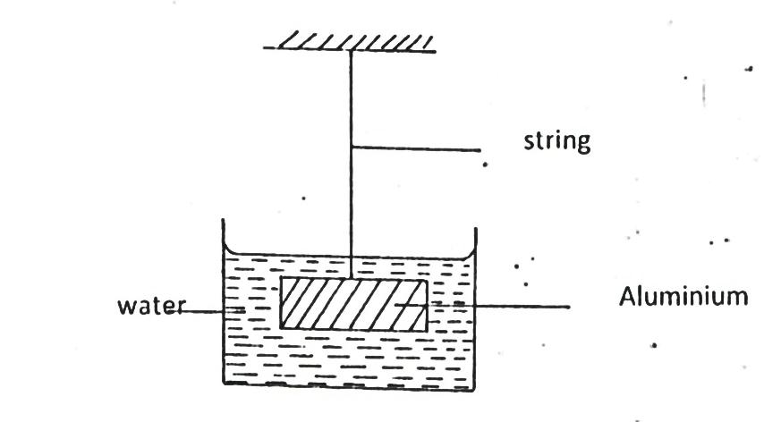
Water
Aluminium
String
Calculate the tension in the string. (3 marks)

