Name………………………………………………… Index. No…………………………
Signature………………………………
Date ………………………………

232/1
PHYSICS
THEORY
PAPER 1
2 HOURS

FORM 4

Instructions:
- Write your name and index number in the spaces provided above.
- Sign and write the date of the examination in the spaces above.
- This paper consists of two sections A and B
- Answer all the questions in section A and B in the spaces provided.
- Mathematical tables and electronic calculators may be used.
- All working MUST be clearly shown where necessary.
- Candidates should answer all questions in English.

For Examiner’s Use Only
Section | Question | Maximum Score | Candidates Score
A | - 14 | 25 marks
B

SECTION A (25 MARKS)
Answer all question in the spaces provided
- Fig. 1 below shows the meniscus of a liquid of density 1.36g/cm³ in a measuring cylinder. Determine the mass of the liquid in SI units. (2 marks)
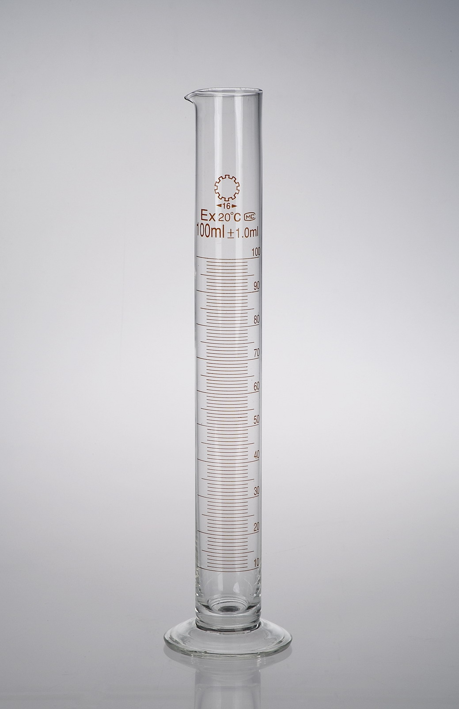
- The fig.2 below shows a cotton thread tied across a soap solution. Fig. 2(a) shows the thread across the surface undisturbed, while fig. 2(b) shows the thread when region marked A has been punctured. Explain the observation ( 1 mark )
Soap solution
‘’’’’’’’’’’’’’’’’’’’’’’B’’’’’’’’’’’’’’’’’’’’’’’’’’’’’’’’’’’’’’’’’’’’A’’’’’’’’’’’’’’’’’’’’’’’’……….,,,,,,,,,,,,,,,…………………………………….;;;;;;;;;;;;,,,,,,,,,,,,,,,…………..
B
A

‘’’’’’B’’’’’’’’’’’’’’’’’’’’’’’’’’’’’’’
A

Thread

(a) (b)

- The fig 3 below represents two identical capillary tube dipped into the beakers containing water and mercury.

Water Mercury

Fig 3 (a) (b)
Indicate on the diagrams the appropriate levels of the liquids in the capillary tubes (2 marks)
- Two identical containers P and Q with same quantities of water are placed over identical lit Bunsen burners. P has a dull black surface while Q is shinny surface. State with reason in which container temperature will be higher after some time. (2 marks )

- A Uniform wooden beam 5 meters long weighs 200N. The beam is placed horizontally on two supports A and B, such that support A is 0.5 m from the end and while the support B is 1m from the other end. Determine the force exerted by each support for the beam to remain horizontal. ( 3marks )

- A student blew a stream of air between two pieces of paper and observed the pieces of paper moving closer to each other. Explain this observation. ( 2 marks)

- The graph below shows acceleration time graph for a body.

Acceleration (m/s²)

Time (s)
On the axis provided sketch a corresponding displacement time graph for the body. (1mark)
Displacement (m)

Time (s)
- A uniform light bar is balanced under action of two balloons filled with different light gases and tied at the middle as shown below.

Balloons

Explain why the system may not remain in equilibrium when the temperature of the surrounding changes.
(2 marks)

- Differentiate between Brownian motion and diffusion. (1 mark)

- The fig below shows three identical springs connected by a rod of negligible weight. Each spring has a mass of 0.5 kg and a spring constant of 300N/M. determine the total extension produced by a force of 100N on the spring. (3 marks)
100 N

Connecting rod
Spring

- a) The figure below shows a flask filled with water. The flask is fitted with a cork through which a tube is inserted. When the flask is cooled, the water level rises slightly, then falls steadily.
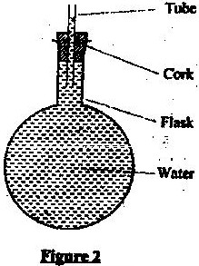

Explain the observation. (2 marks)
The figure below shows the cooling curve of naphthalene. Use it to answer question 12 and 13
A
60

Temp º c 40 B C

20 D

0
Time (S)
- Determine the room temperature (1 mark)

- Explain the shape of the graph for the section AB and BC (2 marks )

- A mini bus of mass 1200kg travelling at a constant velocity of 15m/s collides with a stationary car of mass 600kg. The impact takes 1.5 seconds before the two move together at a constant velocity for 25 seconds. Determine the common velocity. (3 marks)

SECTION B
- a) A gear wheel system has 20 teeth on the driving wheel and a velocity ratio (VR) of 2.5. Determine the number of teeth on the driven wheel. (3 marks)

b) The figure below shows a pulley system used to raise a mass of 20 kg.

Pulley 1
Pulley 3

E
Pulley 2

20KG
State the
- Velocity ratio of the system. (1 mark)

- Purpose of pulley 3. (1 mark )

- Given that the machine has an efficiency of 80 %, determine the minimum effort that can be applied to lift the load. (3 marks)

- State two reasons why the efficiency of this pulley system cannot be 100%. (2 marks )

- In an experiment to determine the relative density of benzene, a student was provided with a spring balance, three masses, a piece of thread, water in a beaker and benzene in a beaker. The results obtained are in the table below.

Mass (g) | 50 | 100 | 200
Weight in air ( N) | 0.5 | 1.0 | 2.0
Weight in water( N) | 0.44 | 0.88 | 1.78
Weight in benzene (N) | 0.46 | 0.9 | 1.81

- State the principal that was applied in this experiment. (1 mark)

- (i) For each mass determine the relative density of benzene ( 3 marks)

(ii) Determine the relative density of benzene (2 marks)

16 (a). A whether balloon of volume 1.2m³ is tied to rigid support being filled with helium gas. The mass of the fabric making the balloon is 0.30kg. given that the density of Helium=0.1785kg/m³ and air= 1.2041 kg/m³
Determine
- The total downward force (3 marks)

- The up thrust force on the balloon. (2 marks )

- The tension on the spring tying the balloon on the rigid support. (2 marks )

- A ball was thrown horizontally from a cliff at a velocity of 30m/s. if the ball takes 3 seconds to reach the ground. Determine
- The velocity with which it hits the ground. (3 marks)

- The horizontal distance covered by the ball (2 marks)

(b) The diagram below shows dots which were made by a ticker timer on a tape attached to an acceleration trolley.
. . . . . . . . .

5cm 5cm

If the frequency of the power used was 50 Hz
- Determine the deceleration of the trolley. (3 marks)

- Using an arrow on the above diagram, show the direction of motion of the tape. (1 mark)

- Draw a well labelled diagram of the apparatus you would use to verify the relationship
between pressure and volume of fixed mass of a gas. (3 marks)

- Describe how to use the apparatus to verify the law. (3 marks

- A Gas has a volume of 20cm³ at 27º c and normal atmospheric pressure. Calculate the volume of the gas if it is at 54ºc at the same pressure. (4 marks)

- (i) What is meant by specific latent heat of Vaporization? (1 mark)

(ii) In an experiment to determine the specific latent heat of vaporization of water, steam at 100°C was passed into water contained in a well lagged copper calorimeter.
The following measurements were made:
Mass of calorimeter = 60g
Initial mass of water =80g
Initial temperature of water = 7°C
Final mass of water + Calorimeter + condensed steam = 125g
Final temperature of mixture =31°C
Specific heat capacity of water = 4200Jkg⁻¹k⁻¹
Specific heat capacity of copper =390J kg⁻¹k⁻¹.
Determine the
(i) Mass of condensed steam (2 marks)

(ii) Heat gained by water and calorimeter. (3 marks)

(c) Given that Q is the specific latent heat of vaporization of steam
(i) Write an expression for the heat given out by steam. (1 mark)

(ii) Determine the value of Q (3 marks)

(d) 450g of water at 20°C is mixed with 200g of water at 55°C Find the final temperature of the
mixture. (3 marks)

