Name…………………………………..…………………………………AND No:…………………………….…….

School ………………………………………………………….… Candidate’s Signature ………………………….

232/2
PHYSICS
THEORY
PAPER 2

TIME: 2 HOUR

FORM 4

INSTRUCTIONS TO CANDIDATES:
- Write your name and index number in the spaces provided above
- This paper consists of two sections A and B.
- Answer all the questions in section A and B in the spaces provided.
- All working must be clearly shown ; marks may be awarded for correct steps even if the answers are wrong
- Mathematical tables and silent electronic calculators may be used.
- Take gravitational acceleration =10m/s² and π=3.142
- This paper consists of 12 printed pages.
- Candidates should check to ascertain that all pages are printed as indicated and that no questions are missing.
For Examiners’ Use Only
Section | Question | Maximum Score | Candidate’s Score
A | 1-14 | 25
B | 15 | 13
 | 16 | 14
 | 17 | 11
 | 18 | 13
 | 19 | 8
Total Score |  | 80

SECTION A (25marks)
- The figure below shows a beam of light incident of a parabolic reflector.

Beam

Complete the diagram to show the path of the rays after reflection. (1mark)

- When a candle flame is brought near the top cap of a charged electroscope, the electroscope discharges. Explain this observation. (2marks)
……………………………………………………………………………………………………………………
………………………………………………………………………………………………………………………………………………………………………….………………………………………………………………
…………………………………………………………………………………………………………………
- The figure below shows a horizontal conductor in a magnetic field parallel to the plane of the paper.
N

S

State the direction in which the wire may be moved so that the induced current is in the
direction shown by the arrow. (1mark)
……………………………………………………………………………………………………………………
……………………………………………………………………………………………………………………
4. The diagram below shows the position of the bright spot on the screen of a C.R.O when there is no signal
on both Y and X –plate. Indicate on the diagram (b) when the Y-plate is connected to a.c signal and for
(c) the X-plate is connected to d.c signal i.e the display on the screen. (2marks)

(+)

(c) (-)

(b)
•
(a)

- The diagram below shows a wave travelling to the right . The time taken by the wave from O to B is 0.0025 seconds.
redraw for better waves
A
B
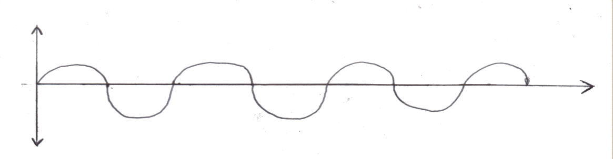
Calculate the frequency of the wave. (2marks)

- State one difference between an image formed by a plane mirror and that observed through a pin hole camera. (1mark)
……………………………………………………………………………………………………………………
……………………………………………………………………………………………………………………

- The figure below shows capacitors connected to a d.c supply.
12V
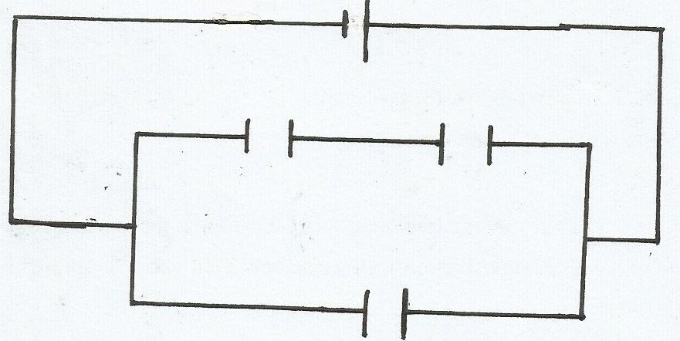

2µF
2µF

Calculate the charge stored in one of the 2µF capacitor. (3marks)

- Give a reason why lecture theatre halls are covered with soft perforated materials. (1mark)
……………………………………………………………………………………………………………………
………………………………………………………………………………………………………………….
- Arrange the following in order of decreasing wavelength: infrared, microwave, gamma rays visible light. (1mark)
……………………………………………………………………………………………………………………
…………………………………………………………………………………………………………………….
- The figure below shows plane waves approaching a very narrow slit S.

S

Complete the diagram to show the pattern after crossing the slit. (2marks)
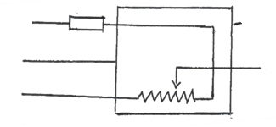
- The diagram below shows an electrical appliance connected to the mains.
A
Fuse
Casing

B
Heating element
C

Name the colour codes for leads A, B, and C and state the purpose of the fuse. (3marks)
A………………………………………… B……………………….…………… C……………………………………….
Purpose for fuse: (1mark)
…………………………………………………………………………………………………………………….
……………………………………………………………………………………………………………………

- The figure below shows a V-shaped magnet with a plotting compass placed between its poles
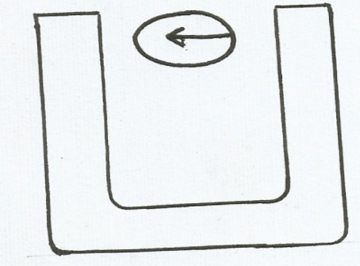

Draw a diagram indicating the magnetic field pattern around the U-shaped magnet. (2marks)
- Each cell in the diagram below has an e.m.f of 2.0 v and zero internal resistance.
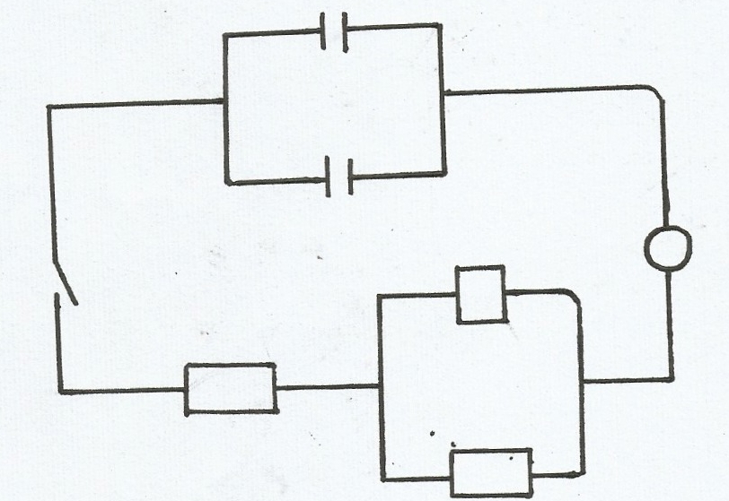

A
4.2Ω

2.9Ω

4.2Ω

Determine the ammeter reading when the switch is closed. (2marks)

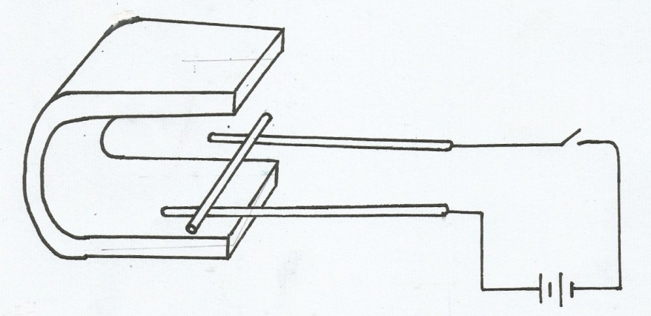
- A conductor XY is placed between the poles of a magnet as shown below. When the current is allowed to flow, the conductor rolls along the rod A and B

X
A

Y

B

Show with an arrow the direction in which it will move. (1marks)

SECTION B (55 MARKS)
- (a)(i) Distinguish between threshold frequency and threshold wavelength. (1mark)
…………………………………………………………………………………………………………………….
…………………………………………………………………………………………………………………….
(ii) The maximum wavelength required to cover photoelectric emission on a metal surface is
8.0 X10⁻⁷m. The metal surface is irradiated with light of frequency8.5 X10¹⁴Hz.
Determine:
(I)The threshold frequency (1mark)

(II)Maximum kinetic energy of the electrons (3marks)

(b) Below shows a plot of the graph of stopping potential Vs against reciprocal of the wave length $\frac{1}{λ}$.
The work function of the metal used was 2.08 X 10⁻¹⁹J and velocity of electromagnetic waves is
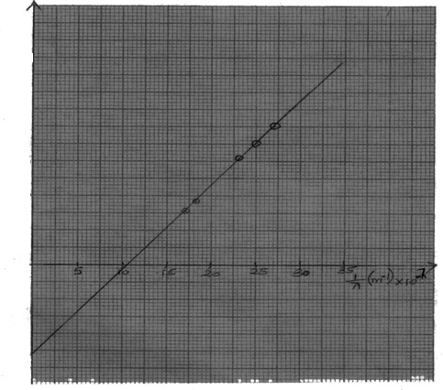
3.0 X 10⁸m/s

30
25
20
15
10
5

0
-5

-10
-15

V s X 10⁻¹(V)

The equation of the graph is given by Vs= $\frac{hc}{eλ}$ - $\frac{ѡo}{e}$
Use the graph to determine:
- The threshold frequency (f_{o}) (2marks)
……………………………………………………………………………………………………………
……………………………………………………………………………………………………………
- The charge of an electron (e-) (2marks)
…………………………………………………………………………………………………………………………………………………………………………………………………………………………
The slope (2marks) ………………………………………………………………………………………………………………
…………………………………………………………………………………………..………………….
- The value of planks constant (2marks)
…………………………………………………………………………………………………………
……………………………………………………………………………………………………………
- (a) (i)Explain why carbon -14 $\frac{14}{6}$ C is radioactive while carbon is not. (2marks)
…………………………………………………………………………………………………………………
…………………………………………………………………………………………………………………
(ii) A radioactive isotope showed a count rate of 82 counts per second initially. After
a time of 210seconds, the count rates dropped to 19 counts per
second. The average background count remained constant at 10 counts per second.
What is the half life of the material? (2marks)
…………………………………………………………………………………………………………………….
………………………………………………………………………………………………………………….
(b) The figure below shows the features of a diffusion cloud chamber used for detecting
Radiations from a radioactive source.
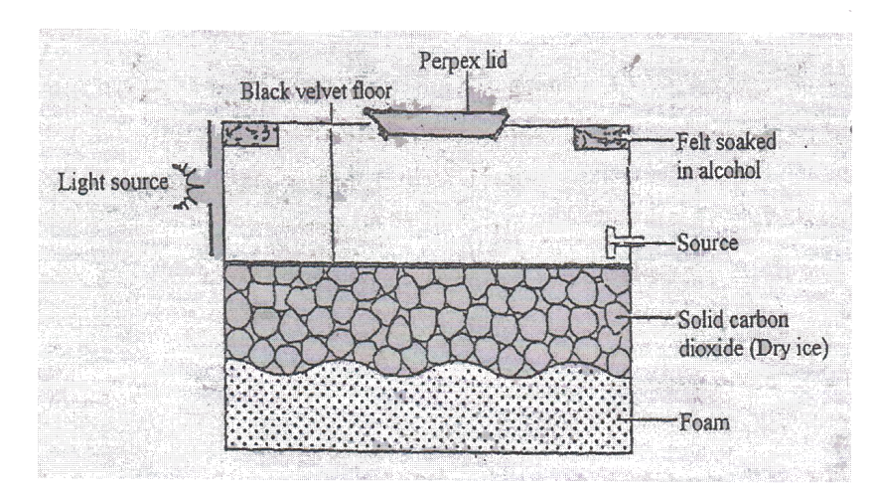

Explain how the chamber works when a radioactive particle is introduced at the
source (2marks)
……………………………………………………………………………………………………………………
……………………………………………………………………………………………………………………
(c ) (i)What is the purpose of solid carbon(iv) oxide? (1mark)
…………………………………………………………………………………………………………………….
…………………………………………………………………………………………………………………….
(ii)State one advantage of the cloud chamber over a G.M tube as a detector of radio
-active radiations. (1mark)
…………………………………………………………………………………………………………………….
…………………………………………………………………………………………………………………….
(d) (i) Using a diagram explain how doping produces a p-type semi-conductor (3marks)
…………………………………………………………………………………………………………………….
…………………………………………………………………………………………………………………….
…………………………………………………………………………………………………………………….
…………………………………………………………………………………………………………………….
(ii) What is biasing? (1marks)
…………………………………………………………………………………………………………………….
…………………………………………………………………………………………………………………….
(iii) The diagram below shows a circuit with a p-n junction and a very lower power
bulb
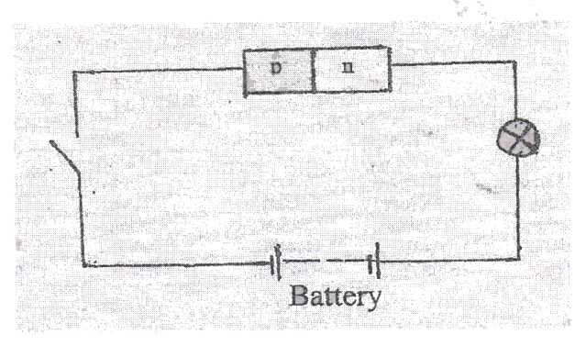
State with reason the observation made on the bulb when the switch is closed. (2marks)
…………………………………………………………………………………………………………………….
…………………………………………………………………………………………………………………….

- The figure below shows the construction and circuit of the modern X-ray tube.

(i) Name the part marked C and state its function (2marks)
…………………………………………………………………………………………………………………….
…………………………………………………………………………………………………………………….
(ii) Name the metals used in A and B and state their functions (2marks)
…………………………………………………………………………………………………………………….
…………………………………………………………………………………………………………………………………….…………………………………………………………..………………………………………
(iii) Why are cooling tins necessary (2marks)
…………………………………………………………………………………………………………………….
………………………………………………………………………………………………………………………………………………………………………………………………………………………………….…….
(b)Explain how energy of the X-rays can be increased. (2marks)
………………………………………………………………………………………………………………………………………………………………………………………………………………………………….…….
(c) An X-ray tube operated at a potential of 10KV and a current of 0.2A flows in the tube.
Calculate the number of electrons reaching the target per second.
(Electrons charge= 1.6 X16⁻¹⁹ Coulombs). (3marks)
……………………………………………………………………………………………………………….
…………………………………………………………………………………………………………………….
……………………………………………………………………………………………………………………
……………………………………………………………………………………………………………………

- The figure below shows how an image is formed by a converging lens.

Redraw
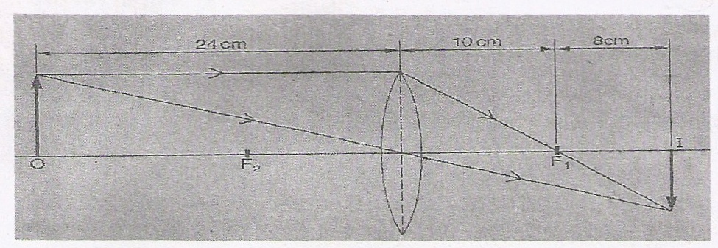
(i)State the value of the focal length of the lens. (1mark)
…………………………………………………………………………………………………………………….
…………………………………………………………………………………………………………………….
(ii) Calculate the magnification of the image produced (2marks)

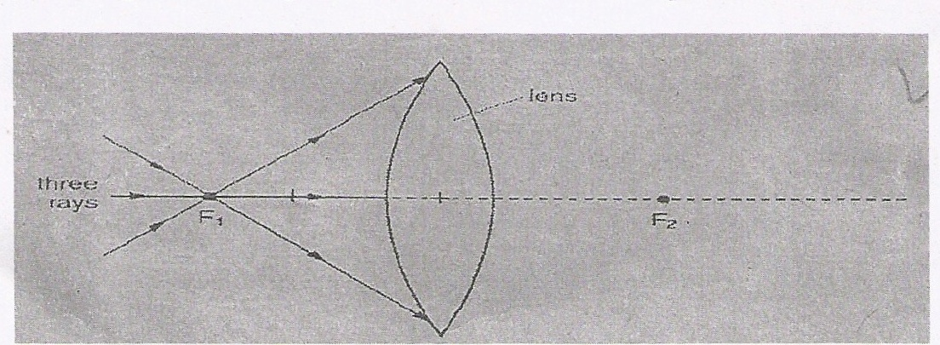
(b) The figure shows a glass lens in air and its two focal points F₁ and F_{2.}

Three rays of light pass through F₁ to the lens.
(i) On the figure continue the three rays through the lens and into the air. (2marks)
(ii) State what happens to the speed of light on entering the glass lens from air. (1mark)
…………………………………………………………………………………………………………………….…………………………………………………………………………………………………………………….

(c ) A ray of light passes through one surface of a glass prism at right angles to surface. Given that
the critical angle of the glass materials is 42⁰, complete the ray to show how it travel until it
leaves the prism. (2marks)

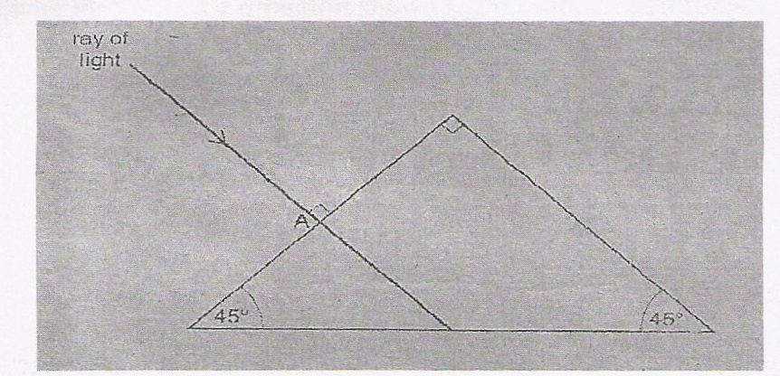

(d) An object is placed 30cm in front of a convex of focal length 20cm. Determine the image
distance. (2marks)

(e ) (i)State two possible causes of long sightedness. (2marks)
…………………………………………………………………………………………………………………….
…………………………………………………………………………………………………………………….
(ii) What type of lens is used to correct long sightedness? (1mark)
…………………………………………………………………………………………………………………….
…………………………………………………………………………………………………………………….

19. The figure below shows an induction coil used to step up voltage.
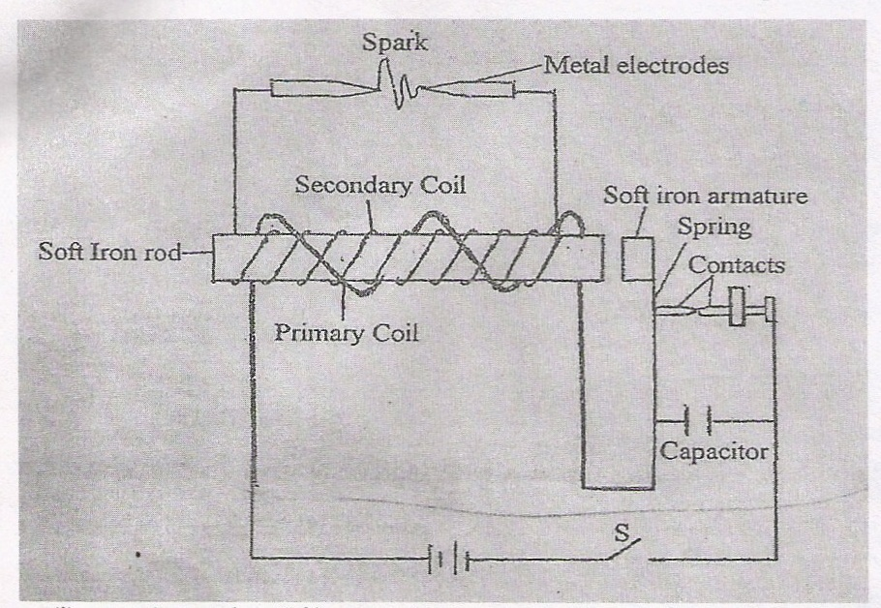
- State the difference between the induction coil and step-up transformer. (1mark)
………………………………………………………………………………………………………
………………………………………………………………………………………………………

- Explain how voltage is stepped up by the induction coil. (2mks)
…………………………………………………………………………………………………
………………………………………………………………………………………………………
- The voltage is stepped up from 12V to 15V. Determine the ratio of the secondary to primary coil in the induction coil. (1mark)
………………………………………………………………………………………………………
………………………………………………………………………………………………………

