**NAME:…………………………………………………INDEX………………..…..DATE……..…**

**SCHOOL:………………………………………………SIGNATURE………………………………**

**232/2**

**PHYSICS**

**PAPER 2**

**2 HOURS**

**FORM 4**

**INSTRUCTIONS TO CANDIDATES**

* *Write your name and index number in the spaces provided above*
* *This paper consists of* ***two*** *sections* ***A*** *and* ***B***
* *Answer* ***all*** *the questions in the spaces provided*
* ***All*** *working* ***must*** *be clearly shown in the spaces provided*
* *Mathematical tables and electronic calculators may be used*
* *Take velocity of light and plank’s constant *

**For Examiner’s Use Only**

|  |  |  |  |
| --- | --- | --- | --- |
| **Section** | **Question** | **Maximum Score** | **Candidates’ Score** |
| A | Q1 – Q15 | 25 |  |
| B | Q16  Q17  Q18  Q19 | 14  13  15  13 |  |
| 80 |  |

***This paper consists of 13 printed pages. Candidates should check the question paper to***

***Ensure that all the pages are printed as indicated and no questions are missing.***

**SECTION A (25 MARKS)**

1. A plane mirror is suspended on a wall by a string shown in the diagram

700

String

Incident ray

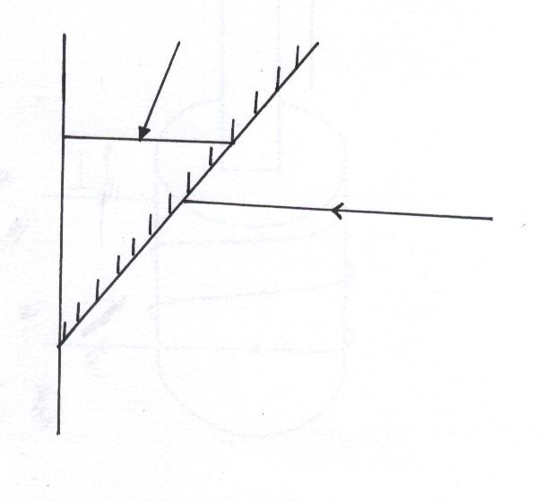

Fig 1

An incident ray then strikes the mirror at an angle of 700. Determine the angle formed between the incident ray and reflected ray. **(2 marks)**

1. Give a reason why a prism disperses white light into the component colours **(1 mark)**

…………………………………………………………………………………………………………………………………………………………………………………………………………

1. Fig 2 below shows a conductor y placed in a magnetic field. The conductor carries a current flowing into the paper.

N



S

S

Fig 2

Sketch the resultant magnetic field between the poles of the bar-magnet **(1 mark)**

Show on the diagram the direction of the force, F acting on the conductor **(1 mark)**

1. Determine the largest number of 75W bulbs which can be safely used to run on a 240V source with a 5A fuse. **(3 marks)**
2. A charge of magnitude flows through a point in 15 minutes. Calculate the current. **(2 marks)**
3. Fig 3 below shows a 5µF and a 3µF capacitors connected to a 6V battery

5 µF

3 µF

6 V

Fig 3

Calculate the charge stored in the circuit **(3 marks)**

1. Complete the diagram below to show how diffraction would occur as the incident waves pass through the obstacle.

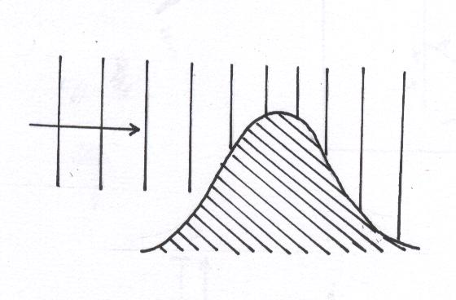

Fig 4

1. State the effect on conductivity of increasing the temperature of a semi-conductor **(1 mark)**

……………………………………………………………………………………………………

……………………………………………………………………………………………………

1. Arrange the following waves in the order of increasing wavelength :- X-rays, visible light, infra-red, T.V waves, micro waves **(1 mark)**

…………………………………………………………………………………………………………………………………………………………………………………………………………

1. An Electric heater is rated 1000W, 240V. Calculate the resistance of this element **(2 marks)**
2. A freely pivoted spike is charged to a high negative voltage in the air

Pivot

Fig 5

Explain why the spikes move **(2 marks)**

………………………………………………………………………………………………………………………………………………………………………………………………………………………………………………………………………………………………………………

……………………………………………………………………………………………..……..

1. What are the values of **m** and **a** in the nuclear equation given below:- **(1 mark)**



Figure **6** below shows the features of a diffusion cloud chamber used for detecting radiations from

radioactive sources. Use it to answer questions 13 and 14.

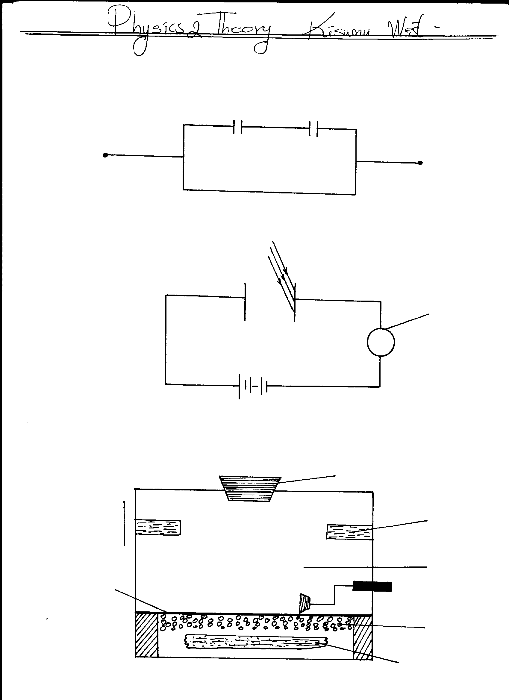

**Source of lig**ht

**Black velvet**

**Chamber**

**Perspex lid**

**Felt soaked in**

**alcohol**

**Air**

**Radioactive source**

**Foam**

**Solid CO2 at**

**-780C**

**Fig.6**

**13.** State the property of alcohol that makes it suitable for use in the chamber **(1 mark)**

**……..** ……………………………………………………………………………………………

……………………………………………………………………………………………………

**14.** Explain how the radiation from the radioactive source is detected in the chamber.  **(4 marks)**

**………………………………………………………………………………………………………………………………………………………………………………………………………………………………………………………………………………………………………………………………………………………………………………………………………………………………………………………………………………………………………………………………………………………………………………………………………………………………**

**15.** On the axes provided in the figure below, sketch a frequency-wavelength graph for

an electro-magnetic wave. **(1 mark)**

Frequency

y (Hz)yy

Wavelength (m)

**SECTION B: (55 MARKS)**

1. **(a)** The diagram below shows an experimental set up consisting of a mounted lens, L, a screen, S, a metre rule and a candle.

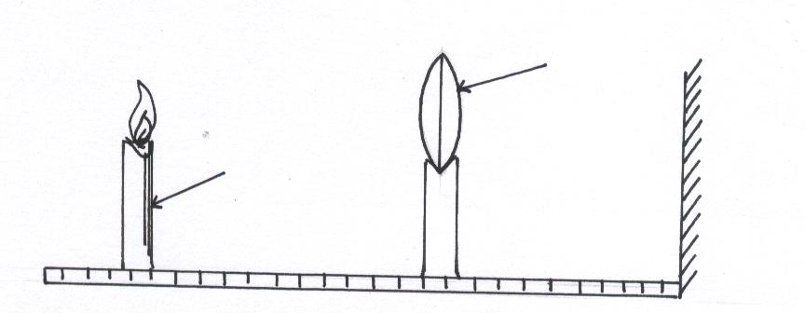

candle

L

A metre rule

**(i)** Describe how the set-up may be used to determine the focal length, f of the lens. **(5 marks)**

…………………………………………………………………………………………………………………………………………………………………………………………………………………………………………………………………………………………………………………………………………………………………………………………………………………………………………………………………………………………………………………………………………………………………………………………………………………………………………………………………………………………………………………………………………………………………………………………………………………………………………

**(ii)** State the reason why the set-up would not work if the lens were replaced with a diverging lens **(1 mark)**

…………………………………………………………………………………………… …………………………………………….................................................................

**(b)** The graph below shows the relationship between and for converging lens where u and v are the object and image distances respectively.

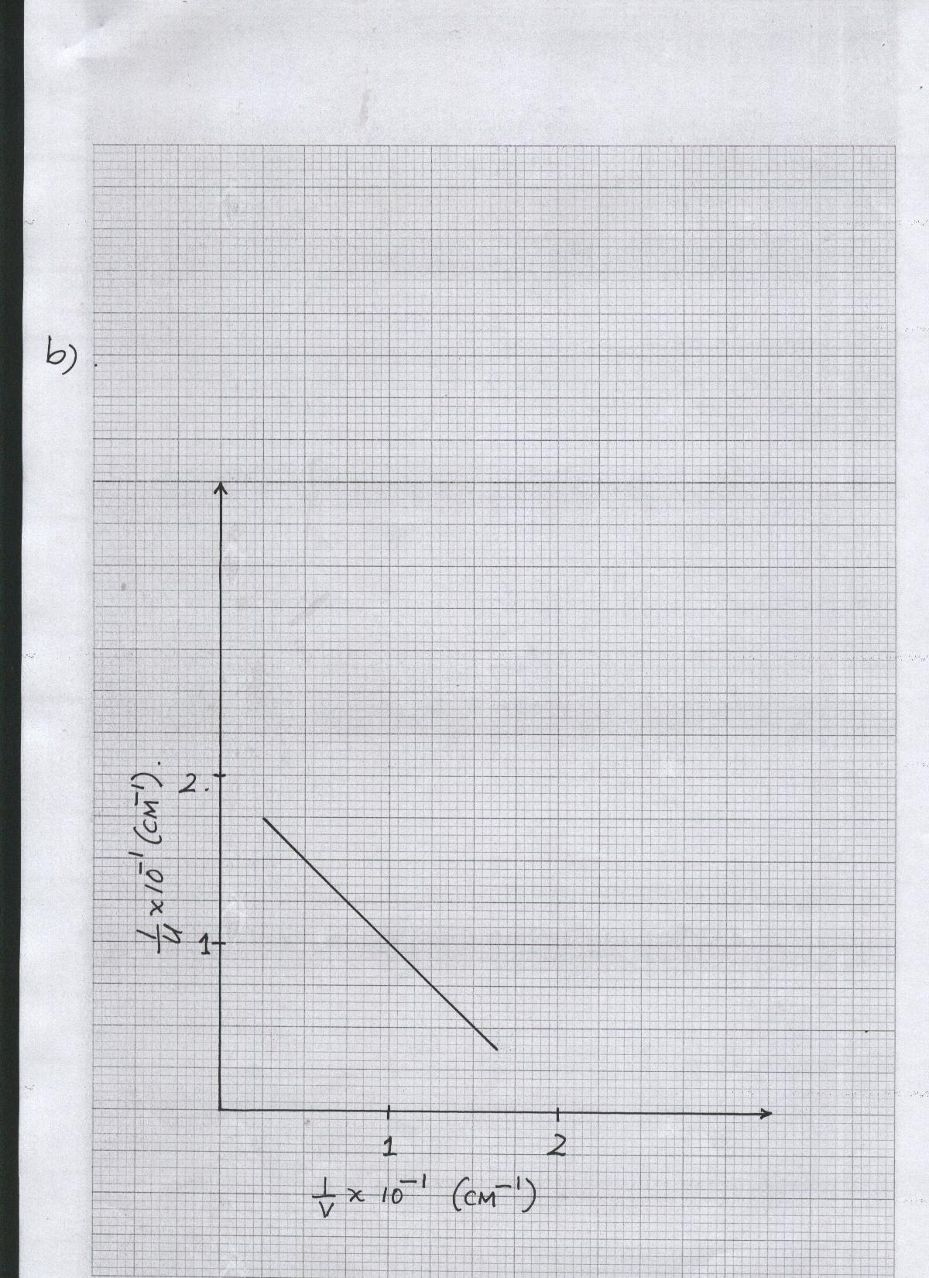

From the graph, determine the focal length, f, of the lens. **(5 marks)**

(c) An object placed 15cm from a convex lens is magnified two times. Determine the focal length of the lens. **(3 marks)**

**17. (a)** Which law relates the potential difference between the points of the conductor

and the current flowing **(1 mark)**

…………………………………………………………………………………………………………………………………………………………………………………………………………

**(b)** Two resistors 4Ώ and the other unknown resistor x are connected in a circuit as

shown in the fig 7 below

V

A

4Ώ

x

Battery

**Fig 7**

The current I passing through the combination is measured for various potential differences, A graph of p.d. against current is shown in the grid below.

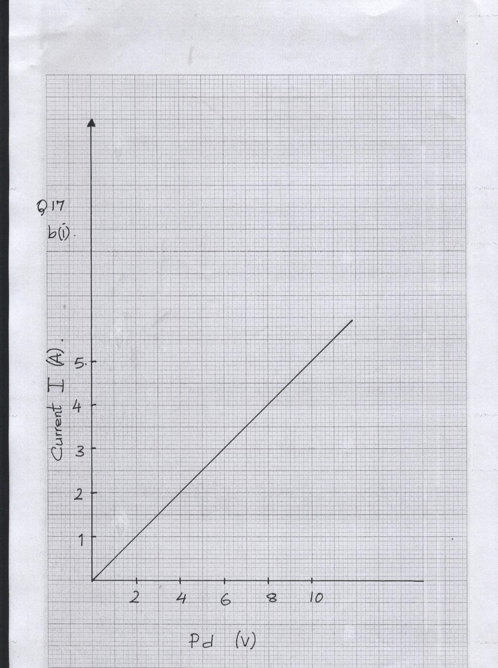

**(i)** Use the graph to determine the total resistance of the combination. **(3 marks)**

**(ii)** Determine the value of the unknown resistance x **(2 marks)**

**(c)** The reading of the ammeter in the figure below is 0.5A when the switch is closed.

A

2Ώ

2Ώ

2.0V

Determine the internal resistance of the cell **(3 marks)**

**(d)** A battery is connected to an external resistor, R. State any two factors that

determine the magnitude of the current produced in the circuit. **(2 marks)**

(e) On the axes provided, sketch a graph to show how current, I varies with potential difference, V, across a metallic conductor that is being heated at the same time. Explain your answer **(2 marks)**

p.d (V)

I (A)

1. (**a) (i)** What is meant by photo-voltaic effect? **(1 mark)**

…………………………………………………………………………………………………………………………………………………………………………………………………………

(ii) You are provided with a clean Zinc plate, a leaf electroscope, a charging rod and a source of ultra-violet (U.V). Describe briefly with the aid of a diagram how photo-electric effect may be demonstrated **(5 marks)**

…………………………………………………………………………………………………………………………………………………………………………………………………………………………………………………………………………………………………………………………………………………………………………………………………………………………………………………………………………………………………………………………

………………………………………………………………………………………………………………………………………………………………………………………………………………………………………………………………………………………………………………………………………………………………………………………………………………………………………………………………………………………………………………………………………………………………………………………………………………………………

(b) The figure below shows the diagram of a setup used in an experiment to investigate photo-electricity. The frequency of the ultra-violet light was constant throughout the experiment

V

U.V Light



Sketch on the same axes the graphs of photo-electric current (y-axis) against the voltage for two different intensities A1 and A2 of ultra-violet where A1> A2 **(3 marks)**

The graph below shows the variation of stopping potential, V­0, with incident frequency, f1 for a certain metal producing photoelectrons

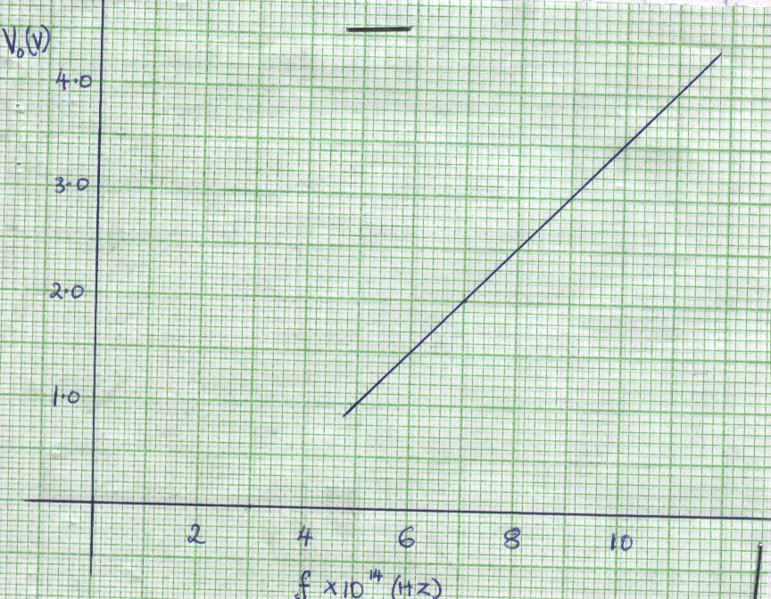

**(i)** What is meant by stopping potential? **(1 mark)**

…………………………………………………………………………………………………………………………………………………………………………………………………………

**(ii)** Use the graph to determine the working function of the metal **(5 marks)**

1. **(a)** State Lenz’s law of electo-magnetic induction **(1 mark)**

…………………………………………………………………………………………………………………………………………………………………………………………………………

**(b)** In the figure below, the bar magnet is moved out of the coil

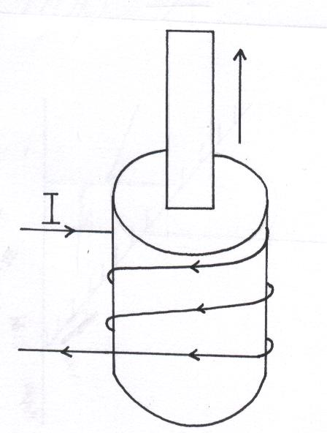

motion

X

**(i)** If the current, I is induced in the coil in the direction shown, what is the polarity of x of the magnet? **(1 mark)**

…………………………………………………………………………………………

…………………………………………………………………………………………

**(ii)** Explain briefly the source of electrical energy in the circuit **(1 mark)**

………………………………………………………………………………………………………………………………………………………………………………………………………………………………………………………………………………………

**(c)** A hydro-electric power station produces 500KW at a voltage of 10KV. The voltage is then stepped up to 150KV and the power is transmitted through cables of resistance 200Ώ to a step down transformer in a sub-station. Assuming that both transformers are 100% efficient calculate;

**(i)** The current produced by the generator **(2 marks)**

**(ii)** The current that flows through the transmission cables **(2 marks)**

**(iii)** The voltage drop across the transmission cables **(2 marks)**

**(iv)** The power loss during transmission **(2 marks)**

**(v)** The power that reaches the sub-station **(2 marks)**