Name………………………………………………… Index. No…………………………
Signature………………………………
Date ………………………………
232/2
PHYSICS
THEORY
Paper 2
2 hours

FORM 4
Instructions:
- Write your name and index number in the spaces provided above.
- Sign and write the date of the examination in the spaces above.
- This paper consists of two sections A and B
- Answer all the questions in section A and B in the spaces provided.
- Mathematical tables and electronic calculators may be used.
- All working MUST be clearly shown where necessary.
- Candidates should answer all questions in English.
For Examiner’s Use Only
Section | Question | Maximum Score marks | Candidates Score
A | - 14 | 25
 | 15 | 12
 | 16 | 10
 | 17 | 10
 | 18 | 13
 | 19 | 10
Total |  | 80

SECTION A (25 MARKS)
Answer all question in the spaces provided
- An object is placed between two morrow inclined to echo ether at an angle of 45º. determine the number of images formed. (2 marks)

- State and explain one defect of a simple cell. (2 marks)

- Fig. 1 below shows a soft iron bar [laced between the poles of two strong magnets.
S N

N S

Sketch the magnetic field pattern formed. (1 mark)

- Fig.2 below shows an image produced by an object placed in front of the convex mirror. By drawing an appropriate rays locate the position of the object on the diagram. (1 mark)

Image

C F F C
Convex mirror

- Sketch the magnetic field lines associated with the current carrying conductor A and B in fig.3
below. (1 mark)

A B

- A ship uses echo sound to search for a sunk boat. One echo is heard after 0.16 seconds and the second one 0.02 second later. If the speed of the sound in water is 300m/s, determine the height of the sunk boat. (3 marks)

- A wave whose wavelength is 2 × 10⁻² meters has a period of 0.2 seconds. Determine the velocity
of the wave. (2 marks)

- A 4 Ω resistor is connected a cross 6 volts d,c supply, determine the power dissipated. (2 marks)

- Arrange the following radiations in the order of decreasing energy
UV, Microwaves, Blue light, Yellow light and red light. (1 mark)

- An optical pin length 40mm is placed horizontal along the principal axis of a convex lens focal length of 40mm. if the near end of the pin is 50 mm from the lens, determine the length of the image.(3 marks)

- Explain why deflection a television screen is done using magnetic field while in A C.R.O screen is done using an electric field. (1 mark)

- Fig. 4 (a) shows a d.c supply connected to a diode and ammeter, R. while fig. 4 (b) shows an a.c supply connected to a diode, a capacitor and resistor, R. sketch current- time graphs as displayed on the C.R.O for each case. (2 marks)
> >
R
R

To C.R.O To C.R.O

I (A)

Time (s)

Fig 4 (a) fig 4(b)

- Four 60W bulbs are used for 4 hours every day for 30 days. If the unit cost of electricity is Ksh 5 determine the cost of this electricity. (2 marks)

- Three capacitors 6µF , 3 µF and 2 µF are connected in series with a 4 V d.c supply. Determine their effective capacitance. (2 marks)

SECTION B
- (a) What is meant by an open circuit? (1 mark)

b) The graph in figure 5 shows the terminal voltage, V, of a certain battery varies with the current, I, being drawn from the battery.

2.0

Potential
Difference (Pd)
V
1.0

0.5 1.0 Current I A
(i) Write an expression relating the e.m.f. E, terminal voltage, V, current, I and the internal resistance, r, of
the battery for the circuit drawn in (i) above. (1 mark)

(ii) From the graph determine the; I internal resistance, r, of the battery. (2 marks)

(b) When the device, X is connected in the circuit below, the voltage across it is 0.70 V.
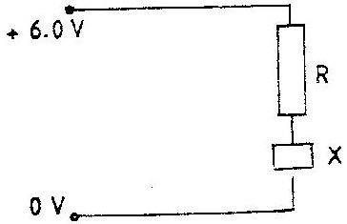

Calculate the value of the resistance R. (3 marks)

(c) The cell in figure 10 has an e.m.f of 2.1 V and negligible internal resistance.
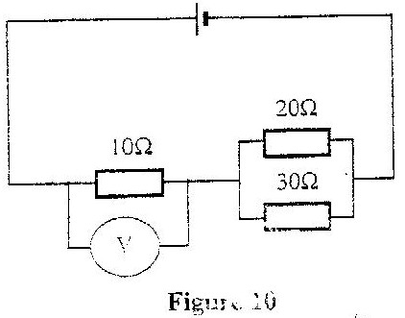

Determine the
(i) Total resistance in the circuit (2 marks)

(ii) Current in the circuit (1 mark)

(iii) Reading of the voltmeter (2 marks)

- a) What is refraction of light (2 marks)

(b) The figure below shows a ray of light passing through a rectangular block of Perspex into the air. The angle of incidence at boundary is 42.5º

Perspex
42.5º

- determine the refractive index of Perspex (3 marks)

- A ray of light now travels from glass into Perspex as shown below.

C Glass

Perspex

Calculate the critical angle C if the refractive index of glass is 1.55 (3 marks)

- State with reasons in which material medium the velocity of light will be higher. (2 marks)

- The figure below shows two coils connected using a soft iron core.
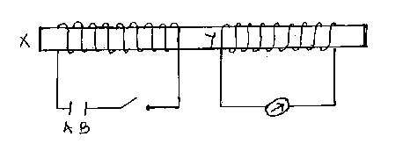

When the switch is closed, the galvanometer deflected in the direction shown. Determine
i) The magnetic poles x and y. (2 marks)

ii) The electric polarities A and B of the cell. (1 mark)

iii) Compare the deflection of the galvanometer when the switch is closed and when it is opened. (2 marks)

b) i) State one property of soft iron that makes it suitable for use as transformer core. (1 mark)

ii) The figure below represents a step down transformer with 600 turns in the primary and 60 turns in the secondary. The turns are wound uniformly on the core.

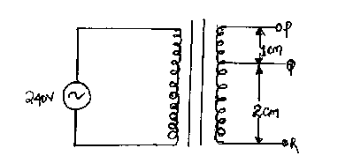

iii) The lengths PQ and QR are as indicated. Determine the P.d across PQ (4 marks)

- a) Name two properties common to both X-rays and gamma rays. (2 marks)

b) Figure 8 shows an X-ray tub 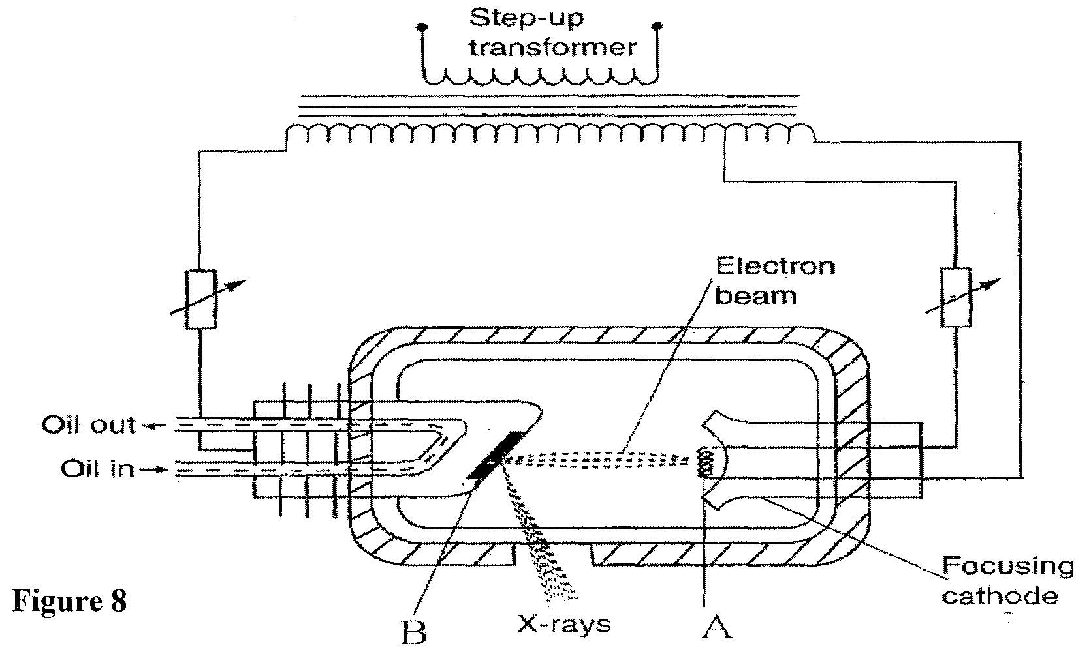

(i) Name the parts labelled A and B (2 marks)
A

B
(ii) State the function each of the parts you have named in (i) (2 marks)
A

B
(iii) In the X-ray tube the voltage between the cathode and anode is more than 50 000V.
Give a reason for this. (1 mark)

c) An X-ray tube operates with a potential difference of 150 kV between the cathode and the anode. Only 0.5% of the kinetic energy of each electron is converted into X-rays. (Take electronic charge, e = 1.6 x 10⁻¹⁹C)
Determine the maximum:
(i) Kinetic energy of each electron. (2 marks)

(ii) Energy of the X-rays (2 marks)

d) A radioactive substance has a half –life of 30 minutes. What amount of mass originally 3kg will remain after 120 minutes? (2 marks)

- (a) What is meant by the term work function? (1 mark)

(b) When the frequency of the illuminating radiation is just equal to the threshold frequency of the surface, no photoelectric effect observed. Explain. (1 mark)

c) In a photoelectric effect experiment, a certain surface was illuminated with radiation of different frequencies and stopping potential determined for each frequency. A graph of stopping potential
(y – axis) against frequency was then plotted as shown
Graph of stopping potential Vs (v) against frequency, £ (HZ)
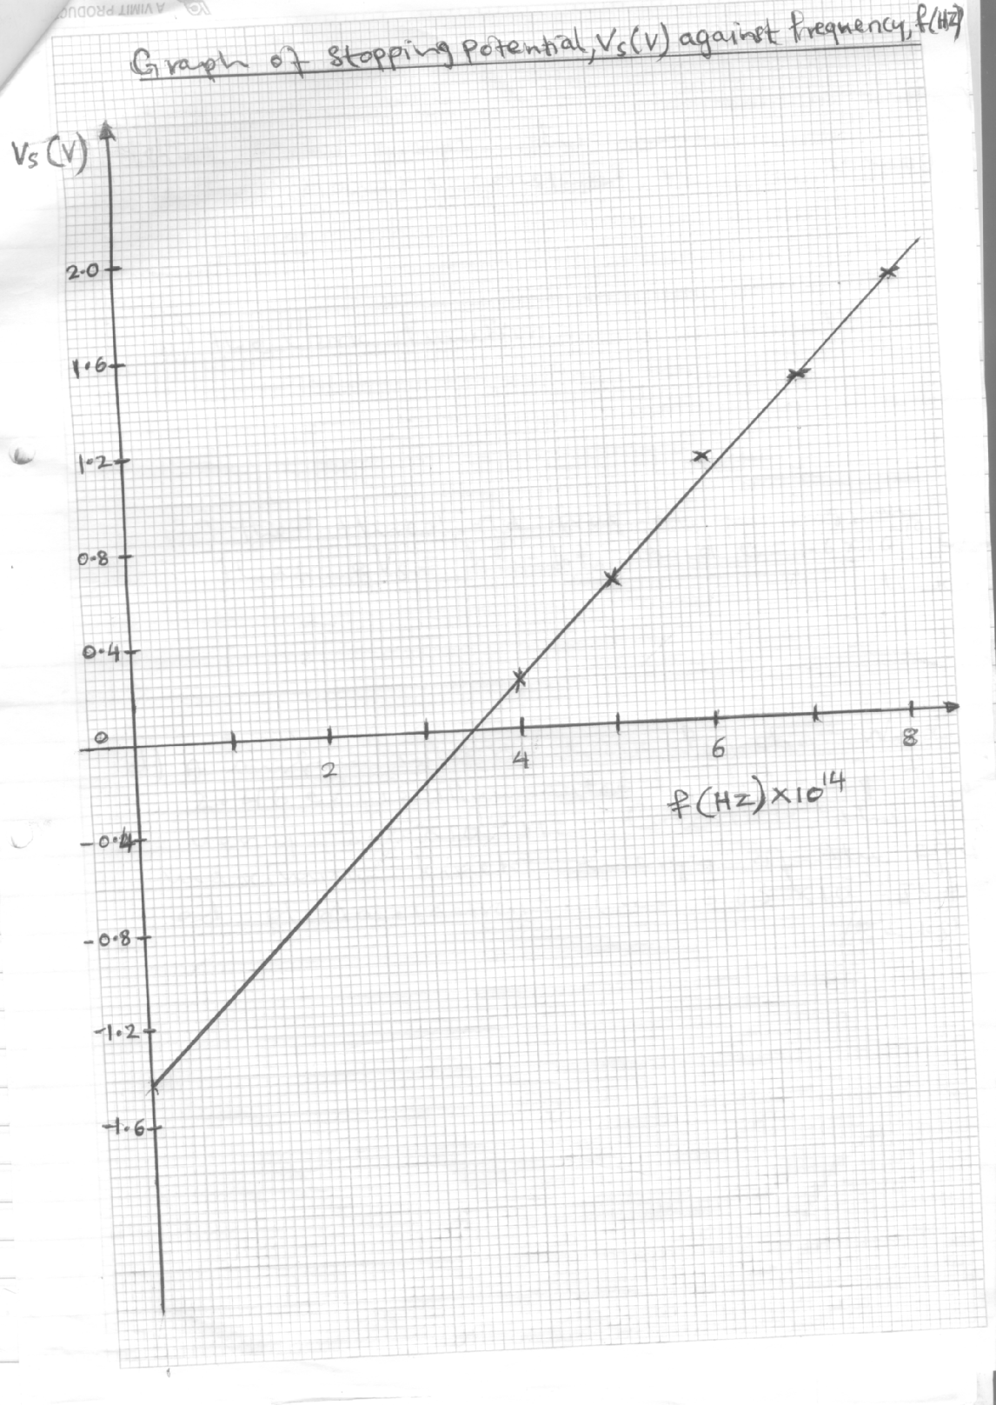

Using the graph determine.
(i) The Plancks constant, h (2 marks)

(ii) The work function (2 marks)

(iii) The threshold frequency given that eVs = hf – hf₀ and e = 1.6 × 10⁻¹⁹C. (1 mark)

(d) A surface whose work function W₀ is 2.4eV is illuminated by light of frequency
3.0 × 10¹⁵ HZ. Calculate the maximum kinetic energy of the ejected photo electrons
(h = 6.63 × 10⁻³⁴ Js) (3 marks)

