Name: …………………………………………………………… Index No. …………………………
School: …………………………………………………………. Candidate’s Sign. …………............
Date: ………………………………............................................

FORM 4

232/3
PHYSICS
PAPER 3
TIME: 2 ½ HOURS

INSTRUCTIONS TO THE CANDIDATES:

- Write your name and index number in the spaces provided above.
- Sign and write the date of the examination in the spaces provided above.
- You are supposed to spend the first 15 minutes of the 2 ½ hours allowed for this paper reading the whole paper carefully.
- Marks are given for a clear record of the observation actually made, their suitability, accuracy and the use made of them.
- Electronic calculators may be used where necessary.

For Examiners’ Use Only
Question 1
 | c) | d) | e) i) | ii) | g) | h) | Total
Marks Score | 5 | 5 | 3 | 2 | 3 | 2 | 20
Candidate’s score
Question 2
 | a) ii) | iii) | iv) | v) | vi) | b) i) | ii) | iii) | iv) | Total
Marks Score | 4 | 1 | 5 | 3 | 1 | 1 | 2 | 1 | 2 | 20
Candidate’s score

This paper consists of 7 printed pages. Candidates should check to ascertain that all pages are printed as indicated and that no questions are missing.

- You are provided with the following:
- Copper wire of length 50cm
- A retort stand, boss and clamp
- An optical pin mounted on a cork
- A stop watch
- Wire cutters (to be shared)
- A metre rule or half metre rule
Proceed as follows:
- Clamp the cork so that the optical pin is horizontal. Hang the copper wire from the pin by the loop as shown in figure 1. Ensure the wire is straight and the length X between the lower tip and the optical pin is 32cm. If the length exceeds 32cm reduce by cutting the lower tip using the wire cutters.

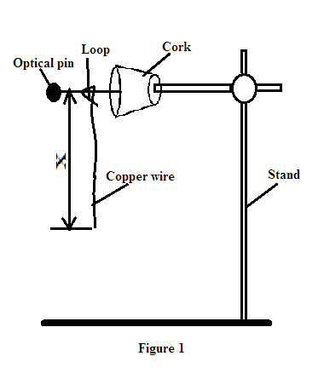

- Displace the lower tip of the wire slightly in a plane perpendicular to the optical pin and then release it. Measure the time t for 20 oscillations of the wire and record the value in the table 1.
- Repeat the procedure in b) above for other values of X shown in the table. (Note that each length X is obtained by cutting off an appropriate length from the lower tip of the wire. For example, to get X = 28cm, cut off 4cm from the lower end) complete the table. (5mks)

Table 1.
Length x (cm) | 32 | 28 | 24 | 20 | 16 | 12
Time for 20 0sillations (s)
Period
T=t/20 (s)
T² (s²)

- Plot a graph of T² (y-axis) against X. (5mks)


- i) Determine the slope, S, of the graph. (3mks)

ii) Obtain the value of k in the equation; (2mks)

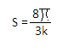

PART B.
You are provided with the following:
- a cylindrical container (1000ml beaker)
- some water
- a stop watch
- a metre rule or half metre rule
- a boiling tube
- some sand in a small plastic beaker
- a rubber band.
Proceed as follows:
- Tie the rubber band round the boiling tube so that it is at a distance L = 12cm from the bottom of the tube (see figure below). Pour water into the cylindrical container until the level is about 2.0cm from the top of the beaker. Float the boiling tube in the water in the container. Add sand gradually into the boiling tube until the tube sinks to the 12cm mark. ( see figure below)

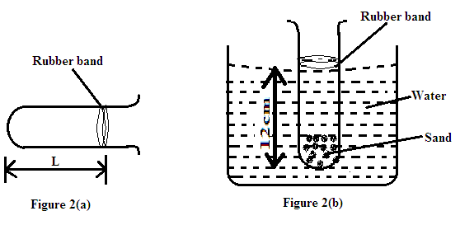

- Depress the boiling tube slightly and release it so that it oscillates vertically without touching the sides of the container. Measure and record in the table 2 the time t1 for five (5) oscillations of the boiling tube. Repeat the procedure two more times to obtain t2 and t3 and record the values in the table 2. Complete the table.

Table 2.
t₁ (s) | t₂ (s) | t₃ (s) | Average t (s)  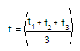 | 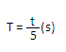

(3mks)

- Use the value of T obtained above to find the value of P in the equation below given that L is the length of the tube up to the rubber band. (2mks)

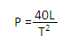

2. You are provided with the following:
- An ammeter r( 0-2.5A) ,A voltmeter(0- 3 V or 0-5V), Two dry cells (size D), A mounted resistance wire on a metre rule , Seven Connecting wires, A bulb and bulb holder
Cell holder, A switch, Jockey or crocodile clip. Micrometer screw gauge.

a. (i).Connect apparatus provided as shown in the circuit diagram blow
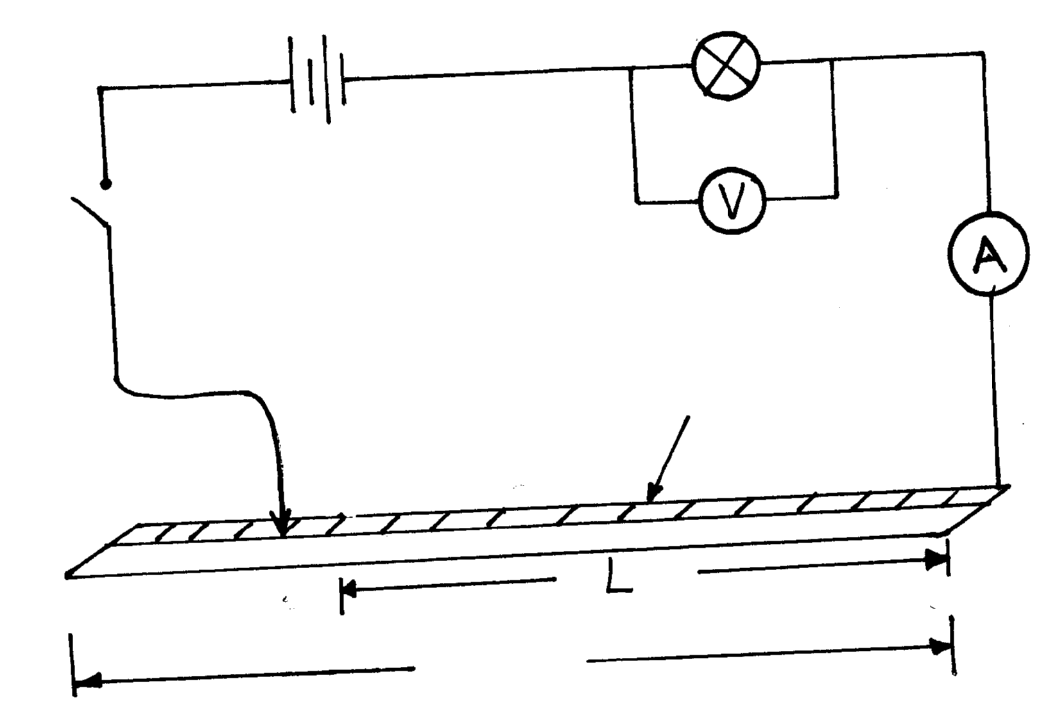
Cells
Bulb
Key
Nichrome wire
L = 100cm
P
Q

(ii). With the crocodile clip at P take the voltmeter reading and the ammeter reading. Record V and I.
Repeat the readings for 1= 80, 60, 40, 20 and 0cm respectively. Complete the table below.

Length L(cm) | 100 | 80 | 60 | 40 | 20 | 0
Voltage V (v).
Current I (A)
(4mks.)

(iii). What changes do you observe on the bulb as L decreases from P? (l mk)
…………………………………………………………………………………………………..………
……………………………………………………………………………………………………....….
(iv). Plot a graph of the ammeter reading (y-axis) against voltmeter reading, (5mks).

(v). Determine the slope of your graph V = 1 volt (3mks).

(vi). What physical quantity is represented by the slope of the graph point? (l mk).

b. (i). Given the apparatus in a (i). above, draw a diagram of the circuit you would use to determine
the current through the resistance wire and potential difference cross it. (l mk).

(ii). Set up the circuit you have drawn. Record the ammeter reading I and voltmeter reading V,
when L= 100cm.
(2mrk)
V = ………………………………………………

I =…………………………………………………
(iii) Using a micrometer screw gauge, measure the diameter d of the wire (1mk).

d = ………………………

(iv) Calculate the quality, ρ = 0.785 V d² and give its units, where L is one metre. (2mk)
I L

