Name…………………………………… Index No…………………………….

Candidates Signature……............... Date………………………………….
232/3
PHYSICS
PAPER 3
PRACTICAL
2 ½ HOURS

FORM 4

INSTRUCTIONS TO CANDIDATES

- Write your name and Index Number in the spaces provided above.
- Sign and write date of examination in the spaces provided above.
- Answer all questions in the spaces provided
- All working must be clearly shown
- Non-programmable silent calculator may be used

FOR EXAMINERS USE ONLY
Question | Maximum | Candidates Score
1A | 16mks
1B | 4mks
2 | 20mks
Total

QUESTION ONE
PART A
You are provided with the following apparatus:
- Two optical pins
- A Cork
- A metre rule or a half metre rule
- Two clamps and two bosses
- One stand
- A plane mirror
- Distilled water about (1000 ml)
- A 600ml beaker or a plastic container

Set up the apparatus as shown below
- Place a beaker containing water, on the base of the stand or on the bench. The depth of the water D should be 2cm
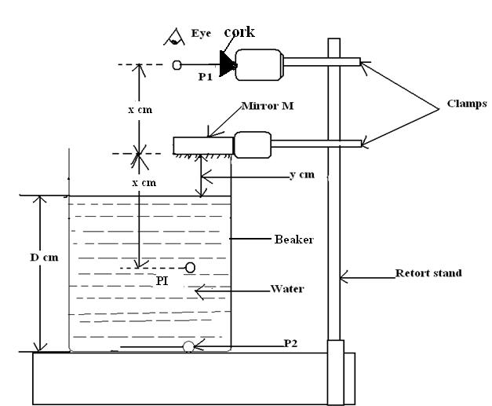
- Place an optical pin P₂, at the bottom of the beaker. Fix a second pin P₁ above the liquid using a clamp and a cork as shown.
- Place a plane mirror (held in a clamp) across the mouth of the beaker so that it touches the rim of the beaker.
- View the pin, P₁ and adjust its position by rising it up or down until its image PI as seen in the mirror, coincides with the image of the pin P₂, as seen in the liquid.
- Measure the distance between P₁ and M and record it as x. Measure also the distance between M and the liquid surface and record the value as y.
- Repeat the experiment using the values of D as in the table.

Real Depth, D (cm) | x (cm) | y (cm) | Apparent Depth, x-y (cm)
2
4
6
8
10
12

- Complete the table above (7mks)

- Plot a graph of real depth, D (cm) against and Apparent depth, (x-y) (cm) on the x-axis (5mks)

- Determine the slope. (3mks)

- What does the slope represent? (1mk)

PART B

You are provided with the following:
    - A metre rule
    - Half metre rule
    - A 300g mass
    - Some threads
    - Two knife edges
Proceeds as follows:
- Place the metre rule on the knife edge such that each knife edge is 45cm from the centre of the rule (50cm mark). Ensure that the millimeter scale of the metre rule is facing upwards. The distance L between the knife edges is now 900mm.
Place the half metre rule vertically against the metre rule at the 50cm mark with the zero mark lowered to touch the bench as shown in figure 1 below:
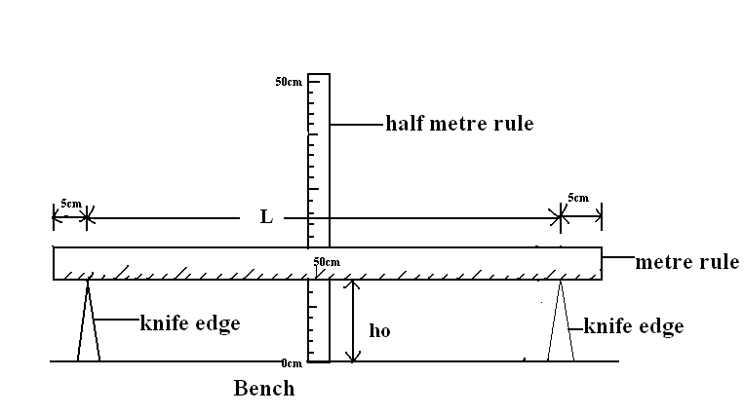

Figure 1

Record the height h_{o} from the upper edge of the meter rule at 50cm mark
h₀= --------------------------mm (1mk)
- Using the thread provided, hang the 300g mass at the 50cm mark of the metre rule. Ensure that the mass does not touch the bench. Measure and record the new height h

h………………………….mm (1mk)

Determine (i) $S=\frac{F}{(ho-h)}$, where F is the force in newtons

S……………………………N/mm (1/2mk)

(ii) $Y=\frac{1}{S}$

Y……………………………mm/N (1/2mk)

Hence evaluate the value of G, given that $G=\frac{\log{L}}{Y}$

G…………………………… (1mk)

QUESTION TWO
You are provided with the following;
-A 200ml glass beaker labeled H
- Any beaker containing cold water labeled W
- A thermometer
- A stop watch
- A measuring cylinder 100ml
- A stand, clamp and boss
- Hot water
Proceed as follows;
- Record the initial temperature of the cold water in beaker W
T₀…………………………………………………………………………… (1mk).
- Clamp the thermometer vertically. Put about 100cm³ of hot water into beaker H Lower the thermometer into the hot water as shown in the figure below.

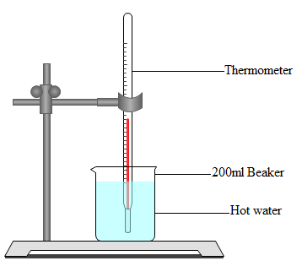

Figure 3

- Record the initial temperature of the hot water
- Start the stop watch when the temperature is 65ºC
- Record the temperature T every two minutes
- Complete the table below

Time (t) (min) | 2 | 4 | 6 | 8 | 10 | 12 | 14
Temperature (T) ^{O}C
(T –T₀) ⁰
Log (T – T₀)
(7mks)

- Plot a graph of Log (T – T_{O}) against Time (t). (5mks)

- Find the value K of log(T – T_{O}) when t = 0 (2mks)

Determine the antilog of K. (2mks)

- Calculate the temperature of the surrounding T_{R} using the expression
Antilog K = 65 - T_{R}. (3mks)

