Name: …………………………………………………………… Index No. …………………………
School: …………………………………………………………. Candidate’s Sign. …………………

232/3
PHYSICS
PAPER 3
TIME: 2 ½ HOURS

FORM 4

INSTRUCTIONS TO CANDIDATES:
- Write your name and index number in the spaces provided above.
- Sign and write the date of the examination in the spaces provided above.
- You are supposed to spend the first 15 minutes of the 2 ½ hours allowed for this paper reading the whole paper carefully before commencing your work.
- Marks are given for a clear record of the observation actually made, their suitability, accuracy and the use made of them.
- Candidates are advised to record their observations as soon as they are made
- Non-programmable silent electronic calculators may be used.
- Candidates should check the question paper to ascertain that all the pages are printed andthat no questions are missing.

For Examiner’s Use Only.

Question | Maximum score | Candidate’s score
1 | 20
2 | 20
Total | 40

This paper consists of 6 printed pages candidates should check the questions to ascertain that all pages are printed as indicated and that no questions are missing

QUESTION 1
You are provided with the following apparatus
- A glass block
- Soft board
- Plain paper
- Four optical pins
- Four thumb pins
- A protractor
- A ruler
  - Fix the plain paper on the soft board using the four thumb pins.
  - Place the glass block on the plain paper (that is fixed on the soft board) Let the glass block rest on the paper from the broader face.
  - Trace the glass block using a pencil.
  - Remove the glass block.
Mark point X on one of the longer side of the traced glass block as shown in the diagram below. Point X should be 2 cm from edge A.

  - Construct a normal at X, to emerge through line DC. Let this normal meet line DC at point M.
  - Mark point N along the emergent normal, 5 cm from M.
  - Construct line NP to meet the normal at N at 90⁰. Line NP is 10 cm.

  - Using a protractor, construct an incident ray RX at an angle of incidence i= 10⁰. Fix two pins P₁ and P₂ along RX.
  - Replace the glass block to the traced figure.
  - View the path of the incident ray RX through the glass block from face DC. Using other two pins P₃ and P₄, fix them to seem to align themselves with images of P₁ and P₂.
  - Remove the glass block and draw the emergent ray through P₃ and P₄.
  - Measure the distance of the emergent ray from point N along line NP as shown in the diagram below.

  - Record the corresponding values of d, $Sin i$ and $Sin^{2}i$ in the table below.
  - Repeat the procedure for other values of $i$. (8 marks)
Angle of incidence i⁰ | 10 | 20 | 30 | 40 | 50 | 60
Distance d (cm)
Sin i
Sin²i

  - i) On the grid provided, plot the graph of Sin²i(vertical axis) against d. (5 marks)

ii) Calculate the gradient of the graph. (3 marks)
…………………………………………………………………………………………………………………………………………………………………………………………………………………………………………………………………………………………………………………………………………….…………………………………………………………………………………
p) What is the equation of the graph (2marks)
…………………………………………………………………………………………………………………………………………………………………………………………………………………………………….………………………………………………………………………………………...
q) Give the value of d when $i=8{0 }^{0}$ (2marks)
…………………………………………………………………………………………………………………………………………………………………………………………………………………………………….………………………………………………………………………………………………
QUESTION 2
You are provided with the following:
- Two new dry cells
- An ammeter 0 – 1A
- A voltmeter 0 – 5V
- A resistance wire labelled XY on mm scale
- Jockey or crocodile clip
- Cell holder
- Switch
- Six connecting wires at least three with crocodile clips at one end
(a) Set up the circuit as shown in figure 4
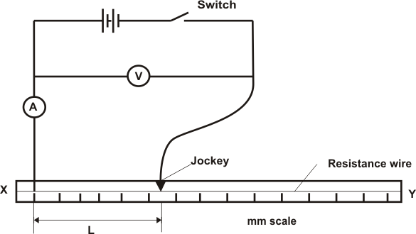

(b) Close the switch and place the jockey in contact with the resistance wire such that the length, L, of the wire XY = 0.20m. Measure and record the current, I, through the wire XY and the P.d., V, across it and enter the results in table below.

(c) Repeat procedure (b) above for the other values of L given. Read and record the corresponding values of I and V.
L (cm) | 0.2 | 0.4 | 0.5 | 0.6 | 0.7 | 0.9 | 1.0
p.d. (V)
I (A)
R (Ω)
(A⁻¹)
(7marks)

(d) Plot a graph of (y axis) against R (5 marks)

(e) Determine the slope, S, of your graph (3 marks)
…………………………………………………………………………………………………………………………………………………………………………………………………………………………………….…………………………………………………………………………………

(f) Given that I and R of the graph are related by the equation , use your graph to determine the values of :
E = (2 marks)
………………………………………………………………………………………………………………………………………………………………………………………………………………
r = (3 marks)
………………………………………………………………………………………………………………………………………………………………………………………………………………

