Name………………………………………………… Index. No…………………………
Signature………………………………
Date ………………………………
232/3
PHYSICS
Practical
Paper 3
2 ½ hours

FORM 4
Instructions:
- Write your name and index number in the spaces provided above.
- Sign and write the date of the examination in the spaces above.
- This paper consists of two sections A and B
- Answer all the questions in section A and B in the spaces provided.
- Mathematical tables and electronic calculators may be used.
- All working MUST be clearly shown where necessary.
- Candidates should answer all questions in English.

For Examiner’s Use Only
Question | Maximum Score | Candidates Score
1 | 23
2 | 17
Total | 40

- A. You are provided with the following apparatus:
- A candle
- A lens holder
- A convex lens
- A screen
- A metre rule
- An object
Proceed as follows:
Using an object at infinity outside the room, focus its image on the screen provided. The image should be as sharp as possible and inverted. Measure the distance from the lens to the screen hcm. Repeat the same for three other values of h. Record your results and then calculate the average value of the three results, Hcm.
First reading of h………………………………………………………….…. (½mk)
Second reading of h ……………………….…………..……………………. (½mk)
Third reading of h ……………………………………………………….…. (½mk)
The average value of h(H) …………………………………………………... (½mk)

Arrange the candle flame, the lens, and the screen as shown in the diagram below:
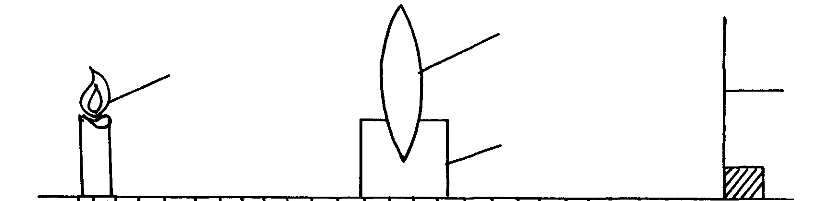
u
v
Candle flame
Screen
Lens holder
Lens

b) i) For particular value of u, adjust the position of the screen until a sharp image appears on the screen. Measure distance Vcm. Repeat the experiment for each of the other values of u, and enter the results in the table below: (5 marks)
Distance L(cm) | Distance V(cm) | uv(cm²) | U + v (cm)
12
15
18
21
24
27
30

(ii) Plot a graph of uv against u + v (5 marks)

(iii) From your graph, calculate the slope S (2 marks)

(iv). Calculate the value of k given that kH = S ( 1 mark)

B. you are provided with following apparatus.
- Metre rule
- Retort stand
- Two pieces of thread
- Mass 20g
- 3 rubber bands
Proceed as follows
- I) Mark the ends of the meter rule as A and B
iI) Balance the metre rule provided by hanging using a thread provided
iii) Note the position P of the thread where the rule balances and record the distance X_{o} from B of the metre rule.

X_{o}
A P B

P=____________________________________________________cm (1 mark)

iv) Place a mass of 20g at 5 cm from the end A and adjust the position of the thread until the metre rule balances a again as shown
A P B

X_{o}

X₁ X₂

Measure and record the distance X₁ and X₂
X1_---------------------------------------------------------------------------------------------------------------------------------------------------------------cm (½mark)

X2_____------------------------------------------------------------------------------------------------------------------------------------------------------------cm (½mark)

v) Calculate the value of W weight of the metre rule from the expression

W= 20X/ X₂- X₀ (2 mark)

- Remove the mass m and replace with the rubber bands of mass Q provided. Adjust the metre rule again until it balances as shown

X_{o} d₁
B P

d ₂ Rubber bands

- Measure and record the distance X_{o} as in a (ii) above, distance of P from end P of the metre rule.

X_{o}=………………………………………………………………………………………………………………………….cm (1 mark)
- Measure and record the distance d₁ and d₂
d₁________________________________________________________ cm (½ marks)
d₂ ________________________________________________________cm (½ marks)
- Calculate the weight of Q of the rubber bands using the expression.
Q= W(d₂- d₁)
d₁ (2 marks)
- You are provided with the following
- A mounted wire AB
- Am ammeter
- A voltmeter
- A switch
- Three dry cells and a cell holder
- A micrometer screw guage
- Six connecting wires, two with crocodile clips at one end
- A set of resistors labelled P
Proceed as follows
- Connect the circuit a shown in the figure below.

A B

Measure the current l_{o} through the wire A B and the voltage V a cross it when the switch is closed. Hence determine the resistance of the wire.
I_{o}__________________________________________________________________A (1 mark)

V__________________________________________________________________V (1 mark)

R_{o}=V/I_{o}_____________________________________________________________Ω (1 mark)

Disconnect the circuit.
- (i) Using a micrometer screw gauge, determine the average diameter d of the wire AB
d___________________________________________ mm ( 1 mark)

(ii) Determine the resistivity ρ of the material of the wire given that

R_{o=} ρ L/A where A is the cross sectional area of the wire in m² and L = 1.0m ( 2 marks)

- Connect the circuit as shown

Wire
A

X Y
The ends XY are connected to the crocodile clips which will be used to connect the appropriate values of resistance from P to the circuit.
i) Connect the crocodile clips to a 2.2 Ω resistor. Close the switch , measure and record in the table the current I (A) (1 mark)
ii) Repeat the procedure in C (i) for other values of resistance shown in the table. (This is done by selecting the suitable terminals on P. these resistors are connected in series. ( 3 marks)
Resistance R Ω | 2.2 | 4.7 | 6.9 | 10.0 | 12.2 | 14.7
Current I (A)

- Connect the crocodile clips a cross the terminals of the coil C and measure the current I_{o} through it. Clip the ends of the cola as close to coil as possible.
I c= ________________________________________________ (1 mark)

- (i) Using the values in the table, plot a graph of resistance R against current I in (D). R_{c} is the resistance of the coil C. (5 marks)

(ii) using the graph obtain Rc the values corresponding to the values of Ic found ( d). Rc is the resistance of the coil C.
R_{c}=_________________________________________________ ohms ( 1 mark)
(iii) given that the wire for the coil C and AB are the same material and have the same diameter , determine the length Lc of the wire making coil C from the relationship.
R_{o=} ρLc/A where A is the cross sectional area of the wire.
Lc =___________________________________________________ (2 marks)

