NAME……………………………………………………….INDEX NO……………………
CLASS………………. DATE……………………

232/1
PHYSICS
PAPER 1
TIME: 2 HOURS

FORM 4
Instructions to candidates
- Write your name and class in the space provided.
- This paper consists of two sections; SECTION A and B
- Answer all the questions in the spaces provided
- ALL working MUST be clearly shown.
- Mathematical tables and electronic calculators may be used
- Take: Acceleration due to gravity: g = 10m/s²

FOR EXAMINER’S USE ONLY

Section | maximum score | Candidates score
A | 25
B | 55
Total score | 80

1.The figures below shows the level of water before and after a stone was immersed into the measuring cylinder If the mass of the stone is 200g, determine its density. (3mks)
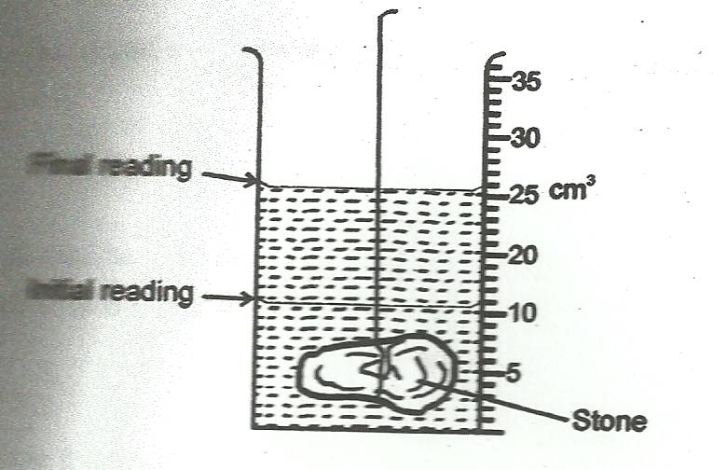
2. The figure below shows the shapes formed when drops of water and mercury are placed on the surface of a clean glass plate
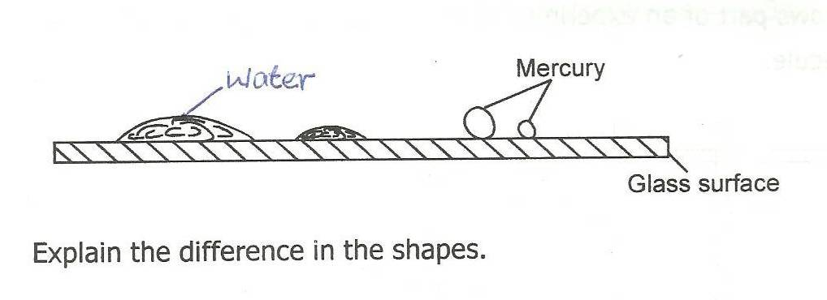
Explain the difference in the shapes. (1mk)

3. Explain why air is not used as a brake fluid. (1mk)

4.) Use kinetic theory to explain pressure law. (1mk)

5.) In an oil drop experiment, it was found that one oil drop spread on water to form a patch of diameter
0.8cm and thickness 2.0 x 10⁻⁶mm. Calculate the radius of the drop. (2mks)

6.)A uniform wooden plank weighing 50N and 5m long is suspended by two ropes A and B, 1.5m apart. A is 2m from one end and B is 1.5m from the other end as shown in figure below. A concrete block of weight 100N is suspended from the centre of the plank
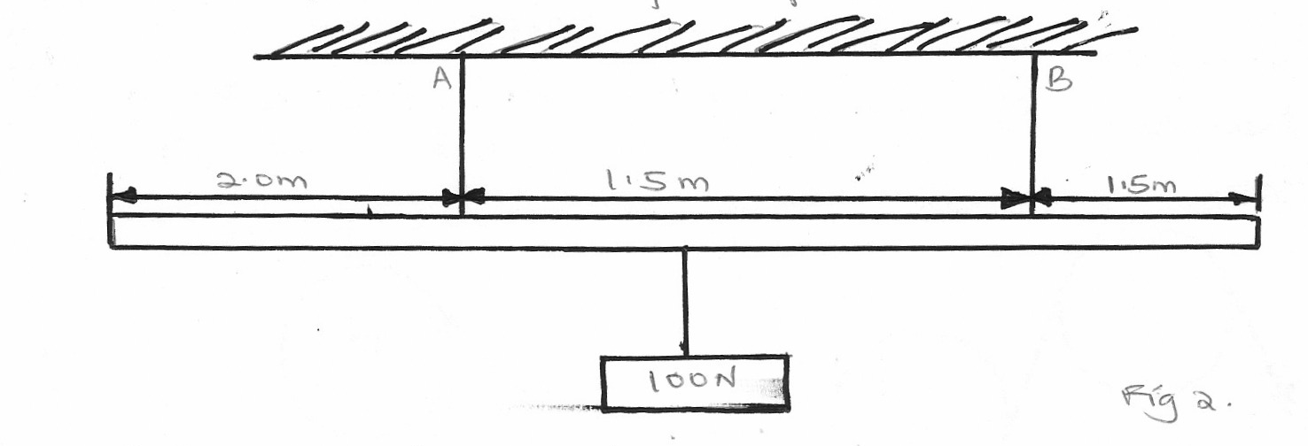

2.0m
1.5m
1.5m
100N
Calculate the tension T_{A} in string A (2mks)

7. The figure below shows a uniform bar of length 1.4m pivoted near one end. The bar is kept in equilibrium by a string as shown.
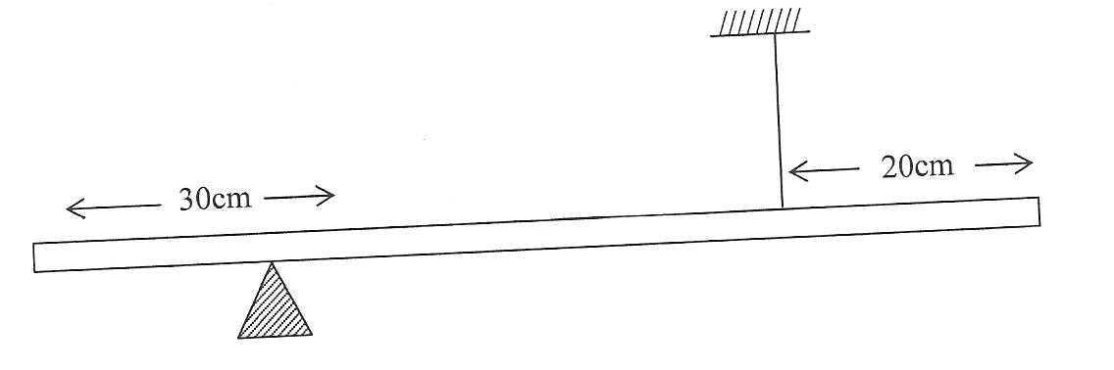

Given that the weight of the bar is 1.5N, determine the tension in the string. (3mks)

8. The table below shows results of an experiment carried out to study properties of a spring.
Force (N) added | 0 | 5 | 10 | 15 | 20
Length of spring (cm) | 10 | 11 | 12 | 13 | 14

State with a reason whether the experiment was done within elastic limit of a spring. (1mk)

9. A beaker is filled completely with water. A spoon full of common salt is added slowly. The salt dissolves and the water does not overflow. State the reason why water does not overflow. (1mk)

10.In a vacuum flask, the walls enclosing the vacuum are silvered on the inside. State the reason for this. (1mk)

11.A bullet is fired horizontally from a platform 15m high. If the initial speed is 300m/s, determine the maximum horizontal distance covered by the bullet. (3mks)

12.A high jumper usually lands on a thick soft mattress. Explain why. (1mk)

13.If the rate of flow of water in the tube is 0.0001 m³/s. Determine the length of tube it will take its flow in 3 seconds through a cross-section area of 5cm². (3mks)

14.The ice and steam points of a certain graduated thermometer are found to be 15cm apart. What is recorded in ⁰c when the length of the mercury thread is 3cm above the ice point?
(2mks)

15.a) Define heat capacity and state its SI units. (2mks)

b) i) 200g of ice at -10ºc was slowly heated by an immersion heater rated 200w. The graph below shows how temperature varied with time.

ii)Given that the specific heat capacity for ice is 2100J/kg/k, specific latent heat of fusion for ice 340000J/kg and the specific heat capacity for water is 4200J/kg/k. Calculate the corresponding times for pints B and C. (4mks)

iii) What factors affect the melting point of a solid. (2mks)

c) i) A sauce pan of mass 0.7kg containing 0.5kg of water is 20oc it takes 5 minutes before the water starts to boil. Find the rate at which heat is supplied to the water by the burner. Take specific heat capacity of the sauce pan as 600Jkg⁻¹k⁻¹. (3mks)

16. (a) In an experiment to determine the relative density of liquid A, the following set up was used.
100g
y
x

STAND
METRE RULE
100g MASS
LIQUID A

The distance x of the mass in liquid A was measured for various length, y of an identical mass of equilibrium and a graph of y against x was drawn as shown in the grid below.

GRAPH OF Y AGAINST X

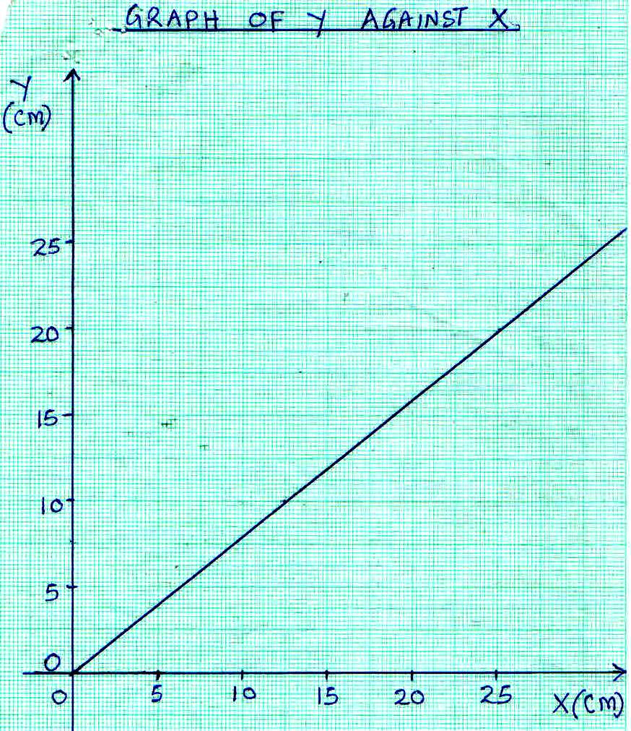

(i) Determine the gradient, S, of the graph. (2 Marks)
……………………………………………………………………………………………
…………………………………………………………………………………………………
…………………………………………………………………………………………………
(ii) If S = $\frac{F}{W}$, where F is the apparent weight of mass in liquid A and W is the actual weight of the mass.
Calculate the value of F and the upthrust u. (3mks)
………………………………………………………………………………………………
……………………………………………………………………………………………….
…………………………………………………………………………………………………..
…………………………………………………………………………………………………..
…………………………………………………………………………………………………
………………………………………………………………………………………………….
(iii) Determine the relative density of the liquid a, Given that the weight of the 100g mass in water was 0.9N. (3mks)
…………………………………………………………………………………………………………………………………………………………………………………………………….
……………………………………………………………………………………………………………………………………………………………………………………………………..
…………………………………………………………………………………………………..
b) A balloon’s fabric weighs 10N and has a gas capacity of 2M³. If the gas in the balloon weighs 2N and air has density 1.29kg/m3, Find the resultant force on the balloon when it is floating in air. (3marks)

17. a) A body having uniform motion in a circular path always accelerates. Explain. (1mk)

b)the figure below shows the path of an object of mass 200g tied to a string 0.2m and being whirled in a vertical circle at a linear speed of 10m/s.

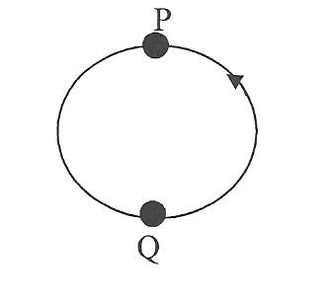

If the string gets cut when the object reaches point Q,
- indicate with an arrow on the diagram, the path direction it is likely to move. ( 1mk)

- Determine the force that cuts the string at point Q (3mks)

- Calculate the minimum tension (3mks)

c) A body is whirled in a horizontal circle at a frequency of 5Hz. Determine its angular velocity.

(3mks)
SECTION B
18.a) State the law of conservation of energy. (1mk)

b)What energy transformation takes place when a car battery is used to light a bulb? (2mks)

c) A pulley system has two pulleys on the lower block and one pulley on the upper block. In order to raise the load of 6N, an effort of 2N is applied.
i)Draw a sketch to show the pulley system. (2mks)

ii)Calculate the efficiency of the pulley system. (3mks)

iii)If the lower block weighs 0.4N. What friction force oppose the motion. (3mks)

19. a) Define (1mk)

- Velocity ratio (1mk)

ii)Mechanical advantage (1mk)

iii)Efficiency (1mk)

b)A small pump develops an average power of 80W. It raises water from a borehole to a point 15m above the water level. Calculate the mass of water delivered in one hour. (3mks)

c)The figure shows a wheel and axle being used o raise a load W by applying an effort ‘E’. The radius of a large wheel is ‘R’ and that of a small wheel is ‘r’.

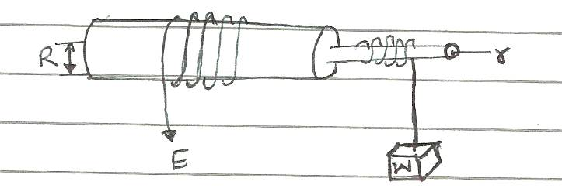

i)Show that the velocity ratio (V.R) of this machine is given by R/r. (2mks)

ii)If r = 5cm and R = 8cm, determine the effort ‘E’ required to raise a load of 40N, given the efficiency of the ma chine is 85%. (3mks)

