NAME:……………………………………………ADM NO:………………………/………..
SCHOOL:……………………………………………SIGN……………………..
DATE:……………………………………………….

232/1
PHYSICS
PAPER 1
TIME: 2 HOURS
FORM 4

INSTRUCTIONS TO THE CANDIDATES:
1. This paper consists of TWO SECTIONS A and B
2. Answer ALL questions in the spaces provided.
3. ALL working MUST be clearly shown.

For Examiners’ Use Only

SECTION | QUESTION | MAXIMUM SCORE | CANDIDATE’S SCORE
I | 1 - 11 | 25
II | 12 | 09
 | 13 | 11
 | 14 | 11
 | 15 | 10
 | 16 | 14
TOTAL SCORE |  | 80

This paper consists of 12 Printed pages. Candidates should check to ascertain that all pages are printed as indicated and that no questions are missing.

SECTION A (25 Marks)

Answer all questions in this section

1. Figure 1 shows a wire wound closely on a test tube. Given that L = 12 mm, determine the thickness of the wire. (2 marks)

Figure1
………………………………………………………………………………………………………………………………………………………………………………………………………………………………………………………………………………………………………………………
2.a)Figure 2 shows an empty beaker placed on of a top pan balance calibrated in grams.

Figure 2

Alcohol of volume 50 ml and density 0.8 gcm⁻³ was added to the beaker. Show on the figure the new pointer position. (2 marks)
………………………………………………………………………………………………………………………………………………………………………………………………………………………………………………………………………………………………

b) Figure 3 shows a micrometer screw gauge holding a ball bearing. Use the figure to answer questions 2.b.(i) and 2(ii)

Figure 3
i) State the function of the part labeled B in measuring the dimension of the ball bearing (1 mark)
……………………………………………………………………………………………………

ii) Determine the radius of the ball bearing in S.I. units. (2 marks)
………………………………………………………………………………………………………………………………………………………………………………………………………………………………………………………………………………………………………………………
Figure 4 shows a hydraulic press system using a lever of negligible mass on the side of a small piston pivoted at point P. A force of 100N is applied at R.
Figure 4

Use the information in figure 4 to answer questions 3 and 4.

3. Determine the force F exerted by the small piston on the liquid. (2 marks)
………………………………………………………………………………………........................
………………………………………………………………………………………………………
………………………………………………………………………………………………………

4. Determine the mass of the bale supported by the large piston. (2 marks)
………………………………………………………………………………………………………
………………………………………………………………………………………………………
………………………………………………………………………………………………………

5. Two match sticks are placed on water in a basin a few centimeters apart as shown in Figure 5. State and explain the observation made when a drop of soap solution is placed at a point marked X. (2 marks)

Figure5
………………………………………………………………………………………………………
………………………………………………………………………………………………………
………………………………………………………………………………………………………
6. Figure 6 shows a setup of apparatus used to investigate the behavior of gases.

Figure 6(a) Figure 6(b)

Bubbles of gas form in water at the lower end of the glass tube in figure 6(a) while water is observed to rise up the glass tube in figure 6(b). Explain these observations. (2 marks)

………………………………………………………………………………………………………………………………………………………………………………………………………………………………………………………………………………………………
7. State the special features of a clinical thermometer that makes it;
i) Very sensitive. (1 mark)
………………………………………………………………………………………………………

ii) Convenient to read. (1 mark)
………………………………………………………………………………………………………

8. Figure 7 shows two corks X and Y fixed on a polished plate and a dark plate with candle wax.

Figure 7

Explain the observation made, when the heater is switched on for a short time interval.
(2 marks)
………………………………………………………………………………………………………………………………………………………………………………………………………………………………………………………………………………………………………………………9.The stability of a body can be increased by increasing the base area and lowering its centre of gravity. State one way of lowering its centre of gravity. (1 mark)
………………………………………………………………………………………………………
10. Three identical springs each of weight 1.5N are arranged to support a 50N load as shown in figure 8.
Figure 8

a) Given that one such a spring extends by 2 cm when a load of 20N hangs on its lower end, determine its spring constant. (1 mark)

………………………………………………………………………………………………………
………………………………………………………………………………………………………
b) If the glass rod weighs 0.5N, determine the total extension of the system of springs.
…………………………………………………………………………………………………........
……………………………………………………………………………………………………
……………………………………………………………………………………………………
(2 marks)
11. The total cross-sectional area of all blood capillaries in a person’s circulatory system is 0.5 m². If the blood flows at 150 cm³/s, determine the average velocity of blood in the capillaries. (2 marks)
………………………………………………………………………………………………………
………………………………………………………………………………………………………
………………………………………………………………………………………………………

SECTION B (55 Marks)

Answer all the questions in this section.

12.(a) A car moving initially at 20 m/s decelerates at 2.5 m/s².

i) Determine the time taken for the car to stop. (2 marks)
………………………………………………………………………………………………………
………………………………………………………………………………………………………
………………………………………………………………………………………………………
ii) Sketch the velocity – time graph for the motion of the car up to the time the car stopped.
(2 marks)

(b) (i) Distinguish between perfect elastic collision and perfect inelastic collision. (1mark)
………………………………………………………………………………………………………………………………………………………………………………………………………………………………………………………………………………………………
(ii) Figure 9 shows a plastic egg supported vertically by a stream of air from a pump.
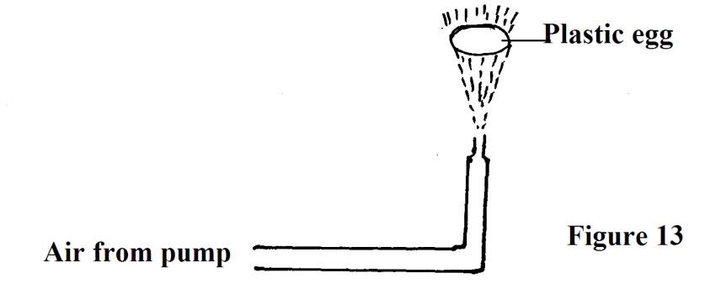
Figure 9
Explain why the egg will not move away from the midstream position. (2marks)
………………………………………………………………………………………………………………………………………………………………………………………………………………………………………………………………………………………………………………………
(c) Give two examples of devices in which Bernoulli’s effect is applied. (2marks)
………………………………………………………………………………………………………………………………………………………………………………………………………………
13(a) Define the term mechanical advantage of a machine. (1mark)
………………………………………………………………………………………………………………………………………………………………………………………………………………
(b) Figure 10 shows a pulley system being used to raise a load.
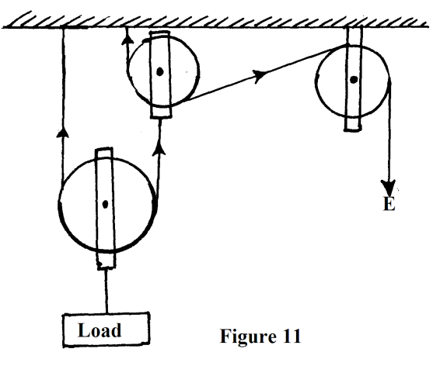
Figure 10
This pulley system has an efficiency of 75%.

(i) Determine the velocity ratio of the system. (1mark)
………………………………………………………………………………………………………………………………………………………………………………………………………………………………………………………………………………………………………………………
(ii) Determine the mechanical advantage of the pulley system. (2marks)
………………………………………………………………………………………………………………………………………………………………………………………………………………………………………………………………………………………………………………………
(iii) Determine the effort required to raise a load of 240kg. (2marks)
………………………………………………………………………………………………………………………………………………………………………………………………………………………………………………………………………………………………………………………………………………………………………
(iv) Determine the work done by a person using this machine in raising a load of 120kg through a vertical distance of 2.5m (2marks)

………………………………………………………………………………………………………………………………………………………………………………………………………………………………………………………………………………………………………………………
(c) Give two reasons to explain why the efficiency of a machine cannot be 100%. (2marks)
………………………………………………………………………………………………………………………………………………………………………………………………………………
14. (a) Define specific latent heat of vaporization. ( 1 mark )
……………………………………………………………………………………………………………………………………………………………………………………………………
(b) In an experiment to determine the specific latent heat of vaporization of water, steam at 100⁰C was passed into water contained in a well lagged copper calorimeter. The following measurements were made:
Mass of calorimeter = 50g
Initial mass of water = 70g
Initial temperature of water = 5⁰C
Final mass of calorimeter + water + condensed steam = 123g
Final temperature of mixture = 30⁰C
Specific heat capacity of water is 4200JKg⁻¹K⁻¹ and specific heat capacity of copper is (390JKg⁻¹K⁻¹ )
(i) Determine the:-
(i) Mass of condensed steam. ( 2 marks )
……………………………………………………………………………………………………………………………………………………………………………………………………………………………………………………………………………………………… (ii) Heat gained by the calorimeter and water. ( 2 marks )
………………………………………………………………………………………………………………………………………………………………………………………………………………………………………………………………………………………………
(II) Given that L is the specific latent heat of vaporization of steam.
(i) Write an expression for the heat given out by the steam. ( 1 mark )
………………………………………………………………………………………………………………………………………………………………………………………………………………
(ii) Determine the value of L. ( 3 marks )
………………………………………………………………………………………………………………………………………………………………………………………………………………………………………………………………………………………………………………………………………………………………………………………………………………………………………………………………………………………………………………………………………15. Figure 11 shows a simple set up for pressure law apparatus:-
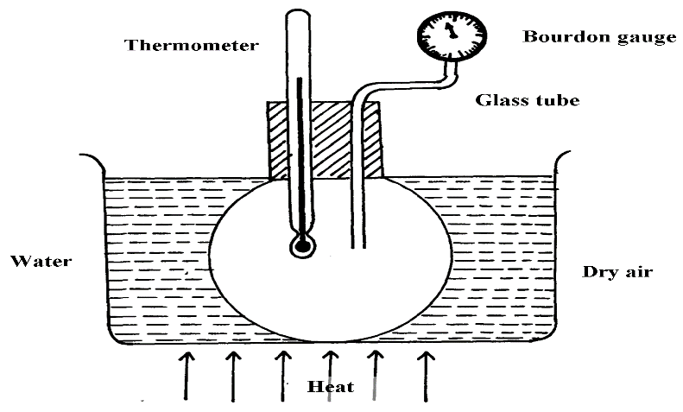

Figure 11

- Describe how the apparatus may be used to verify pressure law (3 marks)
……………………………………………………………………………………………………………………………………………………………………………………………………………………………………………………………………………………………….....................................................................................................................................................................................................................................................................................................................................................................................................................................................................................................................................................................................................................................
- The graph shows the relationship between the pressure and temperature for a fixed mass of an ideal gas at constant volume
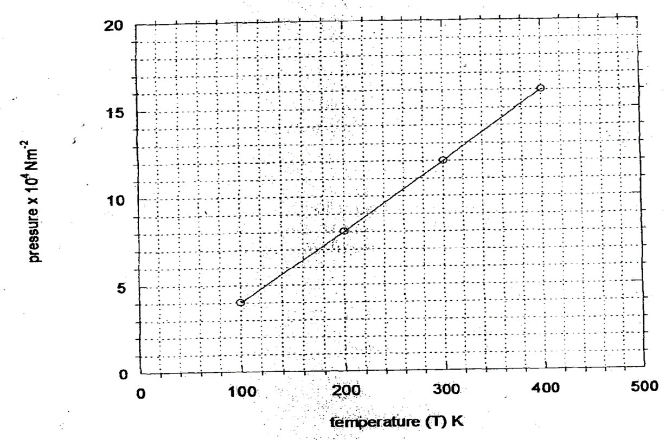

i) Given that the relationship between pressure, P and temperature, T in Kelvin is of the form
P = kT + C where k and C are constants. Determine from the graph,
- Value of k (2 marks)
……………………………………………………………………………………………………………………………………………………………………………………………………………………………………………………………………………………………................................................................................................................................................................................................................................................................................................................................................................

- Value of C (1 mark)
……………………………………………………………………………………………………………………………………………………………………………………………………………….......................................................................................................................................................................................................................................................................................................................
ii) Why would it not be possible for pressure of the gas to be reduced to zero in practice? (1mark)

……………………………………………………………………………………………………………………………………………………………………………………........................................
c) A gas is put into a container of fixed volume at a pressure of 2.1 x 10⁵ Nm⁻² and temperature 27°C. The gas is then heated to a temperature of 327°C. Determine the new pressure (3 marks)
………………………………………………………………………………………………………………………………………………………………………………………………………………………………………………………………………………………………………………………………………………………………………………………………………………………………………………………………………………………………..........................................................
16 (a) Figure 12 was used to investigate the variation of the centripetal force, F with the radius, r of the circle on which a body rotates.
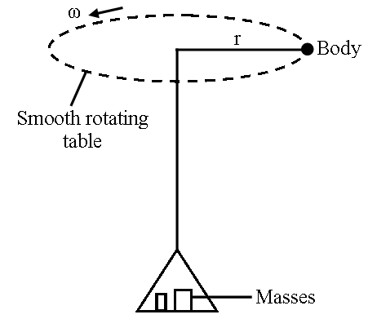
Figure 12
Describe how the setup can be used to carry out the investigations. (3mks)
………………………………………………………………………………………………………………………………………………………………………………………………………………………………………………………………………………………………………………………………………………………………………………………………………………………………………………………………………………………………………………………………………
The graph shows the relationship between force on the body and radius
From the graph determine the angular velocity, ω of the body given that m = 200g and
F = mω²r + c where c is a constant. (2 marks)
- (i) Distinguish between angular and linear velocity. (1 mark)

………………………………………………………………………………………………………………………………………………………………………………………………………………………………………………………………………………………………………………………………………………………………………………………………
(ii) Explain why bodies in circular motion undergo acceleration even when their speed
is constant. (2 marks)

……………………………………………………………………………………………………………………………………………………………………………………………………………………………………………………………………………………………
- State what contributes to the centripetal force when a bucket full of water is at the top while being rotated in a vertical circle. ( 1 mark)

………………………………………………………………………………………………………………………………………………………………………………………………………………………………………………………………………………………………
17 (a) State the law of floatation. (1 mark)
………………………………………………………………………………………………………………………………………………………………………………………………
(b) Figure 13 shows a piece of cork held with a light thread attached to the bottom of a beaker. The beaker is filled with water.
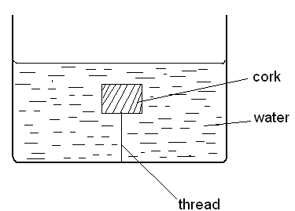

Figure 13
- Indicate and label on the diagram the forces acting on the cork. (1 mark)

- Write an expression showing the relationship between the forces above. (1 mark)
………………………………………………………………………………………………………………………………………………………………………………………………A solid displaces 8.5cm³ of liquid when floating in a certain liquid and 11.5cm³ when fully submerged in the same liquid. The density of the solid is 0.8g/cm³. Determine:-
i)The upthrust on the solid when floating. (2 marks)
………………………………………………………………………………………………………………………………………………………………………………………………………………………………………………………………………………………………
ii) The density of the liquid. (2 marks)
………………………………………………………………………………………………………………………………………………………………………………………………………………………………………………………………………………
- The upthrust on the solid when fully submerged. (2 marks)
………………………………………………………………………………………………………………………………………………………………………………………………………………………………………………………………………………

THIS IS THE LAST PRINTED PAGE

