Name.................................................................................................... Index Number................................/............

Candidate’s signature.................................... Date.................................................................

PHYSICS
PAPER 2
(Theory)
2 HOURS
FORM 4
Instructions to candidates
a) Write your name, admission number and index number in the spaces provided above.
b) Sign and write the date of examination in the spaces provided above
c) This paper consists of TWO sections A and B
d) Answer ALL the questions in section A and B in the spaces provided
e) All working MUST be clearly shown
f) Electronic calculators and mathematical tables may be used.

For Examiners Use Only
Section | Question | Maximum Score | Candidates Score
A | 1-12 | 25
B | 13 | 10
 | 14 | 10
 | 15 | 8
 | 16 | 11
 | 17 | 8
 | 18 | 8
 |  | Total = 80

SECTION A (25 MARKS)
- Fig 1 shows two plane mirrors M₁ and M₂ arranged parallel to each other.
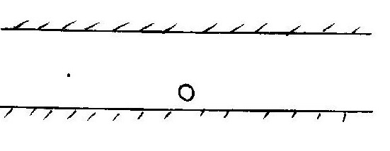Fig. 1
O is an object placed in between the mirrors M₁ and M₂. The eye E observes infinite numbers of images in the mirror M₁. Explain the observation. (2marks)

- State two factors that affect the capacitance of a parallel plate capacitors. (2 marks)

- Figure 2 shows eight resistors forming a network in a circuit between point X and Y
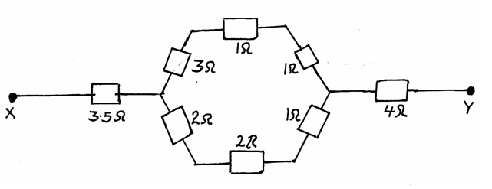Fig. 2
Calculate the effective resistance of the network (2 marks)

- The figure 3 shows regions of the electromagnetic spectrum. D is the region of visible light

A | B | C | D | E | F | G

Decreasing wave length
Indicate the region for the following: (2 marks)
- X - rays _______________________________________________

- Ultraviolet ______________________________________________

- Why is it safer to carry explosive fuels in metal cans instead of plastic cans? (2 mks)

- Peter and John are 12m and X metres respectively away from a wall as shown.

Peter claps his hands once. John hears the echo 0.4s later. Calculate the distance between John and Peter. (Speed of sound in air = 330ms⁻¹). (3 mks)

7 .Complete the path of the ray XY shown, until when it leaves the glass prism, given that the critical angle for glass is 42º. (Show all the angles.) (n = ³/₂ for glass) (3 mks)

60º
x
y

8. An electric heater is found to have a resistance of 950Ω when operating normally on a 240V mains.
Find the power rating of the heater. (2mks)

9. In an x-ray tube, it is observed that the intensity of X-rays increases when potential difference across the filament is increased. Explain this observation (2marks)

10. The figure below shows a magnet being dropped through the centre of a narrow coil. The emf across the coil is monitored on an oscilloscope.
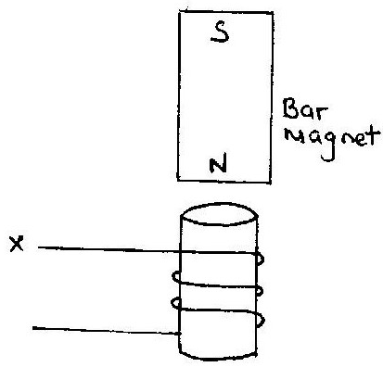
a) What is the induced polarity on top side of the coil as the magnet towards the cell? (1mark)

b) Indicate the direction of current flow at position X as the magnet falls towards the coil. (1mark)

11. The figure below shows a magnetic compass placed under a horizontal wire XY
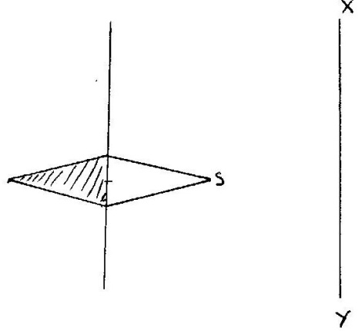
A large current is passed from X to Y. Draw the final position of the magnetic compass needle in the figure. (1marks)

12. The figure below shows a wire placed in between a magnet field
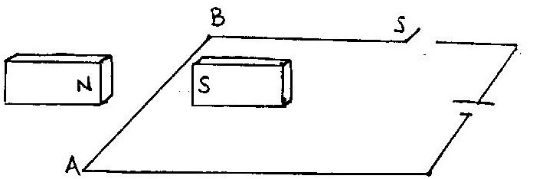
Explain why when switch S is closed then the wire AB experiences an upward force. (2marks)

SECTION B (55 MARKS)
13. a.) The figure below shows a displacement (cm) time graph for a progressive wave

i) State the amplitude of the wave. (1mk)

ii) Determine the frequency of the wave. (3marks)

iii) Given that the velocity of the wave is 320cm/s determine its wavelength (2marks)

b) The figure below shows two identical dippers A and B vibrating in water in phase with each other. The dipper has the same constant frequency and amplitude. The waves produced are observed along line MN.

M
N
It is observed that the amplitudes are maximum at points Q and S and minimum at points P and R
i) State why the amplitude is minimum at R (1marks)

ii) State what would happen if the two dippers had different frequencies (1marks)

c) The figure below shows waves crossing from deep to shallow region. Complete the figure to show the wave front in the shallow region and after leaving the shallow region. (2 mks)
Deep
Shallow

14.a)A magnified erect image and a magnified inverted image both can be formed by a concave mirror. Draw simple ray diagrams to illustrate the two cases. (4 marks)

(b)An object 2cm tall is placed 22.5cm from a convex lens of focal length 15cm. On the other side of the converging lens, a diverging lens of focal length 30cm is placed such that the distance between the lenses is 35cm. Using the lens formula, determine;
(i) The position of the final image. (4 marks)

(ii) The total magnification. (2 marks)

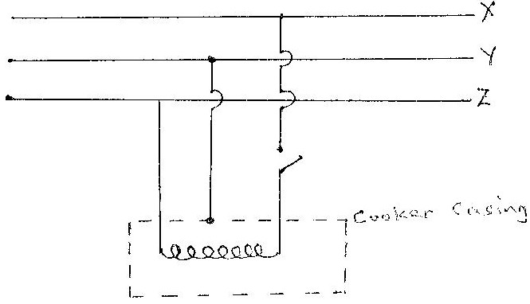
15.a) The figure shows the electric wiring of an electric cooker X, Y and Z are main wires.

Fig. 6
Giving a reason, identify X , Y and Z . (3 marks)
X ___________________________________________________________________________
Y ___________________________________________________________________________
Z----------------------------------------------------------------------------------------------------------------
b) A student has a large number of 240V, 60W colored bulbs he wishes to use for decorations so that the bulbs operate normally.
(i) How many bulbs can be connected to a 240V supply through a 5A fuse? (2 marks)

(ii) If electric energy cost Kshs. 3.00 per unit, what will be the cost of running the above circuit for 5 hours a night for 20 nights? (2 marks)

c) Give one reason why transmission of electric power is done at high voltages. (1 mk)

16. The figure below shows the cross-section of a diffusion cloud chamber used to detect radiation from radioactive sources

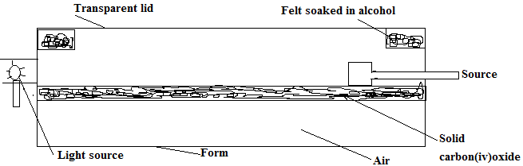

a) When radioactive from the source enters the chamber, some white traces are observed. Explain how these traces are formed and state how the radiation is identified. (4marks)

b) A leaf electroscope can also be used as a detector of radiation. State two advantages of the diffusion cloud chamber over the leaf electroscope as a detector. (2marks)

c) Two samples of the same radioactive material have initial mass M and 2M respectively on the axes provided, sketch the graph of activity verses time for each sample. Label the graph for each sample. (2marks)

d) A radioactive sample of half-life 160 days initially has 2x 10²³ radioactive atoms. Determine the number of radioactive atoms that have decayed after 480 days (3marks)

17.
Figure 18 shows a graph of the square of maximum speed, Vmax of the emitted photoelectrons against its frequency of the radiation causing the photoelectric effect on a clean zinc plate.
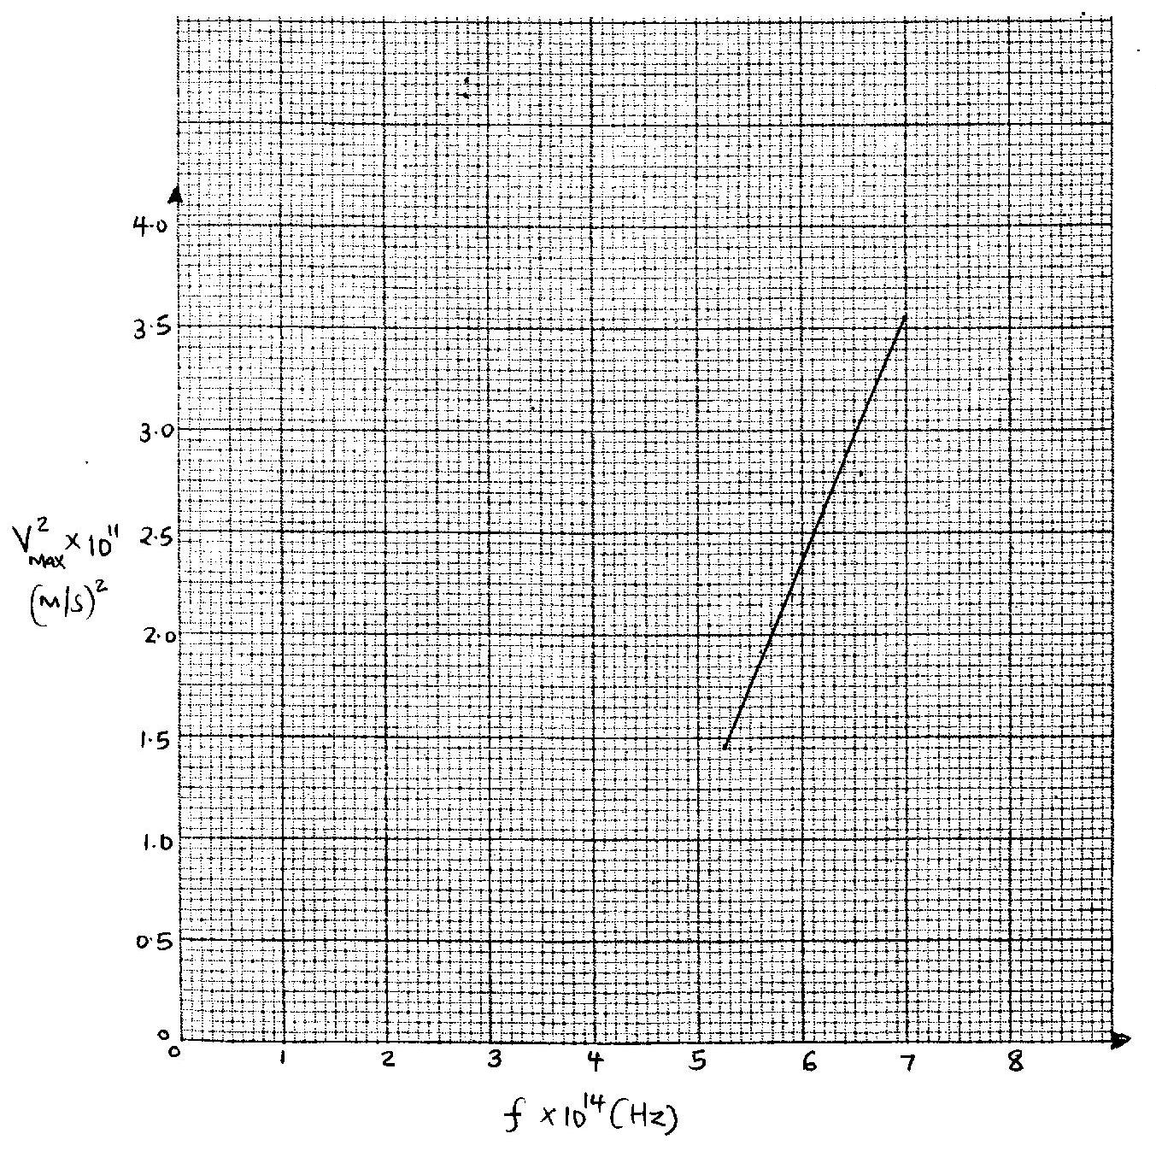

From the graph determine;
i) The threshold frequency. (2marks)
ii) The mass of an electron Me, given that the equation of graph drawn above is given by
V² = $\frac{2h}{me}f- \frac{2d}{me}$
(Take Planck’s constant h= 6.64x10⁻³⁴ Js) (3marks)

iii) Work function Q in electron volts (Take e = 1.6x10⁻¹⁹ C) (3marks)

18.a) What do you understand by the term dopping as used in semi-conductors?(1 mk)

b) Distinguish between n-type and p-type semi-conductors. (2 mks)

c)The circuit diagram below is useful for investigating the current voltage characteristics of a p-n junction diode. Use it to answer the questions that follow.

- Label the terminals X and Y for the diode to be in forward bias. (1 mk)
X ……………………………………………………….
Y…………………………………………………………
- On the axis below, sketch the expected grapy of the current voltage characteristics for the diode. (2 mks)
Voltage (v)
Current (Ma)

iii) Explain why the conductivity of a metallic conductor decreases with increase in temperature while that of an intrinsic semiconductor increases with increase in temperature. (2 marks)

