NAME ------------------------------------------------------------------ ADM NO ---------------------------
SIGNATURE ---------------------------- DATE ------------------------------------

233/3
PHYSICS PRACTICAL
PAPER 3
TIME 2 ½ HOURS

INSTRUCTIONS TO STUDENTS
- Write your name and Adm No in the spaces provided above.
- Answer ALL the questions in the spaces provided in the question paper
- You are supposed to spend the first 15 minutes of the 2 ½ hours allowed for this paper reading the whole paper carefully before commencing your work.
- Marks are given for a clear record of the observations actually made their suitability according and the use made of them
- Candidates are advised to record their observations as soon as they are made
- Use of electronic calculators only
Question 1
Maximum score | 20
Candidate score
Question 2
Maximum score |  | 20
Candidate score
 | GRAND TOTAL

- You are provided with the following
- A glass prism
- A soft board
- 4 optical pins
- A white sheet of paper
- 2 thump pins
a) Draw the outline of the glass prism on the plane paper mounted on the soft board. Label the vertices of the triangle as shown in the figure below. Note that AB and AC are sides of the prism that are equal in length. Mark a point O on the outline drawn. Draw a normal to the face AB via point O as shown in the diagram.
b) Measure an angle of incidence of 30o at the point of incidence O. Stick two pins P1 and P2 to mark the incident ray.
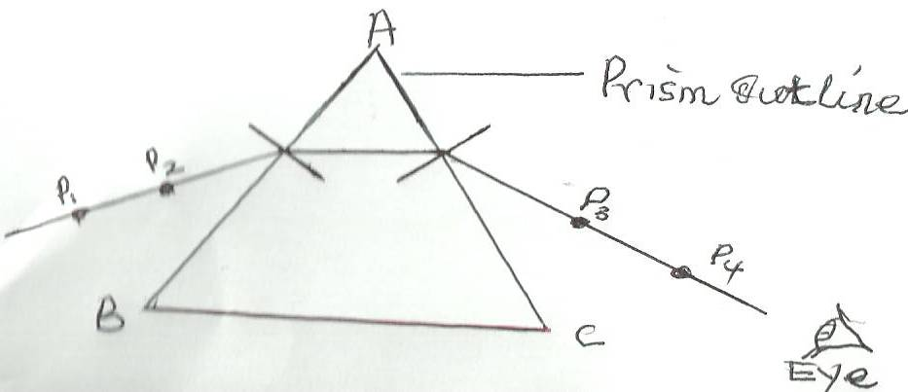

Place the glass prism on the outline and view side AC to see the images of pins P₁ and P₂. Stick pins P₃ below side AC as shown in the figure such that it is in a straight line with the images of P₁ and P₂. Stick the fourth pin P₄ so that it has in the same straight line with P₃ and the images of P₁ and P₂.
ii) Remove the prism and pins. Join points P₃ and P₄ in a straight line to meet AC at E. Join points E to 0. Measure the angle of refraction r.
r = ------------------------------------------------------------------------------------------------------- ( 1mk)

c i) Repeat the experiment for different angles of incidence and complete the table.
Angle of incidence ( iº) | 35 | 40 | 45 | 50 | 55 | 60
Angle of refraction (rº)
Sin i
Sin r

ii) Plot a graph of sin r against sin i. (5mks)
iii) Calculate the slope of graph. (4mks)
2.You are provided with
- A voltmeter
- An ammeter
- Connecting wires
- 2 dry cells
- A switch
- A cell holder
- A jockey
- A resistance wire mounted on a scale
- Micrometer screw
- Gauge

- Set up the apparatus as in the diagram below

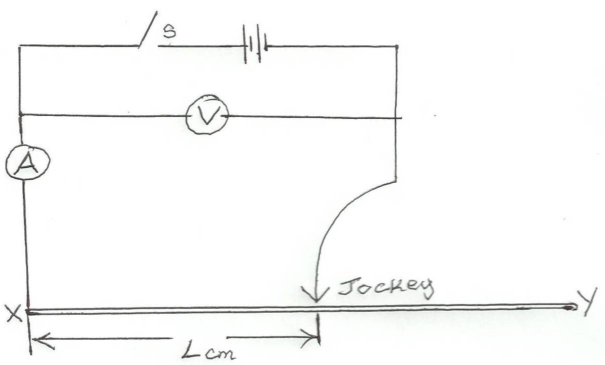

- Move the jockey to point Y and close the switch. Record the ammeter and voltmeter readings.
V ----------------------------------------------------------------------------------------- ( ½ mk)
I -------------------------------------------------------------------------------------------- ( ½ mk)
- Calculate the resistance of the wire

R = V/I-------------------------------------------------------------------- ( ½ mk)

- Hence determine the resistance per unit length I of the wire from
K = R/100 --------------------------------------------------------------------------- (1/2 mk)
- Use the micrometer screw gauge provided to measure the diameter D of the resistance wire.
D ---------------------------------------------------------------------------------------------- (1/2 mk)
- i) Using the same circuit in (a) above vary the length of the resistance wire L by adjusting the position of the jockey to correspond with the length shown in the table and complete the table-given that the e.m.f of the cell is 3v.

Length (cm) | 70 | 60 | 50 | 40 | 30 | 20
Current (A)
P.D (v)
E – V
ii) Plot a graph of ( E - V) y –axis against current. (5mks)
iii) Calculate the gradient of the graph. (1mk)
iv)Which does the slope stand for? (1mk)

