**Name.......................................................................................Date.................................................**

**Index Number................................/............ Candidates signature...................................**

**FORM 4**

**PHYSICS**

**PAPER 3**

**(PRACTICAL)**

**2 ½ HOURS**

**Instructions to candidates**

* Write your name and index number in the spaces provided **above**.
* Sign and write the date of the examination in the spaces provided.
* This paper consists of **two** question
* Answer all the questions in the spaces provided.
* You are supposed to spend the first 15 minutes of the 2**½** hours allowed for this paper reading the whole paper carefully.
* Marks are given for clear recording of the observation actually made, accuracy and use of them
* Record your observation as soon as you get them.
* All working **must** be clearly shown.
* Non programmable silent electronic calculators and **KNEC** mathematical tables may be used.

**For examiners use only**

|  |  |  |
| --- | --- | --- |
| **Question** | **Maximum score** | **Candidates score** |
| 1 | 20 |  |
| 2 | 20 |  |
| **TOTAL** | 40 |  |

***This paper consists of 9 printed pages. Candidates should check the question paper to ensure that all the pages are printed as indicated and no questions are missing***

1. **PART A**

***You are provided with the following***

* 2 dry cells
* A cell holder
* A nichrome wire mounted on a metre rule
* An ammeter **A**
* A voltmeter **V**
* A jockey **J**
* A switch **S**
* 8 connecting wires
* Proceed as follows

figure 1

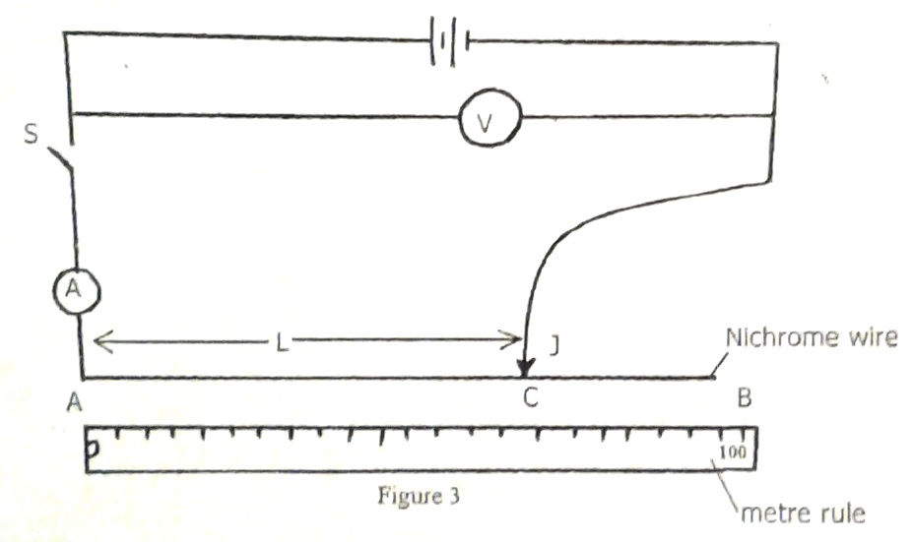

1. Set the apparatus as shown in **figure 1.**
2. With the switch open, record the reading **E** of the voltmeter

**E**............................................................................................................................ (1 mark)

(c) Place the jockey, on the nichrome wire at 100 cm mark. Close the switch, read and record

the values of I(ammeter reading) and the corresponding values of V (voltmeter reading) in

**table 1**

(d) Repeat (c) above for length **L**= 70 cm, 60cm, 50cm, 40cm and 20cm.complete **Table 1**

**Table 1**

|  |  |  |  |  |  |  |
| --- | --- | --- | --- | --- | --- | --- |
| **L(cm)** | **100** | **70** | **60** | **50** | **40** | **20** |
| **I(A)** |  |  |  |  |  |  |
| **V(v)** |  |  |  |  |  |  |
| **E-V (v)** |  |  |  |  |  |  |

(5 marks)

(e) Plot a graph of **(E-V)** (y-axis) against **I** (4 marks)

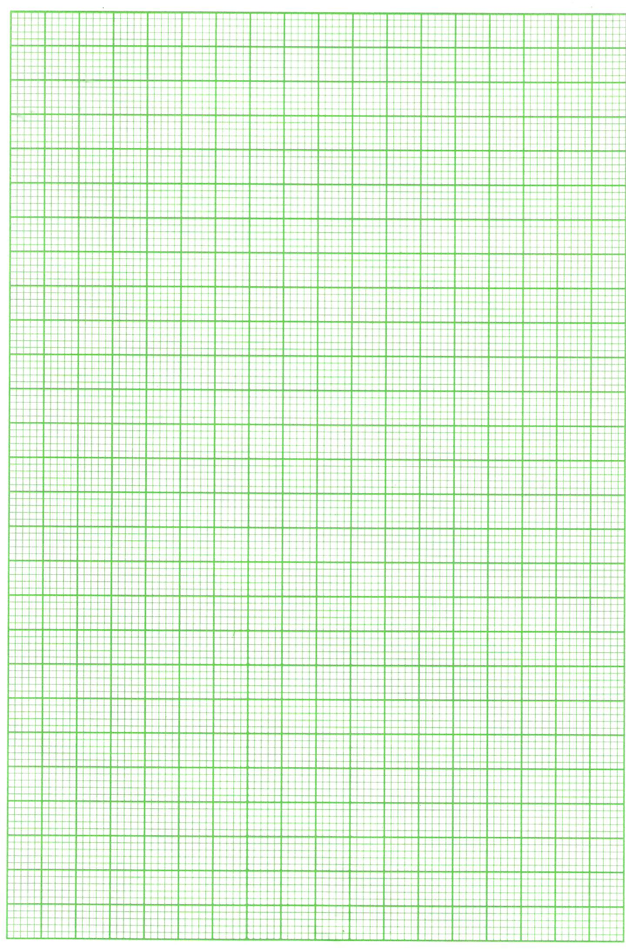

(f) Determine the slope of the graph (2 marks)

.................................................................................................................................................................................................................................................................................................................................................................................................................................................................................... ............................................................................................................................................................

(g) Given that **E = V-Ir**, from the graph determine

(i) The internal resistance, **r**, of the battery (1 marks)

............................................................................................................................................................ ............................................................................................................................................................ ............................................................................................................................................................ ............................................................................................................................................................

(ii) **V** when **I** is 0.3A (1 marks)

....................................................................................................................................................................................................................................................................................................................................................................................................................................................................................

1. **PART B**

* You are provided with the following
* A white screen with cross wires labelled O
* A lens and a lens holder
* A white screen labelled s
* Meter rule
* A candle

***Proceed as follows figure 2***



1. Set up the apparatus as shown in **figure 2**
2. Position the lens so that the object distance **U**= 30 cm
3. Adjust the screen **S** so that a sharp image of the cross wire is formed on the screen **S**. measure the image distance **V**.
4. Repeat the procedure in (c) to obtain an average value of **V**

V=…………………………………………………………………………………………………………………………………………………………………………………………………………………………………………………………………………………………………………………………………………………………………………………………

(3mks)

1. Given that P = $\frac{uv}{ u+v}$

Determine the value of P in SI units (3mks)

………………………………………………………………………………………………………………………………………………………………………………………………………………

……………………………………………………………………………………………………………………………………………………………………………………………………………...

1. **PART A**

You are provided with the following apparatus.

-Clamp

-Stand

- Optical pin

-Copper wire

-Protractor (your own)

-Two pieces of plasticine

-Stop watch

-Cork

1. Set up the apparatus as shown below in **figure 3**.

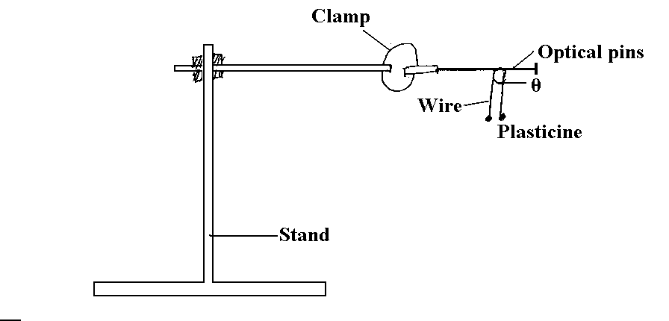

Figure 3

b) Using a meter rule, measure the length L of the copper wire provided.

L=………………………………………………………………………….m (1mk)

1. Bend the copper wire in the middle so as to make an angle of 600. Attach the two small pieces of plasticine at both ends of the wire as shown in figure 3.
2. Place the bent wire on the optical pin and give a small horizontal displacement. Take the time t1 for 10 oscillations.

t1=…………………………………………………………………………………(1mk)

1. Adjust the angle from 600 to 1200 and repeate procedure (d) to obtain the time t2 for another 10 oscillations

t2=…………………………………………………………………………………(1mk)

1. calculate the frequency f of the oscillations given that the period T= (t1+t2)10-1 (2mks)

**f=**

(1mk)

1. Determine the value of z given that f = $\sqrt{\frac{3z}{4πL}\cos{45}}$

…………………………………………………………………………………………………..

…………………………………………………………………………………………………

………………………………………………………………………………………….(2mks)

1. **PART B**

You are provided with the following:

- a rectangular glass block

- 4 optical pins

- a piece of soft board

- a plane sheet of paper

- 4 thumb pins

- micrometer screwgauge

**-** geometrical set

Proceed as follows:

1. Using the micrometer screwgauge measure the breadth w (the second longest length) of the glass block.

W = …………………………………………………………………………..m (1mk)

1. Place the plane sheet on the soft board and fix it using the thermo pins provided. Place the glass block at the centre of the sheet and draw its outline. Remove the glass block( see figure 4)

O

P2

P1

W

d

P3

N

P4

1. Draw a normal ON at a point 2cm from the end of the longest side of the block outline. This normal line will be used for the rest of the experiment. Draw a line at an angle i= 100 from the normal. Stick two pins P1 and P2 vertically on this line.
2. By viewing through the glass from the opposite side ,stick two other pins P3 and P4 vertically such that they are in line with the images of the first two pins. Draw a line through the marks made by P3 and P4 to touch the normal ON. Measure and record in table 2 the distance d between the edge of the block line and where the line P3P4 meet the line ON. Repeat the above procedure in (c) and (d) for other values of i=200,300,400,500,600 and record your results in table 2.

NB- this sheet of paper with drawing must be handed in together with this question paper. Ensure you write your name and index number on this sheet of paper

1. Table 2 (4mks)

|  |  |  |  |  |  |  |
| --- | --- | --- | --- | --- | --- | --- |
| i0(degrees) | 10 | 20 | 30 | 40 | 50 | 60 |
| Sin i |  |  |  |  |  |  |
| d(cm) |  |  |  |  |  |  |

1. (i) On the grid provided plot a graph of sin i(y-axis) against (4mks)



(ii) Using the graph estimate the value of d when i= 150

………………………………………………………………………………………………………

………………………………………………………………………………………………………

…………………………………………………………………………………………(1mks)

(iii) Given that $i = 35°$ and $k=W\sin{i}$. Find k.

………………………………………………………………………………………………………

………………………………………………………………………………………………………

………………………………………………………………………………………………………

……………………………………………………………………………………………..(1 $\frac{1}{2}$ mks)

This is the last printed page.