Name: …………………………………………………………… Index No. …………………………
School: …………………………………………………………. Candidate’s Sign. …………............
Date: ………………………………............................................

232/3
PHYSICS
PAPER 3
TIME: 2 ½ HOURS

FORM 4

INSTRUCTIONS TO CANDIDATES:

- Write your name and index number in the spaces provided above.
- Answer all the questions in the spaces provided in the question paper.
- You are supposed to spend the first 15 minutes of the 2½ hours allowed for this paper reading the whole paper carefully before commencing your work.
- Marks are given for a clear record of the observations actually made, for their suitability accuracy and the use made of them.
- Candidates are advised to record their observations as soon as they are made.
- Mathematical table and electronic calculators may be used.

For Examiners’ Use Only
Question 1 | b(iii) | c(i) | c(iii) | c(iii)
Maximum Score | 10 | 5 | 2 | 3
Candidate’s score

Question 2A | c(iii) | d | e | f | g | total
Maximum Score | 10 | 5 | 2 | 3
Candidate’s score

Question 2A | b | c | d | total
Maximum Score | 10 | 5 | 2
Candidate’s score

This paper consists of 4 printed pages. Candidates should check to ascertain that all pages are printed as indicated and that no questions are missing.

Question One
You are provided with the following apparatus;
- Two retort stands
- Two clamps
- Two bosses
- Inextensible thread(about 120cm long)
- One 50g mass
- One stop watch
Proceed as follows

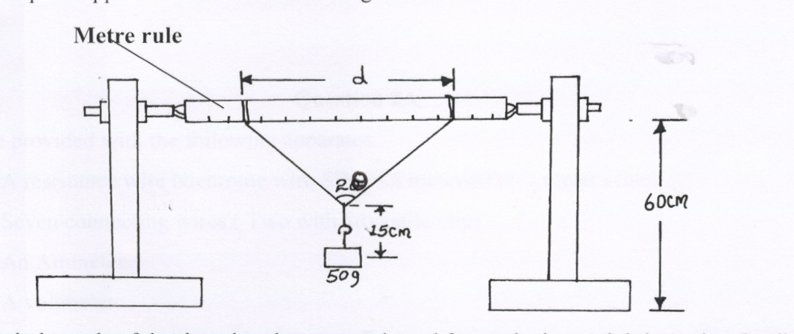
a) (i) Set up the apparatus as shown in the diagram below.

(ii) Attach the ends of the thread to the metre rule and fasten the loops tightly so that the distance
between the loop d = 80cm
(iii) Tie the mass with a thread 20cm long. Fasten the mass at the centre of the thread on the rule
such that the length of the pendulum from the point of suspension is 15cm as shown on the
diagram above.

b) (i) Measure the angle 2θ
(ii) Pull the mass towards you through a small angular displacement and release it to swing freely.
The mass should oscillate perpendicular to the plane of the metre rule. Time 20 oscillations.
(iii) Repeat procedure b) (i) and (ii) above by using different values of and enter your values in the
table below.
d(m) | 0.8 | 0.7 | 0.6 | 0.5 | 0.4 | 0.3
2θº
θº
Cosθº
Time for 20 oscillations
Periodic time T(s)
T²/S²
(10mks)

c) (i) Plot a graph of T² against Cosθ (5mks)



(ii) Determine the value of T² at the point where the graph intercepts the y -axis. (2mks)

(iii) Given that the value of T2 at the point A where the graph cuts the y axis is given by
0.6112
A , use your result in (ii) above to determine the value of K. (3mks)
K

Question 2A
You are provided with the following apparatus.
- A resistance wire Nichrome wire SWG 28 mounted on a meter scale.
- Seven connecting wires (Two with crocodile clip)
- An Ammeter
- A voltmeter
- A switch K
- Two cells size D

Proceed as follows
(a) Set up circuit as shown in the figure below
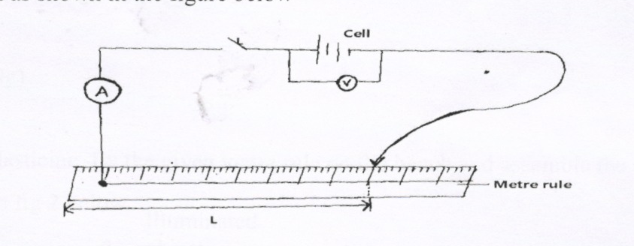

(b) Open the switch and read the voltmeter. E
(c)(i) Close the switch when L = 70cm. Read and record the readings of the ammeter and voltmeter.
Length L (cm) | 70 | 50 | 40 | 30 | 20
Current I (A)
P.D (V) volts

(ii) Repeat step C (i) for each of length L given in the table. (5mks)
(d) Plot a graph of p.d on the (vertical axis) against current I (A)

(e) Determine the slope S, of the graph (2mks)

(f) From the graph determine the e.m.f of one cell. (l mk)

(g) From the graph find the internal resistance r of the dry cell. (1mk)

Question (2 B)
You are provided with the following apparatus
- A full candle
- An object (a wire gauze assembled on a board)
- A lens(convex)
- A lens holder
- A metre rule
- Plasticine (about l0g)
- A match box.
- Using plasticine, fix the given metre rule on the bench and assemble the apparatus as shown in fig 2
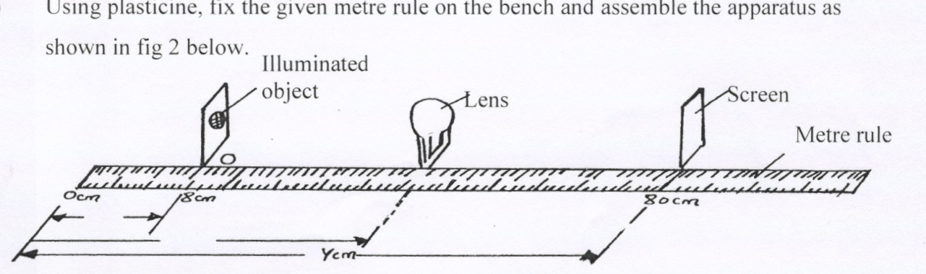
below.

With the screen at point I(at the 65cm mark) move the lens to obtain a sharp magnified image of the object
65cm
65cm
Record in the table the corresponding value V
Repeat procedure above for Y = 55cm and complete the table below;

Y(cm) | U(cm) | V(cm) | uV(cm) | U + V(cm) | uV (cm)  u+V

(b) Point A should be the 0cm mark. On the metre rule and the object should remain at point 0 through
out the experiment. Record the value of a
a……………………………………………………………….. cm (l mk)

- (i) With the screen at point I, the 75cm mark, move the lens to obtain a sharp magnified image of the
object.

Record in the table 2 the corresponding value V
Repeat procedure (i) above for U 60 cm and complete the table below
U(cm) | V(cm) | UV(cm²) | U+V(cm) | UV_  U+V
75
60
(4mks)
d) Using the table above, Find f the focal length of the lens
f = ………………………………………cm. (l mk)

