NAME ……………………………………..………………..ADM. NO. …………….……….……..…..…
CANDIDATE’S SIGNATURE …………..………..………..
DATE ……………….……………

443/2
AGRICULTURE
PAPER 2 (THEORY)
TIME: 2 HOURS

CHAMPIONS JET 1 - 2019
KCSE PRE – TRIALS
MARCH – APRIL 2019

INSTRUCTIONS TO CANDIDATES
- Write your name and Admission Number in the spaces provided above.
- Sign and write the date of examination in the spaces provided above.
- This paper consists of THREE sections: A , B and C
- Answer ALL the questions in section A and B
- Answer any two questions in section C.
- ALL answers should be written in the spaces provided.
- This paper consists of 10 Printed pages.
- Candidates should check the question paper to ascertain that all the pages are printed as indicated and that no questions are missing.

FOR EXAMINER’S USE ONLY

Section | Questions | MAXIMUM SCORE | CANDIDATE’S SCORE
A | 1 – 17 | 30
B | 17 – 20 | 20
C |  | 40
Total Score |  | 90

SECTION A (30 MARKS)
Answer ALL the questions in the section in the spaces provided.
- State four characteristics that makes goats popular in most parts of Kenya. (2 marks)
………………………………………………………………………………………………………………………………………………………………………………………………………………………………………………………………………………………………………………………………………………………………………………………………………………………………………………………………

- List four causes of livestock diseases (2 marks)
………………………………………………………………………………………………………………………………………………………………………………………………………………………………………………………………………………………………………………………………………………………………………………………………………………………………………………………………

- State three classification of hard ticks (1½ marks)
……………………………………………………………………………………………………………………………………………………………………………………………………………………………………………………………………………………………………………………………………………………………………………………………………………………………………………………

- Give four characteristics of concentrates in livestock nutrition. (2 marks)
………………………………………………………………………………………………………………………………………………………………………………………………………………………………
………………………………………………………………………………………………………………………………………………………………………………………………………………………………

- State four reasons of breeding in livestock production (2 marks)
…………………………...…………………………………………………………………………………………………………………..………………………………………………………………………………….
……………………………………………………...……………………………………………………………………………………………………………...……………………………………………………………

- List four advantages of docking in sheep management. (2 marks)
……………...………………………………………………………………………………………………………………..………………………………………………………………………………………………………………...…………………………………………………………………………………………………………….…………………………………………………………………………………………

- Give four precautions a farmer should observe when using a plunge dip. (2 marks)
………………………………………………………………………………………………………………………………………………………………………………………………………………………………………………………………………………………………………………………………………………………………………………………………………………………………………………………………

- State four maintenance practices done on green houses. (2 marks)
…………………………………………………………………………………………………………………………………………………………………………………………………………………………………………………………………………………………………………………………………………………………………………………………………………………………………………………………….

- State four causes of swarming in bee production. (2 marks)
…………………………………………………………………………………………………………………………………………………………………………………………………………………………………………………………………………………………………………………………………………………………………………………………………………………………………………………………….

- List four maintenance practices carried out in a fish pond. (2 marks)
…………………………………………………………………………………………………………………………………………………………………………………………………………………………………………………………………………………………………………………………………………………………………………………………………………………………………………………………….

- Outline four characteristics of a good egg for incubation (2 marks)
…………………………………………………………………………………………………………………………………………………………………………………………………………………………………………………………………………………………………………………………………………………………………………………………………………………………………………………………….

- State four features of a vent that may necessitate culling a layer bird (2 Marks)
…………………………………………………………………………………………………………………………………………………………………………………………………………………………………………………………………………………………………………………………………………………………………………………………………………………………………………………………….

- State four factors that stimulates milk let down in a lactating cow. (2 Marks)
…………………………………………………………………………………………………………………………………………………………………………………………………………………………………………………………………………………………………………………………………………………………………………………………………………………………………………………………….

- Give three ways in which farmers market beef cattle in Kenya. (1½ Marks)
…………………………………………………………………………………………………………………………………………………………………………………………………………………………………………………………………………………………………………………………………………………………………………………………………………………………………………………………….

- The following is a list of livestock diseases
Black quarter
African swine fever
Newcastle
Anthrax
Trypanosomiasis
Brucellosis
Which two diseases are
- Both bacterial and zoonotic (1 Mark)
………………………………………………………………………………………………………………………………………………………………………………………………………………
- Caused by virus (1 Mark)
…………………………………………………………………………………………………………………………………………………………………………………………………………….
- State two major methods of caponisation (1 Mark)
…………………………………………………………………………………………………………………………………………………………………………………………………………………………………………………………………………………………………………………………………………………………………………………………………………………………………………………………….

SECTION B (20MARKS)
Answer ALL the questions in this section in the spaces provided
- The diagram illustrated below shows a structure commonly used in the farm. Study it carefully and answer the questions that follow.
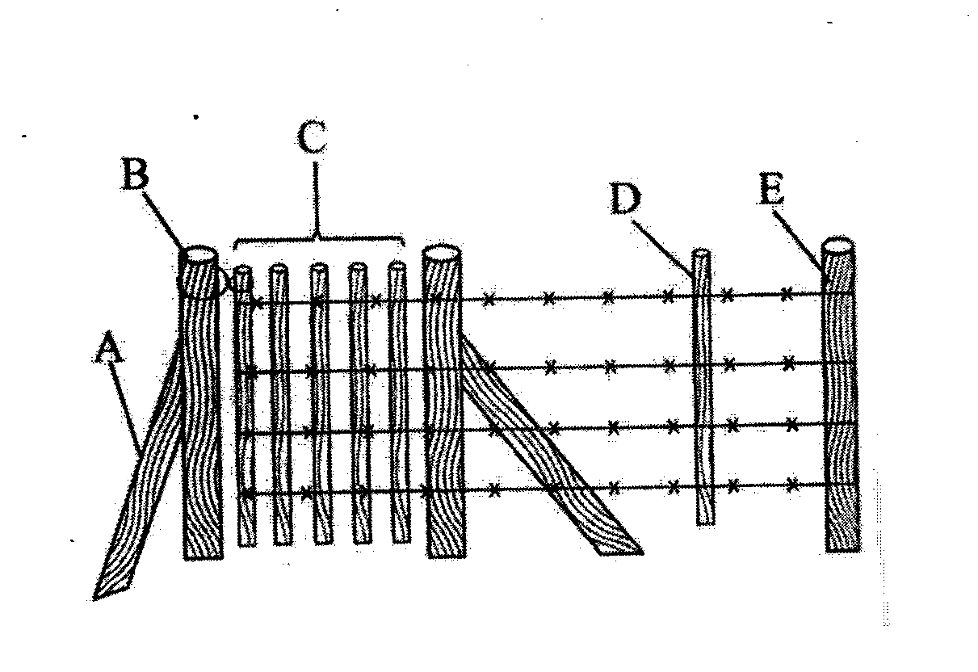

- Name the type of fence illustrated above. (1 mark)
………………………………………………………………………………………………………
- Identify parts labeled B and E (2 marks)
B……………………………………………………………………………………………………
E………………………………………………………………………………………………….
- State three qualities of the part labeled C (3 Marks)
………………………………………………………………………………………………………………………………………………………………………………………………………………
………………………………………………………………………………………………………………………………………………………………………………………………………………
- The diagram illustrated below shows a livestock handling technique. Study it carefully and answer the questions that follow.
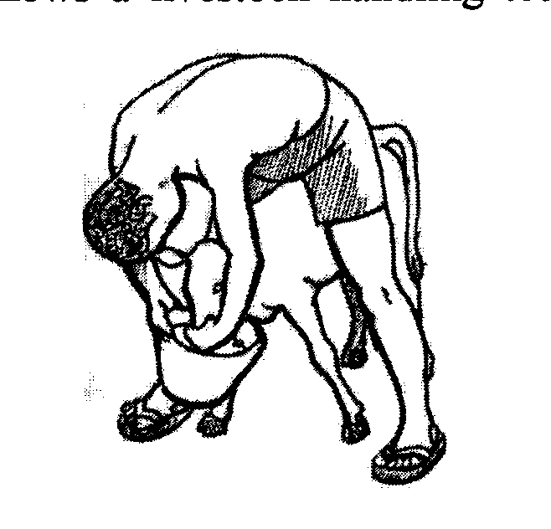

- Identify the practice illustrated above. (1 mark)
………………………………………………………………………………………………………………………………………………………………………………………………………………
- Name one disease a farmer is likely to predispose the calf while using the practice illustrated above. (1 Mark)
………………………………………………………………………………………………………………………………………………………………………………………………………………
- List three advantages of using the practice illustrated above. (3 Marks)
…………………………………………………………………………………………………………………………………………………………………………………………………………………………………………………………………………………………………………………………………………………………………………………………………………………………….
- The diagram below show workshop tools. Study them carefully and answer the questions that follow.
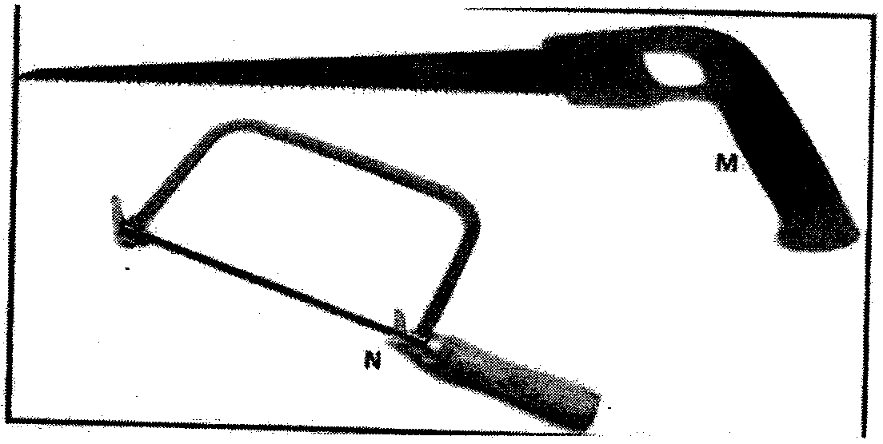

- Identify tools M and N. (1 Mark)
M…………………………………………………………………………………………………
N……………………………………………………………………………………………………
- State one use of each of the tools identified in (a) above. (1 Mark)
.…………………………………………………………………………………………………….…………………………………………………………………………………………………………………………………………………………………………………………………………....
- State two maintenance practices carried out on tool M. (2 Marks)
…………………………………………………………………………………………………………………………………………………………………………………………………………………………………………………………………………………………………………………….
………………………………………………………………………………………………………

- The illustration below shows a lifecycle of an internal parasite. Study it carefully and answer the
questions that follow.

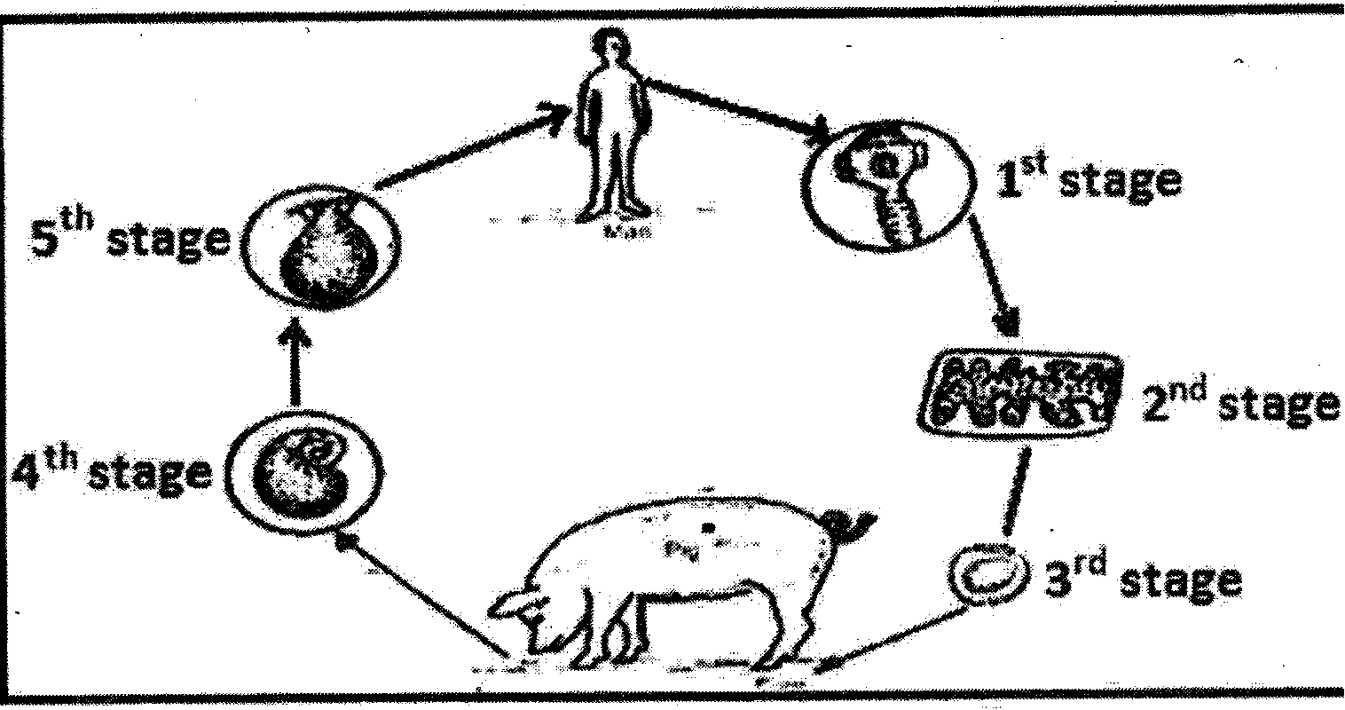

- i. Identify the parasite illustrated above (1 Mark)

ii. How is the parasite passes from livestock to man. (1 Mark)

b) Give two forms in which the parasite is found in livestock (1 mark)

- State two methods used to control the above parasite at the 5th stage. (2 Marks)

SECTION C (40 MARKS)
Answer only TWO questions in this section in the spaces provided after the questions.

- (a) Outline ten management practices carried out to ensure maximum egg production in poultry
production. (10 Marks)
- Explain five advantages of artificial insemination in livestock building (5 Marks)
- Explain five importance of dehorning animals in the farm. (5 Marks)

- (a) Describe ten factors considered when selecting a breeding stock (10 Marks)
(b) Outline five observable behaviours of chicks under excess heat in a brooder. (5 Marks)
(c) Explain five advantages of farm mechanizations. (5 Marks)

- a) Describe anthrax under the following subheadings
- Causal organism (1 Mark)
- Post mortem signs (4 Marks)
- Control measures (5 Marks)

- Describe ten factors considered when selecting construction materials on the farm(10 Marks)
…………………………………………………………………………………………………………………………………………………………………………………………………………………………………………………………………………………………………………………………………………………………………………………………………………………………………………………………….
…………………………………………………………………………………………………………………………………………………………………………………………………………………………………………………………………………………………………………………………………………………………………………………………………………………………………………………………….
…………………………………………………………………………………………………………………………………………………………………………………………………………………………………………………………………………………………………………………………………………………………………………………………………………………………………………………………….
…………………………………………………………………………………………………………………………………………………………………………………………………………………………………………………………………………………………………………………………………………………………………………………………………………………………………………………………….
…………………………………………………………………………………………………………………………………………………………………………………………………………………………………………………………………………………………………………………………………………………………………………………………………………………………………………………………….
…………………………………………………………………………………………………………………………………………………………………………………………………………………………………………………………………………………………………………………………………………………………………………………………………………………………………………………………….
…………………………………………………………………………………………………………………………………………………………………………………………………………………………………………………………………………………………………………………………………………………………………………………………………………………………………………………………….
…………………………………………………………………………………………………………………………………………………………………………………………………………………………………………………………………………………………………………………………………………………………………………………………………………………………………………………………….
…………………………………………………………………………………………………………………………………………………………………………………………………………………………………………………………………………………………………………………………………………………………………………………………………………………………………………………………….
…………………………………………………………………………………………………………………………………………………………………………………………………………………………………………………………………………………………………………………………………………………………………………………………………………………………………………………………….
…………………………………………………………………………………………………………………………………………………………………………………………………………………………………………………………………………………………………………………………………………………………………………………………………………………………………………………………….
…………………………………………………………………………………………………………………………………………………………………………………………………………………………………………………………………………………………………………………………………………………………………………………………………………………………………………………………….
…………………………………………………………………………………………………………………………………………………………………………………………………………………………………………………………………………………………………………………………………………………………………………………………………………………………………………………………….
…………………………………………………………………………………………………………………………………………………………………………………………………………………………………………………………………………………………………………………………………………………………………………………………………………………………………………………………….
…………………………………………………………………………………………………………………………………………………………………………………………………………………………………………………………………………………………………………………………………………………………………………………………………………………………………………………………….
…………………………………………………………………………………………………………………………………………………………………………………………………………………………………………………………………………………………………………………………………………………………………………………………………………………………………………………………….
…………………………………………………………………………………………………………………………………………………………………………………………………………………………………………………………………………………………………………………………………………………………………………………………………………………………………………………………….
…………………………………………………………………………………………………………………………………………………………………………………………………………………………………………………………………………………………………………………………………………………………………………………………………………………………………………………………….
…………………………………………………………………………………………………………………………………………………………………………………………………………………………………………………………………………………………………………………………………………………………………………………………………………………………………………………………….
…………………………………………………………………………………………………………………………………………………………………………………………………………………………………………………………………………………………………………………………………………………………………………………………………………………………………………………………….
………………………………………………………………………………………………………………………………………………………………………………………………………………………………
…………………………………………………………………………………………………………………………………………………………………………………………………………………………………………………………………………………………………………………………………………………………………………………………………………………………………………………………….
…………………………………………………………………………………………………………………………………………………………………………………………………………………………………………………………………………………………………………………………………………………………………………………………………………………………………………………………….…………………………………………………………………………………………………………………………………………………………………………………………………………………………………………………………………………………………………………………………………………………………………………………………………………………………………………………………….
…………………………………………………………………………………………………………………………………………………………………………………………………………………………………………………………………………………………………………………………………………………………………………………………………………………………………………………………….
…………………………………………………………………………………………………………………………………………………………………………………………………………………………………………………………………………………………………………………………………………………………………………………………………………………………………………………………….

