Name: …………………………………………………………… Index no ……..…...............

Admission No.……………………………………………………..Candidate’s sign ……………

School……….………………………. Date: ………………………

231/2
BIOLOGY
PAPER 2
MARCH 2019
TIME: 2 HOURS
CHAMPIONS JET 1 2019.
Kenya Certificate of Secondary Education (K.C.S.E.) 2018
Biology
Paper 2
INSTRUCTIONS TO CANDIDATES:
- Write your name and index number in the spaces provided.
- Answer all the questions in Section A in the spaces provided.
- In section B answer questions 6 (compulsory) and either question 7 or 8 in the spaces provided

For Examiner’s Use Only:
SECTION | QUESTIONS | MAXIMUM SCORE | CANDIDATES SCORE
A | 1 | 8
A | 2 | 8
A | 3 | 8
A | 4 | 8
A | 5 | 8
B | 6 | 20
B | 7 | 20
B | 8 | 20
B | TOTAL | 80

This paper consists of 10 printed pages. Candidates should check to ascertain that all papers are printed as indicated and that no questions are missing

- Below is a diagram of a mammalian skin, use it to answer the questions that follow.
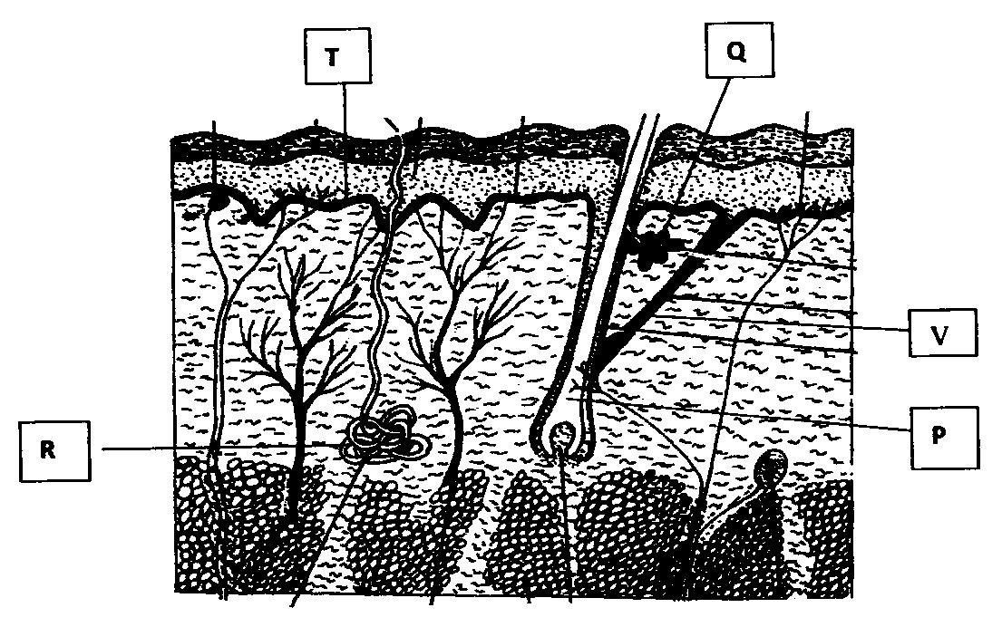
- Name the parts labelled P, Q, R (3mks)
P. Hair follicle;
Q. Sebaceous gland;
R. Sweat gland;
- Give the function of the parts labelled Q and T (2mks)
Q. Secretes sebum;
T. Consist of actively dividing cells that produce new cells to replace cells lost/cells contain melanin that protect skin against harmful ultraviolet rays from the sun;
- Briefly explain how the part labelled R contribute to lowering of body temperature on a hot day. (2mks)
It secretes sweat, water in sweat evaporates; carrying away latent heat of vaporization hence leaving a cooling effect;
- Give one function of the mammalian skin other than thermoregulation. (1mk)
Reception of stimuli
Protection of internal organs and tissues
Storage of fat
Excretion
Synthesis of vitamin D
2. Form two students subjected an orange plant growing outside the laboratory to the
Following;
i) Selected two sized leaves and gently brushed them clean on both sides.
ii) Placed two strips of dry cobalt chloride paper on both sides of each leaf and opposite each other and covered the cobalt chloride papers with cello tape. They observed the time taken for any colour change to occur and recorded the following.
Side of leaf | Upper epidermis | Lower epidermis
Time taken | 5 minutes | 2 minutes
Use the above information to answer the following questions.
a.i) What was the aim of the above experiment. (1mk)
To compare the rate of transpiration between the upper and lower leaf surfaces;
ii) What was the purpose of brush cleaning the leaf (1mk)
To remove dust particles from the surface of the leaf and any moisture;
iii) What was the role of cello-tape in this experiment? (1mk)
To prevent moisture from the atmosphere from reaching cobalt chloride paper;
b.i) What was the original colour of dry cobalt chloride paper. (1mk)
Blue;
ii) What colour change did the students observe? (1mk)
Pink;
c. Explain the difference in time taken for the colour change observed. (3mks)
The upper leaf surface took more time than the lower leaf surface; the upper surface has fewer stomata than the lower surface; therefore lower rate of transpiration on the upper surface than the lower surface;
The lower epidermis took less time because it has more stomata;

3. Red-green colour blindness is controlled by a sex-linked gene. The allele for normal sight is
represented by letter C and of colour blindness is represented by letter c. A carrier female is
married to a colour blind male.
a) What is sex linked gene? (1mk)
Gene that is inherited together with those determining sex of the individual;
b) Write down the genotype of the parents. (2mks)
M ale: X^{c}Y;
Female: X^{C}X^{c};
c) Work out the F1 genotypes. (4mks)
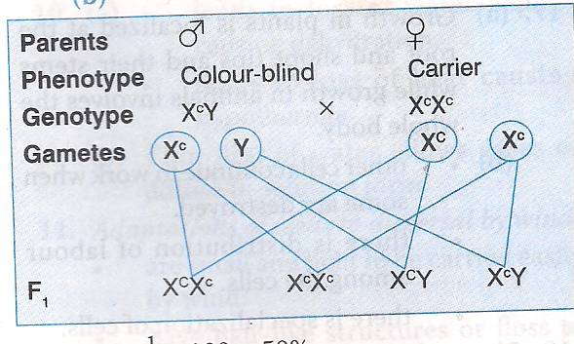
Fusion
Genotypes
d) What is the percentage of colour blind sons in all the male offspring’s (1mk)
1/2×100=50%
4. The photographs below are of organisms resting on different environmental backgrounds.
Observe them and answer the questions that follow;
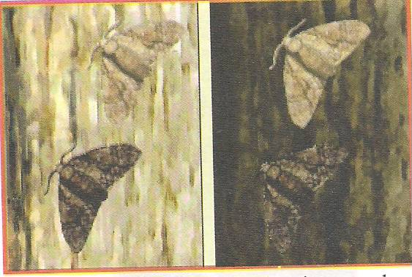
- Name the aspect of evolution depicted in the photograph ( 1 mark)
Industrial melanism
- Explain the phenomenon ( 4 marks)
Prior to industrial revolution there was only one form of peppered moth, speckled white variety which blended well /camouflaged; with the barks of the trees that were covered with lichens; After industrial revolution the barks of trees were covered with soot hence the white moth were easily detected and preyed on by birds; while the black melanic form blended well with the soot-covered barks of trees in industrial regions;
- How do we refer to this concept mentioned in (b) above (1 mark)
Survival of the fittest/adaptive radiation/natural selection;
- State any four other evidences of the phenomenon in (a) above in the modern world( 2 marks)
Sickle trait in humans;
Resistance to drugs, pesticides, and antibiotics by pathogens;
5. The diagram below represents female reproductive system;
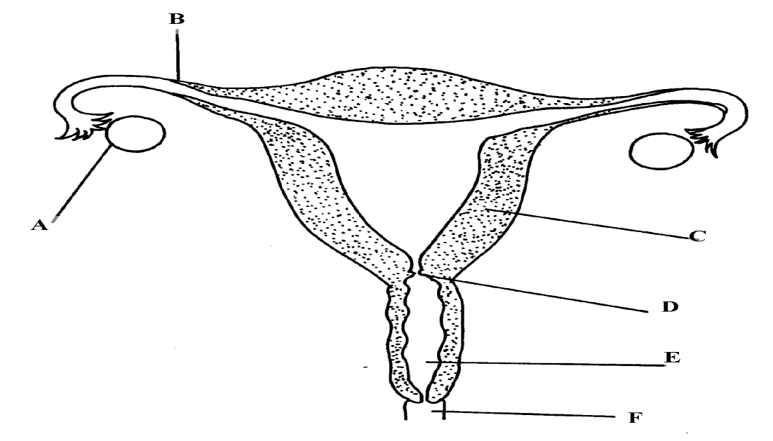
- Name the part labelled A, B, C and D (4mks)
A- Ovary
B- Oviduct/ fallopian tube
C- Uterus/ uterine wall
D- Cervix
- State two functions of structure A (2mks)
Produce ova
Produce female hormones/ oestrogen and progesterone
- How is part C adapted to its function? (1mk)
- Highly vascularized to supply nutrients to foetus/ drain away excretory wastes
- Inner wall lined with endometrium for implantation of fertilized egg/ zygote
- Muscular for peristalsis to expel menses during menstruation/ parturition
- Great capacity to expand during gestation to accommodate developing foetus
- Of what significance is part E to reproduction? (1mk)
-Copulation
- Birth canal
6. A research was carried out to determine the trend of growth for some boys and girls. Their average mass in kilograms was taken separately for a period of 20 years and tabulated as shown in the table below.
Age | Average Mass of boys (kg) | Average mass of girls (kg)
0 | 2.5 | 2.5
2 | 11.1 | 11.5
4 | 15.0 | 16.0
6 | 18.5 | 19.3
8 | 22.1 | 27.1
10 | 25.1 | 27.1
12 | 27.5 | 30.5
14 | 37.0 | 35.5
16 | 44.0 | 44.0
18 | 46.9 | 52.5
20 | 48.5 | 55.0
- On the same axis draw a graph of average mass of girls and of boys against the
Age. (7mks)
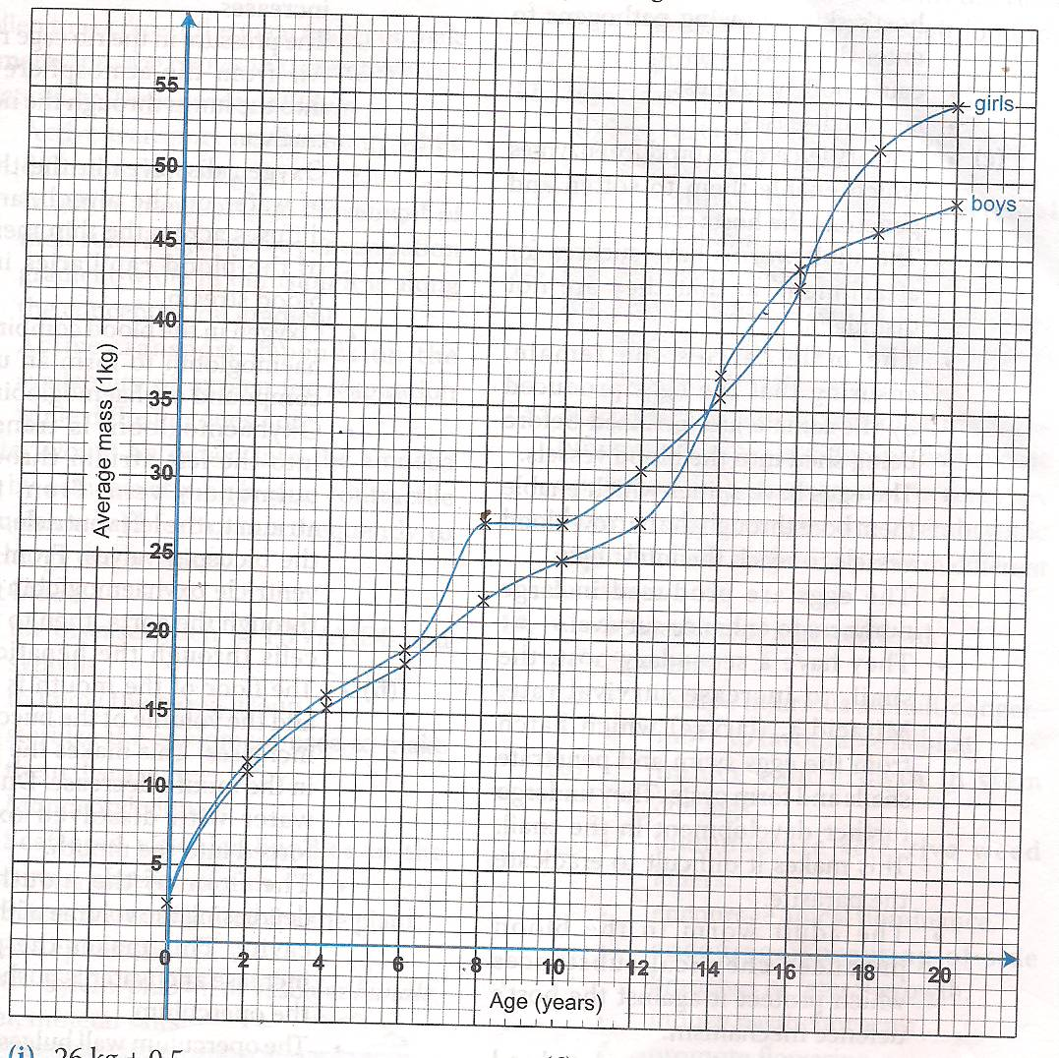
Scale: 1mk ×2=2mks
Axes: 1/2mk ×2=1mk
Plotting: 1mk ×2=2mks
Curve: 1/2mk ×2=1mk
Labeling: 1/2mk ×2=1mks

- From the graph , determine the;
- Mass for boys at age of 11 years. (1mk)
26 kg +_0.5
- Growth rate in girls between ages 13 and 15 (3mks)
Girls 15 years -39
Girls 13 years -33
39-33 =6/2= 3.0kgs/year
- Account for the change in the mass of girls during the age stated in (ii) above (2mks)
There is an increase in mass; because girls at adolescence grow faster;
- Explain the trend observed in the curves for both boys and girls. (2mks)
Girls generally grow faster than boys; boys grow slowly compared to girls but later after puberty they grow more steadily;
- Why do girls above 10 years require intake of food that is richer in iron than boys of the same age. (1mk)
Menstruation cycle begins hence they need more iron to replace blood lost during menstruation;
- Mention two other factors apart from the diet that affect the rate of growth in boys and girls. (2mks)
Genetic composition;
Sex of the child;
State of health
Emotional status

- Apart from using average mass to estimate growth in human beings, name two other parameters that can be used. (2mks)
Height of the body;
Volume of the body;

7. Explain how the following plants are adapted to their habitats.
a) Xerophytes (14mks)
- Some have leaves reduced in size / to spine of reduces the surface area for water loss.
- Some xerophytes have photosynthetic stems that take the place of leaves; to reduce the surface area for transpiration;
- Some shed-off leaves during dry season; reduce surface exposed to transpiration;
- Some have thick wax cuticle; which reduces cuticular transpiration;
- Some xerophytes have fleshy / succulent /juicy stems / roots for storage of water;
- Some have sunken stomata; that accumulate moisture / creating low diffusion gradient; thus reducing transpiration rate;
- Most have reduced number of stomata; mostly on the lower leaf surface to reduce the rate of transpiration; The stomata are also small in size to reduce loss of water by transpiration;
- Some show reversed stomatal rhythm (open stomata at night and close during the day) to prevent excessive loss of water by transpiration;
- Some have succulent stem; that stores water; used in dry season;
- Some have long tap roots that extend deep into the soil to absorb water far below.
- Some xerophytes have shallow roots that spread widely / extensively in order to trap water from any little shower of rain;
- Some xerophytes roll their leaves to reduce surface area exposed thus reducing rate of water loss by transpiration;
- Some xerophytes have thorns on their stems / branches / midribs / leaves to protect the plant from predator / browsers / herbivorous animals;
- Some xerophytes have a very short life cycle thus grow fast to use the little rain within a very short time; and produce seeds that can survive the drought.

b) Halophytes. (6mks)
- They have roots that concentrate a lot of salts in their cells by active transport; to enable them off set osmotic imbalance and take in water by osmosis
- Some have salt glands that secretes excess salts
- Some have water storage tissues to store water that has been taken in.
- Some like mangrooves have pneumatophores which have lenticels for gaseous exchange
- Some mangrooves have stilt roots for extra anchorage in mudflats.
- Most halophytes are found growing close to the water surface to enable them get sufficient light for photosynthesis
- Those in deeper water have highly sensitive chloroplasts to photosynthesise under low light intensity
- Some e.g. coconut have fruits with large aerenchyma tissue to enable them float.

8.a) Describe the mechanism of inhalation in man. (8mks)
This process occurs when the thoracic cavity increases in volume and thereafter decreases in pressure;
During inspiration the external intercostal muscles contract; while the internal intercostal muscles relax;
This movement pulls the ribs upwards and outwards;
The diaphragm which is dome shaped flattens; by the contraction of its muscles
The flattening of the diaphragm together with the outward movement of the ribs increases the volume of the thoracic cavity and decreases the pressure inside it;
Atmospheric pressure being higher; than pressure inside the thoracic cavity forces air to rush into the lungs through the nose and trachea; hence inflating the lungs;

b) State three factors affecting breathing rate in human beings. (6mks)
Exercise;
During vigorous physical activity the rate of breathing increases so as to meet the increased demand of O_{2;}
Faster breathing also eliminates the extra CO₂ produced by the increased respiration.
Age;
Young people have a higher demand of O₂. They therefore have faster breathing rate; This is because young people are actively growing hence the faster rate of breathing is to supply tissues with O₂
Emotions;
Generally the body emotions affect the production of hormone adrenaline which increases the general metabolism and hence increased rate of breathing; e.g. fear anxiety and fright
Temperature ;
When the temperature is high there is a tendency in the rate of gashouse exchange to increase. However if temperature is too high the breathing rate will reduce
Health
During sickness the rate of breathing increases. The faster rate of breathing enables the liver to remove toxins in drugs those released by diseases causing micro-organism
The faster rate of breathing also enables the kidneys to excrete waste products of body metabolism through urine
Altitude
At high altitude the rate of breathing is faster than at low altitude. At high altitude O₂ concentration is low thus faster rate of breathing helps supply tissues with sufficient oxygen

c) Describe how the brain regulates breathing. (6mks)
Breathing movements normally take place unconsciously, in the brain there is a region called medulla oblongata which controls the breathing movements;
As CO₂ in the blood reaches this region it triggers this part of the brain to send impulses to the rib muscles and the diaphragm which in turn respond appropriately;
This makes breathing to continue on and on.
During vigorous activity the concentration of CO₂ increases into the body tissues; hence more CO₂ diffuses into the blood and reaches the medulla oblongata;
The high concentration of CO₂ in blood triggers the medulla oblongata to increase the rate of breathing;
Increased rate of breathing helps to increase the amount of O₂ in the blood thereby meeting the demands of the increased tissue respiration;

