NAME: ............................................................................................... INDEX NO: ......................................
SCHOOL: ................................................... DATE: ................................. SIGNATURE: ...........................
232/2
PHYSICS (Theory)
March, 2019
PAPER 2
CHAMPIONS JET EXAMINATION
Kenya Certificate of Secondary Education
232/2 Physics
Paper 2
INSTRUCTIONS
- This paper consists of two sections A and B.
- Answer ALL the questions in Section A and B in the spaces provided.
- ALL workings MUST be clearly shown in the spaces provided in this booklet
- Non programmable silent electronic calculator and KNEC mathematical table may be used
- This paper consist of 16 printed pages
- Candidates should check the question paper to ascertain that all pages are printed as indicated and that no questions are missing
.
For examiners’ use only.
section | question | Maximum marks | Candidates score
A | 1-13 | 25
B | 14 | 10
 | 15 | 11
 | 16 | 13
 | 17 | 11
 | 18 | 10
 | TOTAL SCORE | 80

SECTION A (25 MARKS)
Answer ALL the questions in this section in the spaces provided after each section

- Figure 1 shows an object in front of a plane mirror
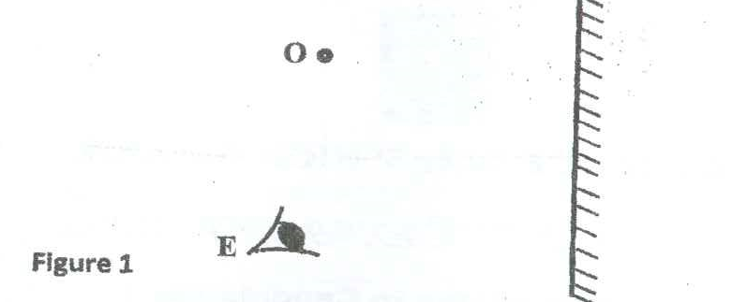
Draw a pair of rays on the diagram above to locate the position of the image I of the object O as seen by the eye, E (2Marks)

- Figure 2 shows an electric circuit in which the ammeter has negligible resistance. When the switch S is closed, the ammeter reads 0.10A. Determine the internal resistance of the cell. (3marks)
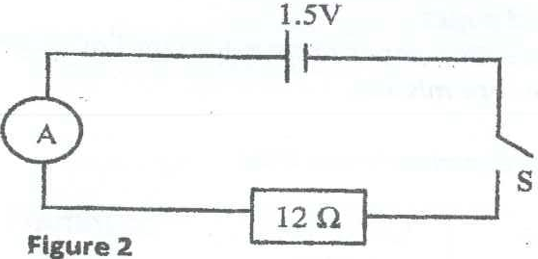

……………………………………………………………………………………………………………………………………………………………………………………………………………………………………………………………………………………………………………………………………………………………………………………………………………………………………………………
…………………………………………………………………………………………………………………………………………………………………………………………………………………………
- A highly positively charged rod is gradually brought close to the cap of negatively charged electroscope, its observed that the leaf initially decreases and then increases. Explain this observation (2marks)
……………………………………………………………………………………………………………………………………………………………………………………………………………………………………………………………………………………………………………………………………………………………………………………………………………………………………………………
…………………………………………………………………………………………………………………………………………………………………………………………………………………………

- Figure 3 shows a circuit containing a battery, two identical bulbs P and Q and a thermistor.
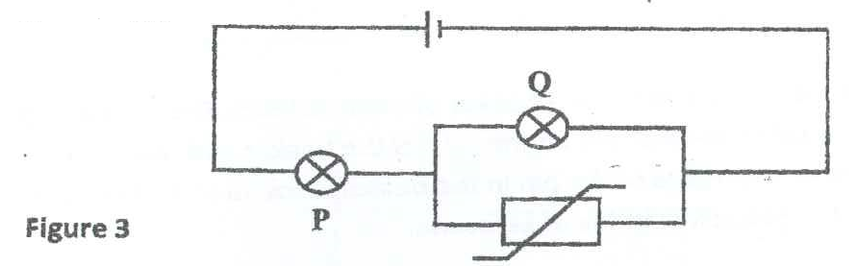

State and explain what will happen to the brightness of the bulb P when the thermistor is steadily heated. (2marks)
……………………………………………………………………………………………………………………………………………………………………………………………………………………………………………………………………………………………………………………………………………………………………………………………………………………………………………………
…………………………………………………………………………………………………………………………………………………………………………………………………………………………

- A lady holds a concave mirror a short distance from her face as shown in figure 4
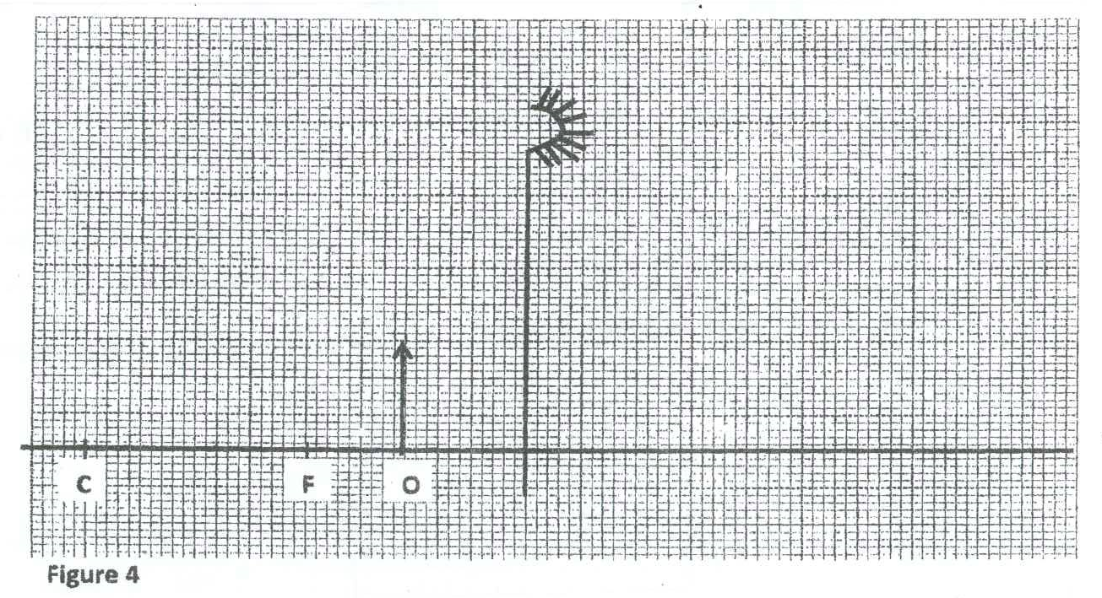
Given that her face represented by object O is as shown on the graph above:
- Draw a ray diagram to show how the image of her face is formed. (2marks)

- State one characteristic of the image formed (1mark)

…………………………………………………………………………………………………………………………………………………………………………………………………………………………

- A pin is placed at the bottom of a beaker of depth 14.5cm. The beaker is then filled with kerosene. By using another pin on the side of the beaker and observing from the top, the distance of the image of the pin in the beaker is found to 4.5cm from the bottom.
Determine the refractive index of kerosene. (2marks)
……………………………………………………………………………………………………………………………………………………………………………………………………………………………………………………………………………………………………………………………………………………………………………………………………………………………………………………
……………………………………………………………………………………………………………

- Figure 5 below shows the paths taken by three radiations A, B and C from a radioactive source through an electric field.
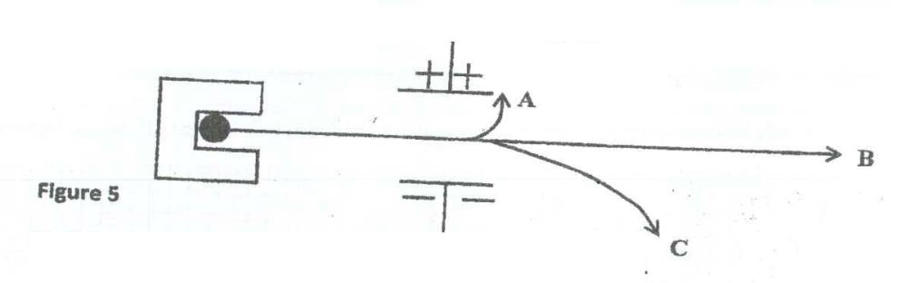
Explain why radiation B is not deviated by the electric field. (1mark)
…………………………………………………………………………………………………………………………………………………………………………………………………………………………
- Figure 6 shows an alternating current (a.c) connected across a diode D and a resistor R
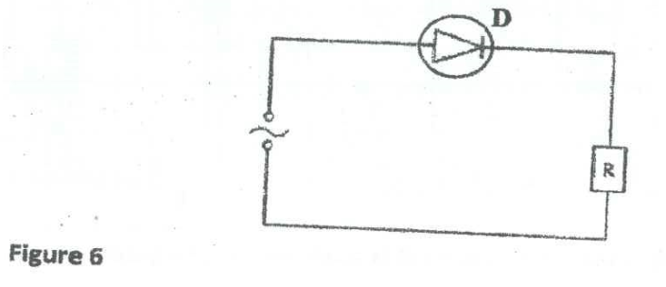
- Show on the diagram where a C.R.O can be connected to display the output voltage. (1mark)

- On the axes provided sketch the output as observed on the C.R.O in (a) above (1mark)

- The two conducting balls shown in figure 7 are identical and contain the number of excess electrons indicated. The two balls are made to touch. Determine how much charge in coulombs each will have.(e=1.6 x10⁻¹⁹C) (2marks)
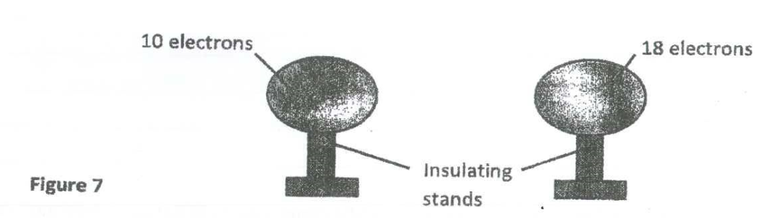
………………………………………………………………………………………………………………………………………………………………………………………………………………………………………………………………………………………………………………………………………

- In a C.R.O, a wave form given in figure 8 was displayed on the screen. The Y gain was set at 5V/cm and time based calibration is 20milliseconds per cm.
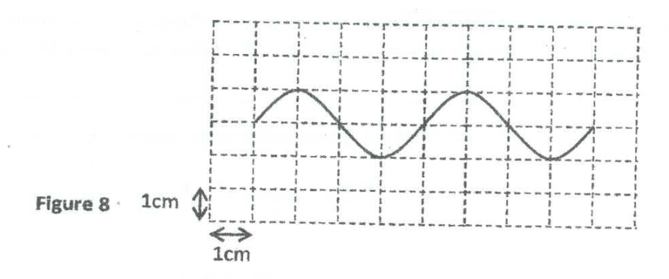
Determine the frequency f the voltage (2marks)
…………………………………………………………………………………………………………………………………………………………………………………………………………………………

- The conductivity of a metallic conductor decreases with increase in temperature whereas the conductivity of a semiconductor increases with increase in temperature. Explain (2marks)
…………………………………………………………………………………………………………………………………………………………………………………………………………………………
…………………………………………………………………………………………………………………………………………………………………………………………………………………………
- Figure 9 shows the cross section of a conductor held between two bar magnets.
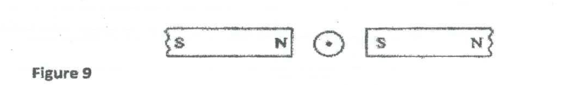
Indicate with an arrow on the diagram the direction in which the conductor should be moved in order to cause current to flow as shown (1mark)

- Electricity can be dangerous. Safety devices such as fuses are often used in circuits and electrical appliances. Give one other example of an electrical safety device (1mark)
…………………………………………………………………………………………………………………………………………………………………………………………………………………………
SECTION B (55 MARKS)
Answer all the questions in this section in the spaces provided after each question

- a)State one difference between light and sournd waves (1mark)
…………………………………………………………………………………………………………………………………………………………………………………………………………………………

b) Briefly explain how sound is propagated in the air (1mark)
…………………………………………………………………………………………………………………………………………………………………………………………………………………………
…………………………………………………………………………………………..

- Figure 10 shows a set up made by a form 2 student at a high School to study an aspect of a wave.

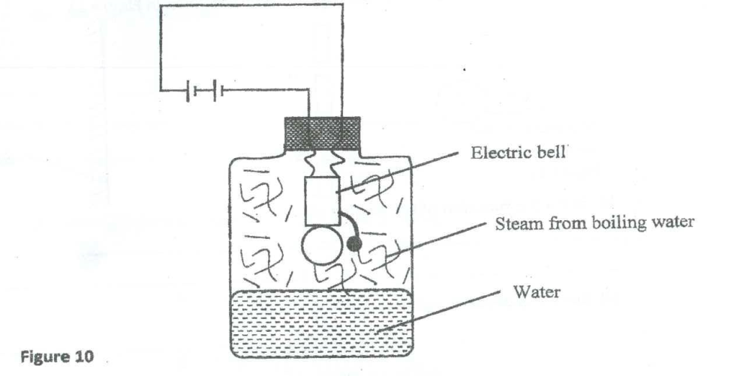

- State what happens to the sound from the bell as the bottle and its contents are cooled to 0⁰C (1mark)
……………………………………………………………………………………………………………

- Explain the observation in (i) above (1mark)
…………………………………………………………………………………………………………………………………………………………………………………………………………………………
……………………………………………………………………………………………….…………..

d)A girl standing on a level ground between two high walls claps her hands. She hears an echo from one wall after 0.7s and from other wall 0.2s later. Determine the distance between the two walls
(Speed of sound in air=ms⁻¹) (3marks)
……………………………………………………………………………………………………………………………………………………………………………………………………………………………………………………………………………………………………………………………………………………………………………………………………………………………………………………
……………………………………………………………………………………………………………………………………………………………………………………………………………………
e)In an experiment to observe the interference of light waves, a double slit was placed close to the source of monochromatic light as shown in figure 11.

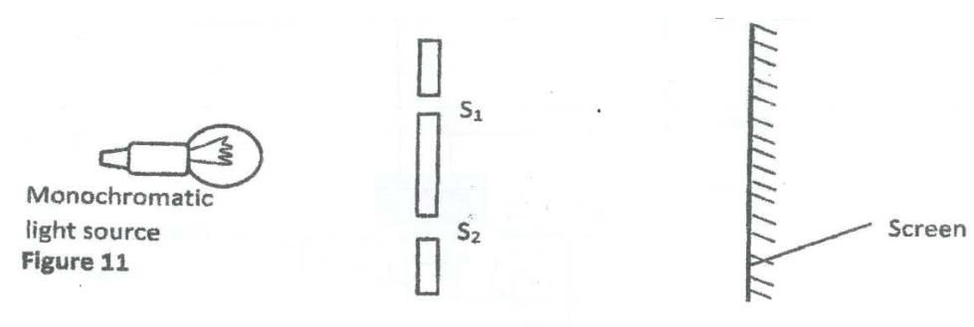

- State the function of the double slit (1mark)
…………………………………………………………………………………………………………………………………………………………………………………………………………………………

- State the observation made on the screen (1mark)
…………………………………………………………………………………………………………………………………………………………………………………………………………………………

- Explain the observation made on the screen (1mark)
…………………………………………………………………………………………………………………………………………………………………………………………………………………………

- a)Give one advantage of transmitting mains electricity as a.c and not as d.c (1mark)
…………………………………………………………………………………………………………………………………………………………………………………………………………………………

b)Figure 12 shows part of a wiring circuit for a house

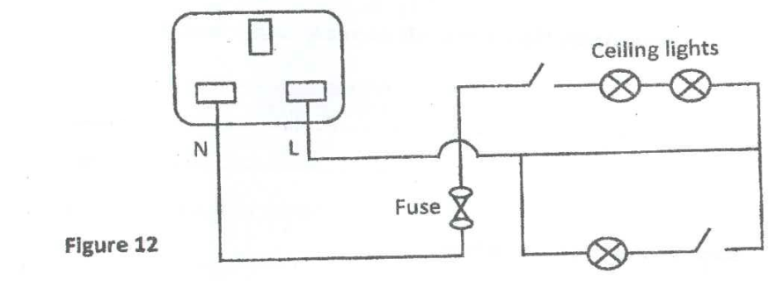

Correct two faults made in the wiring (2marks)
…………………………………………………………………………………………………………………………………………………………………………………………………………………………
…………………………………………………………………………………………………………………………………………………………………………………………………………………………
……………………………………………………………………………………………………………

c)Figure 13 shows a connection to a 3 pin plug

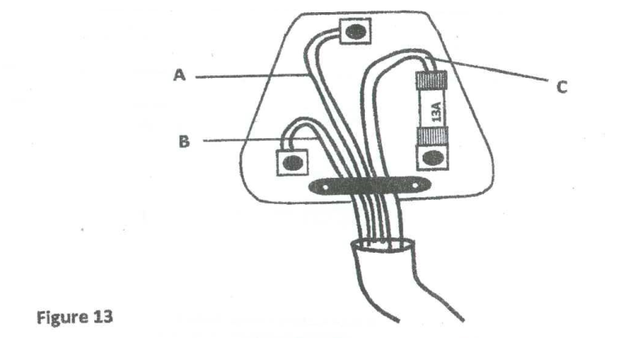

- State the colours of the leads labelled A, B and C (3marks)
A ……………………………………………………………………………………………….
B………………………………………………………………………………………………..
C………………………………………………………………………………………………..

- Give reasons why the earth pin is usually longer than the other two pins (1mark)
…………………………………………………………………………………………………………………………………………………………………………………………………………………………
- State the function of the fuse (1mark)
…………………………………………………………………………………………………………………………………………………………………………………………………………………………
- In a house there is a cooker rated 6KW. The main potential is 240V and the fuses available are 35A, 30A, 15A, and 13A. Determine the fuse that would be suitable for the cooker. (3marks)
…………………………………………………………………………………………………………………………………………………………………………………………………………………………
…………………………………………………………………………………………………………………………………………………………………………………………………………………………

- a)Figure 14 shows a photocell. Study it and answer the questions below
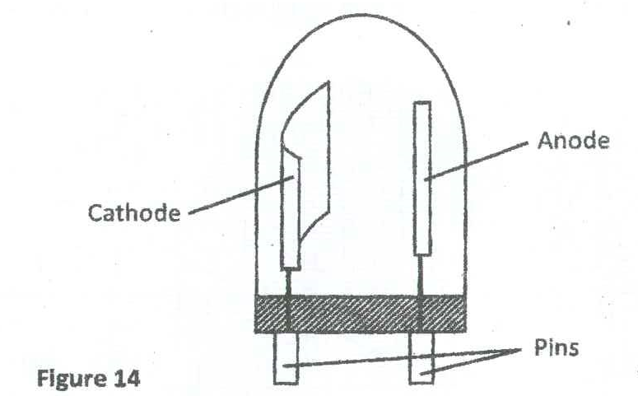
- Explain how the photocell works (1mark)
…………………………………………………………………………………………………………………………………………………………………………………………………………………………

- State two factors that determines the speed of the photoelectrons emitted by the cathode. (2marks)
…………………………………………………………………………………………………………………………………………………………………………………………………………………………
……………………………………………………………………………………………………………

- State one application of the photocell (1mark)
…………………………………………………………………………………………………………………………………………………………………………………………………………………………
b)Figure 15 shows the relation between the stopping potential Vs and the frequency f of radiation when a certain metal surface is illuminated with light of different frequencies
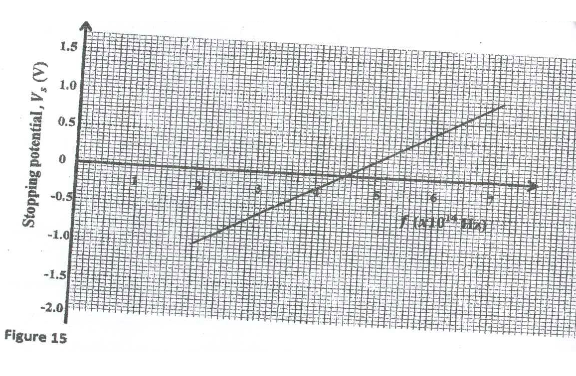
From the graph, determine the:
- Threshold frequency f of the metal surface (1mark)

- Planck’s constant, h (3marks)

- Work function, w0, of the metal surface (2marks)

c)Sodium metal has work function of 2.3ev. if it is irradiated with light of frequency 7.0 x 10¹⁴ Hz, calculate the maximum kinetic energy for the emitted electrons
(change of an electron , e = 1.6 x 10¹⁹C, planck’s constant, h = 6.63 x 10⁻³⁴Js) (3marks)

…………………………………………………………………………………………………………………………………………………………………………………………………………………………
…………………………………………………………………………………………………………………………………………………………………………………………………………………………
………………………………………………………………………………………………………………………………………………………………………………………………………………………………………………………………………………………………………………………………………
……………………………………………………………………………………………………………

- a)Figure 16 shows the features of a diffusion cloud chamber used to detect radiations from radioactive sources
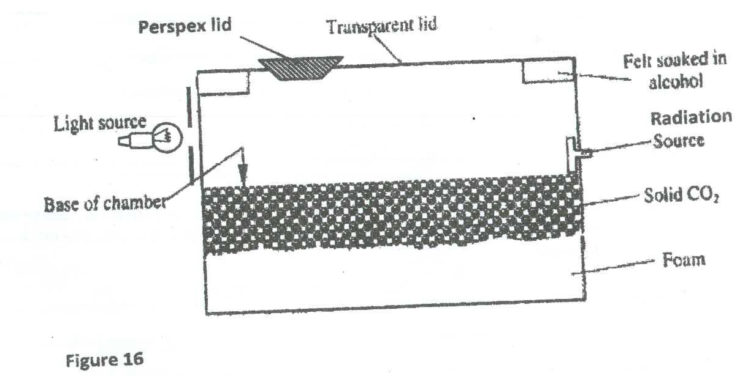
- State the fucnction of the following materials in the chamber (2marks)
Alcohol
………………………………………………………………………………………………………………………………………………………………………………………………………………………………………………………………………………………………………………………………………

Solid CO2
………………………………………………………………………………………………………………………………………………………………………………………………………………………………………………………………………………………………………………………………………

- Explain why the base of the chamber is painted black (1mark)
…………………………………………………………………………………………………………………………………………………………………………………………………………………………

- As the chamber continues to detect radiation, the Perspex lid is rubbed frequently with a piece of cloth. Give a reason for this. (1mark)
…………………………………………………………………………………………………………………………………………………………………………………………………………………………

- Explain how the radiations from the radioactive source are detected in the chamber (2marks)
………………………………………………………………………………………………………………………………………………………………………………………………………………………………………………………………………………………………………………………………………
……………………………………………………………………………………………………………

- A leaf electroscope can also be used as a detector of radiation. State two advantages of the diffusion cloud chamber over the leaf electroscope as a radiation detector (2marks)
………………………………………………………………………………………………………………………………………………………………………………………………………………………………………………………………………………………………………………………………………
…………………………………………………………………………………………………………………………………………………………………………………………………………………………

b)When carrying out experiments using radioactive substances, it is observed that a counter connected to the Geiger muller (GM) tube registers some reading even in the absence of the radioactive source
- State the radiation responsible for the count registered in the absence of the radioactive source(1mark)

……………………………………………………………………………………………………………
…………………………………………………………………………………………………………………………………………………………………………………………………………………………
- State any two possible sources of these radiations (2marks)
……………………………………………………………………………………………………………
…………………………………………………………………………………………………………………………………………………………………………………………………………………………
……………………………………………………………………………………………………………
…………………………………………………………………………………………………………………………………………………………………………………………………………………………

- a)State faraday’s law of electromagnetic induction (1mark)
……………………………………………………………………………………………………………
…………………………………………………………………………………………………………………………………………………………………………………………………………………………

b)Figure 17 shows a simplified illustration of an e.m.f. generator
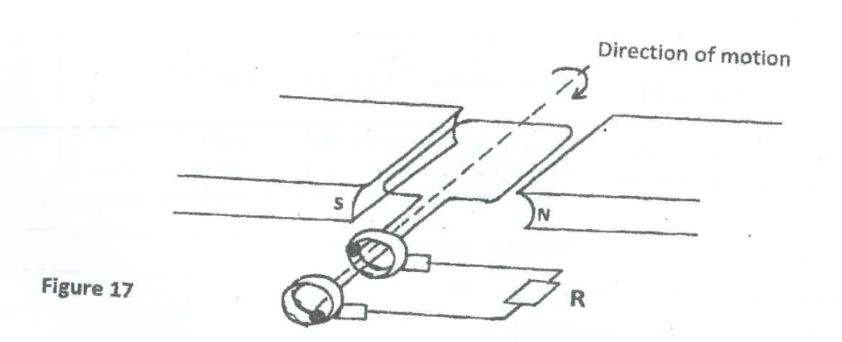
- Show the direction of induced current through R when the coil is in the position shown in the diagram (1mark)
- State two ways of increasing the amount of induced current in this set up (2marks)
……………………………………………………………………………………………………………
…………………………………………………………………………………………………………………………………………………………………………………………………………………………
- On the axes below, sketch a graph to show how potential difference across R varies with the angle of inclination,0. The coil is initially in the vertical position. (1mark)

c)Figure 18 shows a step down transformer connected to a 240V mains socket. The efficiency of the transformer is 60% and a current of 50A flows through P
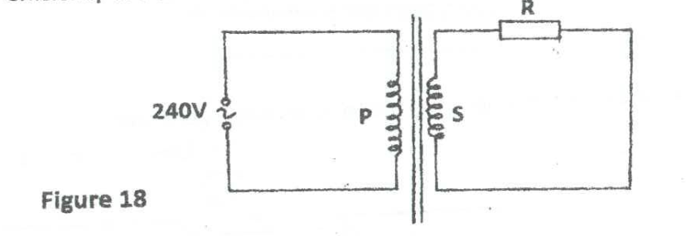
Given that the primary coil has 4000 turns while the secondary coil has 1500 turns, calculate the current through S. (3marks)
……………………………………………………………………………………………………………………………………………………………………………………………………………………………………………………………………………………………………………………………………………………………………………………………………………………………………………………
d)State one similarity and one difference between an induction coil and a step up transformer(2marks)
Similarity
………………………………………………………………………………………………………
Difference ………………………………………………………………………………………………………

