NAME ……………………………………..………………..ADM. NO. …………….……….……..…..…
CANDIDATE’S SIGNATURE …………..………..………..
DATE ……………….……………

443/1
AGRICULTURE
PAPER 1 (THEORY)
TIME: 2 HOURS

CHAMPIONS JET 1 - 2019
KCSE PRE – TRIALS
MARCH – APRIL 2019

INSTRUCTIONS TO CANDIDATES
- Write your name and Admission Number in the spaces provided above.
- Sign and write the date of examination in the spaces provided above.
- This paper consists of THREE sections: A , B and C
- Answer ALL the questions in section A and B
- Answer any two questions in section C.
- ALL answers should be written in the spaces provided.
- This paper consists of 9 Printed pages.
- Candidates should check the question paper to ascertain that all the pages are printed as indicated and that no questions are missing.

FOR EXAMINER’S USE ONLY

Section | Questions | MAXIMUM SCORE | CANDIDATE’S SCORE
A | 1 – 16 | 30
B | 17 – 19 | 20
C |  | 40
Total Score |  | 90

SECTION A (30 MARKS)
Answer ALL the questions in the section in the spaces provided.
- Name three horticultural fields . (2 ½ marks)
………………………………………………………………………………………………………………………………………………………………………………………………………………………………………………………………………………………………………………………………………………………………………………………………………………………………………………………………
- List four ways in which the government can improve local agricultural production. (2 marks)
………………………………………………………………………………………………………………………………………………………………………………………………………………………………………………………………………………………………………………………………………………………………………………………………………………………………………………………………
- State three effects of reliable rainfall in agricultural production (1½ marks)
……………………………………………………………………………………………………………………………………………………………………………………………………………………………………………………………………………………………………………………………………………………………………………………………………………………………………………………
- Give four factors that determines the choice of implements used during primary cultivation.
(2 marks)
………………………………………………………………………………………………………………………………………………………………………………………………………………………………
………………………………………………………………………………………………………………………………………………………………………………………………………………………………

- State four advantages of using inorganic fertilizers over the organic manure. (2 marks)
…………………………...…………………………………………………………………………………………………………………..………………………………………………………………………………….
……………………………………………………...……………………………………………………………………………………………………………...……………………………………………………………

- List four advantages of using vegetative propagation materials. (2 marks)
……………...………………………………………………………………………………………………………………..………………………………………………………………………………………………………………...…………………………………………………………………………………………………………….…………………………………………………………………………………………

- State four advantages of using plastic pipes over metal pipes. (2 marks)
………………………………………………………………………………………………………………………………………………………………………………………………………………………………………………………………………………………………………………………………………………………………………………………………………………………………………………………………

- State four advantages of collective land tenure system (2 marks)
…………………………………………………………………………………………………………………………………………………………………………………………………………………………………………………………………………………………………………………………………………………………………………………………………………………………………………………………….

- State four ways in which threes help in soil conservation. (2 marks)
…………………………………………………………………………………………………………………………………………………………………………………………………………………………………………………………………………………………………………………………………………………………………………………………………………………………………………………………….

- Give four factors that increases depth of planting. (2 marks)
…………………………………………………………………………………………………………………………………………………………………………………………………………………………………………………………………………………………………………………………………………………………………………………………………………………………………………………………….

- State four field conditions that may favour the choice of chemical weed control (2 marks)
…………………………………………………………………………………………………………………………………………………………………………………………………………………………………………………………………………………………………………………………………………………………………………………………………………………………………………………………….

- State four non – chemical methods of controlling storage pests. (2 marks)
…………………………………………………………………………………………………………………………………………………………………………………………………………………………………………………………………………………………………………………………………………………………………………………………………………………………………………………………….

- Give four precautions to observe when harvesting coffee for wet processing method. (1 ½ marks)
…………………………………………………………………………………………………………………………………………………………………………………………………………………………………………………………………………………………………………………………………………………………………………………………………………………………………………………………….

- List four ways in which a farmer can make sufficient use of pasture crop. (2 marks)
…………………………………………………………………………………………………………………………………………………………………………………………………………………………………………………………………………………………………………………………………………………………………………………………………………………………………………………………….

- Outline four limitations of using green manure in crop production. (2 marks)
…………………………………………………………………………………………………………………………………………………………………………………………………………………………………………………………………………………………………………………………………………………………………………………………………………………………………………………………….

- List three factors considered when grading tomatoes for fresh market. (1½ marks)
…………………………………………………………………………………………………………………………………………………………………………………………………………………………………………………………………………………………………………………………………………………………………………………………………………………………………………………………….

SECTION B (20MARKS)
Answer ALL the questions in this section in the spaces provided
- The diagram below illustrates a farming practice. Study it carefully and answer the questions that follow.
Rows of maize

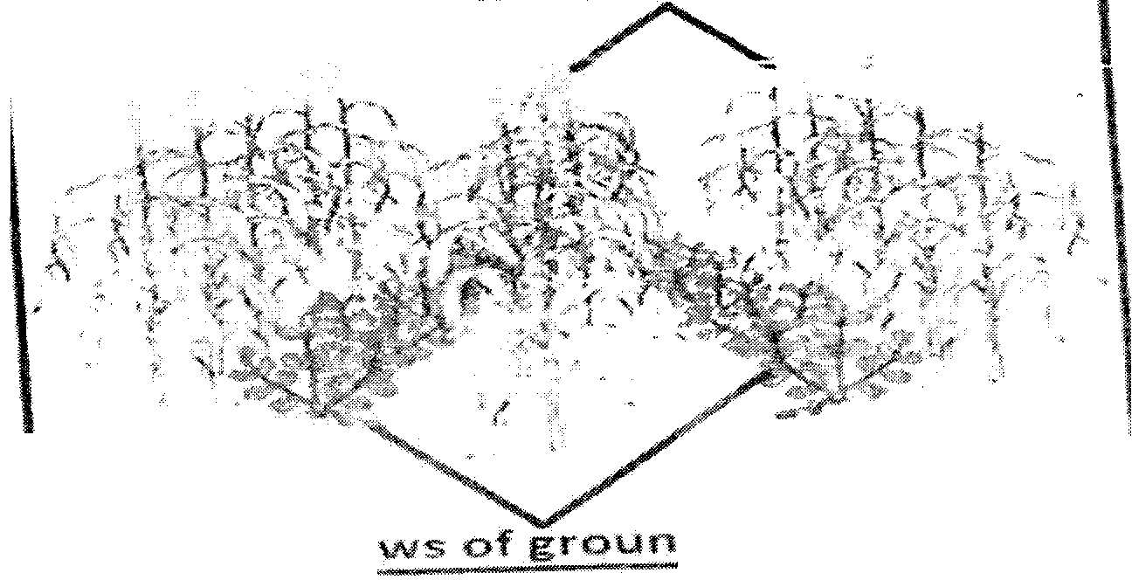

Rows of groundnut

- Name the type of farming practice illustrated above. (1 mark)
………………………………………………………………………………………………………
- List three advantages of the farming practice identified in (a) above (3 marks)
…………………………………………………………………………………………………………………………………………………………………………………………………………
………………………………………………………………………………………………………………………………………………………………………………………………………….
- Give one disadvantage of the farming practice identified. (1 Mark)
………………………………………………………………………………………………………………………………………………………………………………………………………………
- The diagram below shows illustrates a common arable weed. Study it carefully and answer the questions that follow.
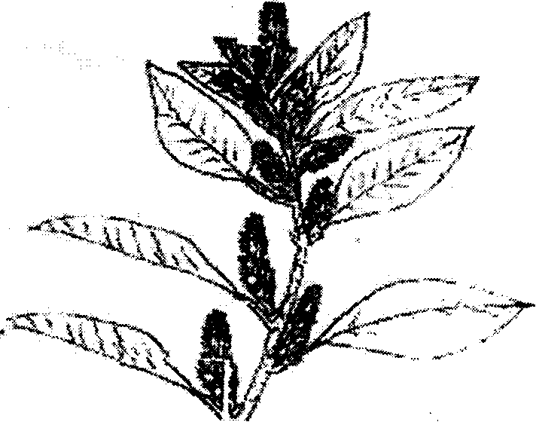

- Identify the weed. (1 mark)
………………………………………………………………………………………………………
- Give two reasons why the weed is successful in its habitat. (2 Marks)
………………………………………………………………………………………………………………………………………………………………………………………………………………………………………………………………………………………………………………………
- State three economic importance of the weed illustrated above. (3 Marks)
…………………………………………………………………………………………………………………………………………………………………………………………………………………………………………………………………………………………………………………………………………………………………………………………………………………………….

- The diagram below illustrates a field crop pest. Study it carefully and answer the questions that follow.


- Identify the pest illustrated. (1 Mark)
………………………………………………………………………………………………………………………………………………………………………………………………………………
- Outline three effects of the pest illustrated above. (3 Marks)
.…………………………………………………………………………………………………….…………………………………………………………………………………………………………………………………………………………………………………………………………....
- State three cultural methods of controlling the pest in (a) above. (3 Marks)
…………………………………………………………………………………………………………………………………………………………………………………………………………………………………………………………………………………………………………………….
- Define the term “economic injury level” of pests in crop production. (2 Marks)
………………………………………………………………………………………………………………………………………………………………………………………………………………………………………………………………………………………………………………………

SECTION C (40 MARKS)
Answer only TWO questions in this section in the spaces provided after the questions.
- a) Outline five importance of health records in the farm (5 marks)
b) Explain five reasons for soil sampling and testing (5 marks)
c) State and explain five factors considered when designing a crop rotation programme. (10 marks)

- (a) Describe carrot production the following subheadings
- Field management (5 Marks)
- Harvesting (5 Marks)

- State and explain ten water harvesting methods in the farm (10 Marks)

- (a) Outline five factors affecting efficiency of pesticides. (5 Marks)
(b) Explain five precautions observed when harvesting pyrethrum. (5 Marks)
(c) Explain various practices carried out in the field to help control crop diseases (10 Marks)

…………………………………………………………………………………………………………………………………………………………………………………………………………………………………………………………………………………………………………………………………………………………………………………………………………………………………………………………….
…………………………………………………………………………………………………………………………………………………………………………………………………………………………………………………………………………………………………………………………………………………………………………………………………………………………………………………………….
…………………………………………………………………………………………………………………………………………………………………………………………………………………………………………………………………………………………………………………………………………………………………………………………………………………………………………………………….
…………………………………………………………………………………………………………………………………………………………………………………………………………………………………………………………………………………………………………………………………………………………………………………………………………………………………………………………….
…………………………………………………………………………………………………………………………………………………………………………………………………………………………………………………………………………………………………………………………………………………………………………………………………………………………………………………………….
…………………………………………………………………………………………………………………………………………………………………………………………………………………………………………………………………………………………………………………………………………………………………………………………………………………………………………………………….
…………………………………………………………………………………………………………………………………………………………………………………………………………………………………………………………………………………………………………………………………………………………………………………………………………………………………………………………….
…………………………………………………………………………………………………………………………………………………………………………………………………………………………………………………………………………………………………………………………………………………………………………………………………………………………………………………………….
…………………………………………………………………………………………………………………………………………………………………………………………………………………………………………………………………………………………………………………………………………………………………………………………………………………………………………………………….
…………………………………………………………………………………………………………………………………………………………………………………………………………………………………………………………………………………………………………………………………………………………………………………………………………………………………………………………….
…………………………………………………………………………………………………………………………………………………………………………………………………………………………………………………………………………………………………………………………………………………………………………………………………………………………………………………………….
…………………………………………………………………………………………………………………………………………………………………………………………………………………………………………………………………………………………………………………………………………………………………………………………………………………………………………………………….
…………………………………………………………………………………………………………………………………………………………………………………………………………………………………………………………………………………………………………………………………………………………………………………………………………………………………………………………….
…………………………………………………………………………………………………………………………………………………………………………………………………………………………………………………………………………………………………………………………………………………………………………………………………………………………………………………………….
…………………………………………………………………………………………………………………………………………………………………………………………………………………………………………………………………………………………………………………………………………………………………………………………………………………………………………………………….
…………………………………………………………………………………………………………………………………………………………………………………………………………………………………………………………………………………………………………………………………………………………………………………………………………………………………………………………….
…………………………………………………………………………………………………………………………………………………………………………………………………………………………………………………………………………………………………………………………………………………………………………………………………………………………………………………………….
…………………………………………………………………………………………………………………………………………………………………………………………………………………………………………………………………………………………………………………………………………………………………………………………………………………………………………………………….
…………………………………………………………………………………………………………………………………………………………………………………………………………………………………………………………………………………………………………………………………………………………………………………………………………………………………………………………….
…………………………………………………………………………………………………………………………………………………………………………………………………………………………………………………………………………………………………………………………………………………………………………………………………………………………………………………………….
………………………………………………………………………………………………………………………………………………………………………………………………………………………………
…………………………………………………………………………………………………………………………………………………………………………………………………………………………………………………………………………………………………………………………………………………………………………………………………………………………………………………………….
…………………………………………………………………………………………………………………………………………………………………………………………………………………………………………………………………………………………………………………………………………………………………………………………………………………………………………………………….

