NAME ………………………………………………………….ADM NO……………………………………………………
SCHOOL……………………………………………………………….STREAM……………………………………………

321/1
BIOLOGY PAPER 1
THEORY
MARCH – 2019

CHAMPIONS JET 1
321/1
BIOLOGY PAPER 1
THEORY
MARCH – 2019

INSTRUCTIONS TO CANDIDATE.

- Write your name, Adm number, school and stream in the spaces proved
- Answer all questions in the spaces provided after each

FOR EXAMINERS’ USE ONLY
Questions | Marks
1 – 20 | 80

- Give a reason for the following precautions during collection and observation of the specimen.
- Returning live specimen to their natural habitat after study. (1mk)
………………………………………………………………………………………………………………………
- Highly mobile animals should be immobilized during the study. (1mk)
………………………………………………………………………………………………………………………
- (a) What is apical dominance ?(1mk)
………………………………………………………………………………………………………………………………………………………………………………………………………………………………………………………….
- State 3 ways of breaking seed dormancy. (3mks)
………………………………………………………………………………………………………………………………………………………………………………………………………………………………………………………………………………………………………………………………………………………………………
- (a) Name the chemical reagents used to test for protein (2mks)
…………………………………………………………………………………………………………………………………………………………………………………………………………………………………………………………
(b) State the main function of co-factors in enzyme controlled reaction.(1mk)
…………………………………………………………………………………………………………………………….
- (a) What is vaccination? (1mk)
………………………………………………………………………………………………………………………………………………………………………………………………………………………………………………………….
(b) Explain the role of vaccination in providing immunity (2mks)
……………………………………………………………………………………………………………………………………………………………………………………………………………………………………………………………………………………………………………………………………………………………………………………….
- Explain the biological significance of emulsification process in duodenum (2mks)
…………………………………………………………………………………………………………………………………………………………………………………………………………………………………………………………………………………………………………………………………………………………………………………….
- (a) Explain why there is less energy production in anaerobic respiration in living organism. (2mks)
…………………………………………………………………………………………………………………………….…………………………………………………………………………………………………………………………….
(b) Define the following terms as used in respiration
(i) Oxygen debt (1mk)
……………………………………………………………………………………………………………………………………………………………………………………………………………………………………
(ii) Respiration Quotient (1mk)
……………………………………………………………………………………………………………………………………………………………………………………………………………………………………
- The diagram below illustrates an experiment carried out by form one students.
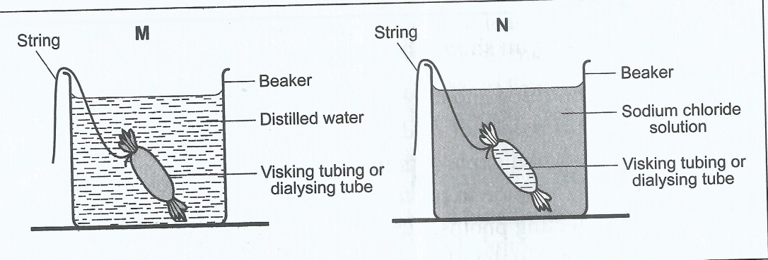

- Explain what happens in set up Mat the end of experiment. (3mks)
………………………………………………………………………………………………………………………………………………………………………………………………………………………………………………………………………………………………………………………………………………………………………
- Explain how the following factors affect the rate of the process being investigated above in a living organism.
- Temperature above 100⁰C. (1mk)
………………………………………………………………………………………………………………………………………………………………………………………………………………………….
- A thin membrane (1mk)
…………………………………………………………………………………………………………………………………………………………………………………………………………………………
- (a) What is pollution ? (1mk)
…………………………………………………………………………………………………………………………………………………………………………………………………………………………………………………………

(b) Distinguish between Global warming and green house effects. (2mks)
………………………………………………………………………………………………………………………………………………………………………………………………………………………………………………………………………………………………………………………………………………………………………………………
- (a) Outline two beliefs held by the proponents of theory of special creation. (2mks)
………………………………………………………………………………………………………………………………………………………………………………………………………………………………………………………….
(b) Outline structural difference between man and apes with respect to the following structures. (2mks)
Structure | Man | Ape
- Pelvis
- Incisor

- State two importance of studying fossils records as evidence of organic evolution (2mks)
………………………………………………………………………………………………………………………………………………………………………………………………………………………………………………
- (a) Name the
- Salivary gland located beneath the tongue (1mk)
…………………………………………………………………………………………………………………
- Hormone that stimulate gall bladder to release the bile juice. (1mk)
………………………………………………………………………………………………………………..
- The diagram bellow illustrates a physiological process in a living organism

- (i) Name the process shown above. (1mk)
………………………………………………………………………………………………………………………

(ii) State the importance of the process named above in fish. (1mk)
………………………………………………………………………………………………………………………………………………………………………………………………………………………………………………
- Name two parts of human being where the above process occurs (2mks)
………………………………………………………………………………………………………………………………………………………………………………………………………………………………………………
- (a) Name the polysaccharide that make up the exoskeleton in phylum Arthropoda
(1mk)
……………………………………………………………………………………………………………………………
(b) Name three external characteristics of animals that enable them to be classified as class Mammalia . (3mks)
………………………………………………………………………………………………………………………………………………………………………………………………………………………………………………………………………………………………………………………………………………………………………………………
- The diagram below shows a stage of cell division in a living organism

- (i) Name the type of cell division shown. (1mk)
……………………………………………………………………………………………………………………………..
(ii)Name the stage of cell division in a(a) (i) above. (1mk)
……………………………………………………………………………………………………………………………..
- Giving a reason for your answer name the Kingdom from which the cell was obtained.
Kingdom…………………………………………………………………………………………………………….
Reason ………………………………………………………………………………………………………………
……………………………………………………………………………………………………………………………..
- State any two importance of mitosis in a living organism. (2mks)
……………………………………………………………………………………………………………………………..
…………………………………………………………………………………………………………………………………………………………………………………………………………………………………………………………..
- (a) State the differences in the composition of blood in the umbilical artery and umbilical vein (3mks)
……………………………………………………………………………………………………………………………..……………………………………………………………………………………………………………………………..
……………………………………………………………………………………………………………………………..
(b) State two functions of the placenta (2mks)
……………………………………………………………………………………………………………………………..
……………………………………………………………………………………………………………………………..
15. Explain how the following structural factors affects the rate of transpiration
(a) Hairy leaves. (2mks)
……………………………………………………………………………………………………………………………..
……………………………………………………………………………………………………………………………..
(b) Glossy leaf surface (2mks)
……………………………………………………………………………………………………………………………..
……………………………………………………………………………………………………………………………..
- (a) What is non disjunction? (1mk)
……………………………………………………………………………………………………………………………..……………………………………………………………………………………………………………………………..
(b) Outline three advantages of polyploidy to plants. (3mks)
……………………………………………………………………………………………………………………………..
……………………………………………………………………………………………………………………………..……………………………………………………………………………………………………………………………..
- (a) What is homeostasis? (1mk)
……………………………………………………………………………………………………………………………..……………………………………………………………………………………………………………………………..

- The quantity of urine passed per in four mammals of the same species, I their natural habitats was S,T,U and V. the results were as shown in the figure below.

Which animal is likely to be living in a desert? Explain the reasons for your answer.
Animal………………………………………………………………………………………………………………
Reason……………………………………………………………………………………………………………………………..…………………………………………………………………………………………………………………
(c) (i) State the cause of liver cirrhosis (1mk)
……………………………………………………………………………………………………………………………..
(ii) Outline any two symptoms of liver cirrhosis (2mks)
……………………………………………………………………………………………………………………………..……………………………………………………………………………………………………………………………..
- Distinguish between Growth and Development (2mks)
……………………………………………………………………………………………………………………………..……………………………………………………………………………………………………………………………..
- (a) Outline any three functional differences between light microscope and electron microscope (3mks)
Light microscope | Electron microscope

- State three functions of golgi apparatus (3mks)
…………………………………………………………………………………………………………………………..……………………………………………………………………………………………………………………………..………………………………………………………………………………………………………………
- (a) Name the causative agents of the following diseases (2 marks)
(i)Typhoid ……………………………………………………………………………………………………………………………..
(ii)Whooping cough
……………………………………………………………………………………………………………………………
(b) Explain why cigarette smoking can cause lung cancer (2mks)
……………………………………………………………………………………………………………………………..……………………………………………………………………………………………………………………………..
……………………………………………………………………………………………………………………………..……………………………………………………………………………………………………………………………..

THIS IS THE LAST PRINTED PAGE.

