Name: ………………….……………………………….……… School………………………………………………
Stream: ……………………….…………………………..……..Index No. …………………………….…………….
312/1
Geography
Paper one
Time: 2 hours 45 minutes
Form Four

CHAMPIONS JET JOINT 2019
Kenya Certificate of Secondary Education

Instructions to candidates
- This paper has two sections, A and B
- Answer all the questions in Section A
- In Section B, answer question 6 and any other TWO questions.
.

FOR OFFICIAL USE ONLY
SECTION A | 1 | 2 | 3 | 4 | 5

SECTION B | 6 | 7 | 8 | 9 | 10

TOTAL

SECTION A (25 MARKS)
Answer all the questions in this section

- (a) Name two forces responsible for the shape of the earth (2mks)
(b) State three reasons why the interior of the earth is hot (3mks)

- The table below represents rainfall and temperature figures for a system in Africa.

Month | J | F | M | A | M | J | J | A | S | O | N | D
Temperature | 24 | 24 | 23 | 22 | 19 | 17 | 17 | 18 | 19 | 20 | 23 | 23
Rainfall (mm) | 109 | 122 | 130 | 76 | 52 | 34 | 28 | 38 | 70 | 108 | 121 | 120

- Calculate the average monthly temperature for the station (2mks)
- Describe the rainfall pattern for the station (3mks)

- The diagram below shows way through which wind transport its load.
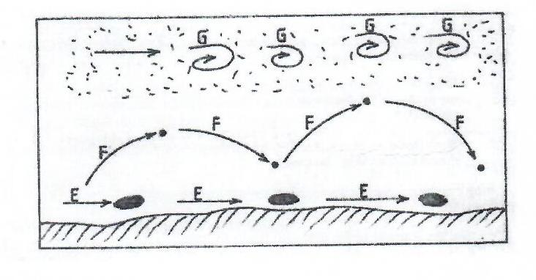
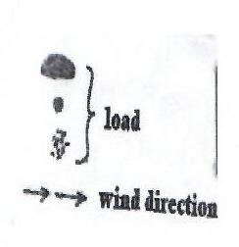

- Name the ways marked E, F and G (3mks)
- Identify two features formed by wind deposition in desert. (2mks)

- (a) What is natural vegetation (2mks)
(b) State three reasons why Tundra region has scanty vegetation (3mks)

- (a) Differentiate between an ocean and a sea (2mks)

(b) The diagram below represents occurrence of tides. Name the parts marked P, Q and R. (3mks)

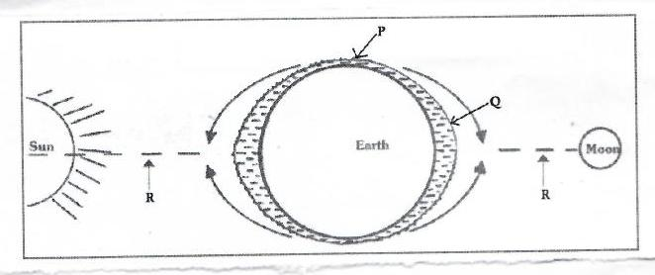

SECTION B
Answer question 6 and any other two questions from this section

- Study the map of Taita hills and answer the questions that follow.

- (i) Measure the distance of river Ruhia from its confluence with river Voi Goshi to grid reference 345270 (2mks)

(ii) Give the location of St Marys’ High School by latitude and longitude (2mks)

- (i) Describe the distribution of vegetation in the area covered by the map (4mks)

(ii) Identify methods which have been used to represent relief in the area covered by the map. (2mks)
- (i) Draw a cross section from grid reference 310140 to grid reference 370140. Use vertical scale of 1 cm represents 20 meters. (3mks)

(ii) Along the cross-section mark and label the following.

- Hill (1mk)
- All weather road (bound surface) (1mk)
- Teita sisal Estate (1mk)

- (i) A bore hole is supposed to be dug in the area covered by grid square 2615.State three factors which may make construction expensive (3mks)
(ii) Citing evidence from the map explain three factors which may favour cattle rearing in the area covered by the map. (6mks)

- (a) Differentiate between a normal fault and a reverse fault (2mks)
(b) Study the diagram below and use it to answer question b(i)

Heave
H
J
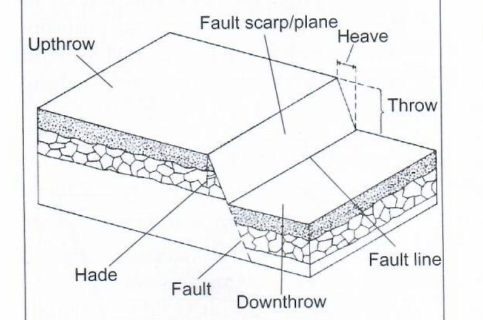

Fault
K
L
Fault line
Throw

- Name the parts labelled H, J, K and L (4mks)
- Give three examples of fault blocks (3mks)

- Using well labelled diagrams, describe the formation of the rift valley by tensional forces (8mks)
- Explain four economic significance of faulting. (8mks)

- (a) (i) Name two areas in Africa associated with karst scenery (2mks)
(ii) State three characteristic of karst scenery (3mks)

(b) (i) State three ways through springs are formed (3mks)
(ii) Explain three conditions necessary for the formation of an artesan well. (6mks)
- Describe how the following features are formed: -

- Grikes and clints (5mks)
- Stalactite (6mks)

- (a) (i) What is an ice sheet? (2mks)
(ii) Name two mountains in East Africa which are ice capped. (2mks)
- Identify three ways in which ice moves. (3mks)
- Explain three factors that influence the movement of ice from the place it has accumulated. (6mks)

(b) Describe how an arete is formed (5mks)
(c) You are required to carry out a field study on erosional features in glaciated lowland areas.
(i) Give two reasons why you would require a working schedule. (2mks)
(ii) Apart from an arete, name two other erosional features you are likely to observe during the field study. (2mks)
- Give three follow up activities you would undertake after the field study. (3mks)

- (a) (i) What is soil (2mks)
(ii) State three main components of soil (3mks)

(b) Explain how the following weathering processes contributes to the formation of soil

- Hydration (3mks)
- Oxidation (4mks)

(c) (i) Name the type of soil structures which fits the following descriptions
- Soil particles are arranged in thin sheets on top of each other. (2mk)
- Soil particles are arranged vertically in cylindrical manner (2mk)
(ii) The diagram below represents soil catena. Identify the nature of soils in the stages marked X, Y and Z. (3mks)

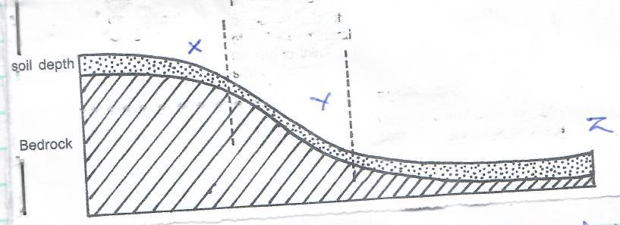
Z
Soil depth
X
Y
Bedrock
- Explain how the following factors cause soil degradation
- Leaching (2mks)
- Mono cropping (2mks)
- Burring of land (2mks)

