CHAMPIONS JET 1, TERM 1, 2019

MARKING SCHEME

PHYSICS PAPER 1

232/1

**1.** 7.6 + ( 0.01 x 4) 7.6 + (0.01 x 4)

= 7.64 cm

Correct reading = 7.64 + 0.02 ✓1

= 7.66 cm✓1

2. -Cohension between mercury molecules is greater than adhesion between mercury and glass; ✓1

- The mercury sinks down the tube to enable molecules to keep together ; ✓1

3. a) v = At ; ✓1

t = v = 0.12cm

A

= 6 x 106 x 10-3 ; ✓1

= 2 x 10-5 cm or 2 x 10-7m ; ✓1

b) i) Thickness of the drop is equal to size of a molecule ; ✓1

ii) The oil drop spread uniformly into a circular path

1. Prevents the column of mercury beyond the constriction from going back to the mercury bulb hence allowing reading at one’s own convenience ; ✓
2. Can painted black ; ✓ it is a better absorber of radiant heat ; ✓
3. Σ ACM = Σcm

30 x 20 = 30 x F✓

F = $\frac{600}{30}=20N$

Magnetic force = 20-5

= 15N✓

1. F=0.1HZ

U = 4/0.2 = 5m/s

V = 0.5/0.2 = 2.5 m/s

a= -2.5 / 0.6 = -4.167

1. Water expands on freezing raising the centre of gravity of the tumbler ; ✓1 Thus the glass tumbler becomes less stable; ✓1

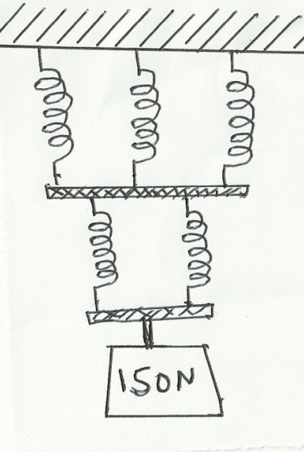

e1

e2

e1 =

e2 =

eT =

(b) The diameter of the spring, number of turns per unit length, thickness of the wire used to make the spring

1. Before braking, distance = 0.3 x 30

= 9m

After braking

S = ut + ½ at2

S= 30 x 2 + ½ (-15) x 22

S= 60 – 30

S = 30m

Total stopping distance = 9 + 30

= 39m

1. As the gas passes through the nozzle, its velocity increases🗸. Hence its pressure reduces above the nozzle. The higher atmospheric pressure pushes air into the gas stream. 🗸

|  |  |
| --- | --- |
|  | 1. i) Archimede’s Principle staes that when a body is partially or wholly immersed in a fluid, it experiences an upthrust equal to the weight of the fluid desplaced.   ii) Upthrust in liquid = 1.04 – 0.72 = 0.32N  Upthrust in water = 1.04 – 0.64 = 0.40  Density of liquid =  Density of liquid =  (b) i) A floating body displaces its own weight of the fluid in which it floats.  ii) A ship is hollow and displaces a large volume of water to provide enough upthrust equal to its own weight, while steel rod sinks since it is denser than water.  iii)Hydrometer   1. Volume of water displced = ¾ x 40 = 30 l = 0.03 m3   Weight of buoy = mg = 10 x 10 = 100N  Weight of sea water displced = density x gravity x volume  = 1.04 x 103 x 10 x 0.03 N = 312N  Weight of sea water displced = Upthrust  Tension T = Upthrust – Weight of buoy = 312 – 100 ; T = 212N |

1. Plotting pressure against absolute temp we get a straight line graph

P

Pas

T (k)

Conclusion

Pressure of infixed mass of a gas indirectly proportional to its absolute to temperature if volume is kept constant

b) i) P = kT + C Where k and C are constants, determine from the graph, values of k and C

K = gradient

= (8-0) X 104 NM -2

200 - 0

K = 400N m-2 K-1

C = O

ii) Why would it be possible for pressure of the gas to be reduced to zero in practice?

* The gas liquefies at low temperature before reaching zero Kelvin

c) A gas is put into a container of fixed volume at a constant volume at a pressure of 2.1 x 105.

Nm-2 and temperature 27°C. The gas is then heated to a temperature of 327°C. Determine

the new pressure

P1 = P2 T2 =273 + 327

T1 T2 = 600K

P1 = 2.1 X 105 Nm-2  P2 = P1 T2

P2 = ? T1 2

T1= 27+ 273 = (2.1 X 6~~00~~) X 105NM -2 = 4.2 X105NM-2

= 300K 3~~00~~

1. (a) i) W=mgh=2000×10×3=60,000 J

ii) P= $w/t$ = $\frac{60,000}{6}$ =10,000W

iii) = $\frac{Power output}{power input}$ ×100

= $\frac{10}{12.5}$ ×100=80%

b)

1. p.e=mgh

=20×10×0.9=180J

1. k.e gained= p.e lost

mv2=mgh

2=

=4.24m/s

1. (a) The direction is continuously changing. This implies change in velocity hence acceleration.

(b) (i) the angular velocity.

$$ω=2πf=2×3.142×6=37.704rad/s$$

(ii) the centripetal acceleration.

2

(iii) c=2

(iv)

(c) (i)

(ii) $\frac{p}{m}=slope$

$p=m×slope=20×0.2=4.0N$

(iii) It represents centripetal force

1. (i) Specific heat capacity is the quantity of heat required to raise the temp.of a unit mass of a substance by one Kelvin.
2. Heat gained by calorimeter = MCCCΔθ

= Heat capacity x Δθ

= 40 x (34 – 25)

= 40 x 9 = 360J

Heat gained by water = MW x CW x Δθ

= 0.10 x 4200 x 9

= 3780J

1. Heat lost by metal block = 3780 + 360 = 4140J 🗸

(iv) Heat lost by metal block = Heat gained by calorimeter + water

Mb x Cb x Δθ = 4140

0.15 x Cb x (100 – 34) = 4140

(66 x 0.15)Cb = 4140 🗸

 🗸

1. ( a) i) A body continues in its state of ret or uniform motion in a straight line unless acted upon by an external force.✓1
2. Ft = m (v-u)

75 x 0.1 = ✓1

V = 30 m/s ✓1

(b) (i) M1V­1 + M2V­2 = (M1V­2)v

V = ✓

= 2.27 m/s✓

(ii) a =

= -1.136 m/s2✓

v2 = u2 + 2as

0 = (2.27)2 – (2 x 1.136s) ✓1

s = 2.268 m ✓1