PHYSICS PP3 SCHEME
a) iii) PART A
Table III
L(cm) | 100 | 80 | 60 | 40 | 20 | 0
V(volts) | 0.5 – 0.7  0.08 – 0.12 | 0.6 – 1.0  0.13 – 0.17 | 0.7 – 1.1  0.18 –1 0.22 | 0.8 – 1.2  0.33 – 0.37 | 0.9 – 1.3  0.68 – 0.72 | 1.1 – 1.5  1.23 – 1.27
I (A) | 0.12 – 0.16  0.04 – 0.08 | 0.14 – 0.18  0.06 – 0.10 | 0.15 – 0.19  0.08 – 0.12 | 0.16 – 0.20  0.12 – 0.16 | 0.17 – 0.21  0.14 – 0.18 | 0.18 – 0.22  0.16 – 0.20
Try both tables and use the one that gives advantage to the candidate . For each correct value / entry give ½ for a maximum of 5 for both v and I
Total (5mrks)
iv)
Axes :- should be well labeled with correct units 1
Scale :- Simple and uniform1
Plotting : correct should be smooth and passing through at least 3 correctly plotted points within 1 small square1
N/B curve should be continuous
Total (5mrks)
- For drawing a tangent at I = 0.15A 1
Slope = ΔV
ΔI
= 0.85 - 0.65 ½ correct intervals from tangent
0.175 – 0.13
= 4.4444 V/A
Or 4.4444 Ω 1 For correct evaluation to 2 d.p rounded or truncating
½ For units
N/B if curve is wrong
i.e Co, this part is awarded zero.
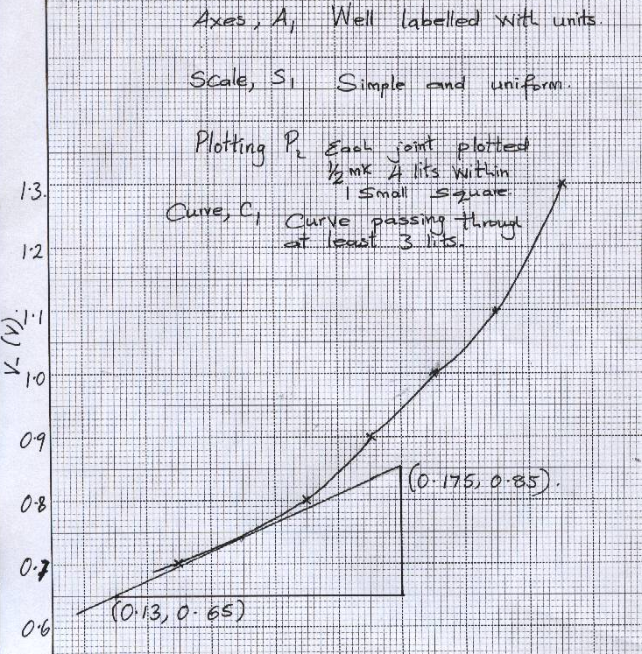
0.12 0.13 0.14 0.15 0.16 0.17 0.18 0.19 0.20 0.21
I (A)

b) (viii)
Angle i⁰ | 10 | 20 | 30 | 40
Distance x (cm) | 5.2 | 4.5 | 3.9 | 3.4

(ix) b = 6.2 cm
(x) A_{x} = 4.25 cm

(xi) Refractive index = 6.2 = 1.45 ± 0.05
4.25

- iii)
Length from A to B (cm) | 80 | 76 | 72 | 68 | 64 | 60
Time for 10 oscillations(s) | 10 | 11 | 12 | 13 | 14 | 15
Period time T (s) | 1.0 | 1.1 | 1.2 | 1.3 | 1.4 | 1.5
T²(S²) | 1.00 | 1.21 | 1.44 | 1.69 | 1.96 | 2.25
2θ | 150⁰ | 138⁰ | 130⁰ | 108⁰ | 104⁰ | 96⁰
θ | 75⁰ | 69⁰ | 65⁰ | 54⁰ | 520 | 48⁰
Cos θ | 0.2588 | 0.3883 | 0.4226 | 0.5878 | 0.6157 | 0.6691
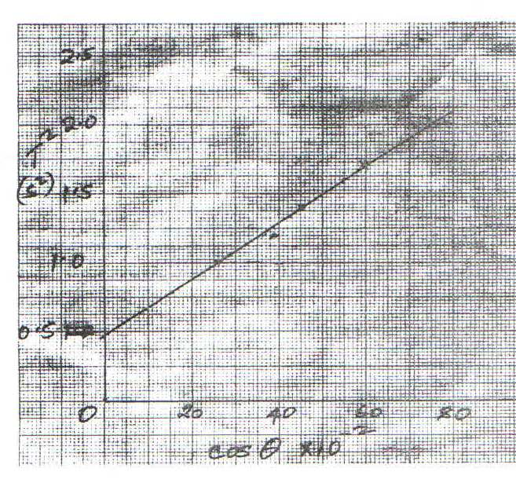
f)

g) $Slope s=\frac{change in y}{change in x}=\frac{∆y}{∆x}=\frac{1.5-1.0}{50-25}=2$
h) $K=\frac{1.6π^{2}}{s}=\frac{1.6x{\left(\frac{22}{7}\right)}^{2}}{2}=0.8x\left(\frac{22}{7}\right)=7.9$

