**NAME:…………………………………………….…INDEX NO:…………………...**

**SCHOOL:……………………………….……CANDIDATES SIGN:……….……...**

**DATE: ………………………..…..**

**443/1**

**AGRICULTURE**

**PAPER 1**

**TIME: 2 HOURS**

**BURAMU FORM FOUR JOINT EVALUATION TEST 2019**

***Kenya Certificate of Secondary Education(K.C.S.E)***

**443/1**

**AGRICULTURE**

**PAPER 1**

**TIME: 2 HOURS**

**INSTRUCTIONS TO CANDIDATES.**

1. This paper has three sections A, B and C
2. Answer ALL questions in section A and B and TWO questions from section C.
3. This paper consists of 9 printed pages.
4. Candidates should check the question paper to ensure that ALL pages are printed as indicated and no questions are missing

**FOR EXAMINER’S USE ONLY.**

|  |  |  |  |
| --- | --- | --- | --- |
| **SECTION** | **QUESTION** | **MAXIMUM SCORE** | **CANDIDATE’S SCORE** |
| A | 1-15 | 30 |  |
| B | 16-19 | 20 |  |
| C | 20-22 | 40 |  |
| **TOTAL SCORE** | | **90** |  |

**SECTION A (30 MARKS).**

1. State **FOUR** ways through which Agriculture contributes to Industrial development. (2mks)

2. state **FOUR** form of horticultural farming. (2mks)

3. State **FOUR** characteristics of shifting cultivation. (2mks)

4. Name **FOUR** beneficial biotic factors that influence crop production.

(2mks)

5. State **FOUR** factors to consider when choosing the type of irrigation to use in the farm. (2mks)

6. State **FOUR** farming practices that ensure minimum tillage. (2mks)

7. Give **FOUR** reasons why land clearing should be carried out. (2mks)

8.a) Name **THREE** vegetative planting materials used for propagating pineapples. (1 ½ mks)

b) Give **THREE** reasons why farmers are encouraged to use certified seeds for planting. (1 ½ mks)

9. State any **FOUR** effects of rainfall on Agriculture. (2mks)

10. State five importance of drainage as a land reclamation method. (2 ½ mks)

11. Give **TWO** reasons for adding well rotten organic manure to a compost heap. (2mks)

12. List **FOUR** soil factors that may lead to low crop yield. (2mks)

13. Give **FOUR** conditions that have led to fragmentation and subdivision of agricultural land in Kenya. (2mks)

14. State **FOUR** cultural methods of soil conservation. (2mks)

15. State **TWO** effects of Aphids on pants. (1mk)

**SECTION B. (20 MARKS).**

16. The diagram below illustrates a field management practice carried out to a fruit crop.

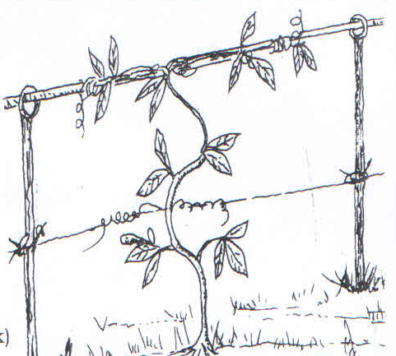

a) Identify the practice illustrated above. (1mk)

b) Give **TWO** reasons for carrying out the practice illustrated above. (2mks)

c) Name **ONE** crop onto which the practice is applicable. (1mk)

17. Study the weeds illustrated below and answer the questions that follows.



a) Identify the weeds shown above. (2mks)

b) Give economic importance of each of the weeds A and B. (1mk)

c) State the advantage of weed C on the farm. (1mk)

d) Give **TWO** reasons why weed D is difficult to control. (1mk)

18. The illustrations below represents types of soil structures. Study them carefully and answer the questions that follow.



a) Identify the soil structure X and Y. (1mk)

b (i) State **TWO** reasons why X is not suitable for growing maize. (2mks)

ii) Give **one** way of improving the soil structure X. (1mk)

19. Observe the following diagram and answer the questions that follow.



a) Identify the type of structure above used to prepare seedlings. (1mk)

b) State **TWO** advantages of this method of preparing seedlings. (2mks)

a) After sowing seeds, give **ONE** practice carried out before seedlings germinate. (1mk)

20. Study the diagram below and answer the questions that follow.

|  |  |  |  |  |  |
| --- | --- | --- | --- | --- | --- |
| Date | Disease Symptom | Animal(s)  Affected | Drugs  Used | Cost of Treatment  Given | Remarks |
|  |  |  |  |  |  |

a) Identify the type of the farm record shown above. (1mk)

b) List **TWO** information contained in the above record. (2mks)

c) Give **one** importance of keeping the above record. (1 mark)

**SECTION C (40 MARKS)**

21.a) Describe **TEN** practices that a farmer should carry out to ensure uniform germination of seeds. (10mks)

b) Outline **SEVEN** advantages of land consolidation in land tenure reforms.

(7mks)

c) List **THREE** factors considered in designing a crop rotational programme.

(3mks)

22.a) Describe the establishment of kales under the following sub headings.

1. Nursery preparation. (6mks)
2. Transplanting (3mks)
3. Field practices. (3mks)

b) Explain **EIGHT** factors considered when spacing crops. (8mks)

23.a) State and explain **FIVE** factors influencing the efficiency of pesticides in crop production. (10mks)

b) State **five** advantages of rotational grazing. (5mks)

c) Describe the procedure of harvesting tea. (5mks)