Name: ……………………………………………... Index no ……..…......................................

Candidate’s sign …………………….......

Date: ……………………………………

443/2
AGRICULTURE
PAPER 2
MARCH. 2019
TIME: 2 HOURS

BURAMU 1 EXAMINATION - 2019
Kenya Certificate of Secondary Education (K.C.S.E.)
Agriculture
Paper 2
2 hours

INSTRUCTIONS TO CANDIDATES:
- Write your name, index number, in the spaces provided.
- Sign and write the date in the spaces provided above.
- This paper consists of three sections A, B and C.
- Answer all questions in section A, B and any two questions from section C
- Answers should be written in the spaces provided.
For Examiner’s Use Only:

SECTION | QUESTIONS | MAXIMUM SCORE | CANDIDATES SCORE
A | 1-20 | 30
B | 21-23 | 20
C |  | 20  20
 | TOTAL SCORE | 90

SECTION A (30 Marks)
Answer all the questions in this section in the spaces provided

1.Name two bloodless methods of castration in lambs. (1 mark
......................................................................................................................................................................................................................................................................................................................

2. Name the strokes in a four stroke cycle engine. (2 marks)
…………………………………………………………………………………………………………………………………………………………………………………………………………………………………………………………………………………………………………………………………………………………………………………………………………………………………………

3. Give the appropriate term that refers to each of the following:

(a) castrated chicken ( ½ mark)
………………………………………………………………………………………………………
(b) young one of a rabbit ( ½ mark)
………………………………………………………………………………………………………

4. Distinguish between the following terms as sued in livestock health:

(a) isolation and quarantine; (1 marks)
………………………………………………………………………………………………………………………………………………………………………………………………………………………………………………………………………………………………………………………

(b) curative drug and prophylactic drug (1 marks)
………………………………………………………………………………………………………………………………………………………………………………………………………………………………………………………………………………………………………………………

5. State four practices that immediately come after complete milking in a milking shade
(2marks)
………………………………………………………………………………………………………………………………………………………………………………………………………………………………………………………………………………………………………………………………………………………………………………………………………………………………

6. Name two practices that are carried out when preparing ewes for mating (1mark) ………………………………………………………………………………………………………………………………………………………………………………………………………………

7. State three factors that would determine the amount of concentrate fed to dairy cattle.
(1 ½ mks) ………………………………………………………………………………………………………………………………………………………………………………………………………………………………………………………………………………………………………………………………………………………………………………………………………………………………

8. Give three reasons why calves should be housed in individual pens. ( 1 ½ marks)
………………………………………………………………………………………………………………………………………………………………………………………………………………………………………………………………………………………………………………………

9. Name two plumbing tools. (1mk)
………………………………………………………………………………………………………………………………………………………………………………………………………………

10. State three advantages of embryo transplant in dairy cattle (1 ½ mks)
………………………………………………………………………………………………………………………………………………………………………………………………………………………………………………………………………………………………………………………
11. Name the breed of sheep which has lambing percentage of 125 – 140 ( ½ mk)
………………………………………………………………………………………………………

12. Give three signs that would indicate a cow has died of anthrax. (1½ mks)
………………………………………………………………………………………………………………………………………………………………………………………………………………………………………………………………………………………………………………………

13. Give three reasons for feeding bees (1½ marks)
………………………………………………………………………………………………………………………………………………………………………………………………………………………………………………………………………………………………………………………

14. Give two reasons why identification of farm animals is important (1 marks)
………………………………………………………………………………………………………………………………………………………………………………………………………………

15. Name two larval stages in the life cycle of a liver fluke (1 mark)
………………………………………………………………………………………………………………………………………………………………………………………………………………

16. Outline four types of fence that can be used in mixed farm (2marks) ………………………………………………………………………………………………………………………………………………………………………………………………………………………………………………………………………………………………………………………………………………………………………………………………………………………………

17. Name three methods of out breeding in livestock production (1 ½ marks)
………………………………………………………………………………………………………………………………………………………………………………………………………………………………………………………………………………………………………………………

18.(a) Give four methods of administering vaccines in poultry. (2marks) ………………………………………………………………………………………………………………………………………………………………………………………………………………………………………………………………………………………………………………………………………………………………………………………………………………………………

(b) State three characteristics of an effective acaricide (1 ½ mks)
………………………………………………………………………………………………………………………………………………………………………………………………………………………………………………………………………………………………………………………
19.Give four reasons for treating timber used in construction of farm store. (2 marks)
………………………………………………………………………………………………………………………………………………………………………………………………………………………………………………………………………………………………………………………………………………………………………………………………………………………………

20.State two factors that influence the daily water intake in a dairy cow (1 marks)
………………………………………………………………………………………………………………………………………………………………………………………………………………

SECTION B (20Marks)
Answer all the questions in this section in the spaces provided
21. The diagram below shows a farm implement. Study it and answer questions that follow

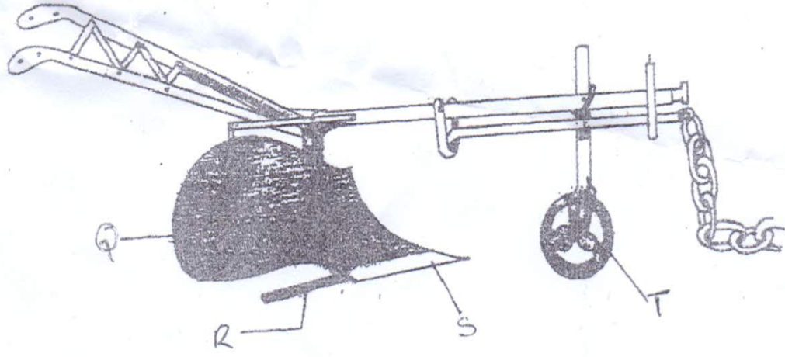

- Identify the farm implement illustrated above. (1mk)
………………………………………………………………………………………………………

- (i) Name the parts labeled Q , R , S and T
Q………………………………………………………………………………….( ½ mk)
R…………………………………………………………………………………..( ½ mk )
S…………………………………………………………………………………...( ½ mk)
T……………………………………………………………………………………( ½ mk)
(ii) Give the function of the part labeled R. (1mk)
………………………………………………………………………………………………….

(c ) Give two functions of the implement illustrated above. (2mks)
………………………………………………………………………………………………………………………………………………………………………………………………………………………………………………………………………………………………………………………

22. (a) The diagram labeled A illustrated show the teeth arrangement of a hand workshop saw. Study it and answer questions that follow.
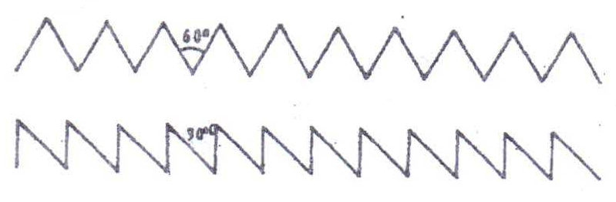
- Name the type of saw represented by the teeth arrangement A and B. (1mk)
A………………………………………………………………………………………...
B………………………………………………………………………………………..

(ii) Give the functional difference between tools A and B represented above. (2mk)
………………………………………………………………………………………………………………………………………………………………………………………………………………………………………………………………………………………………………………………………………………………………………………………………………………………………………………………………………………………………………………………………………………………………………………………………………………………………………………………………………………………………………………………………………………………

- Give two maintenance practices for the tools represented by the teeth illustrated above. (2mks)
………………………………………………………………………………………………………………………………………………………………………………………………………………

23. (a) Below is an illustration of an activity carried out in poultry management. Study it and
answer questions that follow.
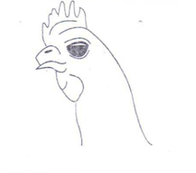
- Identify the practice illustrated above. (1mk)
………………………………………………………………………………………………………
- Give two reasons for carrying out the practice illustrated above. (2mks)
………………………………………………………………………………………………………………………………………………………………………………………………………………

b) The diagram below represents a calf pen. Study the diagram and answer the
questions that follow.
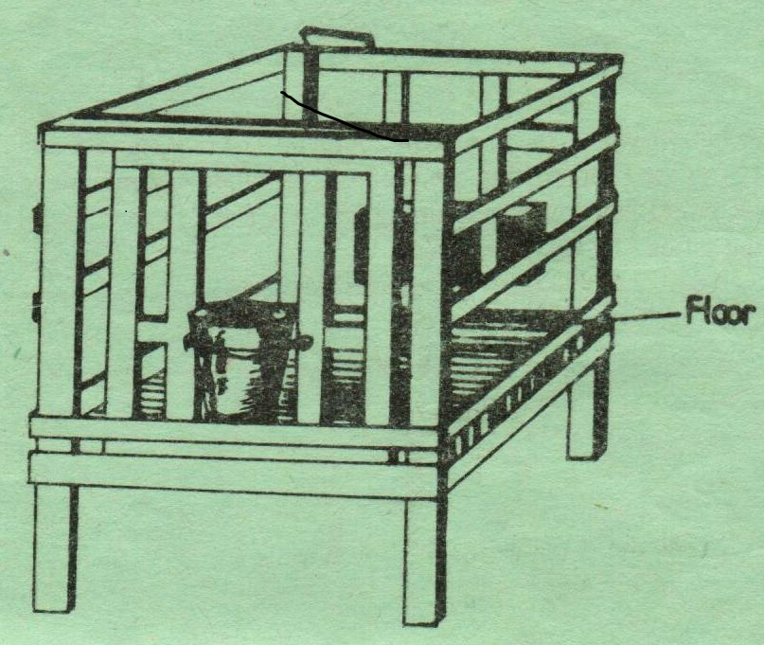
i) Identify the type of floor. (1mk)
………………………………………………………………………………………………………

ii) How high should the floor be raised above the ground level. (1mk)
………………………………………………………………………………………………………
………………………………………………………………………………………………………

c) i) Give one reason for having the floor of the calf pen raised. (1mk)
………………………………………………………………………………………………………
………………………………………………………………………………………………………

ii) State three factors that should be considered in siting the calf pen. (3mks)
………………………………………………………………………………………………………
………………………………………………………………………………………………………
………………………………………………………………………………………………………
………………………………………………………………………………………………………

SECTION C (40 MKS)
Answer any two questions from this section in the spaces provided.
24.(a) (i) State the factors that determine the choice of a poultry rearing system by farmer
(6mks)
………………………………………………………………………………………………………………………………………………………………………………………………………………………………………………………………………………………………………………………………………………………………………………………………………………………………………………………………………………………………………………………………………………………………………………………………………………………………………………

(ii) Outline the factors to consider in sorting and grading eggs (4mks)
………………………………………………………………………………………………………………………………………………………………………………………………………………………………………………………………………………………………………………………………………………………………………………………………………………………………………………………………………………………………………………………………………

(b) (i) Describe five practices that would ensure clean milk production (5mks)
………………………………………………………………………………………………………………………………………………………………………………………………………………………………………………………………………………………………………………………………………………………………………………………………………………………………………………………………………………………………………………………………………
(c) Describe the processing of honey using heat method. (5mks)
………………………………………………………………………………………………………………………………………………………………………………………………………………………………………………………………………………………………………………………………………………………………………………………………………………………………………………………………………………………………………………………………………

25.(a) Discuss milk fever disease under the following subheadings
(i) Cause (1mk)
………………………………………………………………………………………………………
(ii) Livestock attacked (2mks)
………………………………………………………………………………………………………………………………………………………………………………………………………………
(iii) Symptoms (5mks)
………………………………………………………………………………………………………………………………………………………………………………………………………………………………………………………………………………………………………………………………………………………………………………………………………………………………………………………………………………………………………………………………………………………………………………………………………………………………………………………………………………………………………………………………………………………………………………………………………………………………………………………………………………………………………………………………………………………………………………………………………………………………………………………………………………

(iv) Control measures (2mks)
………………………………………………………………………………………………………………………………………………………………………………………………………………………………………………………………………………………………………………………………………………………………………………………………………………………………………………………………………………………………………………………………………………………………………………………………………………………………………………………………………………………………………………………………………………………………………………………………………………………………………………………………………………………………………………………………………………………………………………………………………………………………………………………………………………………………………………………………………………………………………………………………………………………………………………………………………………………………

(b) State the major difference in the digestion of food between ruminants and non- ruminants in the following parts of the digestive systems.

(i) Mouth (3mks)
………………………………………………………………………………………………………………………………………………………………………………………………………………………………………………………………………………………………………………………………………………………………………………………………………………………………………………………………………………………………………………………………………

(ii) Caecum (2mks)
………………………………………………………………………………………………………………………………………………………………………………………………………………………………………………………………………………………………………………………………………………………………………………………………………………………………………………………………………………………………………………………………………
(c) Describe five methods of controlling cannibalism in a flock of layers (5mks)
………………………………………………………………………………………………………………………………………………………………………………………………………………………………………………………………………………………………………………………………………………………………………………………………………………………………………………………………………………………………………………………………………………………………………………………………………………………………………………

26.(a) State five non – chemical methods of controlling ticks in cattle (5mks)
………………………………………………………………………………………………………………………………………………………………………………………………………………………………………………………………………………………………………………………………………………………………………………………………………………………………………………………………………………………………………………………………………………………………………………………………………………………………………………………………………………………………………………………………………………………………………………………………………………………………………………………………………………………………………………………………………………………………………

(b) Explain five construction features necessary in a fish pond (5mks)
………………………………………………………………………………………………………………………………………………………………………………………………………………………………………………………………………………………………………………………………………………………………………………………………………………………………………………………………………………………………………………………………………………………………………………………………………………………………………………………………………………………………………………………………………………………………………………………………………………………………………………………………………………………………………………………………………………………………………………………………………………………………………………………………………………………………………………………………………………………………………………………………………………………………………………………………………………………………………………………………………………………………………………………………………………………………………………………………………………………………………………………………………………………………………………………………………………………………………………………………………………………………………………………………………………………………………………………………………………………………………

(c) (i)State five maintenance practices of a tractor battery (5mks)
………………………………………………………………………………………………………………………………………………………………………………………………………………………………………………………………………………………………………………………………………………………………………………………………………………………………………………………………………………………………………………………………………………………………………………………………………………………………………………………………………………………………………………………………………………………………………………………………………………………………………………………………………………………………………………………………………………………………………………………………………………………………………………………………………………

(ii) Explain five possible causes of overheating in an engine (5mks)
……………………………………………………………………………………………………………………………………………………………………………………………………………………………………………………………………………………………………………………………………………………………………………………………………………………………………………………………………………………………………………………………………………………………………………………………………………………………………………………………………………………………………………………………………………………………………………………………………………………………………………………………………………………………………………………………………………………………………………………………………………………………………………………………………………………………………………………………………………………………………………………………………………………………………………………………………………………………………………………………………………………………………………………………………………………………………………………………………………………………………………………………………………………………………………………………………………………………………………………………………………………………………………………………………………………………………………………………………………………………………………….……………………………………………………………………………………………………………………………………………………………………………………………………………………………………………………………………………………………………………………………………………………………………………………………………………………………………………………………………………………………………………………………………………………………………………………………………………………………………………………………………………………………………………………………………………………………………………………………………………………………………………………………………………………………………………………………………………………………

