Name: ……………………………………………………………… Index No.: …………

Candidate’s Signature: ………………………………………….. Date: ……………………….

442/1
ART AND DESIGN
Paper 1
Time: 1½Hrs

BURAMU I JOINT EXAM – 2019
Kenya Certificate of Secondary Education
442/1
ART AND DESIGN
Paper 1
Time: 1½Hrs

INSTRUCTIONS TO CANDIDATES

- Write your name and index number in the spaces provided above.
- Sign and write the date of the examination in the spaces provided above.
- This question paper consists of three sections A, B and C.
- Answer all questions in section A and B.
- Answer any one question in section C.
- All answers should be written in the spaces provided.
- Where drawings and diagrams are appropriate they should be included within the text of your answer.

For Official Use Only

Section | Question | Maximum  Score | Score
A | 1 | 20
B | 2 | 05
B | 3 | 05
B | 4 | 05
B | 5 | 05
B | 6 | 05
C |  | 15
Max. Score Paper 1 |  | 60

Candidates should check the question paper to ascertain that
All the pages are printed as indicated and that no questions are missing.

SECTION A: 20 MARKS

Answer all questions in the spaces provided.

(a) Explain the contemporary functions of ornaments (2 marks)

………………………………………………………………………………………………………………………………………………………………………………………………………………………………………………………………………………………………………………………………………………………………………………………………

(b) Name three properties of clay (1½ marks)
………………………………………………………………………………………………………………………………………………………………………………………………………………………………………………………………………………………………

(c) (i) State the functions of voids in a sculpture during construction
(1 mark)

…………………………………………………………………………………………

(ii) What is the importance of priming a surface before painting (1½ marks)
………………………………………………………………………………………………………………………………………………………………………………………………………………………………………………………………………………

(d) Give the name assigned to a person who poses to be drawn by an artist. (1 mark)
……………………………………………………………………………………………...

(e) State two reasons for sketching . (2 marks)
………………………………………………………………………………………………………………………………………………………………………………………………………………………………………………………………………………………………………………………………………………………………………………………………
………………………………………………………………………………………………

(f) Describe three basic hues and give examples (2 marks) ………………………………………………………………………………………………………………………………………………………………………………………………………………………………………………………………………………………………………………………………………………………………………………………………

(g) The diagram below illustrates a ceramic decoration process.

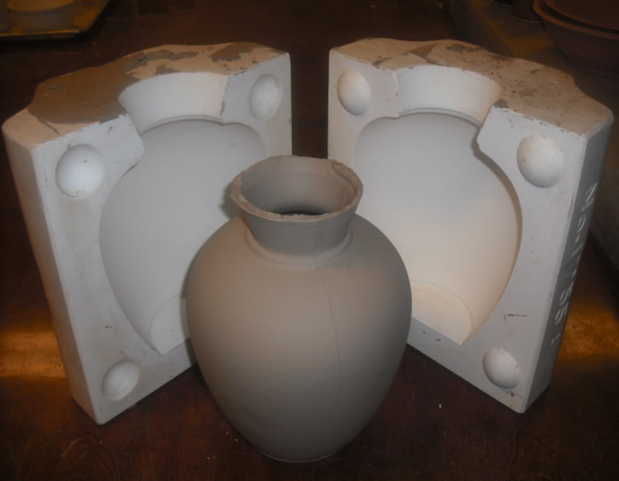

Name and explain the process being illustrated. (2 marks)
………………………………………………………………………………………………………………………………………………………………………………………………………………………………………………………………………………………………………………………………………………………………………………………………

(h) Study the form below and use it to answer the questions that follow.

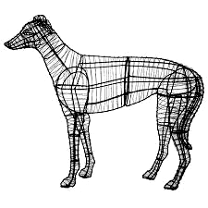

- Name the material and the technique used to make the form (2 marks)
……………………………………………………………………………………………………………………………………………………………………………………………………………………………………………………………………………………………………………………………………………………………….

- State the characteristics of a sculpture made using this technique
(1 mark)
……………………………………………………………………………………….

- State the importance and function of the form (2 marks)
……………………………………………………………………………………………………………………………………………………………………………………………………………………………………………………………………………………………………………………………………………………………….

(i) State any two reasons why green ware should be fired (2 marks)
………………………………………………………………………………………………………………………………………………………………………………………………………………………………………………………………………………………………

(j) State the function and placement of the graphic art work below (1 mark)



SECTION B: 25 MARKS

Answer all questions in the spaces provided

- Explain the difference of the following in painting

- Thinners and binders. (2 marks)
………………………………………………………………………………………………………………………………………………………………………………………………………………………………………………………………………………………………………………………………………………………………………………………………………………………………………………………………………………………………………………………………………………………………………………………………

- Tools and materials. (2 marks)
………………………………………………………………………………………………………………………………………………………………………………………………………………………………………………………………………………………………………………………………………………………………………………………………………………………………………………………………………………………………………………………………………………………………………………………………

- Supports and display boards. (2 marks)
………………………………………………………………………………………………………………………………………………………………………………………………………………………………………………………………………………………………………………………………………………………………………………………………………………………………………………………………………………………………………………………………………………………………………………………………

- Explain the following terms as used in Mosaic and Collage:

- Tesserae (1 mark)
………………………………………………………………………………………………………………………………………………………………………………………………………………………………………………………………………………………

- Interstices. (1 mark)
………………………………………………………………………………………………………………………………………………………………………………………………………………………………………………………………………………………

- Juxtaposition. (1 mark)
………………………………………………………………………………………………………………………………………………………………………………………………………………………………………………………………………………………

- Superimposition (1 mark)
………………………………………………………………………………………………………………………………………………………………………………………………………………………………………………………………………………………

- (i) Write the word ‘love’ in upper case block letters as it would appear on a block for
printing and on the printing surface. (2 marks)

(ii) State characteristics of a letterhead (3 marks)
……………………………………………………………………………………………………………………………………………………………………………………………………………………………………………………………………………………………………………………………………………………………………………………………………………………………………………………………………………………

- (i) Define and explain “weaving” (2 marks)
…………………………………………………………………………………………………………………………………………………………………………………………………………………………………………………………………………………………………………………………………………………………………………………………………………………………………………………………………………………………………………………………………………………………………………………

(ii) With illustrations explain any three book making techniques (3 marks)

…………………………………………………………………………………………………………………………………………………………………………………………………………………………………………………………………………………………

- (a) Discuss the following components of an effective graphic design work. (3 marks)

- Illustration
- Typography
- Layout
………………………………………………………………………………………………………………………………………………………………………………………………………………………………………………………………………………………………………………………………………………………………………………………………………………………………………………………………………………………………………………………………………………
………………………………………………………………………………………………………………………………………………………………………………………………………………………………………………………………………………………………………………………………………………………………………………………………………………………………………………………………………………………………………………………………………………………………………………………………………………………………………

(b) What is a design brief? (2 marks) ………………………………………………………………………………………………………………………………………………………………………………………………………………………………………………………………………………………………………………………………………………………………………………………………………………………………………………………………………………………………………………………………………………………………………………
SECTION C: 15 MARKS

Answer ONE question in the spaces provided

- (i) Discuss the terms ‘addition’ and ‘subtraction’ in sculpture. (3 marks)
(ii) What is an armature in sculpture? (1 mark)
Illustrate your answer. (2 marks)
(iii) Explain briefly how Paper Mache can be prepared and used as a material for sculpture.

(9 marks)

- (i) Draw a clearly labeled color wheel. (5 marks)
(ii) Explain the following terms as related to color.

- Analogous (2 marks)
- Chromatic and achromatic. (2 marks)
- Complementary. (2 marks)
- Tertiary (2 marks)
- Triad (2 marks)

- (i) Define crackled or marbled effect and explain how it is achieved in batik. (2 marks)
(ii) Illustrate the safest way of heating wax for fabric decoration. (5 marks)
(iii) Using illustrations, describe the process of producing a mono-colored fabric using the pleating technique in tie and dye. (8 marks)

………………………………………………………………………………………………………………………………………………………………………………………………………………………………………………………………………………………………………………………………………………………………………………………………………………………………………………………………………………………………………………………………………………………………………………………………………………………………………………………………………………………………………………………………………………………………………………………………………………………………………………………………………………………………………………………………………………………………………………………………………………………………………………………………………………………………………………………………………………………………………………………………………………………………………………………………………………………………………………………………………………………………………………………………………………………………………………………………………………………………………………………………………………………………………………………………………………………………………………………………………………………………………………………………………………………………………………………………………………………………………………………………………………………………………………………………………………
………………………………………………………………………………………………………………………………………………………………………………………………………………………………………………………………………………………………………………………………………………………………………………………………………………………………………………………………………………………………………………………………………………………………………………………………………………………………………………………………………………………………………………………………………………………………………………………………………………………………………………………………………………………………………………………………………………………………………
………………………………………………………………………………………………………………………………………………………………………………………………………………………………………………………………………………………………………………………………………………………………………………………………………………………………………………………………………………………………………………………………………………………………………………………………………………………………………………

………………………………………………………………………………………………………………………………………………………………………………………………………………………………………………………………………………………………………………………………………………………………………………………………………………………………………………………………………………………………………………………………………………………………………………………………………………………………………………………………………………………………………………………………………………………………………………………………………………………………………………………………………………………………………………………………………………………………………
………………………………………………………………………………………………………………………………………………………………………………………………………………………………………………………………………………………………………………………………………………………………………………………………………………………………………………………………………………………………………………………………………………………………………………………………………………………………………………………………………………………………………………………………………………………………………………………………………………………………………………………………………………………………………………………………………………………………………
………………………………………………………………………………………………………………………………………………………………………………………………………………………………………………………………………………………………………………………………………………………………………………………………………………………………………………………………………………………………………………………………………………………………………………………………………………………………………………………………………………………………………………………………………………………………………………………………………………………………………………………………………………………………………………………………………………………………………
………………………………………………………………………………………………………………………………………………………………………………………………………………………………………………………………………………………………………………………………………………………………………………………………………………………………………………………………………………………………………………………………………………………………………………………………………………………………………………

