NAME:…………………………………………………INDEX NUMBER:………………..
SCHOOL………………………………………………ADM No:………………STREAM…..
231/2
BIOLOGY
PAPER 2
MARCH- 2019
TIME: 2 HOURS

BURAMU1 JOINT EXAMINATION -2019
Kenya Certificate of Secondary Education

INSTRUCTIONS TO CANDIDATES:
- Write your name and index number in the spaces provided.
- Answer all the questions in Section A in the spaces provided.
- In section B answer questions 6 (compulsory) and either question 7 or 8 in the spaces provided

FOR EXAMINER’S USE ONLY
SECTION | QUESTIONS | MAXIMUM SCORE | CANDIDATES SCORE
A | 1 | 8
 | 2 | 8
 | 3 | 8
 | 4 | 8
 | 5 | 8
B | 6 | 20
 | 7 | 20
 | 8 | 20
 | TOTAL | 80
- Study the diagram below and answer the questions there after.
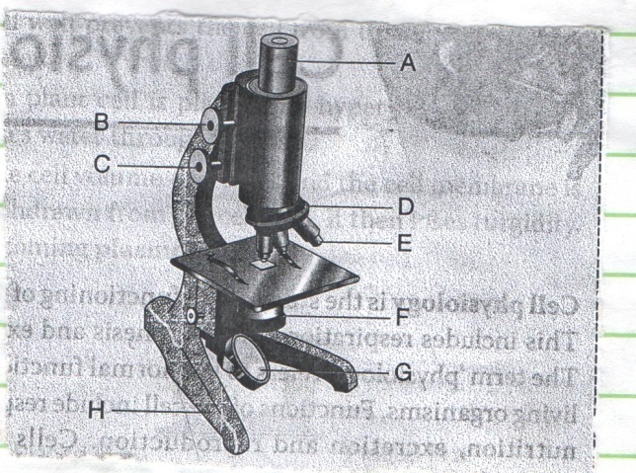

- Name the parts labeled A, B, E and F (4mks)
A……………………………………………………………………………………….
B………………………………………………………………………………….........
E……………………………………………………………………………………….
F……………………………………………………………………………………….
- State two differences between the microscope shown above and electron microscope.(2mks)
Light Microscope | Electron Microscope

- A student used a light microscope to observe and draw the transverse section of a leaf petiole. The total magnification of the image was x400. Given that the eye piece lens was marked x10, work out the objective lens magnification. (2mks)
………………………………………………………………………………………………………………………………………………………………………………………………………………………………………………………………………………
- Two herbivorous mammalian species were introduced into an ecosystem at the same period and in equal numbers. The population growth during their first seven years. Study the graph and answer the questions that follow.
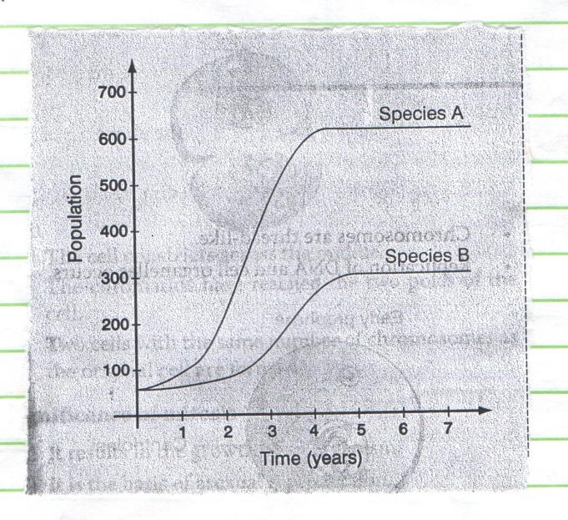

- Which species is better adapted to the ecosystem. Give a reason. (2mks)
………………………………………………………………………………………………………………………………………………………………………………………………………………………………………………………………………………………………
- Account for the shape of the curve for species a between:
- One and a half years (1¹/₂years) and three and a half years (3¹/₂ years). (2mks)
………………………………………………………………………………………………………………………………………………………………………………
- Three and a half years (3¹/₂ years) and seven years (7yrs) (2 mks)
………………………………………………………………………………………………………………………………………………………………………………………………………………………………………………………………………
- A natural predator for species A was introduced into the ecosystem.
Giving a reason explaining how the population of each species would be affected (2mks)
………………………………………………………………………………………………………………………………………………………………………………………………………………………………………………………………………………………………

3. 4. Use the photograph of mammalian digestive system and associated organs to answer the questions that follow.
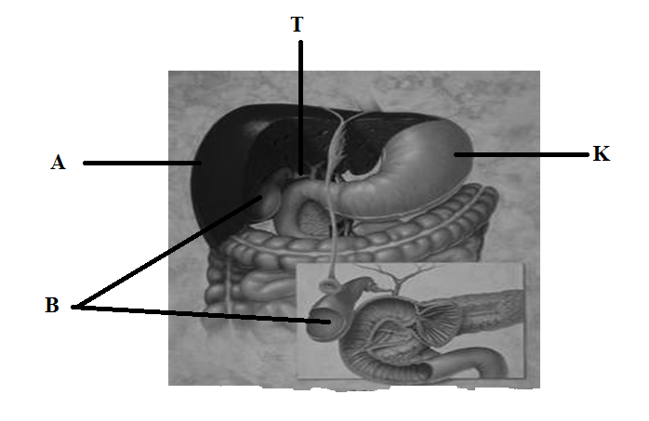

(i) Name the structures marked A, R, K andT. (4marks)
A……………………………………………………………………………………………….B……………………………………………………………………………………………….K……………………………………………………………………………………………….T………………………………………………………………………………………………..
(ii) Name an acid found in the structure labelled K. (1mark)
………………………………………………………………………………………………...
(iii) Name the juice stored in the structure labelled B and give its function. (2marks)
Juice…………………………………………………………………..…………………..
Function………………………………………………………………………………………………………………………………………………………………………………………...…………………………………………………...………………………………………………………………………………………………....................................................…
(iv) Label with letter D part where function named in (iii) above takes place. ( 1 mark)
……………………………………………………………………………………………………...
4. In humans, hairy ear is controlled by a gene on the Y chromosome.
(a) Using letter Y^{H} to represent the chromosome carrying gene for hairy ears, work out a cross between a hairy eared man and wife. (4 marks)

(b) (i) What is the probability of girls having hairy ears? (1 mark)

(ii) Give a reason for your answer in b(i) above. (1 mark) ............................................................................................................................................... ................................................................................................................................................
(c) Name two disorders in humand that is determined by sex-linked genes. (2 marks)
................................................................................................................................................
................................................................................................................................................
5.(a) Examine the drawings of the leaves and the dichotomous key shown below.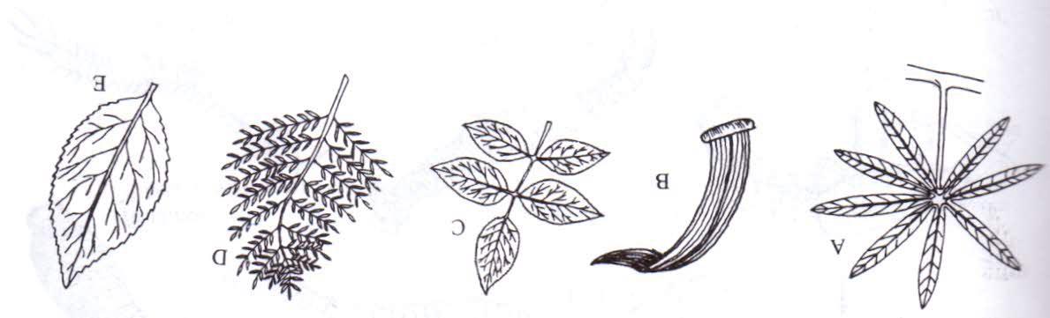

1 (a) Leaf simple .........................................................................................go to 2.
(b) Leaf compound....................................................................................go to 6
2 (a) Leaf needle shaped...............................................................................pine.
(b) Leaf thin and flat .................................................................................go to 3.
3 (a) Leaf parallel veined.....................................................................star grass
(b) Leaf net-veined ..................................................................................go to 4
4 (a) Leaf divided into several tubes.......................................................passion fruit
(b) Leaf not divided ...............................................................................go to 5
5 (a) Leaf margin smooth ........................................................................Avocado
(b) Leaf margin toothed......................................................................Hibiscus
6 (a) Leaflets arising from the same point at tip of petiole.................cassava
(b) Leafless arising at different points along a common stalk..............go to 7
7 (a) Each leaflet divided further into several leaflets.............................Jacaranda
(b) Leaflets not divided ........................................................................Rose
Using the key, identify each of the leaves A – E. In each case, give the sequence of steps which you followed in identifying each leaf. (5 marks)
Specimen | Steps | Identify
A
B
C
D
E

(b) State three characteristics of Monera that are not found in other kingdoms
(3 marks)
................................................................................................................................................
................................................................................................................................................
................................................................................................................................................
...............................................................................................................................................

SECTION B.
Answer question 6 (COMPULSORY) and either question 7 or 8 in the spaces provided.
6. An experiment was done to determine the concentration in the blood of two hormones X and Y produced in the ovaries of a healthy woman aged 30 years within a period of 28 days. The results obtained are shown in the table below.
Time (days) | Concentration of hormone X (arbitrary units) | Concentration of hormone Y (arbitrary units)
2 | 5 | 4
4 | 12 | 4
6 | 18 | 4
8 | 28 | 4
10 | 40 | 4
12 | 56 | 4
14 | 24 | 4
16 | 20 | 9
18 | 24 | 20
20 | 24 | 36
22 | 22 | 48
24 | 16 | 32
26 | 8 | 24
28 | 3 | 4

(a) Using same axes, plot a graph of the concentration of hormones X and Y against time. (7 marks)

(b) Suggest the identity of the hormones X and Y. (2 marks)
X .........................................................................................................................................
Y .........................................................................................................................................
(c) When was the concentration of hormones X and Y equal? (1 mark)
X .........................................................................................................................................
Y .........................................................................................................................................
(d) Explain the role played by the hormones X and Y during menstrual cycle. (4 marks)
X .........................................................................................................................................
.........................................................................................................................................
Y .........................................................................................................................................
.........................................................................................................................................
(e) Briefly describe three features and mechanisms that hinder self-pollination and self fertilization in plants. (6 marks)
................................................................................................................................................
................................................................................................................................................
................................................................................................................................................
................................................................................................................................................
................................................................................................................................................
................................................................................................................................................
7. (a) Describe how gaseous exchange takes place in terrestrial plants. (12 marks)
(b) Explain how blood clotting occurs. (8 marks)

8. (a) Explain the role of Antidiuretic hormone when there is excess water in the human body. (8 marks)
(b) Explain the conditions necessary for germination. (12 marks)

................................................................................................................................................................................................................................................................................................................................................................................................................................................................................................................................................................................................................................................................................................................................................................................................................................................................................................................................................................................................................................................................................................................................................................................................................................................................................................................................................................................................................................................................................................
................................................................................................................................................................................................................................................................................................................................................................................................................................................................................................................................................................................................................................................................................................................................................
................................................................................................................................................................................................................................................................................................................................................................................................................................................................................................................................................................................................................................................................................................................................................
................................................................................................................................................................................................................................................................................................................................................................................................................................................................................................................................................................................................................................................................................................................................................
................................................................................................................................................................................................................................................................................................................................................................................................................................................................................................................................................................................................................................................................................................................................................
................................................................................................................................................................................................................................................................................................................................................................................................................................................................................................................................................................................................................................................................................................................................................
...............................................................................................................................................................................................................................................................................................................................................................................................................................................................................................................................................................................................................................................................................................................................................................................................................................................................................................................................................................................................................................................................................................................................................................................................................................................................................................................................................................................................................................................................................................................................................................................................................................................
………………………………………………………………………………………………………………………………………………………………………………………………………………………………………………………………………………………………………………………………………………………………………………………………………………………………………………………………………………………………………………………………………………………………………………………………………………………………………………………………………………………………………………………………………………………………………………………………………………………………………………………………………………………………………………………………………………………………………………………………………………………………………………………………………………………………………………………………………………………………………………………………………………………………………………………………………………………………………………………………………………………………………………………………………………………………………………………………………………………………………………………………………………………………………………………………………………………………………………………………………………………………………………………………………………………………………………………………

