Name…………………………………… ………………………Index No:……………………
School:………………………………………………………..Adm No…………..STREAM…..

231/3
BIOLOGY
Paper 3
(Practical)
MARCH-2019
Time: 1 ¾ Hours
BURAMU1 JOINT EXAMINATION-2019
Kenya Certificate of Secondary Education

INSTRUCTIONS TO CANDIDATES
- Answer all the questions in the spaces provided.
- You are required to spend 15 minutes of the 1 ¾ hours allowed for this paper reading the whole paper carefully before commencing your work.
- Answer must be written in the spaces provided.
- Additional pages must not be inserted.
For Examiners Use Only
Question | Maximum score | Candidate’s score
1 | 12
2 | 16
3 | 12
TOTAL | 40

- You are provided with an extract labeled T. using the reagents provided, test for the various food substances. Fill the table below. (12 marks)
Food Tested | Procedure | Observation | Conclusion

- The photographs below show fruits of different plants.
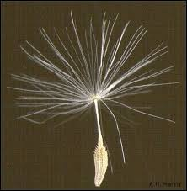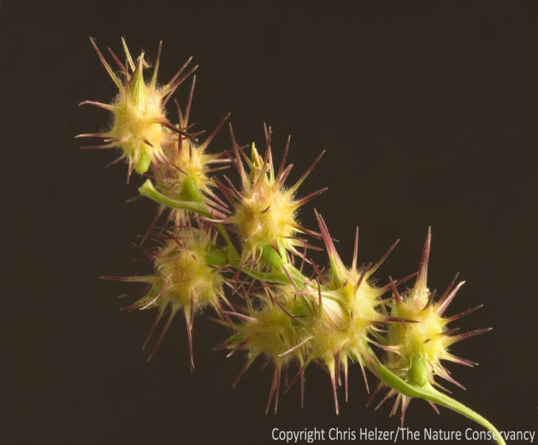
B
A
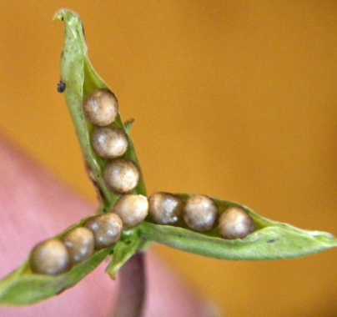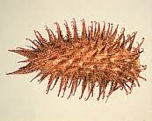
D
C

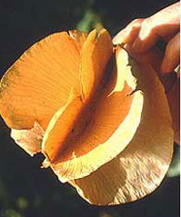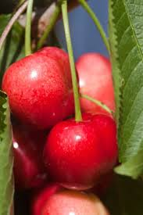
F
E

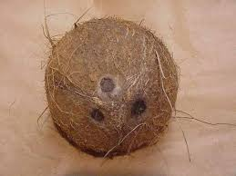
G

- From the appearance of the structures, categorise the fruits according to their mode of dispersal. Give reasons for your answer in each category.
- Dispersal by wind: (1 mark)
………………………………………………………………………………………………
Reason: (1mark)
..............................................................................................................................................
- Dispersal by Animals: (1mark)
…………………………………………………………………………………………….
Reasons: (2marks) ………………………………………………………………………………………………………………………………………………………………………………………………
- Dispersal by water: (1mark)
………………………………………………………………………………………………
Reason: (1mark) …………………………………………………………………………………………….
- Self dispersal: (1mark)
……………………………………………………………………………………………..
Reason: (1mark) ……………………………………………………………………………………………..
- State the type of fruit represented by specimen A, C and G. (3marks)
A: …………………………………………………………………………………………….
C: …………………………………………………………………………………………….
G: ……………………………………………………………………………………………
- What are the advantages to a plant of an effective method of seed dispersal? (2marks) ……………………………………………………………………………………………………………………………………………………………………………………………..
- State two ways in which specimen F is adapted to its mode of dispersal. (2mks)
…………………………………………………………………………………………………………………………………………………………………………………………………………………..…………………………………………………………………………..
- Below are photographs of a section of a mammalian alimentary canal. Study it and answer the following questions.
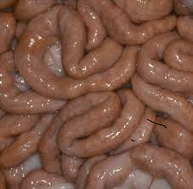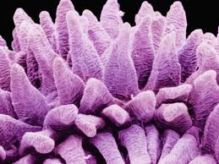
D
Photograph Q
Photograph P

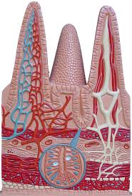
E
Photomicrograph of cells of lining of parts D
Diagram of parts D showing blood supply

- Identify the section represented in the two photographs. (1 mark) ………………………………………………………………………………………………..
- Name the parts marked D and E (2marks)
D: ………………………………………………………………………………………….
E: ………………………………………………………………………………………….
- (i) State the function of the parts labeled D. (1mark) ……………………………………………………………………………………………….
- How is the part labeled D adapted to its function you have stated in (c)(i) above?
(3 marks)
……………………………………………………………………………………………………………………………………………………………………………………………………………………………………………………………………………………………….
- Suggest one role of the cell from which the photomicrograph was taken, on the basis of the structure E highlighted on the photomicrograph. (1 mark)
………………………………………………………………………………………………
- Draw a well labelled diagram the part labelledD in the space provided. (4marks)

