**Name ……………………………………………Index No………………... Adm no……..**

**Class……………………………Candidate’s sign…………………… Date……………….**

**233/1**

**Chemistry**

**(theory)**

**PAPER**

**MARCH 2019**

**2 Hours**

**BURAMU I - JOINT EXAMS - 2019**

Kenya Secondary of Education

**INSTRUCTIONS**

1. **Write your name and index number in the spaces provided.**
2. **Sign and write the date of examination in the spaces provided.**
3. **Answer ALL questions in the spaces provided**
4. **Mathematical tables and electronic calculators nay be used.**
5. **All working MUST be shown clearly where necessary.**

**For examiners use only**

|  |  |  |
| --- | --- | --- |
| **Questions** | **Maximum score** | **Candidate’s score** |
| **1-30** | **80** |  |

***This paper consists of 14 printed pages. Candidates should check the questions to ensure that all pages are printed as indicated and no question(s) are missing***

1. A Student in form four placed a thermometer in molten naphthalene at 850C and recorded the temperature and time until the naphthalene solidified. From the values obtained, the figure below was drawn.

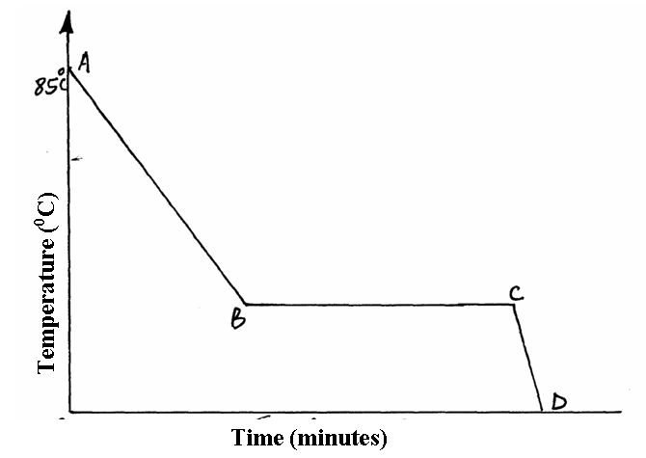

1. What name is given to such a figure?....................................................................... (1mk)
2. Which part of the figure represents the change of state of naphthalene?............. (1mk)
3. In terms of kinetic theory. Explain what happens to molecules along AB. (1mk)

**……………………………………………………………………………………………………………………………………………………………………………………………………………………………………………………………………………………………………………………………………………………………………………………**

1. In a certain reaction, 18.7cm3 of a dibasic acid required 25cm3 of 0.1M NaOH for complete neutralization.
2. How many moles of Sodium hydroxide are contained in 25cm3? (1mk)

**……………………………………………………………………………………………**

**……………………………………………………………………………………………………………………………………………………………………………………………………………………………………………………………………………………………………………………………………………………………………………………**

1. Calculate the molarity of the dibasic acid. (2mks)

**……………………………………………………………………………………………………………………………………………………………………………………………………………………………………………………………………………………………………………………………………………………………………………………................................................................................................................................................**

1. Study the flow chart below and answer the questions that follow.

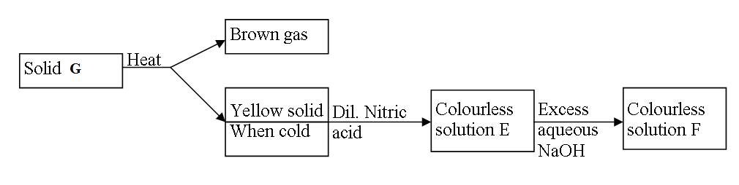

(a) Identify solid G (1mk)

**…………………………………………………………………………………………………**

(b) Write a balanced chemical equation between the yellow solid and dilute nitric acid. (1mk)

**……………………………………………………………………………………………………………………………………………………………………………………………………………………………………………………………………………………………………………………....**

(c) Write the formula of the complex ion in solution F (1mk)

**………………………………………………………………………………………………………………………………………………………………………………………………………………………………………………………………………………………………………………………**

1. Explain this observation:

When hydrogen chloride gas is dissolved in water, the solution conducts electricity while a solution of hydrogen chloride gas in methyl benzene does not conduct electricity. (2mks)

**…………………………………………………………………………………………………………………………………………………………………………………………………………………………………………………………………………………………………………………………………………………………………………………………………………**

1. Matter exists in three states which can be related as shown in the diagram below.

1. **Name** processes: P: ------------------------------------------------------- (1mark)

R: ----------------------------------------------------- (1mark)

1. **Explain** whether process **Q** is exothermic or endothermic (1mark)

………………………………………………………………………………………………………………………………………………………………………………………………………………………………………………………………………………………………………………………………………………………………………………………………………………………………………………………………………………………………………………………………………………………………………………………………………………

1. (a) What is meant by allotropy? (1mark)

**……………………………………………………………………………………………………….……………………………………………………………………………………………………**

(b) Name two allotropes of carbon. (1mark)

**………………………………………………………………………………………………………**

(c) Give one other element that has allotropes. (1mk)

**………………………………………………………………………………………………………**

1. (a) State Graham’s Law of Diffusion (1mk)

**………………………………………………………………………………………………………………………………………………………………………………………………………………**

1. A given volume of ozone (O3) diffused from a certain apparatus in 96 seconds. Calculate the time taken by an equal volume of carbon(IV) oxide to diffuse under the same conditions. (C=12,O=16) (2mks)

**………………………………………………………………………………………………………………………………………………………………………………………………………………………………………………………………………………………………………………………………………………………………………………………………………………………………8.** Below is a sample of the periodic table

|  |  |  |  |  |  |  |  |  |
| --- | --- | --- | --- | --- | --- | --- | --- | --- |
|  |  | | | | | | |  |
|  |  |  |  |  |  |  |  |  |
| I |  |  |  |  | Q | M |  |
|  | J |  |  |  |  |  | N |  |
| K | L | P |  |  |  |  |  |

1. Give the family name to which elements **M** and **N** belong (1 mark)

……………………………………………………………………………………………

(b) Compare the reactivity of elements **I** and **K**. Give a reason (1 mark)

……………………………………………………………………………………………

……………………………………………………………………………………………

(c) Write the formular of the compound formed when **P r**eacts with **Q (1 mark)**

……………………………………………………………………………………………

…………………………………………………………………………………………

1. Draw a dot (⚫ ) and cross (**X**) diagram to show bonding in sulphur (IV) oxide (1mk
2. A form one class carried out an experiment to determine the active part of air. The diagram below shows the set-up of the experiment and also the observation made.

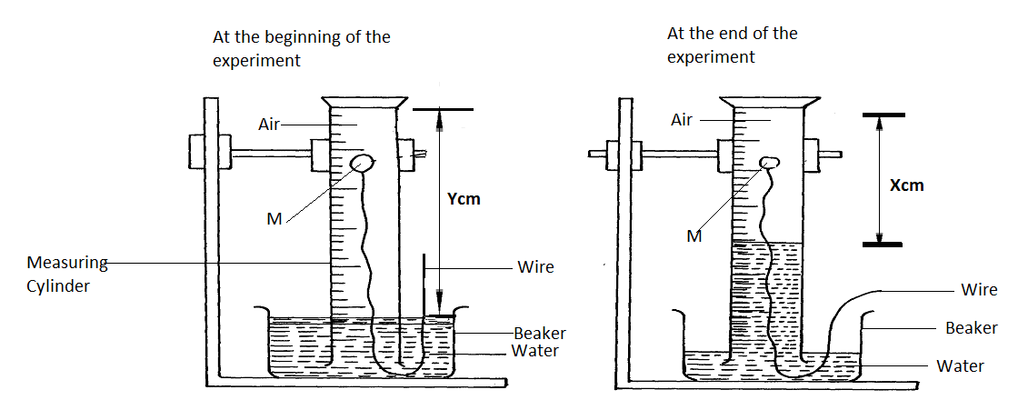

1. Identify substance M ……………………………………… (1mk)
2. State two reasons for the suitability of substance M for this experiment (1mk)

………………………………………………………………………………………………………………………………………………………………………………………………………………

1. Write the equation for the reaction of substance **M** and the active part of air (1mk)

……………………………………………………………………………………………………

1. (a) Complete the following equation (1mk)

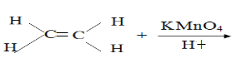

(b) Name the homologous series to which the following compounds belong?

(i) CH3CCH ……………………………………… (1mk)

(ii) CH3CH2CHCH2 **…………………………………………………** (1mk)

1. The scheme below was used to prepare a cleansing agent. Study it The table below shows the pH values of solutions J to N

|  |  |  |  |  |  |
| --- | --- | --- | --- | --- | --- |
| Solution | J | K | L | M | N |
| **pH** | 5 | 13 | 2 | 10 | 7 |

1. Which solution contains the largest concentration of hydroxides ions?.................... (1mk)
2. Which solution is likely to be a solution of acetic acid?..............................................(1mk)
3. 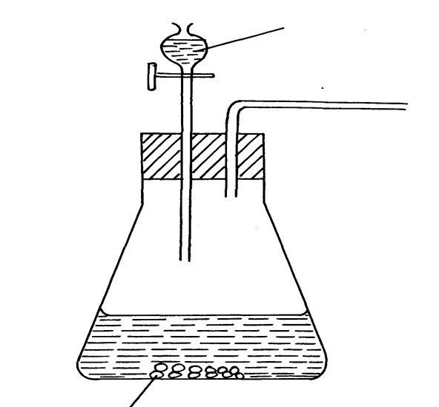The diagram below shows an incomplete set up of the laboratory preparation of **dry** sulphur (IV) oxide gas. Complete it. (3mks)

Sodium sulphite

1. The chemical equations below are the main reactions in large scale manufacture of sodium carbonate.

NH3(g) + CO2(g) + H2O(l) NH4HCO3(aq)

NH4HCO3(aq)  + NaCl(aq) Nahco3(s) + NH4Cl(aq)

(a) Explain how the two products NaHCO3 and NH4Cl are separated (1 mark)

…………………………………………………………………………………………

(b)How sodium carbonate is finally obtained? (1 mark)

…………………………………………………………………………………………

…………………………………………………………………………………………

(c) Explain how ammonia is recovered in this process. (1 mark)

……………………………………………………………………………………………

1. Magnesium was burnt in air forming a white residue T. When put in a boiling tube with water effervescence was noticed and colourless gas D with a characteristic pungent smell was evolved. The gas turned a wet red litmus paper blue.
2. **Identify** 
   1. Residue **T …………………………………………………………….**(1mk)
   2. Gas D**……………………………………………………………** .(1mk)
3. **Write** an equation for liberation of gas D. ( 1mk)

**……………………………………………………………………………………………………………………………………………………………………………………**

1. Explain why the bleaching action of chlorine is permanent while bleaching by sulphur (IV) oxide is temporary. (2marks)

……………………………………………………………………………………………………………………………………………………………………………………………………………………………………………………………………………………………………

17. Explain how you would separate a mixture of nitrogen and oxygen gases given that their boiling points are -196oC and -183oC respectively. (3mks)

**……………………………………………………………………………………………………..**

**………………………………………………………………………………………………………………………………………………………………………………………………………………**

1. Study the information in the table below and answer the questions that follow.

|  |  |
| --- | --- |
| Bond | Bond energy |
| C – H  Cl – Cl  C – Cl  H – Cl | 414  244  326  431 |

Calculate the enthalpy change of the reaction: (3mks)

CH4 (g) + 2 Cl2 (g) U.V light CH2 Cl2 (g) + 2 HCl (g).

……………………………………………………………………………………………………………………………………………………………………………………………………………………………………………………………………………………………………………………………………………………………………………………………………………………………………………………………………………………………………………………………………………………………………………………………………………………………………………………………………………………………………………………………………………………………………………………………………………………………………………………………………………………………………………

1. Using reagents provided only, explain how you could prepare solid Zinc carbonate. (2mks)

* Zinc powder
* Nitric (V) acid (dilute)
* Water
* Solid sodium carbonate

**………………………………………………………………………………………………………………………………………………………………………………………………………………………………………………………………………………………………………………………………………………………………………………………………**

1. The apparatus below was set up to show the catalytic oxidation of ammonia.

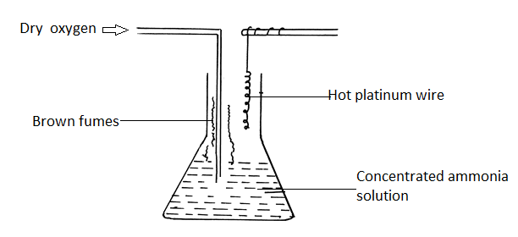

1. Identify the brown fumes observed at the mouth of the conical flask. (1mk)

……………………………………………………………………………………………….

1. Write down the equations of the reactions representing

1. Catalytic oxidation of ammonia (1mk)

……………………………………………………………………………………

1. The formation of the brown fumes. (1mk)

……………………………………………………………………………………

1. Consider the chromatogram below.



A piece of chromatogram paper was spotted with colour inks obtained from pens labeled A to F. The diagram above shows the spots after the chromatograph was developed.

* + - 1. Which two pens contained the same pigment? (1mk)

………………………………………………………………………………………………………………………………………………………………………………………………………………………………………………………………………………………………………

* + - 1. According to the chromatogram which pigments are present in the inks of the pen number F

……………………………………………………………………………………… (1mk)

* + - 1. Describe how one could get a sample of yellow pigment (1mk)

………………………………………………………………………………………………………………………………………………………………………………………………………………………………………………………………………………………………………………………………………………………………………………………………

1. In an experiment, a gas jar containing moist sulphur (IV) oxide was inverted over another gas jar containing hydrogen sulphide gas.

(a) State and explain the observation that was made (2marks)

……………………………………………………………………………………………

……………………………………………………………………………………………

(b) State the precautions that should be taken when carrying out this experiment (1mk)

……………………………………………………………………………………………

…………………………………………………………………………………………

1. A student investigated the effect of an electric current by passing it through some substances. The student used inert electrodes and connected a bulb to the circuit. The table below shows the substances used and their states.

|  |  |  |
| --- | --- | --- |
| Experiment | Substance | State |
| 1 | Potassium carbonate | Solid |
| 2 | Copper (II) sulphate | Solution |
| 3 | Sugar | Solution |
| 4 | Lead (II) iodide | Molten |

1. In which experiments did the bulb not light? ………………………………….. (1mk)
2. Explain your answer in (a) above. (2mks)

……………………………………………………………………………………………………………………………………………………………………………………………………………………………………………………………………………………………..

1. Give a reason why the formula mass of NO2 is sometimes 92 instead of 46. (1mk)

…………………………………………………………………………………………………………………………………………………………………………………………………………………………………………………………………………………………………………………………………………………………………………………………………………

1. A compound contains only carbon, hydrogen and oxygen .Combustion of 1.068g of the compound produces 1.601g of carbon (IV) oxide and 0.437g of water. The molar mass of the compound is 176.1 $g/{mol}$. What is the empirical and molecular formulae of the compound?

(2mks)

……………………………………………………………………………………………………………………………………………………………………………………………………………………………………………………………………………………………………………………………………………………………………………………………………………………………………………………………………………………………………………………………………………………………………………………………………………………………………………………………………………………………………………………………………………………………………………………………………………………

1. (a) A sample of water in a beaker was found to boil at 102 $℃$ at 1 atmospheric pressure. Assume that the thermometer was not faulty explain this observation (1mk)

……………………………………………………………………………………………………………………………………………………………………………………………………

(b)Study the information in the table below and answer the questions that follow.

|  |  |  |
| --- | --- | --- |
| Salt | Solubility (g/100g water) | |
| At 40 $℃$ | At 60 |
| CuSO4 | 28 | 38 |
| Pb(No3)2 | 79 | 98 |

A mixture containing 35g of CuSO4 and 78g of Pb(NO3)2 in 100g of water at 60 $℃$ was cooled to 40 $℃$

1. Which salt crystallized out? Give a reason. ……………………………… (1mk)
2. Calculate the mass of the salt that crystallized out. (1mk)

………………………………………………………………………………………………………………………………………………………………………………………………………………………………………………

1. A student was asked to determine the percentage of zinc metal in a mixture of zinc metal and zinc oxide. He reacted the mixture with excess hydrochloric acid and accurately collected the gas evolved, which was then used to calculate the amount of zinc in the mixture.
2. Name the gas that was evolved………………………………………………… (1 mark)
3. Apart from the reaction liberating the gas write a balanced equation for the other reaction that took place . (1 mark)

……………………………………………………………………………………………………………………………………………………………………………………………………………………………………………………………………………………………..

1. Why would dilute nitric acid not suitable for this reaction? (1 mark)

……………………………………………………………………………………………………………………………………………………………………………………………………………………………………………………………………………………………………………………………………………………………………………………

1. Below is part of the flow diagram of the contact process.

**SO3**

**CHAMBER**

**A**

**CHAMBER**

**B**

**Liquid N**

**Liquid M**

**Concentrated Sulphuric (VI)**

**acid**

* + 1. Identify (i) Liquid **M**………………………………………………… (1mk)

(ii) Liquid **N**………………………………………………… (1mk)

* + 1. Write the equation for the reaction taking place in chamber **B**. (1mk)

…………………………………………………………………………………………………………………………………………………………………………………….

1. Chlorine gas dissolved in distilled water to form chlorine water
2. Name the compounds present in the chlorine water. ………………………………… (1mk)
3. What would be observed if blue litmus paper is dipped in chlorine water? Explain. ( 2mks)

…………………………………………………………………………………………………………………………………………………………………………………………………………………………

30. A fixed mass of gas occupies 105cm3 at -14 and 650mmHg pressure. At what temperature will it have a volume of 15cm3 if the pressure is adjusted to 690 mmHg pressure (2mks)

………………………………………………………………………………………………………………………………………………………………………………………………………………………………………………………………………………………………………

**THIS IS THE LAST PRINTED PAGE**