Name: …………………………………………………………… Index No.:……………
School: …………………………………………………………. Candidate’s Sign:……
Date:…..……………..…………………………….........................

233/2
CHEMISTRY
PAPER 2
(THEORY)
MARCH - 2019
TIME: 2 HOURS

BURAMU JOINT EXAMINATION-2019

INSTRUCTIONS TO THE CANDIDATES

- Write your name and index number in the spaces provided above.
- Sign and write the date of examination in the spaces provided.
- Answer all questions in the spaces provided.
- KNEC mathematical table and silent non-programmable electronic calculators may be used.
- All workings must be clearly shown where necessary.
- Candidates should answer the questions in English.

For Examiner’s Use Only:-

QUESTION | MAXIMUM SCORE | CANDIDATE’S SCORE
1 | 12
2 | 11
3 | 11
4 | 12
5 | 11
6 | 12
7 | 12
Total | 80

- The table below shows the positions of some elements in the periodic table. The letters are not the actual symbols of the elements.

 |  |  |  |  |  | A
 | B |  | C |  | D |  | E
F | G
 |  |  |  |  |  |  | H

a) Select an element that can form an ion with a charge of +2. Explain your answer. (2mks)
……………………………………………………………………………………………………………………………………………………………………………………………………………………………………………………………………………………………………………………………………………………………………………………………………………………

b) What type of structure would the oxide of C have? Explain your answer. (2mks)
………………………………………………………………………………………………………………………………………………………………………………………………………………………………………………………………………………………………………………

c) How does the reactivity of H compare with that of E? Explain your answer. (2mks)
………………………………………………………………………………………………………………………………………………………………………………………………………………………………………………………………………………………………………………………………………………..

Explain how you would expect the following to compare.

(i) Atomic radii of F and G. (1mk) ……………………………………………………………………………………………………........................................................................................................................................................

(ii) The pH values of aqueous solution of the oxide of B and D. (1mk)
………………………………………………………………………………………………………………………………………………………………………………………………………………………………………………………………………………………………………………

f) Draw a diagram to represent an ion of element D. (2mks)

2. a) Name the solution and the catalyst used in preparation of oxygen in the laboratory (1mk) ………………………………………………………………………………………………………………………………………………………………………………………………………………………………

b) Give an equation for the reaction above, for the production of oxygen. (1mk)
………………………………………………………………………………………………………………

c) In an experiment to determine the proportion of oxygen in the air, copper turnings are packed in excess in a long combustion tube connected to two syringes of 120cm³ each in volume. Syringe R contains 120cm³ of air while syringe S is closed and empty as shown.
Copper turnings
Syringe S
Heat
Syringe R

After the air passes over heated copper slowly and repeatedly, until there is no further change, 95.5cm³ of the air remained in syringe R.

i) Why should copper be in excess? (1mk)
………………………………………………………………………………………………………………

ii) Why should air be passed over heated copper slowly? (1mk) ………………………………………………………………………………………………………………………………………………………………………………………………………………………………

iii) State one observation made during the experiment. (1mk)
………………………………………………………………………………………………………………………………………………………………………………………………………………………………

iv) Give an equation for the reaction-taking place in the combustion tube. (1mk) ………………………………………………………………………………………………………………………………………………………………………………………………………………………………

v) Determine the percentage of oxygen used up during the experiment. (1mk)
………………………………………………………………………………………………………………………………………………………………………………………………………………………………

vi) Give test for the oxygen gas. (1mk) ………………………………………………………………………………………………………………………………………………………………………………………………………………………………

- Sodium nitric and oxygen are produced when sodium nitrate is heated.
2NaNO_{(s)} 2NaNO_{2(g) +} O_{2(g)}
Calculate the volume of oxygen gas produced at s.t.p. from 8.5g of sodium nitrate.
(N=14, O=16, Na=23; Molar gas volume = 22.4dm³ at s.t.p) (3mks)

5. a) The diagram below is a set up to prepare ethyne gas.
Sand + Solid B
Conc. H₂SO₄
Water
Ethyne
Liquid A

- Name the reagents used in the above reaction.
Solid B …………………………………………………………………… ( 1mk)
Liquid A ……………………………………………………………………. ( 1mk)

(ii) Write an equation for the reaction taking place between liquid A and solid B. (1mk)
…………………………………………………………………………………………………………………………………………………………………………………………………………

(iii) What property of the gas enables it to be collected as shown above. ( 1 mk)
…………………………………………………………………………………………………………………………………………………………………………………………………………

(iv) State the MAIN commercial use of ethyne. ( 1 mk)
…………………………………………………………………………………………………………………………………………………………………………………………………………

b) The scheme below represents some reactions of ethyne. Study it and answer the questions that follow

POLYMER T P

2 Moles of Br₂

CH₂=CHCl Step I HC= CH

Process R

CH₃CH₃

(i) Name compound P. (1mk)
…………………………………………………………………………………………………………………………………………………………………………………………………………
(ii) Draw the structural formula of compound P labelled above. (1 mk)
…………………………………………………………………………………………………………………………………………………………………………………………………………
(iii) Name the reagents used in:-
I process R ( 1mk)
…………………………………………………………………………………………………………………………………………………………………………………………………………
II Step I (1 mk)
…………………………………………………………………………………………………………………………………………………………………………………………………………

iv) Name the polymer T. (1 mk)
…………………………………………………………………………………………………………………………………………………………………………………………………………

v) State the conditions necessary for the polymerization reaction to take place. (1mk)
…………………………………………………………………………………………………………………………………………………………………………………………………………

vi) State one use of polymer T. (1 mk)
…………………………………………………………………………………………………………………………………………………………………………………………………………

4. Use the flow chart below to answer the questions that follow.

Na₂ CO₃
Q
P
Ammoniated Brine
R
NaHCO₃
Heat
NH₄Cl
Water
Slaker (T)
S
Ammonia
CaCl₂
Limestone
CaCO₃
Substance X
Water
CaO
Substance Y
Brine (Saturated Sodium Chloride)

- (i) Name the substances labeled

X……………………………. (½mk)
Y……………………………… (½mk

(ii) Name two substances being recycled in the process represented by the flow chart (1mk)
………………………………………………………………………………………... …………………………………………………………………………………………………………………………………………………………………………………………

- Name the processes that take place in

S……………………………………. (½mk)

R…………………………………… (½mk)

(iv) State one use of calcium chloride (CaCl₂) (1mk)
………………………………………………………………………………………………………………………………………………………………………………………………………………………………………………………………………………………

- Write the equations for the reactions taking place in

Q……………………………………………………………………………….(½mk)

T…………………………………………………………………… (½mk)

- Explain how sodium carbonate can be used to soften hard water. (Use ionic equations where
necessary) (1mk)

…………………………………………………………………………………………………………………………………………………………………

- Give one other commercial use of sodium carbonate other than softening hard water
(1mk)
………………………………………………………………………………………………

- X grams of sodium carbonate Na₂CO₃reacted with 30cm3 of dilute hydrochloric acid completely to produce 72cm3 of carbon dioxide gas s.t.p (1 mole of gas at s.t.p occupies 22.4 liters. C=12, O=1, Na=23)

- Write the equation for the reaction (1mk) ………………………………………………………………………………………

- Calculate the concentration of the acid in moles per liter (2mks)

- Calculate the value of X (2mks)

5. The set up below is used to prepare and collect dry samples of hydrogen sulphide gas.
L
S
a) Name suitable substances for use as (1mk)
(i) L ………………………………………………..
(ii) S ……………………………………………….

b) Complete the diagram to show how dry hydrogen sulphide gas is obtained and collected.
(1 ½ mks)
c) Write a balanced equation for the reaction between L and S named in (a) above. (1mk)
…………………………………………………………………………………………………………………………………………………………………………………………………………
d) (i) State the effect of hydrogen sulphide gas on litmus. (1mk)
…………………………………………………………………………………………………………………………………………………………………………………………………………
(ii) State a chemical test for hydrogen sulphide gas. (1mk)
…………………………………………………………………………………………………………………………………………………………………………………………………………
(iii) What do you observe when hydrogen sulphide gas is passed through aqueous zinc chloride? (½ mk)
…………………………………………………………………………………………………………………………………………………………………………………………………………
e) (i) Name the process used to extract sulphur from the ground in Lousiana and Texas. (½ mk)
…………………………………………………………………………………………………………………………………………………………………………………………………………

- State the uses of the following materials during extraction of sulphur.
I - Super heated water. ( ½ mk)
…………………………………………………………………………………………………………………………………………………………………………………………………………

II - Hot compressed air. (½ mk)
…………………………………………………………………………………………………………………………………………………………………………………………………………

f) (i) Name the process used to manufacture sulphuric acid. ( ½ )
…………………………………………………………………………………………………………………………………………………………………………………………………………

(ii) Calculate the mass of sulphuric acid required to react with excess ammonia gas to produce 125.2 tons of ammonium sulphate fertilizer.(S=32,N=14,O=16,H=1) (3mks)
…………………………………………………………………………………………………………………………………………………………………………………………………………
…………………………………………………………………………………………………………………………………………………………………………………………………………
…………………………………………………………………………………………………………………………………………………………………………………………………………

- State the property of sulhuric acid that is illustrated by its reaction with sucrose.(1mk)
…………………………………………………………………………………………………………………………………………………………………………………………………………

6. The table below show how the solubilities of three salts vary with temperature. Use ito answer the questions that follow.
Solubility g/100g H₂O | Temperature
 | 0 | 10 | 20 | 30 | 40 | 50 | 60 | 70
KNO₃ | 12.5 | 22.5 | 32.5 | 47.5 | 62.5 | 82.5 | 112.5 | 137.5
Pb(NO₃)₂ | 37.5 | 45.0 | 52.5 | 62.5 | 70.0 | 77.5 | 87.5 | 100.0
a) On the same set of axes, plot a graph of the solubility of the two salts (y-axis) against the temperature. (5mks)

b) From the graph, determine:
(i) the temperature at which the solubility of potassium nitrate and lead nitrate is the same. (1mk)
……………………………………………………………………………………………………

(ii) the moles of lead nitrate that would dissolve in one litre of water at 25⁰C (density of water = 1g/cm³, Pb= 207, N=14, O=16) (3mks)
……………………………………………………………………………………………………
…………………………………………………………………………………………………………………………………………………………………………………………………………
……………………………………………………………………………………………………………………………………………………………………………………………………………………………………………………………………………………………………………………………………………………………………………………………………………………

(iii) A solution of potassium nitrate is cooled from 45⁰C to 15⁰C. Determine the mass of the crystals formed. (2mks)
……………………………………………………………………………………………………………………………………………………………………………………………………………………………………………………………………………………………………………………………………………………………………………………………………………………

c) What is fractional crystallization. (1mk)
……………………………………………………………………………………………………………………………………………………………………………………………………..

7. I. Study the given diagram and answer the questions that follow.
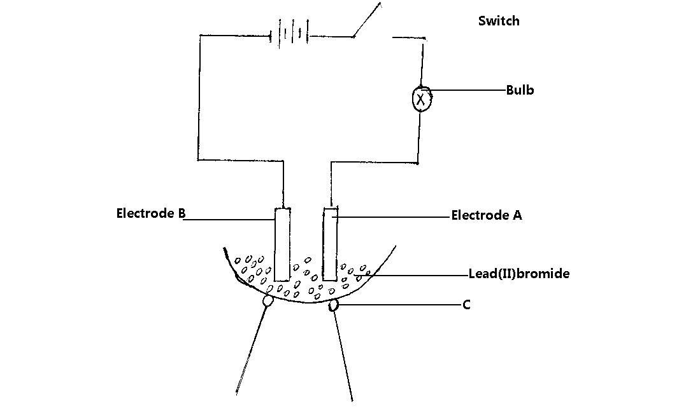
- Name A,B and C (3mks)
A…………………………………………………………………………………………
B…………………………………………………………………………………………
C.………………………………………………………………………………………

- (i) Give two elements that are the most appropriate to be used as electrodes (1mk)
…………………………………………………………………………………………………………………………………………………………………………………………………………
…………………………………………………………………………………………………………………………………………………………………………………………………………

(ii) Explain your answer in b (i) (1mk)
……………………………………………………………………………………………………
…………………………………………………………………………………………………………………………………………………………………………………………………………

- (i) State the observation made on the bulb after the electric current was switched on (1mk)
…………………………………………………………………………………………………………………………………………………………………………………………………………

(ii) Explain your answer in C (i) (1mk)
……………………………………………………………………………………………………
……………………………………………………………………………………………………

II. The table below shows the electrical conductivity of substance A, B and C

Substance | Solid state | Molten state | Aqueous solution
A | Conducts | Conducts | Not soluble
B | Doesn’t conduct | Conducts | Conducts
C | Doesn’t conduct | Doesn’t conduct | Not soluble

(a) Which one of the substance is likely to be plastic?(1mk)
………………………………………………………………………………………………………………………………………………………………………………………………………………………………………………………………………………………………………………

(b) Explain why the substance you have given in (a) above behaves in the way it does. (1mk)
…………………………………………………………………………………………………………………………………………………………………………………………………………

(c) Which of the substances is likely to be sodium chloride? Explain. (2mks) ……………………………………………………………………………………………………………………………………………………………………………………………………………………………………………………………………………………………….

- Give the type of structure and bonding that is present in substance A (1mk) ……………………………………………………………………………………………………………………………………………………………………………………………………………………………...

