232/1
Physics
Paper 1
March- 2019
Time: 2 Hours

BURAMU JOINT
Kenya Certificate of Secondary Education
Physics
Paper 1
March – 2019
Time: 2 Hours

Instructions.

- Write you name and index number in the spaces provided
- This paper consists of two sections, A and B.
- Answer all the questions in the spaces provided.
- All working must be clearly shown in the spaces provided in this booklet.
- Mathematical tables and electronic calculators may be used.
- Take gravitational acceleration, g=10N/kg

For Examiners Use Only

Section | Question | Maximum Score | Candidates’ Score
A | 1 – 14
B | 15  16  17  18  19 | 12  11  10  11  11
 | Total Score

SECTION A: (25 MARKS)
Answer all questions in this section in the spaces provided:

- The figure below shows a uniform triangular lamina.

Locate the centre of gravity of lamina. (2mks)

2. The figure below shows two containers of equal volume but of different diameters.

Equal volume of hot water was put in both containers. Explain why it cools faster in the wider container than in the narrower one. (1mk)

3. State one advantage of hydraulic brakes over mechanical brakes. (1mk)

4. A body in a uniform circular motion experiences acceleration despite moving at a constant speed. Explain. (1mk)

Use the information below to answer question 5 and 6:

In an experiment to determine the density of a liquid, the following readings were made.
Mass of empty density bottle = 20g
Mass of bottle filled with water = 70g
Mass of bottle filled with a liquid = 69.5g

5. Find the density of the liquid, given that density of water is 1000kgmˉ³. (3mks)

6. Find the mass of the liquid. (3mks)

7. The diagram below shows a metal tube made of iron and copper. The joint is tight at room temperature.
Copper
Iron
Joint

Explain how you would separate the two by changing the temperature given that copper expands more than iron for some change in temperature. (2mks)

8. State one assumption made when estimating the size of an oil molecule in the oil drop experiment. (1mk)

9. The figure below shows a load-extension graph for various loads hung from a single spring.
Extension (m)
Load (N)

On the same axes sketch a graph for a spring double the diameter and half the length of the first one.
(1mk)

Use the information below which represents hydraulic braking system to answer questions 10 and 11.

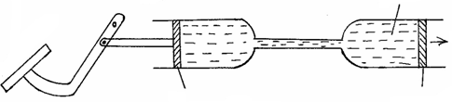
Fluid
Force
produced
Slave piston
Master piston
Pivot
Brake pedal

10. State one property the fluid should have. (1mk)

11. Explain briefly how the system operates. (3mks)

12. An object of mass 0.5 kg is whirled in a vertical circle with a String of length 3.6m. Determine the velocity of the stone if the maximum tension is 14.0 N. (3 mks)

13. Figure below shows a section of a pipe XY. A constant pressure difference maintains a streamline flow of a liquid in the pipe.
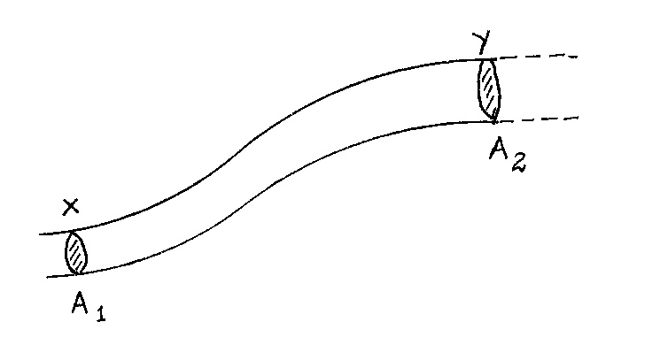

If the cross-sectional area A₁ at X is less than A₂ ay Y, state how the liquid velocity V₂ at Y compares with V₁ at X. (1mk)

14. Explain the cause of random motion of smoke particles as observed in Brownian motion experiment using a smoke cell. (2mks)

SECTION B (55 marks)
15. (a) what do we mean by acceleration? (1mark)

(b) Below is a displacement-time graph for a rally vehicle.
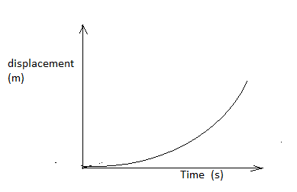
- Describe the way the vehicle is moving. (2marks)

(ii) Draw a velocity-time graph for this vehicle. (1mark)

(c) A bullet is fired horizontally at a velocity of 400m/s from a cliff which is 50m tall as shown below.

- On the diagram draw the trajectory of the bullet until it comes to rest. (1mark)

- Find the time taken for the bullet to hit the ground. (2marks)

- Find the range. (2marks)

(d) Below is a velocity-time graph of a public service vehicle.

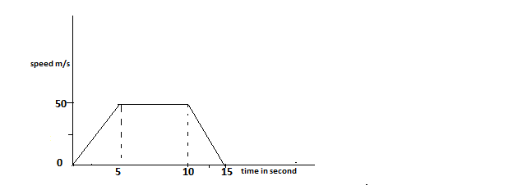

Determine the distance covered. (3marks)

16. (a) Define Pressure Law. (1mk)

    - State one basic assumption of the Kinetic Theory of gases. (1mk)

    - Figure 12 shows a set up that may be used to verify Pressure Law.
Figure 12
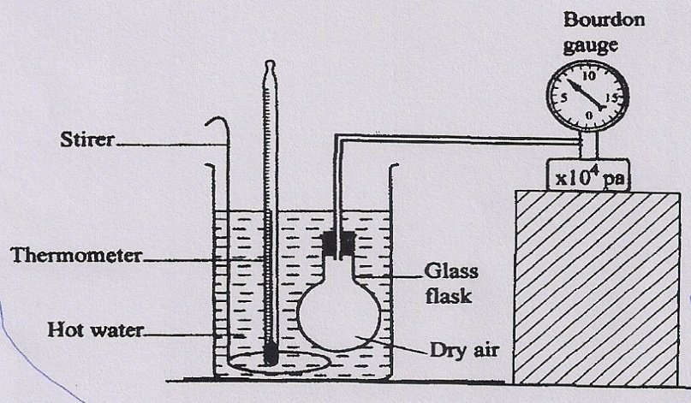
- State the measurements that may be taken in the experiment. (2mks)

- Explain how the measurement in (i) above may be used to verify Pressure Law. (4mks)

- A car tyre is at an air pressure of 4.0 x 10⁵ Pa at a temperature of 27⁰C. While it is running, the temperature rises to 75⁰C. What is the new pressure in the tyre? (Assume the tyre does not expand). (3mks)

17. The figure below shows a machine being used to raise a load. Use the information given in the figure to answer questions below.
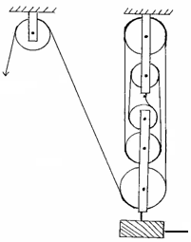
Effort
Load

(a) Determine the velocity ratio (V.R) of the machine. (1 mark)

- If a load of 800N is raised by applying an effort of 272N, determine the efficiency
of the machine. (1 mark)

- A crane lifts a load of 2000kg through a vertical distance of 3.0m in six seconds. Determine
(i) Work done. (2 marks)

(ii) Power of the crane. (2 marks)

- Name the transducer that is used to convert the following form of energies.
(i) Electrical to sound. (1 mark)

(ii) Electrical to kinetic. (1 mark)

18. (a) Define specific heat capacity of a substance (1mrk)

b) In an experiment to determine the specific heat capacity of paraffin 2.0kg of paraffin was supplied with 21600J of heat and its temperature rose by 4.9⁰C .Calculate the specific heat capacity of paraffin. (3mrks)

(c) Boiling water is poured into two identical vacuum flasks A and B. Flask A is partially filled while flask B is completely filled. Both are closed tightly. State with reason the flask in which the water is likely to have a higher temperature eight hours later (2mrks)

(d) A block of ice of mass 40g at 0⁰C is placed in a calorimeter containing 400g of water at 20⁰C. Ignoring the heat absorbed by the calometer, determine the final temperature of the mixture after all the ice has melted.(specific heat capacity of water = 4200Jkg ⁻¹K⁻¹, Specific latent heat of fusion of ice = 340000Jkg⁻¹.) (6mrks)

- (a) (i) State Archimedes’s Principle. (1mk)

(ii) An object weights 1.04N in air, 0.64N when fully immersed in water and 0.72N when fully immersed in a liquid. If the density of water is 1000kgm⁻³, find the density of the liquid. (3mks)

(b) (i) State the Law of floatation. (1mk)

(ii) Give a reason why a steel rod sinks in water while a ship made of steel floats on water. (1mk)

(c) Figure 13 shows a buoy, B, of volume 40 litres and mass 10kg. it is held in
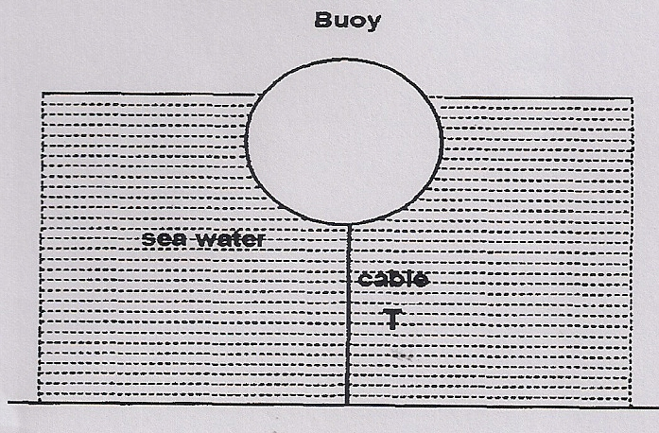
position in sea water of density 1.04gcm⁻³ by a light cable fixed to the bottom so that ¾ of the volume of the buoy is below the surface of the sea water. Determine the tension T in the cable. (4mks)

(d) The figure below shows a diagram of a hydrometer which is suitable for
measuring the densities of liquids varying between 1.0 and 1.2gcm⁻¹.
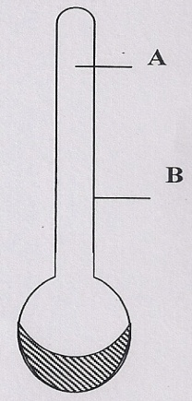
On the diagram indicate the label corresponding to 1.0 and 1.2g/cm³. (1mk)

