Name………………………………………………………. Adm No…………………/…….
School……………………………………………………… Date ………………………….…
Candidate’s Signature…………………………………….

232/3
PHYSICS
Paper 3
PRACTICAL
March/April 2019
2 ½ hours

BURAMU I JOINT EXAMINATION -2019
Kenya Certificate of Secondary Education (K.C.S.E)

INSTRUCTIONS TO CANDIDATES.

- Answer all the questions in the spaces provided in this question paper.
- You are supposed to spend the first 15 minutes of the 2 ½ hours allowed for this paper reading the whole paper carefully before commencing your work.
- Marks are given for a clear record of the observations actually made, their suitability and accuracy, and the use made of them.
- Candidates are advised to record their observations as soon as they are made.
- Mathematical tables and non-programmable electronic calculators may be used.

FOR EXAMINERS USE ONLY.

QUESTION | 1 | 2
MAX SCORE | 20 | 20
CANDIDATES SCORE
TOTAL

This paper consists of 6 printed pages.
Candidates should check the question paper to ensure that all pages are printed as indicated
and no questions are missing
.

QUESTION 1
You are provided with the following:
- Ammeter (0 – 2.5A)
- A voltmeter (0 – 5.0V)
- Two D – size cells
- A cell holder
- A switch
- A wire mounted on a millimeter scale
- Six connecting wires, two with crocodile clips at one end.
Proceed as follows:-
a) Draw a set up that can be used to determine the e.m.f of a cell. (1mk)

Use the set up to determine the emf of the cell.
e.m.f = (1mk)
(b) Connect the circuit as shown in figure 1 below:
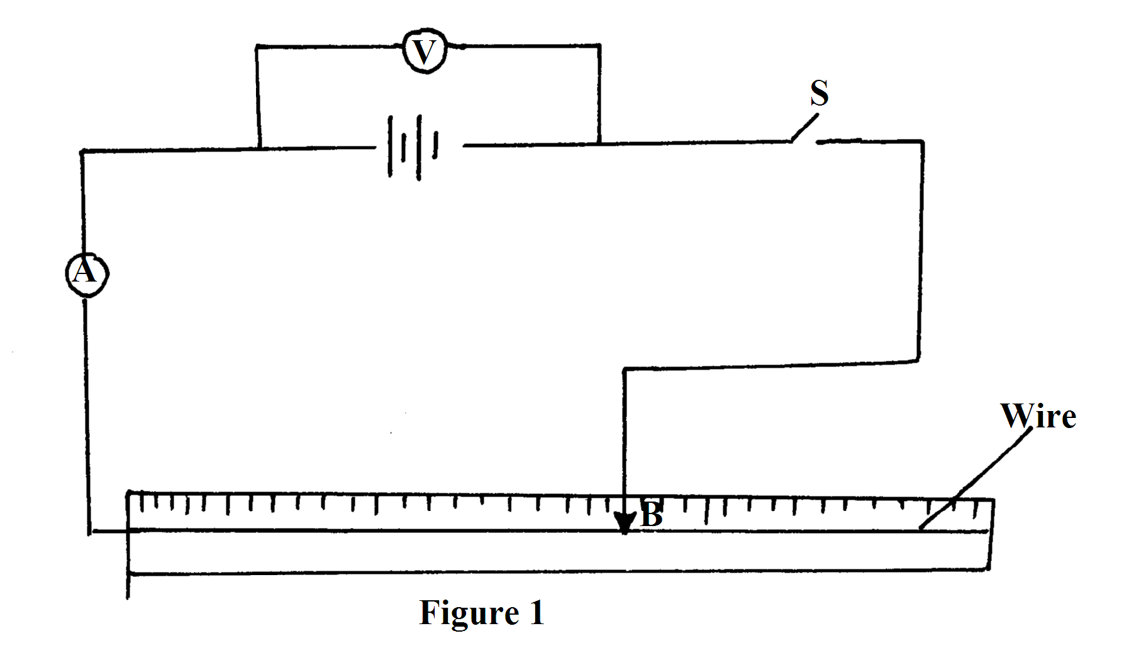
(c) Adjust the contact B so that the reading on the voltmeter is 2.7V. Read and record the
current in table 1 below. Adjust further the contact B to have voltmeter reading of 2.6V,
2.5V, 2.4V, 2.3V, 2.2V and 2.1V. Each time read and record the ammeter reading.
complete the table below.
p.d(V) | 2.8 | 2.6 | 2.4 | 2.2 | 2.0 | 1.8 | 1.6
I(A)
(6mks)

(d) Plot a graph of voltage against current. (5mks)


(e) Determine the gradient of the graph. (3mks)

(f) Given that E= V ₊ Ir, determine the following using the graph
(i) Internal resistance r of the battery. (2mks)

(ii) The e.m.f E of the battery. (2mks)

QUESTION 2
PART I
You are provided with the following
  - Boiling tube
  - Gas jar or 250ml measuring cylinder
  - Sand in a small beaker.
  - Vernier calipers (to be shared)
  - A weighing balance (to be shared)
  - Half metre rule.
  - Spatula and water
Proceed as follows
- Set up the apparatus as shown in the figure below by adding sand into the test-tube until the test-tube just floats upright.
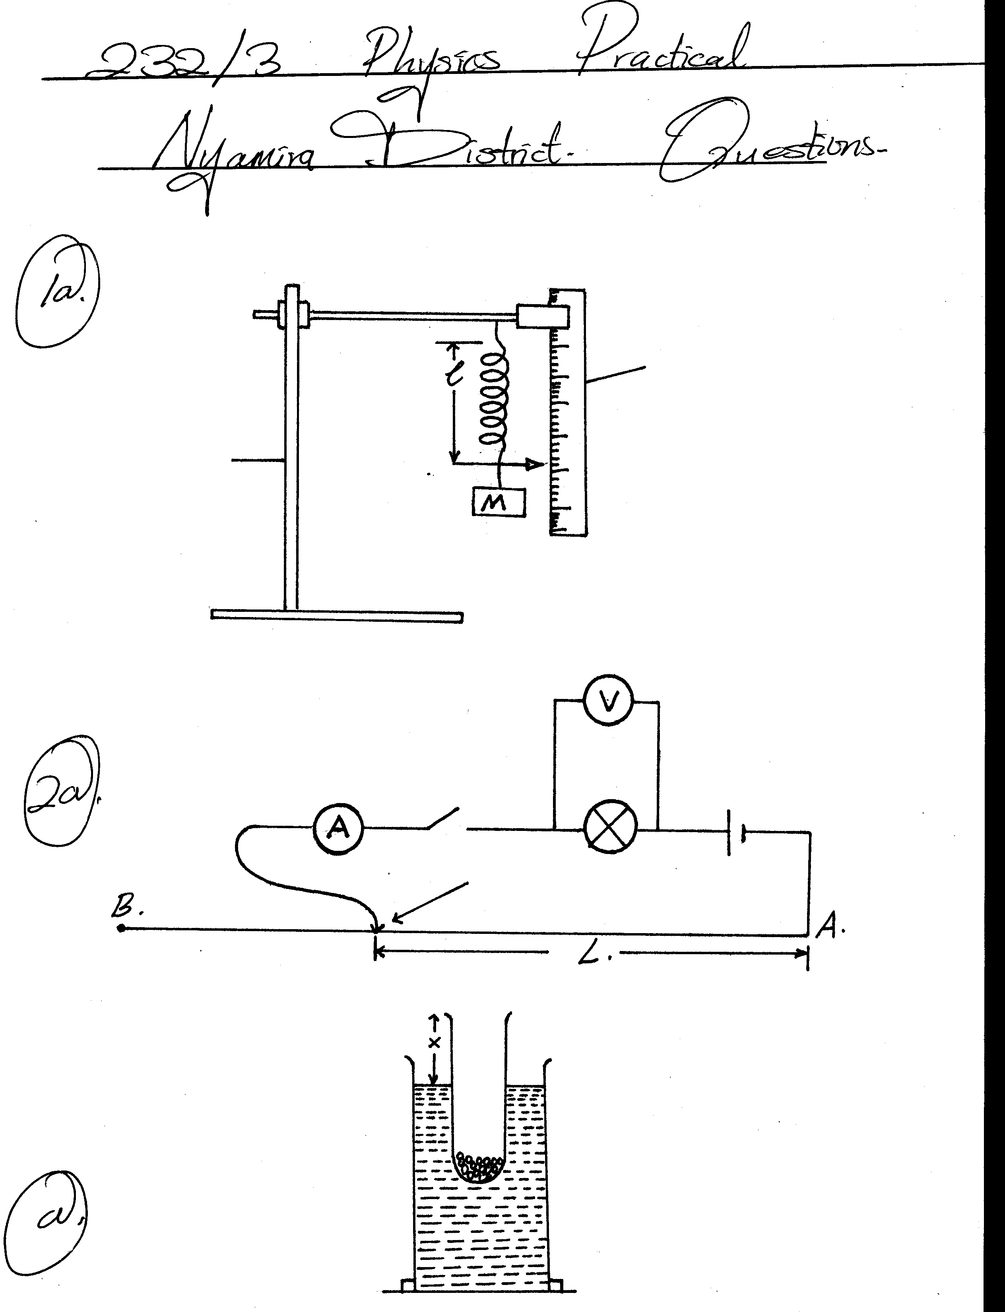
Test tube
Gas jar
sand
water
- Measure the length, x
x =…………………………cm (1 mk)
- Measure the whole length of test tube, y (1 mk)
y = …………………………. cm
- Determine the external diameter of the test tube using the vernier caliper.
External diameter = ………………………………. cm (1 mk)
External radius, r = ……………………………….. cm (1 mk)
- Measure the mass of the test-tube and its contents,
Mass, m = …………………………………………. g (1 mk)
- Determine the density of water given that
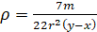 (3 mks)

PART II
You are provided with the following
- Watch glass
- A glass marble
- Plasticine
- Stop watch
- Micrometer screw gauge

a) Place the watch glass on a flat table and hold it firmly using plasticine.

b) Roll the marble and count five oscillations
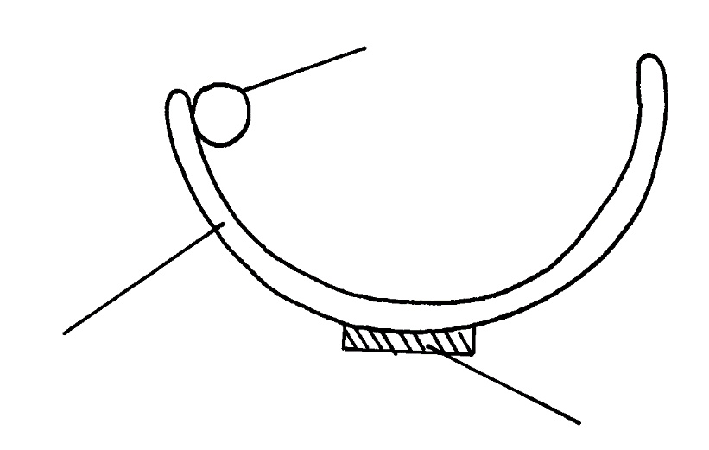

Marble

Watch glass

Plasticine

(i) Time for five Oscillations, t (1 mks)
t₁ =
(ii) Repeat two more times and find the average . (2mks)
t₂ ₌
t₃ ₌

t _{av} =
(iii) Find the avarage periodic time of the marble (2mks)
T =

T² =
(c) Measure the diameter, d of the marble using micrometer screw gauge
d ……………………….. (2 mks)
r ………………………..

(d) You are given the following equation

√
T = 2π 7(b-r)
5g

Where r is the radius of the marble, g is acceleration due to gravity, b is a constant of the system.
Determine the value of b. (g =10ms⁻² ) (3mks)

(e) Explain why the marble stops oscillating after sometime. (2 mks)

THIS IS THE LAST PRINTED PAGE

