Name………………………………………………………………………….Index……………………………………AdmNo…………….
Class…………………..... Date:………………………………………..Signature:……………………………………………………….
443/1
AGRICULTURE
Paper 1
MOKASA II EXAMINATION
JULY 2019
2 Hours
MOKASA II EXAMINATION
Kenya Certificate of Secondary Education
443/1
Agriculture Paper 1
2 hours

Instructions to candidates
This paper consists of three sections, A,B and C. Answer all questions in sections A and B and any two questions in section C.
All answers be written in the spaces provided after every question.
Candidates should write their names and index numbers in the spaces provided above.
For Examiner’s Use Only
Section | Question | Maximum Score | Candidates Score
A | 1 -17 | 30
B | 18 -21 | 20
C |  | 20
 |  | 20
 |  | 90

SECTION A (30 Marks)
Answer all questions in this section in the spaces provided.
1 Differentiate between pastoralism and nomadic pastoralism. (1mk)
……………………………………………………………………………………………………………………………………………………………………………………………………………………………………………………………………………………………………………………………………
2 Give four reasons for sub-soiling. (2mks)
…………………………………………………………………………………………………………………………………………………………………………………………………………………………………………………………………………………………………………………………………………………………………………………………………………………………………………………………………………………………………………………………………………………………………………………………………………………………………………………………………………
3 State four advantages of drip irrigation. (2mks)
…………………………………………………………………………………………………………………………………………………………………………………………………………………………………………………………………………………………………………………………………………………………………………………………………………………………………………………………………………………………………………………………………………………………………………………………………………………………………………………………………………
4 Give three farming practices that will lead to pollution of water. (1 ½ mks)
………………………………………………………………………………………………………………………………………………………………………………………………………………………………………………………………………………………………………………………………………………………………………………………………………………………………………………………………………………………………………
5 Outline four factors that influence quality of compost manure. (2mks)
…………………………………………………………………………………………………………………………………………………………………………………………………………………………………………………………………………………………………………………………………………………………………………………………………………………………………………………………………………………………………………………………………………………………………………………………………………………………………………………………………………
6 (a) what is opportunity cost as used in agricultural economics? (1mk)
…………………………………………………………………………………………………………………………………………………………………………………………………………………………………………………………………………………………………………………………………….

(b) State two conditions under which opportunity cost is said to be Zero. (1mk)
……………………………………………………………………………………………………………………………………………………………………………………………………………………………………………………………………………………………………………………………………
7 Differentiate between under sowing and over sowing as used in pasture in production. (1mk)
………………………………………………………………………………………………………………………………………………………………………………………………………………………………………………………………………………………………………………………………………………………………………………………………………………………………………………………………………………………………………
8 State four disadvantages of broadcasting in crop production. (2mks)
…………………………………………………………………………………………………………………………………………………………………………………………………………………………………………………………………………………………………………………………………………………………………………………………………………………………………………………………………………………………………………………………………………………………………………………………………………………………………………………………………………
9 Give four objectives of settlement schemes in Kenya soon after independence. (2mks)
…………………………………………………………………………………………………………………………………………………………………………………………………………………………………………………………………………………………………………………………………………………………………………………………………………………………………………………………………………………………………………………………………………………………………………………………………………………………………………………………………………
10 (a) Name three types of legume trees used as a fodder. (1 ½ mks)
………………………………………………………………………………………………………………………………………………………………………………………………………………………………………………………………………………………………………………………………………………………………………………………………………………………………………………………………………………………………………
(b) Give four reasons for top-dressing pasture. (2mks)
…………………………………………………………………………………………………………………………………………………………………………………………………………………………………………………………………………………………………………………………………………………………………………………………………………………………………………………………………………………………………………………………………………………………………………………………………………………………………………………………………………
11 Name three insect pests of cabbages. (1 ½ mks)
………………………………………………………………………………………………………………………………………………………………………………………………………………………………………………………………………………………………………………………………………………………………………………………………………………………………………………………………………………………………………
12 Give three importance of Agricultural Society of Kenya (A.S.K). ( 1 ½ mks)
………………………………………………………………………………………………………………………………………………………………………………………………………………………………………………………………………………………………………………………………………………………………………………………………………………………………………………………………………………………………………
13 (a) State two reasons for carrying out agroforestry on a river – bank. (2mks)
……………………………………………………………………………………………………………………………………………………………………………………………………………………………………………………………………………………………………………………………………
(b) Give four ways in which agroforestry seeds are prepared after collection in readiness for planting. (2mks)
…………………………………………………………………………………………………………………………………………………………………………………………………………………………………………………………………………………………………………………………………………………………………………………………………………………………………………………………………………………………………………………………………………………………………………………………………………………………………………………………………………
14 Give two reasons for processing agricultural produce. (1mk)
……………………………………………………………………………………………………………………………………………………………………………………………………………………………………………………………………………………………………………………………………
15 State two functions of calcium in the soil. (1mk)
……………………………………………………………………………………………………………………………………………………………………………………………………………………………………………………………………………………………………………………………………
16 List four methods of applying fertilizers in crops. (2mks)
…………………………………………………………………………………………………………………………………………………………………………………………………………………………………………………………………………………………………………………………………………………………………………………………………………………………………………………………………………………………………………………………………………………………………………………………………………………………………………………………………………
17. Give two reasons for cutting back in pyrethrum production. (1mk)
……………………………………………………………………………………………………………………………………………………………………………………………………………………………………………………………………………………………………………………………………

SECTION B (20 Marks)
Answer all questions in this section in the spaces provided.
18 The diagrams below shows two weeds labeled A and B. Study them and answer questions that follow.
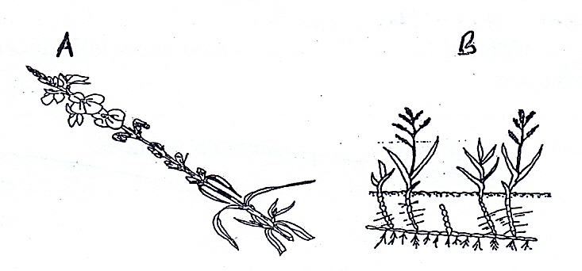
- Identify the weeds labeled A and B. (1mk)
A……………………………………………………………………………………………………………………………………………
B……………………………………………………………………………………………………………………………………………..
- Give one reason why the weed labeled A is referred to as a parasitic weed. (1mk)
………………………………………………………………………………………………………………………………………………………………….
- Name two crops that the weed illustrated A above commonly attack. (1mk)
………………………………………………………………………………………………………………………………………………………………….
…………………………………………………………………………………………………………………………………………………………………
- Give one reason why it is very difficult to control weed labeled B. (1mk)
………………………………………………………………………………………………………………………………………………………………….
- State one cultural method of controlling weed labeled A. (1mk)
………………………………………………………………………………………………………………………………………………………………….

19 The diagrams below illustrate a pineapple plant. Study it carefully and answer the questions that follow.
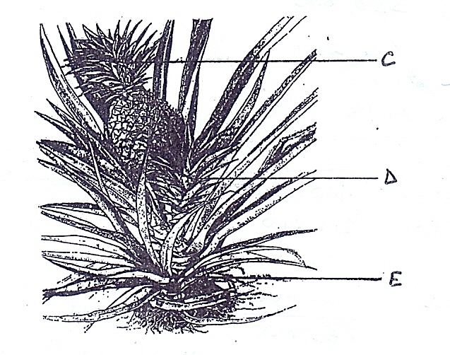
- Name the parts of propagating pineapple labeled C,D and E. (1 ½ mks)
C……………………………………………………………………………………………………………………………………………………
D……………………………………………………………………………………………………………………………………………………
E…………………………………………………………………………………………………………………………………………………..
- (i)Which of the vegetative material is more suitable for propagation? (½mk)
…………………………………………………………………………………………………………………………………………………….
(ii) Give a reason for your answer above. (1mk)

............................................................................................................................................................
- State three advantages of vegetative propagation. (1 ½ mks)
……………………………………………………………………………………………………………………………………………………………………………………………………………………………………………………………………………………………………………………………………………………………………………………………………………………………………………………………………………………………………..

20 The following information was extracted from Mr. Njengas farm records on 31/12/2018. Use the information to answer the questions that follow.
Description | Kshs
Five year bank loan | 400,000
One year loan with AFC | 200,000
Creditors | 45000
Debtors | 20000
Land | 600000
Buildings | 420000
Dairy cattle | 180000
Dairy meal | 10000
Cash in hand | 35000

- Prepare a balance sheet of Mr. Njengas farm. (5mks)
………………………………………………………………………………………………………………………………………………………………………………………………………………………………………………………………………………………………………………………………………………………………………………………………………………………………………………………………………………………………………………………………………………………………………………………………………………………………………………………………………………………………………………………………………………………………………………………………………………………………………………………………………………………………………………………………………………………………………………………………………………………………………………………………………………………………………………………………………………………………………………………………………………………………………………………………………………………………………………………………………………………………………………………………………………………………………………………………………………………………………………………………………………………………………………………………………………………………………………………………………………………………………………………………………………………………………………………………………………………………………………………………………………………………………………………………………………………………………………………………………………………………
- Was Mr. Njengas business solvent or insolvent? (1mk)
………………………………………………………………………………………………………………………………………………………………….
21 An experiment was carried out to investigate soil constituents as described below.
- A 250 cm³measuring cylinder was filed with water to 100cm³ mark.
- A 100cm³ beaker was filled with garden soil up to brim.
- The soil was emptied into one measuring cylinder and shook well.
- The final volume was 150cm³.
- What was lost when the 100cm³ garden soil was poured to 100cm³ of water in the measuring cylinder? (½mk)
…………………………………………………………………………………………………………………………………………………………………
- Calculate one percentage content of the soil constituents investigated in the experiment. (2mks)
…………………………………………………………………………………………………………………………………………………………………………………………………………………………………………………………………………………………………………………………………………………………………………………………………………………………………………………………………………………………………………………………………………………………………………………………………………………………………………………………………………
- Give two importance of the substance lost above in the soil. (2mks)
……………………………………………………………………………………………………………………………………………………………………………………………………………………………………………………………………………………………………………………………………

SECTION C (40 Marks)
Answer any two questions from this section in the spaces provided.
22 (a) Describe the production of beans under the following sub-headings
- Field preparation (3mks)
………………………………………………………………………………………………………………………………………………………………………………………………………………………………………………………………………………………………………………………………………………………………………………………………………………………………………………………………………………………………………………………………………………………………………………………………………………………………………………………………………………………………………………………………………………………………………………………………………………………………………………………………………………………………………………………………………………………………………………………………………………………………………………………………………………………………………………………………………………………………………………….…………………………………………………………………………………………………………………………………………………………………………………………………………………………………………………………………………………………………………………………………….
- Planting (3mks)
………………………………………………………………………………………………………………………………………………………………………………………………………………………………………………………………………………………………………………………………………………………………………………………………………………………………………………………………………………………………………………………………………………………………………………………………………………………………………………………………………………………………………………………………………………………………………………………………………………………………………………………………………………………………………………………………………………………………………………………………………………………………………………………………………………………………………………………………………………………………………………….…………………………………………………………………………………………………………………………………………………………………
- Field management practices (5mks)
………………………………………………………………………………………………………………………………………………………………………………………………………………………………………………………………………………………………………………………………………………………………………………………………………………………………………………………………………………………………………………………………………………………………………………………………………………………………………………………………………………………………………………………………………………………………………………………………………………………………………………………………………………………………………………………………………………………………………………………………………………………………………………………………………………………………………………………………………………………………………………….………………………………………………………………………………………………………………………………………………………………………………………………………………………………………………………………………………………………………………………………………………………………………………………………………………………………………………………………………………………………………………………………………………………………………………………………………………………………………………………………………..
b) Outline the procedure of harvesting sugarcane. (5mks)
………………………………………………………………………………………………………………………………………………………………………………………………………………………………………………………………………………………………………………………………………………………………………………………………………………………………………………………………………………………………………………………………………………………………………………………………………………………………………………………………………………………………………………………………………………………………………………………………………………………………………………………………………………………………………………………………………………………………………………………………………………………………………………………………………………………………………………………………………………………………………………….……………………………………………………………………………………………………………………………………………………………………………………………………………………………………………………………………………………………………………………………………
23 (a) Explain five land tenure systems practiced in Kenya. (10 mks)
………………………………………………………………………………………………………………………………………………………………………………………………………………………………………………………………………………………………………………………………………………………………………………………………………………………………………………………………………………………………………………………………………………………………………………………………………………………………………………………………………………………………………………………………………………………………………………………………………………………………………………………………………………………………………………………………………………………………………………………………………………………………………………………………………………………………………………………………………………………………………………….………………………………………………………………………………………………………………………………………………………………………………………………………………………………………………………………………………………………………………………………………………………………………………………………………………………………………………………………………………………………………………………………………………………………………………………………………………………………………………………………………………………………………………………………………………………………………………………………………………………………………………………………………………………………………………………………………………………………………………………………………………………………………………………………………………………………………………………………………………………………………………….
b) Describe ten functions of agricultural marketing in Kenya. (10 mks)
………………………………………………………………………………………………………………………………………………………………………………………………………………………………………………………………………………………………………………………………………………………………………………………………………………………………………………………………………………………………………………………………………………………………………………………………………………………………………………………………………………………………………………………………………………………………………………………………………………………………………………………………………………………………………………………………………………………………………………………………………………………………………………………………………………………………………………………………………………………………………………….………………………………………………………………………………………………………………………………………………………………………………………………………………………………………………………………………………………………………………………………………………………………………………………………………………………………………………………………………………………………………………………………………………………………………………………………………………………………………………………………………………………………………………………………………………………………………………………………………………………………………………………………………………………………………………………………………………………………………………………………………………………………………………………………………………………………………………………………………………………………………………….
24 (a) Explain five farming activities which may encourage soil erosion. (10 mks)
………………………………………………………………………………………………………………………………………………………………………………………………………………………………………………………………………………………………………………………………………………………………………………………………………………………………………………………………………………………………………………………………………………………………………………………………………………………………………………………………………………………………………………………………………………………………………………………………………………………………………………………………………………………………………………………………………………………………………………………………………………………………………………………………………………………………………………………………………………………………………………….……………………………………………………………………………………………………………………………………………………………………………………………………………………………………………………………………………………………………………………………………………………………………………………………………………………………………………………………………………………………………………………………………………………………………………………………………………………………………………………………………………………………………………………………………………………………………………………………………………………………………………………………………………………………………………………………………………………………………………………………………………………………………………………………………………………………………………………………………………………………………………………………………………………………………………………………………………………………………………………………………………………
b) Explain five factors determining stage and time of harvesting crops. (10 mks)
………………………………………………………………………………………………………………………………………………………………………………………………………………………………………………………………………………………………………………………………………………………………………………………………………………………………………………………………………………………………………………………………………………………………………………………………………………………………………………………………………………………………………………………………………………………………………………………………………………………………………………………………………………………………………………………………………………………………………………………………………………………………………………………………………………………………………………………………………………………………………………….……………………………………………………………………………………………………………………………………………………………………………………………………………………………………………………………………………………………………………………………………………………………………………………………………………………………………………………………………………………………………………………………………………………………………………………………………………………………………………………………………………………………………………………………………………………………………………………………………………………………………………………………………………………………………………………………………………………………………………………………………………………………………………………………………………………………………………………………………………………………………………………………………………………………………………………………………………………………………………………………………………………

