Name................................................................................................ Index Number.......................
School: ............................................................................................ Adm. No: ..............................
Student’s Signature...................................

231/2
BIOLOGY
JULY 2019
2 HOURS

MOKASA II JOINT EXAMINATION
Kenya Certificate of Secondary Education
BIOLOGY
Paper 2

Instructions to candidates
- Write your name, index number and signature in the spaces provided above.
- Answer all questions in section A.
- In section B answer question 6 (compulsory) and either question 7 or 8.

For Examiners Use Only

Section A | Maximum Score | Student’s  Score
1 | 8
2 | 8
3 | 8
4 | 8
5 | 8
Section B | Marks
6 | 20
7 | 20
8 | 20
TOTAL | 80

SECTION A

Answer all questions in this section

1. A student carried out an investigation on the methods of reproduction and feeding in Amoeba species. He observed that amoeba doubled in water after 20 minutes.

(a) Name the type of reproduction shown by amoeba species. (1 mark)
...............................................................................................................................................................

(b) Illustrate the process of reproduction named in (a) above. (2 marks)

(c) If at the start of the investigation, there were 20 amoeba cells in a given quantity of pond water. Calculate the total number of amoeba cells which would be present in the sample of pond water after three (3) hours.
(2 marks)
............................................................................................................................................................... ............................................................................................................................................................... ............................................................................................................................................................... ............................................................................................................................................................... ...............................................................................................................................................................
(d) State the functions of pseudopodia in amoeba species. (2 marks)
............................................................................................................................................................... ...............................................................................................................................................................
(e) (i) Name one type of specialized cells in human body which shows a similar mode of feeding as amoeba species. (1 mark)

………………………………………………………………………………………………………..

(ii) Name the process of feeding shown by the cell named in (e) (i) above.
(1 mark)
.................................................................................................................................................

2. During an ecological study of a lake, a group of students recorded the following
observations;

- Planktonic crustaceans feed a planktonic algae.
- Small fish feed on planktonic crustaceans, worms and insect larvae.
- Worms feed on insect larvae.
- A bird species feeds on small fish, planktonic crustaceans and worms.
- Insect larvae feed on planktonic algae.
- Large fish feed on small fish.

- Construct a food web to represent the record of observation provided
above. (3 marks)

- From the food web you have constructed in (a) above isolate and write down a food chain that ends with;

- Birds species as secondary consumer. (1 mark)
..................................................................................................................................................
- Large fish as tertiary consumer. (1 mark)
..................................................................................................................................................
..................................................................................................................................................
- The biomass of the producers in the lake was found to be greater than that of the primary consumers. Give an explanation for this observation.
(1 mark)
…………………………………………………………………………………………………………………
…………………………………………………………………………………………………………………
…………………………………………………………………………………………………………………
- State two ways by which man may interfere with this ecosystem. (2 marks)
……………………………………………………………………………………………………………………………………………………………………………………………………………………………………
3. Broad and thin lips are inheritable characteristics in humans. When a homozygote broad lipped man is married to a homozygote thin lipped woman, all the children in the family are broad lipped. In a particular family, a woman that is heterozygote for broad lips is married to a man whose parents were both thin lipped. Let B represent gene for broad lips.

- Work out the genotypes of the children in that family. (Use a punnet square).
(4 marks)

- Work out the phenotypic ratio and genotypic ratio of the resulting children from the crossing in (a) above. (2 marks)

................................................................................................................................................................
................................................................................................................................................................

(c) Give two sex- linked traits in man ( 2 marks)

................................................................................................................................................................
................................................................................................................................................................

4. The figure below shows a model which was used by a group of Form 2 students to show the effect of or action of intercostal muscles on the movement of ribs.

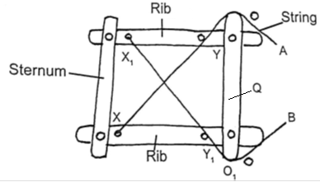

(a) How does the sternum move when; (2 marks)

(i) String A is pulled tight.
...............................................................................................................................................................
(ii) String B is pulled tight.
...............................................................................................................................................................
(b) Between string A and B, which one represents; (2 marks)

- External intercostal muscles?
...............................................................................................................................................
(ii) Internal intercostal muscles?
...............................................................................................................................................
(c) What does structure Q represent in an animal? (1 mark)
..............................................................................................................................................................
- The rates of gaseous exchange by different respiratory surfaces of plants were determined and recorded in the table below.

Structure | Gaseous exchange in %
A | 89
B | 3
C | 0.3

Sugges t the possible plant structure represented by A, B, C. (3 marks)
A ……………………………………… B …………………………………………
C ………………………………………

5. The diagram below shows an experiment set up using a seedling enclosed in a desk box with a hole on one side at the beginning of the experiment and after five days of growth.

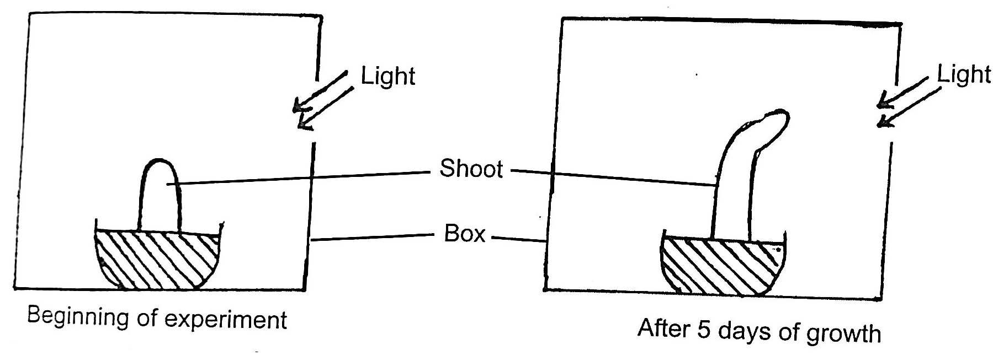

(a) What type of response is shown by the above shoot? (1 mark)

................................................................................................................................................................

(b) State two observable changes which took place in the seedling after five days of growth. (2 marks)

................................................................................................................................................................
................................................................................................................................................................
(c) Account for the observable changes in (b) above. (2 marks)
................................................................................................................................................................
................................................................................................................................................................
................................................................................................................................................................
................................................................................................................................................................
................................................................................................................................................................
................................................................................................................................................................
(d) What observations would be made after five days of growth if the shoot was placed in a box without a hole on one side? ( marks)

................................................................................................................................................................
................................................................................................................................................................

SECTION B

6. The table below shows how variation in environmental temperature relate to the body temperatures of two different types of animals A and B.

 | Body temperature (⁰C)
Environmental temp (⁰C) | Animal A | Animal B
5 | 5 | 36
10 | 10 | 37
15 | 15 | 37
20 | 20 | 37
25 | 25 | 37
30 | 29 | 37
35 | 36 | 37
40 | 41 | 37
45 | 44 | 37

- Using the information in the table above, plot a graph on same axes of body temperatures animals against environmental temperature. (7 marks)

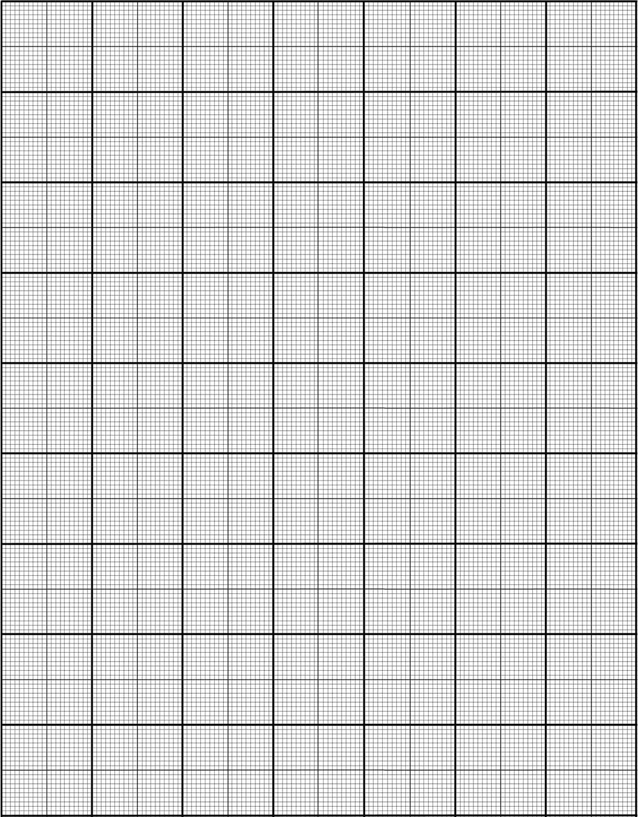

(b) With reference to thermoregulation, state the general name given to animals of the A and B types. (2 marks)

A - type animals …………………………………………………………………………………
B - type animals …………………………………………………………………………………

(c) What three advantages do B-type animals have over A-type animals?
(3 marks)
…………………………………………………………………………………………………………………
…………………………………………………………………………………………………………………
…………………………………………………………………………………………………………………
……………………………………………………………………………………………………………………………………………………………………………………………………………………………………
(d) Briefly describe how B-type
i) Physiologically respond to heat ( 4 marks)
……………………………………………………………………………………………………………………………
……………………………………………………………………………………………………………………………
……………………………………………………………………………………………………………………………

……………………………………………………………………………………………………………………………...

..............................................................................................................................................................................................

ii) Physiologically respond to cold ( 4 marks)
……………………………………………………………………………………………………………………………
…………………………………………………………………………………………………………………………….
…………………………………………………………………………………………………………………………… …………………………………………………………………………………………………………………………… …………………………………………………………………………………………………………………………….

7. Describe experiments you would conduct to show that;

- Carbon (IV) oxide, (b) Chlorophyll and (c) Sunlight are necessary for the
process of photosynthesis under the following subheadings:- (20 marks)

- Aim
- Materials and apparatus
- Procedure
- Expected observation
- Conclusion

8. Describe five evidences which support the theory of organic evolution. (20 marks)

………………………………………………………………………………………………………………………………………………………………………………………………………………………………………………………………………………………………………………………………………………………………………………………………………………………………………………………………………………………………………………………………………………………………………………………………………………………………………………………………………………………………………………………………………………………………………………………………………………………………………………………………………………………………………………………………………………………………………………………………………………………………………………………………………………………………………………………………………………………………………………………………………………………………………………………………………………………………………………………………………………………………………………………………………………………………………………………………………………………………………………………………………………………………………………………………………………………………………………………………………………………………………………………………………………………………………………………………………………………………………………………………………………………………………………………………………………………………………………………………………………………………………………………………………………………………………………………………………………………………………………………………………………………………………………………………………………………………………………………………………………………………………………………………………………………………………………………………………………………………………………………………………………………………………………………………………………………………………………………………………………………………………………………………………………………………………………………………………………………………………………………………………………………………………………………………………………………………………………………………………………………………………………………………………………………………………………………………………………………………………………………………………………………………………………………………………………………………………………………………………………………………………………………………………………………………………………………………………………………………………………………………………………………………………………………………………………………………………………………………………………………………………………………………………………………………………………………………………………………………………………………………………………………………………………………………………………………………………………………………………………………………………………………………………………………………………………………………………………………………………………………………………………………………………………………………………………………………………………………………………………………………………………………………………………………………………………………………………………………………………………………………………………………………………………………………………………………………………………………………………………………………………………………………………………………………………………………………………………………………………………………………………………………………………………………………………………………………………………………………………………………………………………………………………………………………………………………………………………………………………………………………………………………………………………………………………………………………………………………………………………………………………………………………………………………………………………………………………………………………………………………………………………………………………………………………………………………………………………………………………………………………………………………………………………………………………………………………………………………………………………………………………………………………………………………………………………………………………………………………………………………………………………………………………………………………………………………………………………………………………………………………………………………………………………………………………………………………………………………………………………………………………………………………………………………………………………………………………………………………………………………………………………………………………………………………………………………………………………………………………………………………………………………………………………………………………………………………………………………………………………………………………………………………………………………………………………………………………………………………………………………………………………………………………………………………………………………………………………………………………………………………………………………………………………………………………………………………………………………………………………………………………………………………………………………………………………………………………………………………………………………………………………………………………………………………………………………………………………
………………………………………………………………………………………………………………………………………………………………………………………………………………………………………………………………………………………………………………………………………………………………………………………………………………………………………………………………………………………………………………………………………………………………………………………………………………………………………………………………………………………………………………………………………………………………………………………………………………………………………………………………………………………………………………………………………………………………………………………………………………………………………………………………………………………………………………………………………………………………………………………………………………………………………………………………………………………………………………………………………………………………………………………………………………………………………………………………………………………………………………………………………………………………………………………………………………………………………………………………………………………………………………………………………………………………………………………………………………………………………………………………………………………………………………………………………………………………………………………………………………………………………………………………………………………………………………………………………………………………………………………………………………………………………………………………………………………………………………………………………………………………………………………………………………………………………………………………………………………………………………………………………………………………………………………………………………………………………………………………………………………………………………………………………………………………………………………………………………………………………………………………………………………………………………………………………………………………………………………………………………………………………………………………………………………………………………………………………………………………………………………………………………………………………………………………………………………………………………………………………………………………………………………………
………………………………………………………………………………………………………………………………………
………………………………………………………………………………………………………………………………………………………………………………………………………………………………………………………………………………………………………………………………………………………………………………………………………………………
………………………………………………………………………………………………………………………………………………………………………………………………………………………………………………………………………………………………………………………………………………………………………………………………………………………………………………………………………………………………………………………………………………………………………………………………………………………………………………………………………………………………………………………………………………………………………………………………………………………………………………………………………………………………………………………………………………………………………………………………………………………………………………………………………………………………………………………………………………………………………………………………………………………………………………………………………………………………………………………………………………………………………………………………………………………………………………………………………………………………………………………………………………………………………………………………………………………………………………………………………………………………………………………………………………………………………………………………………………………………………………………………………………………………………………………………………………………………………………………………………………………………………………………………………………………………………………………………………………………………………………………………………………………………………………………………………………………………………………………………………………………………………………………………………………………………………………………………………………………………………………………………………………………………………………………………………………………………………………………………………………………………………………………………………………………………………………………………………………………………………………………………………………………………………………………………………………………………………………………………………………………………………………………………………………………………………………………………………………………………………………………………………………………………………………………………………………………………………………………………………………………………………………………………………………………………………………………………………………………………………………………………………………………………………………………………………………………………………………………………………………………………………………………………………………………………………………………………………………………………………………………………………………………………………………………………………………………………………………………………………………………………………………………………………………………………………………………………………………………………………………………………………………………………………………………………………………………………………………………………………………………………………………………
………………………………………………………………………………………………………………………………………………………………………………………………………………………………………………………………………………………………………………………………………………………………………………………………………………………………………………………………………………………………………………………………………………………………………………………………………………………………………………………………………………………………………………………………………………………………………………………………………………………………………………………………………………………………………………………………………………………………………………………………………………………………………………………………………………………………………………………………………………………………………………………………………………………………………………………………………

